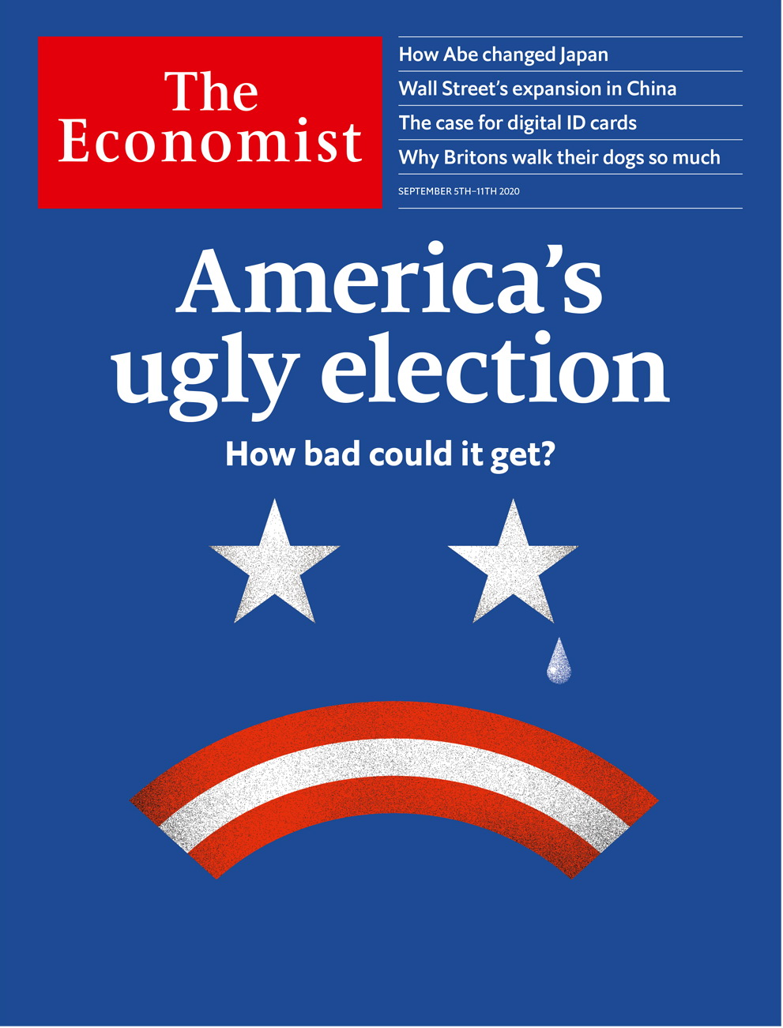

# Table of Contents

The world this week

Politics this week

Business this week

KAL’s cartoon

Leaders

Politics: America’s ugly election

A prime minister’s legacy: How Abe Shinzo changed Japan

High finance in China: The exception

Digital ID cards: Time for proof

Rwanda: Nowhere to hide

Letters

On coming out, competition, the Midwest, Turkey, John Snow, York: Letters to the editor

Briefing

America’s presidential election: A house divided

United States

Swing states: The suburban strategy

Polls and nerves: Shorting volatility

Inclusivity v fairness: Vitrix ludorum

NYC’s MTA: Train wreck

Lexington: It’s the covid-economy, stupid

The Americas

Brazil: An increasingly prickly partnership

Canada and the United States: Frontier friendship

Asia

Japanese politics: A new story at last

Feminism in Pakistan: No shrinking violets

Covid-19 in India: Double whammy

Taiwan: Unambiguously dangerous

Banyan: Three-finger salute

China

Education reform: Testy times

Inner Mongolia: Mongolingualism

Chaguan: Keeping a grip

Middle East & Africa

United Nations peacekeeping in Congo: Blue helmet blues

Rwanda’s celebrated hotel manager: We don’t need another hero

Elections in Burkina Faso: Sacking the voters

Lebanon: The sultan et le président

Egyptian politics: Defendant number 54,000,000

Europe

France: The man with le Plan

Belarus and Russia: A distorted picture

Germany’s envoy to Poland: Not much of a welcome

Animal rights in the Netherlands: Not fur sale

Charlemagne: Politicians or technocrats?

Britain

Boris Johnson: Could do better

Dog-walking: Parading the pooch

Brexit negotiations: Deal or no deal?

Covid-19 in England: A summer break

The housing market: Flatlining

5G: Moobile networks

Rave revival: Third summer of love

Bagehot: The Lib Dems might just fly again

International

The digitisation of government: Paper travails

Business

Prosus: Winner’s curse

Wizz Air: Rising in the east

Japanese business: Rebalancing act

Berkshire Hathaway’s Japanese bet: Buffett bets on Japan

Bartleby: After the fall

Indian business: Over-Reliance

TikTok: Limbo dance

Schumpeter: Reconstituted

Finance & economics

Financial coupling in China: Present tense, future market

The Federal Reserve: New job description

Indian finance: Silent no more

Campaign finance: Wall Street’s money

World Bank: Unease of Doing Business

Buttonwood: Impaired visibility

Free exchange: Parting shot

Schools brief

A social turn: Hard work and black swans

Science & technology

Military strategy: What motivates the dogs of war?

Brain-computer interfaces: And pigs may drive

Forensic botany: Murder will out

Psychology: Lucid dreams

Books & arts

Violence and music: Drilling down

Johnson: Lost in dictation

Myrmecology: A bug’s life

Abe Shinzo: Family man

Home Entertainment: Assassin’s creed

Economic & financial indicators

Economic data, commodities and markets

Graphic detail

Air pollution: Blue skies turn grey

Obituary

Chadwick Boseman: To be a king



### Friday, September 4, 2020

|  |  |
| --- | --- |
| The world this week | 3 |
| Leaders | 5 |
| Letters | 1 |
| Briefing | 1 |
| United States | 5 |
| The Americas | 2 |
| Asia | 5 |
| China | 3 |
| Middle East & Africa | 5 |
| Europe | 5 |
| Britain | 8 |
| International | 1 |
| Business | 8 |
| Finance & economics | 7 |
| Schools brief | 1 |
| Science & technology | 4 |
| Books & arts | 5 |
| Economic & financial indicators | 1 |
| Graphic detail | 1 |
| Obituary | 1 |

|  |  |  |
| --- | --- | --- |
|  | Sections | Leaders |

The world this week

Politics this week

.

Business this week

.

KAL’s cartoon

.

|  |  |  |
| --- | --- | --- |
|  | Sections | Leaders |

|  |  |  |  |
| --- | --- | --- | --- |
|  | Articles | Sections | Next |

# Politics this week

Sep 5th 2020 |

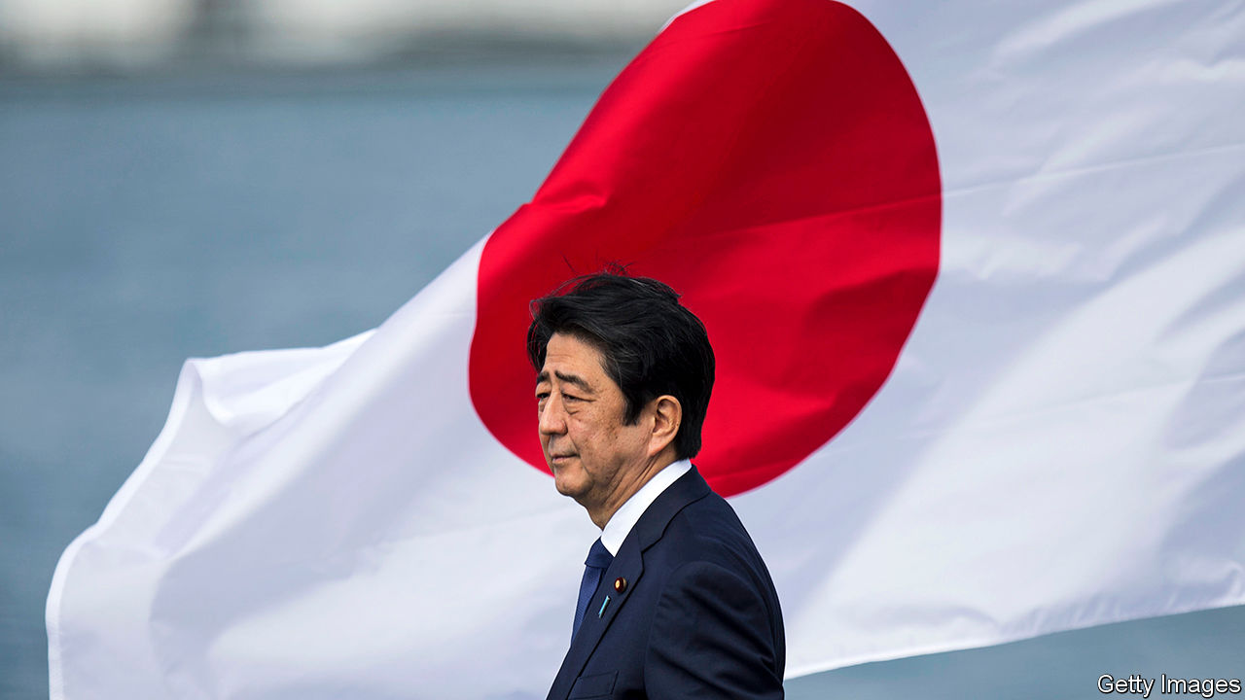

Abe Shinzo announced that he was stepping down as prime minister of Japan because of ill health. Mr Abe has held the job longer than anyone else. He will be remembered for “Abenomics”, a programme of monetary easing, spending and structural reforms. The ruling Liberal Democratic Party will choose a successor on September 14th. The leading candidate is Suga Yoshihide, Mr Abe’s cabinet secretary. See article.

Thailand’s King Maha Vajiralongkorn restored Sineenat Wongvajirapakdi to her position as royal “consort”. Last year the king made her Thailand’s first officially designated consort in almost a century, but she was stripped of her privileges a few months later for trying to elevate herself as an equal to the queen, the king’s fourth wife.

Tensions flared anew in a disputed border area between India and China. India accused China of violating an agreement reached during recent peace talks by carrying out “provocative military movements” in the Himalayas. China said its troops had not violated the status quo.

Ethnic-Mongol parents in the Chinese province of Inner Mongolia kept their children at home in protest against a government effort to extend the use of Mandarin in schools. Some parents fear the new policy will diminish young people’s knowledge of the Mongol language. See [article](https://www.economist.com/china/2020/09/05/chinas-drive-to-boost-the-use-of-mandarin-in-schools-angers-ethnic-mongols).

Australia said one of its citizens, a prominent journalist working for Chinese state television, had been detained by the Chinese authorities. No details of any charges against the woman, Cheng Lei, have been released.

Venezuela’s dictator, Nicolás Maduro, pardoned 110 opponents who had been charged with crimes by his regime. They include associates of Juan Guaidó, the president of the National Assembly, who is recognised as Venezuela’s interim president by more than 50 countries. Most opposition leaders intend to boycott the legislative election due in December.

Protesters in Montreal pulled down a statue of John Macdonald, Canada’s first prime minister. They accuse him of perpetrating “genocide” by founding the residential-schools system, where tens of thousands of indigenous children were forcibly enrolled. Many were abused.

The German government said that Alexei Navalny, a prominent Russian opposition leader taken ill on a plane in Siberia and evacuated to Berlin, had been poisoned by a form of Novichok, a nerve agent used in Britain in 2018 in an assassination attempt on another enemy of Vladimir Putin. The confirmation increases the likelihood of more sanctions on Russia. Mr Navalny remains in a medically induced coma. See [article](https://www.economist.com/europe/2020/09/02/germany-says-that-alexei-navalny-was-poisoned-with-novichok).

France released details of a €100bn ($119bn) stimulus package, aimed at countering the recession brought on by covid-19, and also reintroduced the concept of a national economic plan. See article.

Mustapha Adib, Lebanon’s ambassador to Germany, was selected as the country’s next prime minister. This came a day before a visit by Emmanuel Macron, the president of France, who pushed Lebanese officials to tackle corruption and implement political reform. Lebanon was already mired in a financial crisis when its capital, Beirut, suffered billions of dollars in damage from an explosion four weeks ago. See article.

A delegation of American and Israeli officials took the first official flight from Israel to the United Arab Emirates. The two Middle Eastern countries agreed to normalise relations last month. The flight crossed Saudi Arabian airspace, which had been closed to Israeli air traffic. The UAE also repealed a law boycotting Israel.

King Salman of Saudi Arabia sacked six defence officials over allegations of corruption. Prince Fahd bin Turki bin Abdulaziz Al Saud, who commands the Saudi-led coalition in Yemen, and his son were among those removed from their posts. Muhammad bin Salman, the crown prince, has used past anti-corruption drives to consolidate power.

Alpha Condé, the president of Guinea,will stand in an election scheduled for October, after he abolished a two-term limit in a contested referendum earlier this year. Mr Condé has run the country since 2010; under the new law he may rule until 2032, when he will be 94.

The government and rebel groups in Sudan signed a peace deal promising to end a civil war centred largely in the Darfur region that has lasted 17 years. Several earlier ceasefires and peace deals have been signed and then broken.

Donald Trump visited Kenosha, a town in Wisconsin that has been embroiled in violence since a black man was shot by police and paralysed. The president reiterated his resolute message on law-and-order, which he hopes will help him win re-election. In Portland, another scene of widespread disturbances, a white man who took part in a pro-Trump demonstration was fatally shot amid clashes with left-wing protesters. See article.

A member of the Kennedy clan lost an election in Massachusetts, a first for the state. Joseph Kennedy, a congressman, failed to wrest a Senate seat from Ed Markey in the Democratic primary.

## Coronavirus briefs

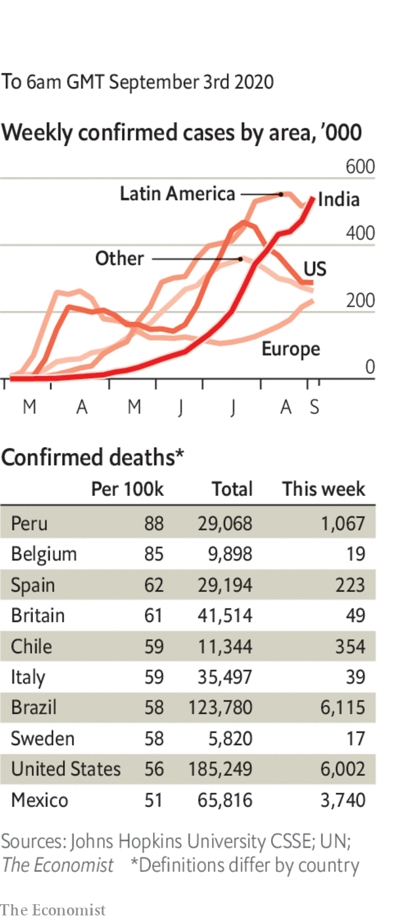

The World Health Organisation recommended the use of cheap, everyday steroids for the treatment of severely ill covid-19 patients, after a meta-analysis of data found they reduced deaths by over a third.

The United States passed 6m cases in total; the number of new cases continues to fall. France and Spain recorded their most infections in a day since March. Argentina registered its biggest jump since the start of the pandemic.

India reported 2m infections in August, the highest monthly tally for any country since the outbreak of the coronavirus. It has recorded 3.9m cases in all.

As in many other countries, pupils in England started returning to school for the first time since March. New York City postponed the reopening of its schools as it resolved a dispute with teachers over testing (for covid-19, not students’ academic ability).

This article was downloaded by calibre from <https://www.economist.com/the-world-this-week/2020/09/05/politics-this-week>

|  |  |  |  |
| --- | --- | --- | --- |
|  | Articles | Sections | Next |

|  |  |  |  |
| --- | --- | --- | --- |
| Previous | Articles | Sections | Next |

# Business this week

Sep 3rd 2020 |

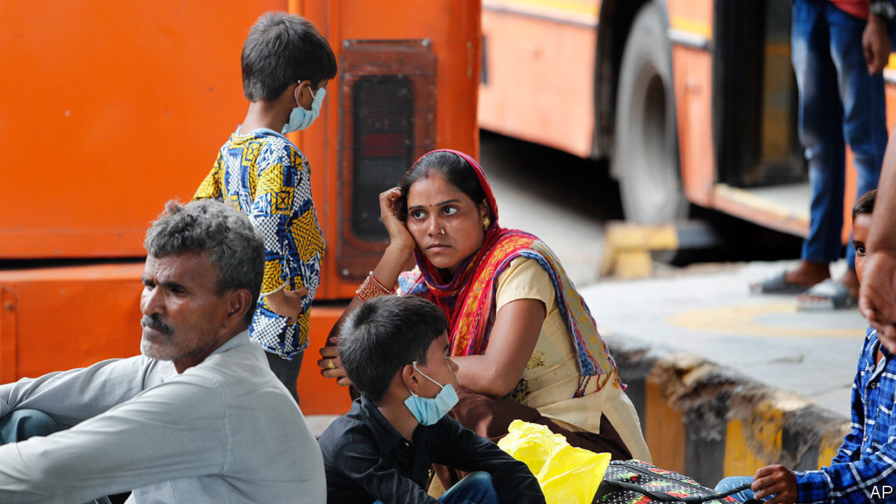

Another raft of data underscored the toll that covid-19 is taking on economies, as more countries reported record-breaking contractions in quarterly GDP. India’s economy was around a quarter smaller in April to June than in the first three months of the year. Australia’s GDP shrank by 7%, Brazil’s by 9.7%, and Turkey’s by 11%. Those countries are in recession, in Australia’s case for the first time in nearly three decades. See [article](https://www.economist.com/node/21791422).

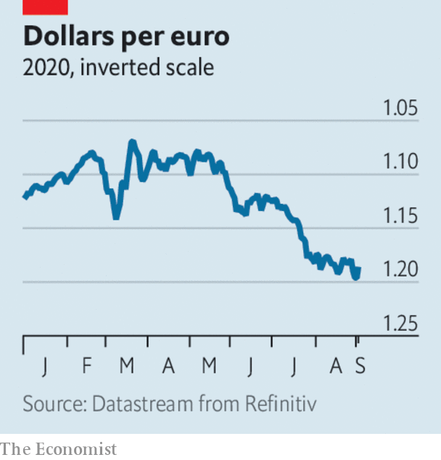

The dollar fell to another two-year low against the euro, notching up a fourth consecutive month of losses, after Jerome Powell announced a major shift in policy at the Federal Reserve. The central bank’s chairman said that “maximum employment” and a “strong labour market” would guide future decisions, in effect suggesting the Fed will not raise interest rates for years to come. It will now allow inflation to run above 2% sometimes, rather than strictly target that figure as a goal. See [article](https://www.economist.com/node/21791405).

A first estimate showed that the annual rate of inflation in the euro zone fell to -0.2% in August, the first time in four years that the currency bloc has slipped into deflation. Cheaper energy was the main factor behind shrinking prices.

Tesla announced that it would sell new shares “from time to time” to raise up to $5bn on capital markets. This came after the electric-car maker completed its stock split, which provided existing investors with more shares but at a lower price. Before the split Tesla’s stock traded above $2,210 a share, up by 500% since the start of the year. It reopened at $496. After the split Elon Musk, Tesla’s boss, joined the club of just five men in the world who are worth over $100bn.

Stockmarkets had their best August since 1986. The MSCI World Index of share prices rose by 6.6% over the month. Fuelled by a rally in tech shares, and by quarterly earnings from companies that were more positive than had been expected, the S&P 500 and NASDAQ are at record highs.

## Scrubbing up nicely

Unilever became the first big provider of everyday household goods to commit to green sourcing for its cleaning and laundry products. The conglomerate, which sells a wide range of familiar brands, including Persil (in Britain), Surf and Domestos, said that it would shift to renewable or recycled sources of carbon, and by 2030 no longer use chemicals derived from fossil-fuel feedstocks, such as petroleum and natural gas.

With food allergies on the rise, Nestlé struck a deal to buy Aimmune Therapeutics, which makes the only approved remedy in America to treat a reaction to peanuts among children. Up to 240m people worldwide suffer with food allergies, peanut allergy being the most common.

Lee Jae-yong, the de facto boss of Samsung, was indicted on new charges in South Korea, including manipulating share prices. The latest claims focus on the merger in 2015 of two of the conglomerate’s affiliates. Mr Lee is already being retried in a related bribery case.

Zoom’s customer base (firms with at least ten employees) rose by 458% in the three months ending July compared with the same quarter last year, generating soaring profits.

India’s Supreme Court compromised and gave the country’s mobile-phone operators ten years to pay a collective $13bn in retrospective licence fees and penalties that an earlier ruling found were owed to the government. The court had been insisting on immediate payment, which threatened to wipe out Vodafone’s venture in the country.

In a surprise announcement, SoftBank said it would sell $14bn-worth of shares in its telecoms business, which it bought from Vodafone in 2006, reducing its stake from 62% to 40%. Proceeds of the sale will go some way towards shoring up the debt-laden conglomerate’s balance-sheet.

Apple removed Epic Games’s access to its app store in a dispute over the fees that Apple levies. It had already removed “Fortnite”, Epic’s most popular game. Deleting the firm’s account means its other games are also unavailable; iPhone users who have installed “Fortnite” can continue to play, but not with Android or PC gamers. People claiming that “Fortnite” is already on their iPhone are selling their devices for thousands of dollars online.

## Pomp and circumstance

Britain’s public broadcaster, the BBC, did a U-turn and will allow the lyrics to “Rule, Britannia!” and “Land of Hope and Glory” to be sung on the last night of a popular festival of music that it broadcasts. The decision to rearrange the patriotic songs without words was criticised for being soppy and woke. Restoring them is a wise move by Tim Davie, the BBC’s new boss, as he negotiates funding with the government. It reportedly wants the BBC, which is funded by a household television-tax, to look for alternative sources of revenue.

This article was downloaded by calibre from <https://www.economist.com/the-world-this-week/2020/09/03/business-this-week>

|  |  |  |  |
| --- | --- | --- | --- |
| Previous | Articles | Sections | Next |

|  |  |  |  |
| --- | --- | --- | --- |
| Previous | Articles | Sections | Next |

# KAL’s cartoon

Sep 3rd 2020 |

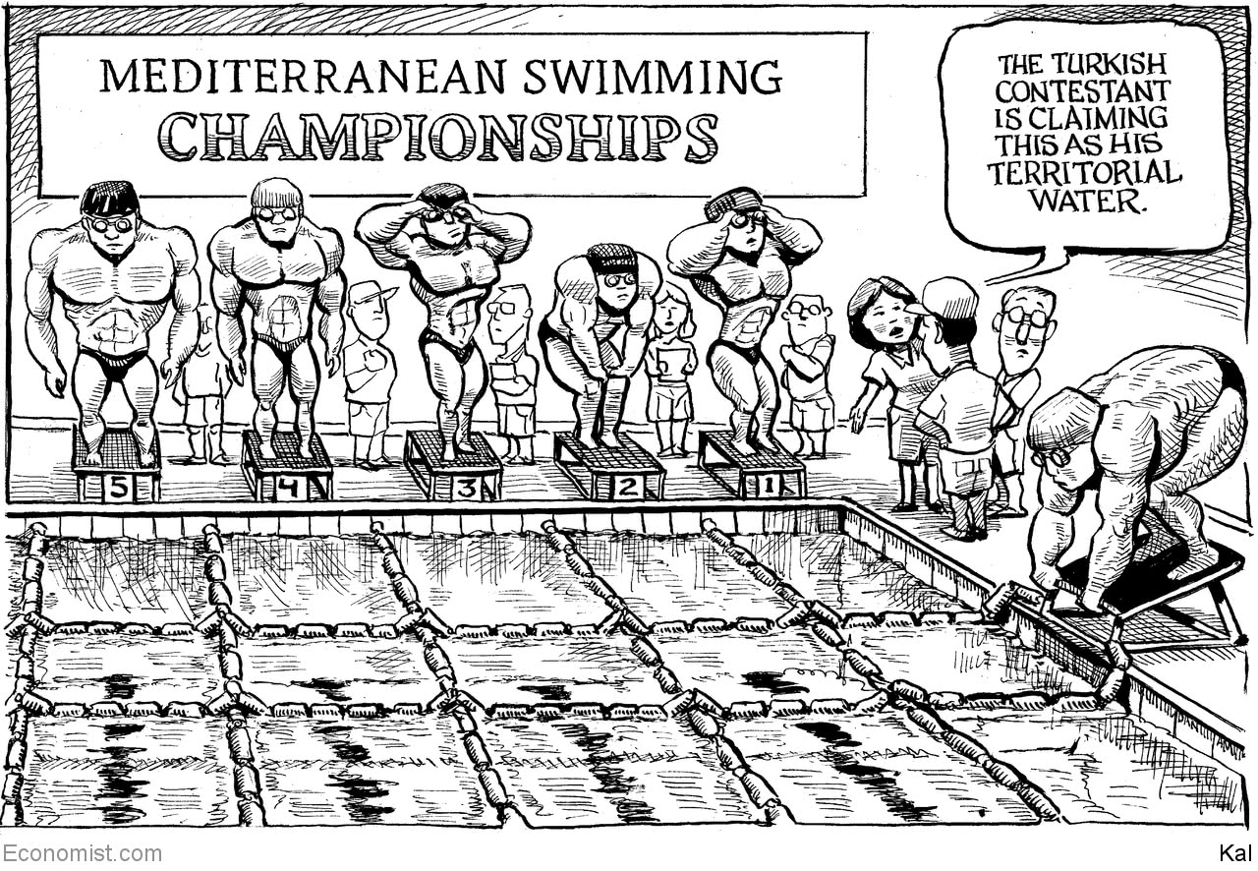

This article was downloaded by calibre from <https://www.economist.com/the-world-this-week/2020/09/03/kals-cartoon>

|  |  |  |  |
| --- | --- | --- | --- |
| Previous | Articles | Sections | Next |

|  |  |  |
| --- | --- | --- |
| The world this week | Sections | Letters |

Leaders

Politics: America’s ugly election

.

A prime minister’s legacy: How Abe Shinzo changed Japan

.

High finance in China: The exception

.

Digital ID cards: Time for proof

.

Rwanda: Nowhere to hide

.

|  |  |  |
| --- | --- | --- |
| The world this week | Sections | Letters |

|  |  |  |  |
| --- | --- | --- | --- |
|  | Articles | Sections | Next |

#### What could go wrong?

# America’s ugly election

A disputed result in November could be dangerous

Sep 3rd 2020 |



LABOR DAY marks the beginning of the home straight in a presidential election. This one threatens to be ugly. The president’s supporters are clashing with Black Lives Matter protesters in Portland, Oregon. Donald Trump flew to Kenosha, Wisconsin, for a photo-op in front of burned-out buildings, a week after police shot and paralysed an unarmed African-American man and one of the president’s supporters shot and killed two demonstrators, possibly in self-defence. Having adopted a strategy built around profiting from fears about unrest, the president has an interest in stoking it. Many Americans worry that November could herald not a smooth exercise of democracy but violent discord and a constitutional crisis.

Is this all hyperbole? America has had violent, contested elections in the past. In 1968 one of the candidates, Bobby Kennedy, was assassinated. In 1912 Teddy Roosevelt was shot in the chest while making a speech in Wisconsin. (He finished the speech before heading to hospital, and survived.) Historians are still arguing about who really won the election of 1876. Yet the country has always managed to gain the consent of the losers in its presidential elections—even in the midst of the civil war. That long unbroken streak suggests that doomsayers need to keep things in proportion. However, there is a real risk that things could go wrong in November.

To ensure the peaceful handover of power, democracies need the losing candidates and most of their followers to admit defeat. A clear result on polling day helps a lot: the losers may hate it, but they accept it and start preparing for the next election. When the result is unclear, a backup system is needed. Contested election results are rare in mature Western democracies, but they happen. In 2006 Silvio Berlusconi narrowly lost an election in Italy and claimed, without evidence, that there had been widespread fraud. The country’s Supreme Court ruled in favour of his opponent, and Mr Berlusconi grudgingly surrendered. In 2000 America’s presidential election was settled in the Supreme Court after contested recounts in Florida. In both cases, decrees from judges were just about enough to end the squabbling and let the country move on.

In the case of a landslide win for Mr Trump or Joe Biden, about half of America will be miserable. Many Democrats view Mr Trump as a threat to democracy itself. If he wins again millions of them will be distraught. Among Republicans, by contrast, Mr Trump still enjoys an 87% approval rating. If he loses, many will grouse that the other side cheated. But that need not stop a smooth transfer of power if the margin of victory is big enough. If Mr Trump were to lose by eight points, as polls currently suggest he will, there will be no way to challenge the result plausibly—though he may try anyway, possibly fomenting further unrest.

If the election is much closer, things could get even uglier. America is unusual in the degree of power it gives to Republican and Democratic partisans to administer elections. Decisions over who is removed from lists of eligible voters when they are updated, the design of ballot papers, where polling stations are situated, whether early voting is allowed and how many people have to witness a postal vote—things which in other mature democracies are in the hands of non-partisan commissions—are all taken by people with a D or an R by their name. If the election is close then all this will be litigated over, and ultimately end up in courts presided over by judges who have also been appointed by Republican or Democratic governors and presidents.

As if that were not worrying enough, covid-19 could add to the legal slugfest. Already more than 200 covid-related lawsuits have been filed by the campaigns (see Briefing). The evidence from party primaries suggests that though some states, such as Wisconsin, conducted a relatively orderly election despite the virus, others did not. Postal ballots were still being counted weeks after election day in New York’s primary. In November some swing states, including Michigan, will experiment with widespread voting by mail for the first time.

If the election is close and there are delays in counting ballots on election night, it could well appear that Mr Trump is winning in some key states. He might then claim victory before the results were in, as he did in Florida’s 2018 mid-terms. As more postal votes are counted, the result could then shift in Mr Biden’s favour. America would have two candidates claiming victory. Electoral cases in multiple states might have to be heard in the courts. Protests would surely erupt, some of them armed. The president might call out the national guard, as he threatened to do this summer, or send federal agents into Democratic cities to police restive crowds, as happened in Portland. At this distance, it is easy to forget quite how wrenching a disputed presidential election was in 2000. And that dispute took place at a time of maximum American self-confidence, before 9/11, before the rise of China, before elections were fought on social media, and when the choice was between two men who would be considered moderate centrists by current standards.

Now imagine something like the Florida recount taking place in several states, after an epidemic has killed 200,000 Americans, and at a moment when the incumbent is viewed as both illegitimate and odious by a very large number of voters, while on the other side millions are convinced, regardless of the evidence, that their man would have won clearly but for widespread electoral fraud.

Were Mr Trump to lose the popular vote but win in the electoral college, as happened in 2016, then almost 40% of Democrats say that the election ought to be re-run. It should not. Were he to lose the presidency, then almost 30% of Republicans think that it would be appropriate for Mr Trump to refuse to leave office if there were claims of widespread illegal voting—claims he has already made in relation to postal voting. It would not.

There is so much riding on this election—for America and for the rest of the world—that state officials must do everything they can to make sure it goes as smoothly as possible, remembering that they owe loyalty to the constitution, not their party. Even a landslide election win will be fraught. In the event of a narrow one, America might not be able to generate losers’ consent. And without that, democracies are in big trouble.■

Dig deeper:  
Read the [best of our 2020 campaign coverage](https://www.economist.com/us-election-2020) and our [presidential-election forecast](https://projects.economist.com/us-2020-forecast/president), then sign up for Checks and Balance, our [weekly newsletter](https://www.economist.com/checksandbalance/) and [podcast](https://www.economist.com/podcasts/2020/08/28/checks-and-balance-our-weekly-podcast-on-american-politics) on American politics.

This article was downloaded by calibre from <https://www.economist.com/leaders/2020/09/03/americas-ugly-election>

|  |  |  |  |
| --- | --- | --- | --- |
|  | Articles | Sections | Next |

|  |  |  |  |
| --- | --- | --- | --- |
| Previous | Articles | Sections | Next |

#### A reformer bids farewell

# Abe Shinzo’s legacy is more impressive than his muted exit suggests

He not only reshaped the economy and foreign relations—he also paved the way for future reforms

Sep 3rd 2020 |

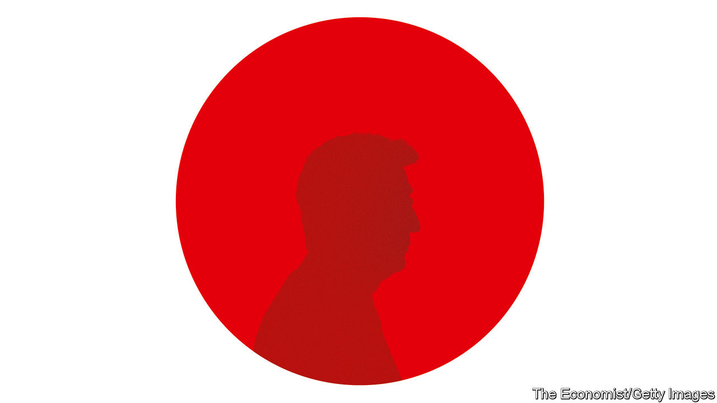

THE RECORD was beaten in late August. Then, just four days later, the record-breaker said that he was, too. After serving the longest continuous stint of any Japanese prime minister (as well as the longest time in the job overall) Abe Shinzo announced his resignation on August 28th.

Mr Abe blamed the abrupt decision, over a year before the rules of his Liberal Democratic Party (LDP) would have obliged him to step down, on an old digestive ailment. But many have cast his departure as an admission of defeat. The economy, which he has worked hard to revive after decades of listlessness, is swooning again because of covid-19. His campaign to revise Japan’s pacifist constitution to give the armed forces a proper legal underpinning has gone nowhere. His planned swansong, the Tokyo Olympics that were supposed to have taken place this summer, may never happen. His approval rating is dire.

It is a gloomy moment. What with the depredations of the coronavirus, the growing pugnacity of China and Japan’s shrinking and ageing population, Mr Abe’s successor, who will be chosen on September 14th by the LDP’s MPs, will have his work cut out (see article). But all these problems have been made more manageable by Mr Abe’s eight years in office. The outgoing prime minister has done a far better job than is commonly acknowledged. Before covid-19 struck, “Abenomics” was succeeding, albeit slowly, in resuscitating the economy. Japan, something of a wallflower in global affairs since the second world war, was playing an unusually prominent and constructive role in Asia and around the world. And Mr Abe was pushing through difficult reforms that shorter-lived and less adept prime ministers had shirked for decades. He leaves a much more impressive legacy than his muted exit suggests.

Abenomics was supposed to banish deflation and spur growth through lavish spending, radical monetary policy and structural reforms. Mr Abe never met his own, ambitious target to pump up inflation to 2% a year, but he did at least turn it positive. Before he took office, prices had been falling for four years straight; they have risen in all but one of the seven years since. During his tenure the economy enjoyed a 71-month recovery, just two months shy of a post-war record. And productivity has risen faster in Japan than in America.

To get the economy moving, Mr Abe adopted policies previously considered politically or culturally impossible. As part of the Trans Pacific Partnership (TPP), a big regional trade deal, he agreed to slash tariffs and increase import quotas for agricultural goods, even though coddled farmers are some of the LDP’s most loyal supporters. Japanese women entered the workforce in droves, helped by free nursery school and other subsidies for child care. They are now more likely to work than their American counterparts. And there are more than twice as many foreign workers in Japan as there were when Mr Abe took office, despite a supposed national phobia about immigration.

Corporate governance has also improved dramatically. Almost all big listed firms have at least one independent director, compared with less than 40% in 2012. That in turn has broadened Japan’s appeal to foreign investors. Just this week Warren Buffett piled into Japanese conglomerates (see [article](https://www.economist.com/node/21791413)). The main stockmarket index has more than doubled on Mr Abe’s watch, having barely budged for the previous decade.

There have been mistakes, too, of course, most notably the decision to raise the sales tax twice, both times sending the economy into brief recession. But the pundits’ grim warnings—that the scale of government borrowing would prompt unaffordable rises in the interest rate it had to pay or, conversely, that the central bank’s adoption of negative interest rates would fatally injure the big banks—were simply wrong (see [Free exchange](https://www.economist.com/node/21791407)).

Mr Abe confounded expectations even more with his vigorous and adroit diplomacy. As the grandson of one of the architects of Japan’s imperial war machine and an avowed nationalist himself, he was expected to spark dangerous rows with China while alienating Japan’s allies (see article). He has, it is true, got locked into a pointless historical feud with South Korea. For the most part, however, he has managed to rally like-minded governments in the region to counter China’s military and economic might without unduly provoking China’s ire. When America pulled out of the TPP it was Mr Abe who kept the project alive. He also strengthened military co-operation with fellow democracies like Australia and India. He has stayed chummy with President Donald Trump, yet he is also, remarkably, on goodish terms with Xi Jinping, China’s president, who had been due to visit Japan in April until covid-19 intervened.

The constitution may remain unchanged, but Mr Abe has nonetheless made Japan a more credible force on the world stage. He has increased spending on the armed forces and pushed through legal changes allowing them to take part in joint-defence pacts and peacekeeping missions. Despite constant Chinese prodding, he has held firm on a territorial dispute over some tiny islands in the East China Sea.

Mr Abe leaves plenty of pressing problems to his successor. Japan’s shrinking population makes it all the more important to get as many people as possible into the workforce and to raise their productivity. Although more women are working, corporate culture remains too sexist to make the most of their skills: most are in dead-end jobs. The rigid divide between salaried and part-time workers also makes the labour market inefficient. Far too little, especially of the work of government, is digital. And Japan has made little progress in greening its energy mix.

Although Mr Abe leaves lots of unfinished business, he also leaves his successor the tools to complete the job. Perhaps his most important and least recognised achievement is to have made Japan more governable. He managed to quell, at least for now, factional jockeying within the LDP, which doomed previous prime ministers to short, turbulent stints in office. And he brought the bureaucracy, which used to run the show as the politicians rotated, more firmly under the control of its elected bosses. Japan’s economy, in particular, still needs a lot of help. But if the next prime minister manages to get anything done, it will be thanks in large part to the groundwork laid by Mr Abe. ■

This article was downloaded by calibre from <https://www.economist.com/leaders/2020/09/03/abe-shinzos-legacy-is-more-impressive-than-his-muted-exit-suggests>

|  |  |  |  |
| --- | --- | --- | --- |
| Previous | Articles | Sections | Next |

|  |  |  |  |
| --- | --- | --- | --- |
| Previous | Articles | Sections | Next |

#### The exception

# Why is Wall Street expanding in China?

It may be a step on the way to China becoming a financial superpower

Sep 5th 2020 |

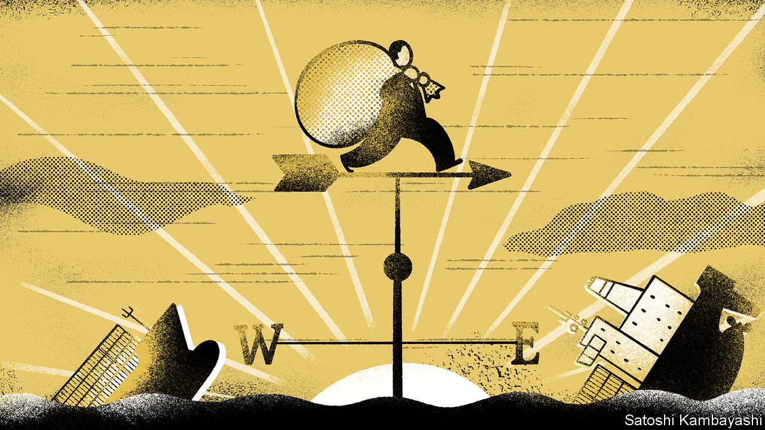

IN THE TECH industry the rupture between China and America continues to grow. Will Uncle Sam force a sale of TikTok, a Chinese-run app popular in the West (see [article](https://www.economist.com/node/21791418))? Can Huawei survive the embargo? Is Apple shifting its supply chains from China? Yet in one part of the global economy the pattern is of superpower engagement, not estrangement: high finance. BlackRock, a giant asset manager, has got the nod to set up a Chinese fund business. Vanguard, a rival, is shifting its Asian headquarters to Shanghai. JPMorgan Chase may spend $1bn to buy control of its Chinese money-management venture (see [article](https://www.economist.com/node/21791377)). Foreign fund managers bought nearly $200bn of mainland Chinese shares and bonds in the past year. Far from short-term greed, Wall Street’s taste for China reflects a long-term bet that finance’s centre of gravity will shift east. And unlike in tech, both sides think they can capture the benefits of interaction without taking too much risk.

Western, and in particular American, capital markets still reign supreme on most measures. Derivatives are often traded in Chicago; currencies in London. American firms dominate the league tables in asset management and investment banking. The White House has sought to weaponise America’s pre-eminence, by pushing Chinese firms to delist their shares from New York, for example. But if anything the trade war has shown the growing muscle of China in finance. A big wave of IPOs is taking place in Hong Kong, often done by firms keen for an alternative to New York. China’s prowess in fintech will soon be centre-stage with the listing of Ant Group, which may be the world’s largest IPO ever. And then there is the surprising rush of Wall Street firms and other foreign investors into mainland China.

They have been knocking on the door for 30 years with little success. Now they are betting that China is serious about welcoming foreign finance. With its current-account surplus set to fall over time, or even fall into deficit, it needs to attract more foreign capital. The terms of access have improved. China is at last allowing Western firms to take control of their mainland operations and has made it easier for fund managers to buy and sell mainland securities. The potential prize is vast: a new source of fees for Wall Street banks, and for fund managers a huge universe of potential customers and companies to invest in.

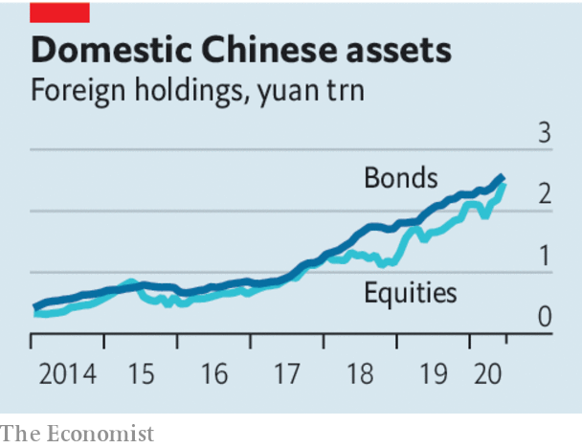

There are risks. China could bend the rules to protect local banks and brokers. Corruption is a hazard: in 2016 JPMorgan Chase was fined by American regulators for giving jobs to well-connected Chinese “princelings”. Worries over human-rights abuses may intensify. And navigating America’s sanctions regime will be tricky—global banks active in Hong Kong, such as HSBC, are already under pressure to cut off some Chinese officials there. Yet American financial firms’ exposure to China is low enough that they have little to lose. The tech industry is dangerously dependent on China: Apple assembles many of its devices there. By contrast, the top five Wall Street banks have only 1.6% of their assets exposed to China and Hong Kong.

China’s ability to attract Wall Street firms during a bitter trade war shows the clout its capital markets have. But to become a financial superpower it would need to create its own global finance and payments infrastructure and make the yuan more freely convertible. The leading Chinese firms have a tiny presence abroad (just 5% of revenues for Ant) and most of China’s trade is invoiced in dollars, making it vulnerable to American sanctions. Building an alternative to America’s global monetary network is a huge task that will take years and require China’s control-obsessed officials to loosen their grip further. Still, the trade war has given China a big incentive to take the next step.■

This article was downloaded by calibre from <https://www.economist.com/leaders/2020/09/05/why-is-wall-street-expanding-in-china>

|  |  |  |  |
| --- | --- | --- | --- |
| Previous | Articles | Sections | Next |

|  |  |  |  |
| --- | --- | --- | --- |
| Previous | Articles | Sections | Next |

#### Time for proof

# Covid-19 strengthens the case for digital ID cards

With safeguards for privacy and security, they make government work better

Sep 5th 2020 |



Editor’s note: Some of our covid-19 coverage is free for readers of The Economist Today, our daily [newsletter](https://my.economist.com/user#newsletter). For more stories and our pandemic tracker, see our [hub](https://www.economist.com/news/2020/03/11/the-economists-coverage-of-the-coronavirus)

THE PANDEMIC has had few silver linings. One is that a huge range of human activities have moved online far more smoothly than almost anyone expected. Businesses have let their white-collar staff work from home for half a year now. People are attending yoga classes remotely. Brits are appearing in court digitally; New Yorkers are tying the knot online.

Yet as they migrate to the virtual world, many people are discovering that they do not have the right documents to prove their identity. Businesses use credit cards, in effect, as a rough-and-ready proof that people are who they say. Governments cannot do that. Rather than simply exchanging goods for money, they give money away and issue commands, so they need to know more about their “customers” than, say, a supermarket does. In countries without a system of secure digital identities, the closure of bricks-and-mortar government offices and the shift of public services online have caused havoc (see article). Divorces and adoptions have run into a virtual brick wall. Italy’s system for doling out emergency payments crashed and then demanded paperwork that applicants could not obtain because government offices were shut. In America, Washington state paid $650m in unemployment insurance to fraudsters who made applications using stolen identities.

No such havoc occurred in Estonia, a tiny Baltic state where every citizen has an electronic identity. More than just an identity card, it links every Estonian’s records together. So when the government created a furlough system for workers affected by the pandemic, it already knew where they worked and how to pay them. Nobody in Estonia had to join a queue on a pavement to claim benefits, as people in other places did.

Other countries, such as Britain and America, have long resisted introducing a national identity system. Some fear that it would make it too easy for the government to spy on people, or would be too easy to hack, or would simply be botched by incompetent bureaucrats. Feelings run high. Boris Johnson, Britain’s prime minister, once vowed that if he had to carry an ID card and a bossy official demanded to see it, he would “physically eat it”.

However, the pandemic has strengthened the case for a digital ID. It would not only make it quicker and easier to access government services remotely. It would also make track-and-trace systems more effective. If, in an emergency such as the pandemic, health data were linked to work data, governments could quickly spot when a cluster of covid patients all happened to work at the same factory.

Worries about privacy and security can be allayed, albeit imperfectly. Estonians, who learned a healthy suspicion of Big Brother during five decades under the Soviet boot, are broadly reassured by a data-protection law and continually updated anti-hacking safeguards that include two-factor authentication. Similarly, laws can be passed to stop police from demanding to see people’s ID cards. Autocratic regimes will abuse ID systems, of course, but democratic governments can be constrained. Estonia’s system records every time a piece of data is viewed, and it is a crime for anyone, including officials, to access private information without good cause. That is a good model.

Creating a digital ID system is hard and expensive. Yet India, a gigantic and largely poor country, has managed it. Its “Aadhaar” biometric system has created digital identities for 1.3bn people. It has flaws: many Indians who were unable to register have suffered gravely from not being able to access services. But it has streamlined government services and massively reduced fraud. If rural Indians can prove who they are online, it is scandalous that many Brits and Americans cannot.

Digital ID systems can be introduced gradually, building on pre-existing platforms. They do not have to be compulsory. If they are reasonably safe and reduce the hassle of dealing with the state, people will willingly sign up for them.■

This article was downloaded by calibre from <https://www.economist.com/leaders/2020/09/05/covid-19-strengthens-the-case-for-digital-id-cards>

|  |  |  |  |
| --- | --- | --- | --- |
| Previous | Articles | Sections | Next |

|  |  |  |  |
| --- | --- | --- | --- |
| Previous | Articles | Sections | Next |

#### Nowhere to hide

# What the arrest of a hero of the genocide says about Paul Kagame’s rule

Paul Rusesabagina, whose story inspired “Hotel Rwanda”, faces charges of terrorism

Sep 3rd 2020 |

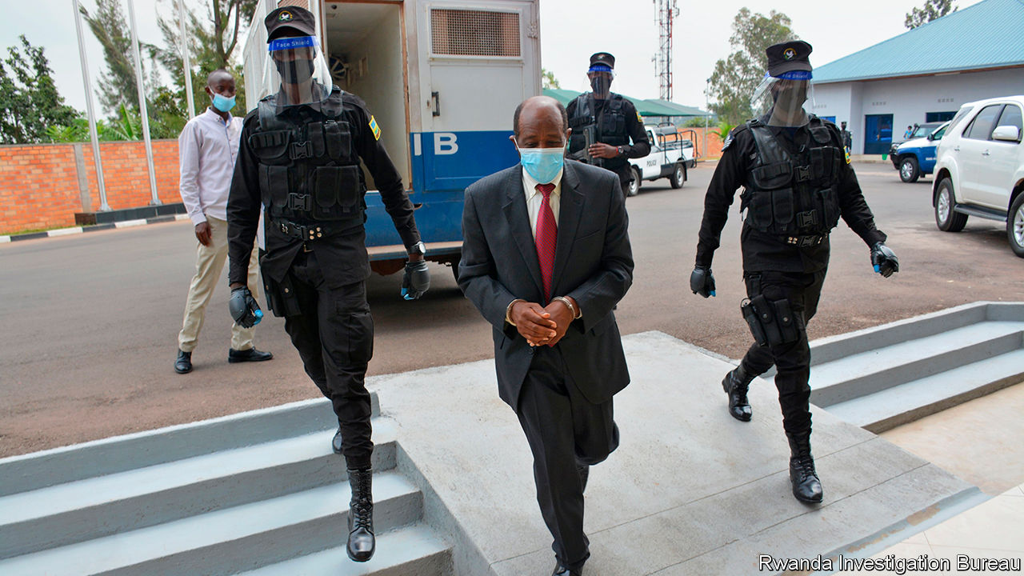

TOURISTS WHO gawp at gorillas and foreign businessfolk who meet in Kigali’s convention centre sometimes call Rwanda the Switzerland of Africa. It has beautiful mountains, clean streets, a functional bureaucracy and low levels of petty corruption and crime. But it differs from Switzerland in ways that casual visitors often miss. Rwandans are terrified of their government. They are constantly watched for hints of dissent, which is ruthlessly suppressed. History is rewritten to suit the present. Heroes can become “unheroes” overnight.

One such person is Paul Rusesabagina, who as the manager of the Hotel des Mille Collines saved more than 1,200 people from a genocidal army and machete-waving militias that were hunting down members of Rwanda’s minority Tutsi group in 1994. Although a member of the majority Hutus, Mr Rusesabagina risked his life to keep Tutsis and moderate Hutus safe. He bribed militiamen with booze so they would not attack. When an assault seemed imminent he phoned contacts in the regime, begging them to order the killers back. The genocide ended only after rebels seized the country under the command of Paul Kagame, who is now in his third presidential term.

Mr Rusesabagina’s courage inspired a film, “Hotel Rwanda”. America awarded him the Presidential Medal of Freedom, commending his “remarkable courage and compassion in the face of genocidal terror”. Some compared Mr Rusesabagina to Oskar Schindler, who risked his life saving Jews during the Holocaust. Yet in Mr Kagame’s Rwanda, Mr Rusesabagina is now portrayed as the equivalent of a Nazi fugitive, who must be abducted and brought home to justice (see [article](https://www.economist.com/node/21791385)).

Although Mr Rusesabagina initially won official plaudits in Rwanda, too, this changed after he criticised Mr Kagame for rigging elections and spoke of entering politics. Government officials swiftly (and absurdly) accused him of genocide denial, a crime in Rwanda. Mr Rusesabagina disappeared after flying to Dubai. He reappeared a few days later in manacles in Kigali, Rwanda’s capital. His family says he was kidnapped. Rwanda says he was arrested “through international co-operation”.

Mr Kagame’s opponents have often met with misfortune far from home. His former intelligence chief was strangled in a Johannesburg hotel. A former interior minister was shot in Nairobi after starting an opposition party. But the grabbing of Mr Rusesabagina marks a new level of brazenness.

Rwanda says that he supported armed groups trying to overthrow the government. There is some truth to this: he once called for an armed struggle against the regime. This is a terrible idea, though the government has produced no evidence that he ever tried to turn words into deeds. And dissidents in Rwanda note that they have few options. Elections are a sham—Mr Kagame won 99% of the vote in 2017, and could remain in office until 2034. Peaceful opponents often end up behind bars, or worse. When Diane Rwigara, a businesswoman, tried to run for the presidency, she was arrested and jailed for more than a year on charges of insurrection. A Rwandan court later said the charges were baseless. Her mother was also held and the family’s assets were confiscated.

Western governments occasionally tut at Mr Kagame’s abuses, but they also sell arms and provide aid to his government. They see Rwanda as an island of stability in a volatile region and him as a leader who gets things done. Yet 26 years after he first shot his way to power, he seems ever less constrained. His authoritarianism, once deemed by many a necessary evil to hold the country together, now risks pushing it back towards conflict. And that, in Rwanda, is a terrifying thought. ■

This article was downloaded by calibre from <https://www.economist.com/leaders/2020/09/03/what-the-arrest-of-a-hero-of-the-genocide-says-about-paul-kagames-rule>

|  |  |  |  |
| --- | --- | --- | --- |
| Previous | Articles | Sections | Next |

|  |  |  |
| --- | --- | --- |
| Leaders | Sections | Briefing |

Letters

On coming out, competition, the Midwest, Turkey, John Snow, York: Letters to the editor

.

|  |  |  |
| --- | --- | --- |
| Leaders | Sections | Briefing |

|  |  |  |  |
| --- | --- | --- | --- |
|  | Articles | Sections | Next |

#### On coming out, competition, the Midwest, Turkey, John Snow, York

# Letters to the editor

A selection of correspondence

Sep 5th 2020 |

Letters are welcome via e-mail to letters@economist.com



## I want the world to know

Your interesting article on the coming-out experiences of gay people did not mention the widespread institutionalised discrimination they face in eastern Europe (“Queer, there and everywhere”, [August 8th](https://www.economist.com/international/2020/08/08/how-the-internet-is-changing-the-experience-of-coming-out)). In Russia a recent referendum contained a draft amendment banning same-sex marriage. In Poland Andrzej Duda, the president, declared during his re-election campaign in June that gays “are not people” but are worse than Bolshevism, and that gay marriage is out of the question for Poland.

Just days after his swearing-in ceremony, the police used heavy-handed tactics against demonstrators who were protesting against the detention of a gay activist; 48 were arrested. The police claimed the protesters were being disruptive and denied them access to lawyers.

You wrote about a generally more tolerant world for gay people, but there are still places in Europe where discrimination and bigotry are entrenched and where equality before the law does not exist.

PIOTR ZIENTARA  
Associate professor of economics  
University of Gdansk

“Tolerance” of gay people is progress, but it is not a Utopia of respect, acceptance and celebration of differences. Yes, more of us are coming out, and earlier, but it is still not easy. I don’t want to settle for “gay rights”. I want equal rights. Pride events are visible because they are unusual. For the rest of the year we check our surroundings before holding hands, even in San Francisco or London. Most American states still allow the panic defence, which allows someone to claim temporary insanity if they attack a gay person. And gay sex is still illegal in nearly 70 countries.

I have been out for decades and have grown used to being told that things are fine for us now, and that I should be grateful for other people’s tolerance. I was delighted when you called for equal marriage 24 years ago (“Let them wed”, [January 6th 1996](https://www.economist.com/news/2014/10/10/let-them-wed)). But please consider a place for us gay folks beyond being tolerated.

JON HUGGETT  
All Out  
San Francisco

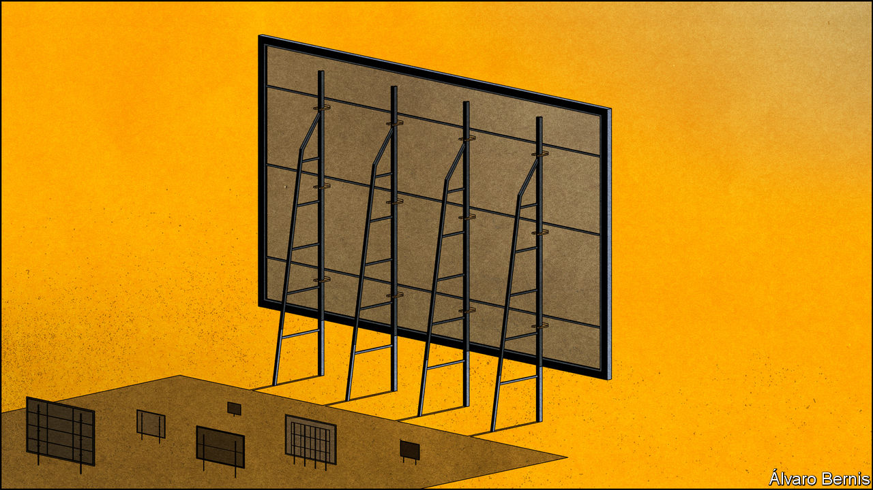

## Advertising costs

Your economics brief on competition argued that were “the market less concentrated” for digital advertising, the cost for firms might fall (“From hospitality to hipsterism”, [August 8th](https://www.economist.com/schools-brief/2020/08/08/what-more-should-antitrust-be-doing)). This ignores one of the unique aspects of the business model of the digital-advertising platforms: negative marginal costs. Machine learning, which powers these advertising systems, is famously data hungry. The models that serve ads get better with scale.

These negative marginal costs are a big reason why many believe that breaking up the platforms will ultimately be ineffective. The other dimension of digital advertising is that advertisers get value for showing digital ads that are more relevant in these large-scale systems. I, for one, enjoy seeing ads related to my interest in The Economist on Google and Facebook.

MATT STONE  
San Francisco

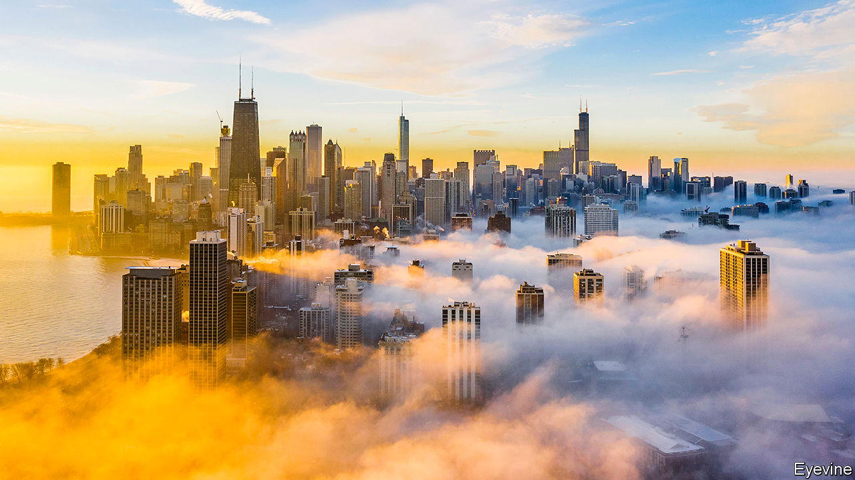

## A lovely place to live

I enjoyed your special report on the Midwest ([July 25th](https://www.economist.com/special-report/2020/07/23/a-region-with-outsized-punch)), though you were dismissive of rural areas. My small hometown in Minnesota is surrounded by the hills and hardwood forests of the unglaciated Driftless Area. A state-of-the-art school opened in 2017. A 60-mile paved bike-trail winds through the limestone bluffs of the Root river valley. The professional Commonweal Theatre Company operates year-round in a neighbouring town. Within an hour’s drive are nine colleges and universities, the Mayo Clinic and Medical School, the Minnesota Beethoven Festival and the Minnesota Marine Art Museum. In Fillmore county, which is nearly the size of Luxembourg but hasn’t a single four-lane road, no one complains about traffic.

Our rural areas have an extraordinarily productive agricultural sector, vibrant small businesses, inexpensive housing, low crime, and a sense of community. Nominal income and GDP per person may lag behind that of our cities, but our quality of life is second to none.

DAVID SCHOBER  
Rushford, Minnesota

Why did you refer to those who live in country areas as “folk” while their city counterparts are “dwellers”? Can you not dwell in the countryside, or is such a word too sophisticated for such folk? Why not go further and call them bumpkins? Alternatively, both could be referred to as people.

FINTAN TUOHY  
Zurich

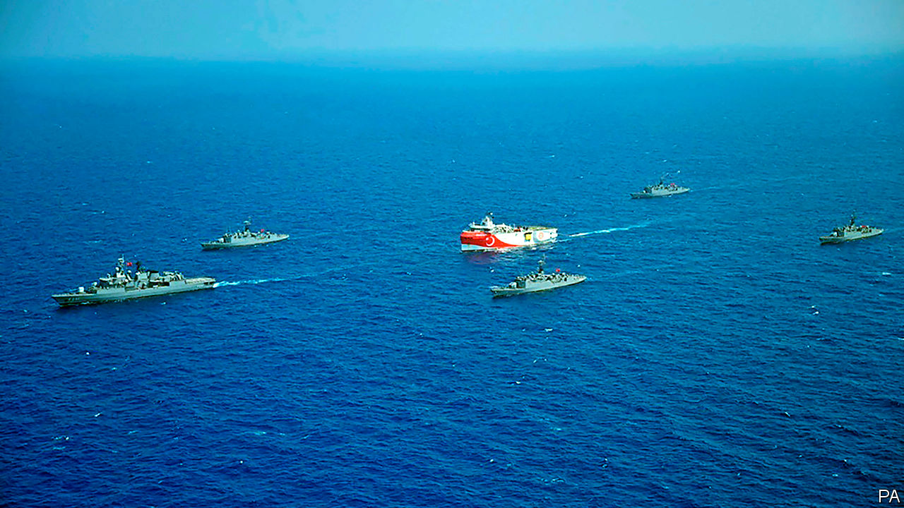

## Confrontation at sea

Your piece on the eastern Mediterranean was very interesting (“Battling over boundaries”, [August 22nd](https://www.economist.com/international/2020/08/22/a-row-between-turkey-and-greece-over-gas-is-raising-tension-in-the-eastern-mediterranean)). But you didn’t mention Britain, apart from the briefest reference to British support for Kurdish fighters. Britain has traditionally played a historic role in eastern Mediterranean affairs, and has strategically important Sovereign Base Areas in Cyprus. Could one have a more eloquent commentary on Britain’s decline in international relevance, presumably fuelled by Brexit? We don’t even rate a mention.

SIR DAVID MADDEN  
Oxford

Turkey’s situation is particularly tragic, as it actually has a good case for getting Greece’s exclusive economic zones (EEZ) reduced. If only it pursued legal channels in good faith. Virtually all island disputes that have been brought to international arbitration, from St Pierre and Miquelon by Newfoundland, to the Kerkennah Islands by Libya, have resulted in smaller EEZs for islands that are far from a country’s mainland.

Kastellorizo in particular, would seem to have little claim to an EEZ. It is only a mile off the coast of Turkey and nearly 100 miles east of Rhodes, with only a few hundred residents, and virtually no economy. The tragedy though, is that no one can take Turkey seriously when it instead thunders about its “blue homeland” and signs agreements with Libya that pretend Crete and Rhodes are no different from Kastellorizo.

MAGNUS WESTERGREN  
New York

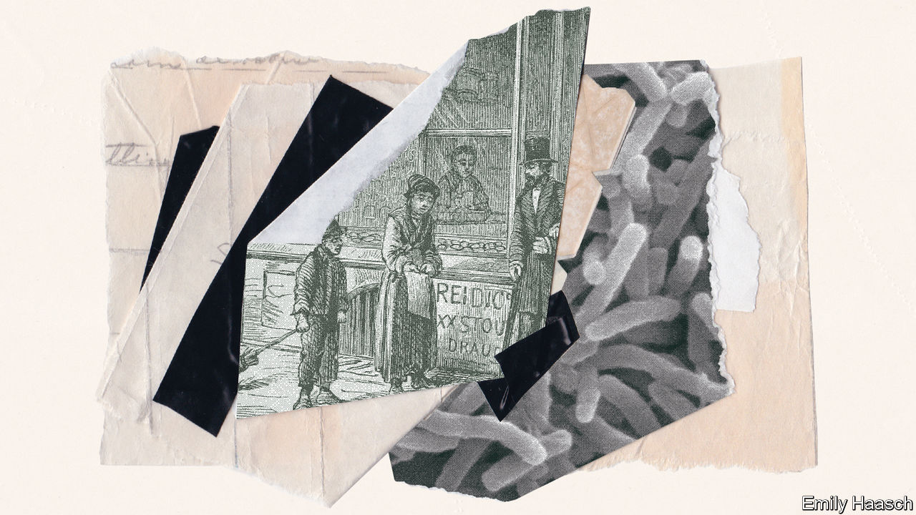

## Raise a glass!

I was surprised that you did not include the contribution of John Snow in your perspective on pandemics and economic expansion (“Cleanliness is next to growth”, [August 1st](https://www.economist.com/books-and-arts/2020/08/01/how-hand-washing-explains-economic-expansion)). Snow established that cholera is a water-borne disease, laying the groundwork for the science of epidemiology. Like many public-health professionals, I made a pilgrimage to the site of the Broad Street Pump in London’s Soho, which Snow identified as the source of a cholera outbreak, and stopped at the John Snow pub.

EDWARD COSGROVE  
Needham Board of Health  
Needham, Massachusetts

## Yorkminster parliament

Andrew Adonis rightly criticised you for mocking the idea of Parliament relocating to York (Letters, [August 22nd](https://www.economist.com/letters/2020/08/22/letters-to-the-editor)). In 1963 you argued that “nobody really believes” in Britain’s local democracy (“Federal Britain’s new frontiers”, [May 18th 1963](https://docs.google.com/gview?embedded=true&url=https://media.economist.com/sites/default/files/pdfs/editorial_links/York_Parliament.pdf)). That is as true today as it was then. At the time you called for the creation of a federal Britain to be organised by regions, with its capital, Elizabetha, located near that northern city.

CHRIS KEATING  
Liverpool

This article was downloaded by calibre from <https://www.economist.com/letters/2020/09/05/letters-to-the-editor>

|  |  |  |  |
| --- | --- | --- | --- |
|  | Articles | Sections | Next |

|  |  |  |
| --- | --- | --- |
| Letters | Sections | United States |

Briefing

America’s presidential election: A house divided

.

|  |  |  |
| --- | --- | --- |
| Letters | Sections | United States |

|  |  |  |  |
| --- | --- | --- | --- |
|  | Articles | Sections | Next |

#### A covid-struck, confused and polarised poll

# Donald Trump is very likely to challenge the results of the US election

If he does so it will be bad, quite possibly very bad indeed

Sep 3rd 2020 | WASHINGTON, DC

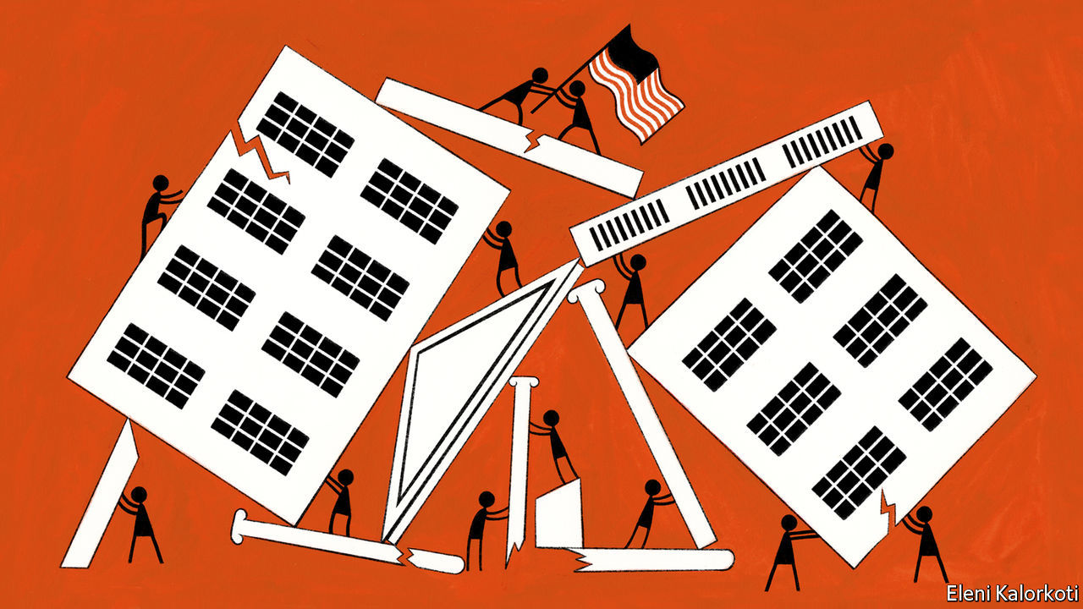

IN HIS FINAL debate with Hillary Clinton in 2016, Donald Trump refused to commit himself to accepting the results of the coming election. The following day he made his position clearer. “I will totally accept the results of this great and historic presidential election,” he said in mock solemnity—before adding, with finger-wagging emphasis: “If I win.” The stubby finger levelled itself at the crowd, which erupted into cheers; the not-yet-president grinned.

President Trump went on to win with 304 Electoral College votes to Mrs Clinton’s 227, and so how he would in fact have reacted had things gone the other way remains a matter of speculation. This year there appears to be a strong chance that he will not win; The Economist’s election-forecasting model currently puts his chances at one in seven. Mr Trump, though, denies any possibility that he could lose a fair contest: “The only way we’re going to lose this election is if the election is rigged,” he told his followers in August. There can be no real doubt that, should he indeed lose, he would claim that the election was stolen.

That, come November 4th, such a theft will actually have taken place is remarkably unlikely. Admittedly William Evanina, who directs the National Counterintelligence and Security Centre, says that China and Iran have joined Russia in seeking to influence this election through covert means, presumably emboldened by Russia having paid little price for having done so last time. This is a shocking development. But even if they were all pushing in the same direction—which is unlikely—there is no reason to think that they could decisively tip the result. America’s electoral system is sufficiently decentralised for attempts to rig the vote on a large scale to be incredibly hard. And though voter fraud occasionally takes place, both in-person and by means of absentee ballots, it is harshly punished and very rare; various studies have found the rate to be well below one in a million votes cast.

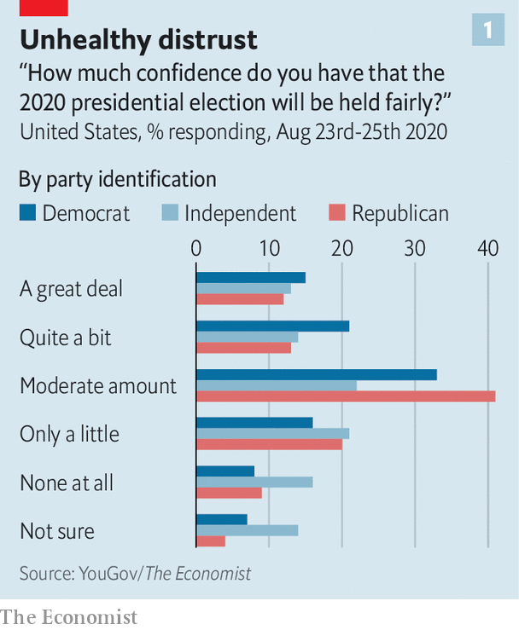

But this does not mean that Mr Trump’s protestations will be of no account. America is deeply polarised, and in a few places armed partisans have taken to the streets. Both parties have portrayed this year’s contest as existentially important to America’s future, warning that the country will be forever altered for the worse if the other candidate wins. The new round of foreign interference, like the lies and fearmongering from the president himself, add both to the stock of disinformation and the pervasive sense that things are not to be trusted. As a result a significant number of Americans of all political stripes doubt that the election will be held fairly (see chart). On top of it all, the election is being held during an epidemic that will, by election day, have killed over 200,000.

In June a bipartisan group of campaign veterans, elected officials, journalists and academics convened by the Transition Integrity Project, a group founded last year, set about war-gaming four different possible election results: a commanding victory for Joe Biden, a narrow victory for Mr Biden, a narrow victory for Mr Trump achieved, as his previous one was, without a majority of the popular vote, and a result in which, because of contested outcomes in battleground states, the identity of the victor was unclear. In all four scenarios the role playing produced levels of gamesmanship and tumult beyond anything seen in recent American elections. In the narrow-Biden-victory scenario the Secret Service escorted Mr Trump from the White House on inauguration day. It is hard to overestimate what such a sight would mean to Americans—and to the rest of the world.

## More, not merrier

In principle, an election is a fairly simple thing. Identify the people entitled to vote; provide them with the means to vote; accurately count their votes; after that, just abide by the results in the way the constitution requires.

As far as the first step goes, America’s constitution says that only citizens can vote, and that those over the age of 18 cannot be barred from doing so on the basis of their race or their sex. The Voting Rights Act of 1965 took aim at the legal requirements, such as literacy tests and poll taxes, by which Democrats in southern states had contrived to maintain race-based disenfranchisement. Those changes saw conservative whites in the south switch their allegiance from Democratic to Republican.

In the decades since, conservative whites have become increasingly central to Republican fortunes and an increasingly smaller share of the American electorate. The party has thus developed an interest in limiting electoral participation, rather than increasing it. As Mr Trump put it earlier this year, discussing a proposal greatly to expand postal ballots, “They had things, levels of voting that if you’d ever agreed to it, you’d never have a Republican elected in this country again.”

Erecting barriers to voting has grown easier to do since the Supreme Court in 2013 struck down a provision of the Voting Rights Act that required jurisdictions with a history of racial discrimination to “preclear” any electoral changes with the Justice Department. In 2016 a federal court struck down a voter-ID law in North Carolina because it “target[ed] African-Americans with almost surgical precision”. The fact that courts have ruled in this way is heartening; the fact that they have to is not.

America’s electorate is becoming ever more diverse regardless. This year non-whites comprise one-third of eligible voters, an all-time high, with Hispanics outnumbering African-Americans for the first time. The electorate is also younger than in recent times—another factor that favours Democrats. Most analysts predict a high turnout in November. As much as 70% of the 240m-strong electorate is expected to vote, compared with 60% in the 2016 election and 50% in the 2018 midterms.

They will not all find it easy. The Leadership Conference on Civil and Human Rights, an umbrella group, has found that nearly 1,700 polling places were closed between 2012 and 2018 in states formerly covered by the pre-clearance rule. The largest numbers have been in Texas, Arizona and Georgia—three battleground states this year. Many of the closures are in areas where the population is disproportionately black or Hispanic.

Polling-place closures can be expected to lead to queues elsewhere, and queues are already a problem. The Bipartisan Policy Centre, a think-tank, found that in 2016 over 560,000 voters failed to cast a ballot because of polling-place management problems, including queues. Predictably, a study of the 2018 midterms from the Brennan Centre for Justice, another think-tank, found that black and Latino voters were markedly more likely than white voters to find themselves waiting more than 30 minutes to vote. Such delays can be expected to discourage voting at the best of times.

And this is not the best of times. Covid-19 makes standing in a long November queue particularly unappealing. It may also make the queues, and the time taken to vote, longer. The epidemic meant that Wisconsin had trouble recruiting enough poll workers for its primary election in April; as a result, the state’s biggest city, Milwaukee, had just five polling places, down from 180 in 2016. There has been more time for planning since then, which will doubtless improve things, but America remains grievously short of poll workers. With local governments already cash-strapped, private enterprise has begun to step in: the National Basketball Association, for instance, says it will convert many of its arenas into polling places.

Coronaviruses are not the only invisible threat such places need to take account of. Computer viruses, ransomware and other hacks and attacks are also a worry. The Senate Intelligence Committee, which is chaired by a Republican, Marco Rubio, concluded in 2019 that Russian hackers probed all 50 states’ electoral systems in 2016, looking for vulnerabilities. Congress’s ability to look into what is happening this time, though, may be circumscribed. John Ratcliffe, a three-term congressman with no previous intelligence experience who was recently installed as the administration’s Director of National Intelligence, has stopped providing personal briefings to the Democratic-led House Intelligence Committee. He argues that written briefings will somehow reduce the chance of leaks; they will also eliminate committee members’ opportunity to question him. According to Mr Rubio, Mr Ratcliffe will continue in-person briefings for the Senate committee.

At the state level, according to Marian Schneider, president of Verified Voting, a non-partisan group focused on election technology, “There have been significant improvements” since 2016. Many states have got rid of voting machines that do not produce paper trails for validation, thus inviting fraud. But Ms Schneider sees much more to be done: “America has woefully underfunded election infrastructure forever.” And new support does not always get to where it can do the most good. According to Mac Warner, who as secretary of state is West Virginia’s chief election official, “The most vulnerable piece is the county. They may not have [an] information officer, and even if they knew the problem, they might not have the money to fix it.”

## Boggling the mind

There is little risk of any hackers, even those with the support of nation states, changing a meaningful number of votes on the national scale. But hacking into a crucial county in a swing state is a much less onerous task, as is taking a state election system down for a few hours on election day, thereby increasing voter wait times and sapping public confidence. That Americans are even having such conversations is, in a sense, a victory for bad actors. As Ms Schneider explains, “The destructive narrative that our elections are rigged and someone is going to hack into them is almost as bad as actually doing it.”

It is hardly the only such destructive narrative around. Mr Trump is doing his best to undermine trust in one of the key responses on which states and individuals are relying in order to ease elections at a time of contagion: voting by mail.

In 34 states any voter may now request an absentee ballot for any reason. Nearly every swing state falls into this category, and fear of covid may see more voters than ever take up the opportunity. In a number of states the opportunity to vote by mail has been, or is being, widened specifically to respond to covid (see chart 2). It allows voters to feel more secure and reduces the pressures on polling places. Four states, along with Washington, DC, will swell the ranks of those states which, like Colorado, mail ballots to every registered voter.

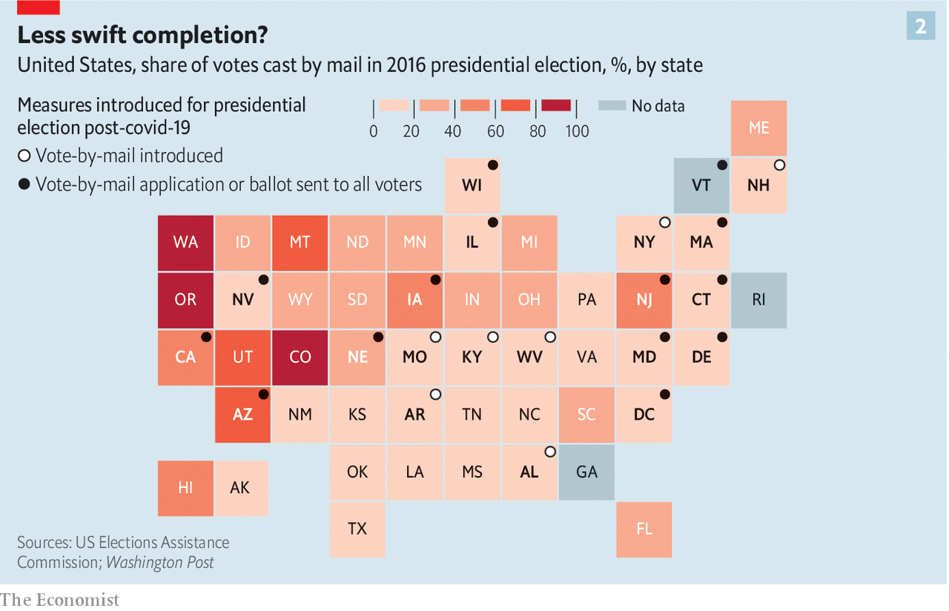

Mr Trump has been fulminating against these changes since early summer: “MILLIONS OF MAIL-IN BALLOTS WILL BE PRINTED BY FOREIGN COUNTRIES AND OTHERS. IT WILL BE THE SCANDAL OF OUR TIMES!”; voting by mail is “a corrupt disaster” that “will lead to the most CORRUPT ELECTION in our Nation’s History”; and so on. His animus is not restricted to Twitter; expansions of mail-in voting are among a huge number of changes to voting rules related to the covid-19 epidemic currently being challenged in the courts. As of August 31st, according to Justin Levitt, a professor at Loyola Law School, courts in 43 states, Puerto Rico and the District of Columbia were looking at at least 228 such cases. When rules change quickly in response to an emergency, a certain amount of legal scrutiny is a good thing. Still, it is notable that most cases involve Democrats pressing for broader ballot access and/or Republicans doing the opposite.

Take Pennsylvania, a swing state that Mr Trump barely won in 2016 and where polls currently show him trailing Mr Biden. Last year it expanded its provisions for voting in absentia; Mr Trump’s campaign is challenging some of that expansion. The campaign has also sued Nevada over a law that sends an absentee ballot to every registered voter—something which several other western states do—increases the number of polling places, and allows non-relatives to deliver the ballots of elderly or disabled voters. All those things, Mr Trump’s legal term argues without evidence, raise the risk of fraud.

Some cases have already risen as far as the Supreme Court, where the conservative majority has shown little interest in expanding voter participation, to the infuriation of the liberal minority. When the majority overturned a decision by a Wisconsin court to allow a period of grace for late ballots in the state’s primary elections, Justice Ruth Bader Ginsburg wrote that “It boggles the mind” that the court would risk “massive disenfranchisement” by treating voting during a pandemic as no different from “an ordinary election”.

In July Justice Sonia Sotomayor excoriated the majority for allowing Florida to bar around 800,000 released felons from the polls. In 2018 Florida’s voters passed a constitutional amendment allowing all felons except murderers and sex offenders to vote as soon as they had completed their sentence. In response the Republican-controlled legislature defined the completion of a sentence to include the payment of all fines, fees and penalties. The Supreme Court was not persuaded by arguments suggesting that this amounted to a poll tax. By ratifying a “pay-to-vote scheme” under which ex-offenders must pay all fines before punching a ballot, Justice Sotomayor wrote, the Supreme Court “continues a trend of condoning disfranchisement”.

Because of the limited time available, many of these election questions are making their way to the court as emergency applications; in such cases the justices hand down verdicts with little or no explanation after only partial briefing, no live hearing and quick deliberation, and reveal their votes only if they so choose. Dale Ho, the director of the voting-rights project at the American Civil Liberties Union, argues that the justices “need to explain their reasoning more” in cases about electoral law, so as to provide a guide for lower courts and the next round of litigants. Rick Pildes, a law professor at New York University, says the justices should strive for “significant consensus” in issuing decisions on voting rules if the election results are to be “broadly accepted as legitimate”.

## Falls the shadow

While the courts deal with questions raised by the states’ responses to covid-19, election officials have to make them work on the ground. Dealing with new counting systems that comply with social-distancing requirements while also handling absentee and mail-in ballots in unprecedented quantities will be challenging. In New York’s primary, on June 23rd, the volume of mailed ballots returned in New York City was ten times higher than usual. Thousands of people did not receive the ballots they requested; winners in some congressional contests were not announced until well over a month later.

To be counted at all, ballots need to get where they are meant to be going by a certain date, no matter when they were sent or postmarked. This is why the tenure of Louis DeJoy, a generous Republican donor, as postmaster general has been a subject of great scrutiny. After being appointed in May, Mr DeJoy set about implementing various operational changes at the United States Postal Service (USPS), an institution where he had never previously worked. These included restrictions on overtime and limits on the number of trips mail carriers can make back to the post office to pick up more mail.

The USPS has also removed hundreds of mail-sorting machines from processing facilities, which makes delivery slower. In Michigan—a crucial swing state which, like Pennsylvania, Mr Trump narrowly won in 2016 and where he is on track to lose this year—postal-union officials say the removal of machines has slowed sorting capacity by 270,000 pieces of mail per hour. For a ballot to count in Michigan, it must arrive at a county board of elections by election day, no matter when it was postmarked; delayed mail could easily disenfranchise voters.

Mr DeJoy has said this is all essential cost-saving. Others see his changes, implemented so soon before an election heavily dependent on mailed ballots, as deliberate sabotage. At least 20 states have sued the USPS over his changes or announced plans to do so. Mr DeJoy reassured Congress in August that the USPS could handle the upcoming election. And under public pressure he has vowed no further operational changes. But he has not committed to reversing the changes already made.

These new burdens on changed systems make it quite possible that America will not see the sort of clean result it has come to expect on election night. This was one of the main conclusions drawn by the Transition Integrity Project through its war-gaming. A number of swing states forbid election officials from even sorting mailed ballots before election day, which all but assures several days spent counting. Officials will also need to verify provisional ballots cast by voters whose eligibility is for some reason—such as a forgotten ID card, changed address or mistake on the voter rolls—in doubt. Such verification can take a while in person; it may take even longer for mailed ballots.

Jocelyn Benson, a Democrat who is Michigan’s secretary of state, says that the gap between when polls close and when results are announced “is when we anticipate individuals...may drum up uncertainty and plant doubts about the sanctity of the process...By constantly providing information and being transparent we hope to mitigate [those] efforts.”

The gap is particularly concerning because of the likelihood that the ballots counted early may tell a different story from those counted late. After the 2012 elections Edward Foley, a professor of law at Ohio State University, noticed a tendency for later-counted votes to favour Democrats. He called this phenomenon the “blue shift”. In Pennsylvania, for example, late-counted ballots have added around 20,000 more votes to the Democratic tally than the Republican one in the past four presidential elections. In 2016 Mr Trump’s lead in the state whittled down from 67,951 on election night to just 44,292 in the end.

There are various factors at play in the blue shift, and their relative importance is a matter of some debate. Part of the story is the urban/rural split. Rural counts are by and large faster; rural areas are by and large more Republican. Young and urban voters, being more transient as well as more likely to vote Democratic, may be more likely to vote with provisional ballots.

This year mail-in ballots may exacerbate the shift in places where they are not counted until late in the process, or where their sheer number clogs up the system. Mail-in ballots are not normally expected to show a pattern of support different from that seen in the election as a whole. But this year Mr Biden’s supporters tend to be more worried about covid-19 than Mr Trump’s, while Mr Trump’s are likely to share his professed views as to the nefariousness of the whole idea. A recent YouGov poll found that half of Mr Biden’s supporters planned to vote by mail, compared with just a fifth of Mr Trump’s.

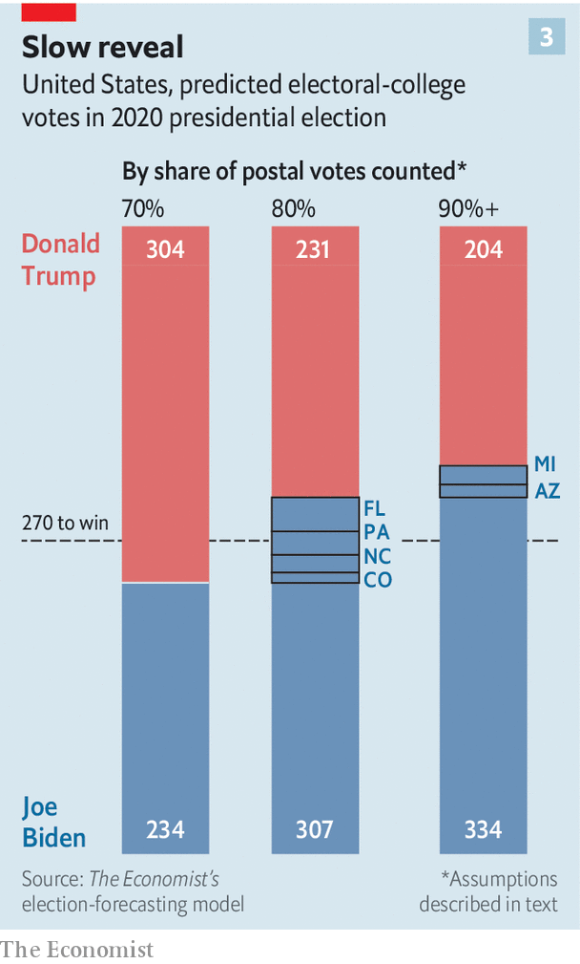

An enhanced blue shift raises the possibility of a “red mirage”: a situation in which Mr Trump appears to be leading around the time when people are used to having the television networks call the result, but falls behind when the counting continues. Calculations based on our election-forecast model provide a sense of how that might look (see chart 3).

Though there is obviously a significant margin for error, the model currently predicts that Mr Biden will, when all the votes are counted, win 334 Electoral College votes. Now imagine that every state sees a doubling of mail-in and other late ballots, which is hardly a sure thing but seems reasonable, and that the proportion of Biden votes in those mail-in ballots is 75%, which would square with what likely voters for the two candidates are telling YouGov about their intentions when it comes to voting by mail or in person. At a stage when only 70% of the strongly pro-Biden mail-in votes have been counted, the election will look like a clear win for Mr Trump. Only after 90% are counted will the true outcomes for each state become clear.

In reality there will be no such evenly spread national mirage. But the conditions necessary for late swings will be present in many states. Michigan expects that its share of absentee votes may nearly triple from its levels in 2018. In the swing states of Wisconsin and North Carolina, where in 2016, 5% and 4%, respectively, of votes were cast by mail, the odds of a precipitous rise look strong. And if Mr Trump seizes on what looks like a mirage in a single battleground state—if, for example, he sees a small lead in Pennsylvania narrow by the customary 20,000 votes and then keep on narrowing—the effect on the narrative of the election, if not its underlying process, will immediately become national.

## How not to be a loser

Nils Gilman of the Berggruen Institute, a think-tank, one of the founders of the Transition Integrity Project, says one of the lessons he took away from June’s war games was that “the aggression of the first mover had a really decisive effect on how the game played out”. If instead of just tweeting that counts should be stopped, as he did when he saw the blue shift in action in 2018, Mr Trump gave consequential orders to that end, they might be followed. Nearly 80 left-leaning groups have joined what they call the Protect the Results coalition, which aims to push state election officials to keep counting whatever the president says or does.

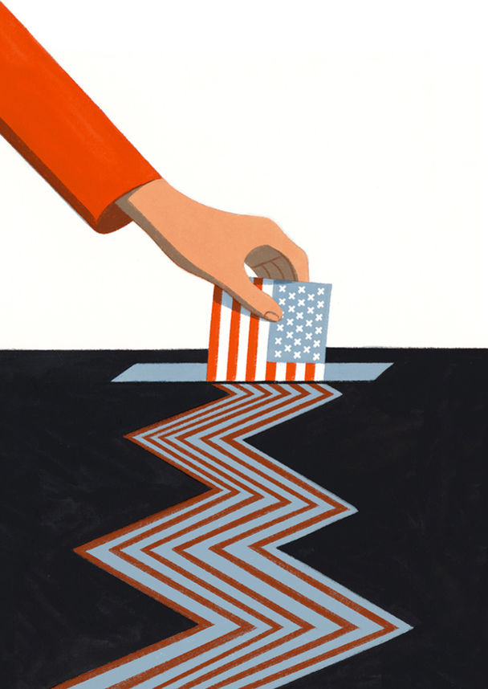

If Mr Trump refuses to concede, Sean Eldridge, who founded Protect the Results, vows “an unprecedented presence on the streets.” This year, when the presence of politics on the streets in the form of justified peaceful protest has been used a pretext for rioting and looting, and when a Trump supporter has been arrested for murder after going to Kenosha, Wisconsin as an armed vigilante, “unprecedented” has a disturbing ring to it.

Mr Gilman’s other conclusion from the war-game was “just how few boundaries there are on a sitting president who is unbounded by democratic norms and unrestrained by his own political party”. It is in the fact that there is a sitting president, and one who meets that description, that one sees the most important difference between this year’s prospects and the previous contested election result. In 2000 George W. Bush and Al Gore were challengers on an equal footing. When the Supreme Court decided, in a five to four decision along ideological lines, that moves to recount Florida’s votes should be ended, giving victory to Mr Bush, Mr Gore stepped aside. In the eloquent and graceful concession speech he gave on December 13th, 36 days after the election, he called on all Americans to “unite behind our next president”, and asked God to bless Mr Bush’s stewardship. He also expressed a hope that “the very closeness [of the contest] can serve to remind us that we are one people with a shared history and a shared destiny.” Today those words sound like a dispatch from another country.■

Dig deeper:  
Read the [best of our 2020 campaign coverage](https://www.economist.com/us-election-2020) and our [presidential-election forecast](https://projects.economist.com/us-2020-forecast/president), then sign up for Checks and Balance, our [weekly newsletter](https://www.economist.com/checksandbalance/) and [podcast](https://www.economist.com/podcasts/2020/08/28/checks-and-balance-our-weekly-podcast-on-american-politics) on American politics.

This article was downloaded by calibre from <https://www.economist.com/briefing/2020/09/03/donald-trump-is-very-likely-to-challenge-the-results-of-the-us-election>

|  |  |  |  |
| --- | --- | --- | --- |
|  | Articles | Sections | Next |

|  |  |  |
| --- | --- | --- |
| Briefing | Sections | The Americas |

United States

Swing states: The suburban strategy

.

Polls and nerves: Shorting volatility

.

Inclusivity v fairness: Vitrix ludorum

.

NYC’s MTA: Train wreck

.

Lexington: It’s the covid-economy, stupid

.

|  |  |  |
| --- | --- | --- |
| Briefing | Sections | The Americas |

|  |  |  |  |
| --- | --- | --- | --- |
|  | Articles | Sections | Next |

#### The suburban strategy

# Donald Trump tries out law-and-order talk on suburban voters

A dispatch from the pundits’ favourite county suggests the president has not yet made a breakthrough

Sep 2nd 2020 | CEDARBURG, WISCONSIN, AND WASHINGTON, DC

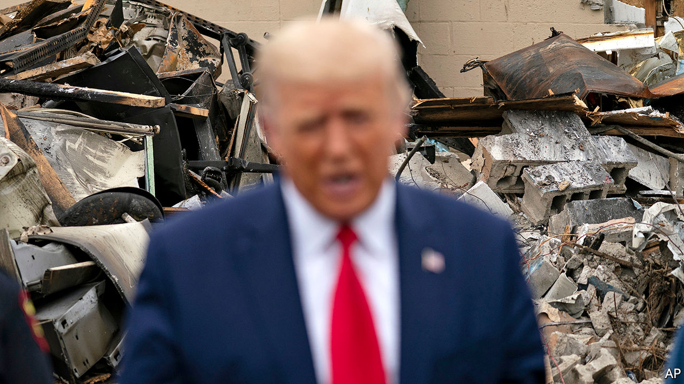

IN THE MOST genteel suburbs around Milwaukee, in southern Wisconsin, the quaintness can be overpowering. Enormous baskets of flowers hang from Victorian-style street lamps along the main street of Cedarburg, a riverside town in Ozaukee County. Tourists, caught in a summer downpour, may choose to take their shelter with a chocolatier, a cakemaker, two wineries or a French bakery.

Cedarburg is also an avowedly conservative place. In the previous presidential election, the county preferred Donald Trump by a margin of 19 percentage points. Although a poster for Black Lives Matter adorns the front door of one shop—a purveyor of colourful socks—a worker whispers that it has provoked several complaints. One customer called to say he would never return because of it. Another declared it offensive (even here, cancel culture reigns). Locals exist in a “Cedarbubble” says a young barista nearby. The city’s population was 94% white at the last census. The barista says many folk avoid visiting Milwaukee, the large and much less white metropolis just 30 minutes away, fearful of its reputation for crime.

Ozaukee and the other similarly populous, wealthy and twee counties west of Milwaukee are usually comfortable terrain for Republicans. High turnout and high margins typically counterbalance Democratic voters in the cities. But the suburbs now look rocky for Mr Trump’s re-election chances, which, just as last time, may require knife-edge victories in the Midwest. He has consistently trailed Joe Biden, his Democratic opponent, by five percentage points in Wisconsin since May, notes Charles Franklin, who runs polling at Marquette University Law School.

The president’s re-election campaign has noticed and alighted on a new strategy to court the suburbs again. The campaign has clothed itself in the Nixonian garb of “law and order”, alleging that the protests against racism in American cities, which have recently become violent again, are but a preview of “Joe Biden’s America”. For evidence he pointed to nearby Kenosha where looting, arson and two murders have followed the shooting by police of Jacob Blake, an unarmed black man. A man who may well have been a supporter of Mr Trump, in turn, was also shot dead in Portland, Oregon, at the weekend.

The coded, racialised appeal is not difficult to decipher. To make it even clearer, Mr Trump has also taken to arguing that Democrats plan to “destroy our suburbs” by building public housing and inviting crime—an effort he for some reason insists will be spearheaded by Cory Booker, a black senator from New Jersey. On September 1st Mr Trump visited Kenosha, praising the police and arguing that Democratic mayors and governors across the country are soft on looters. He compared the upheaval there to “domestic terror”. Earlier, when asked about the white teenager charged with killing two protesters and injuring another in Kenosha, who has become a cause célèbre among some conservative media hosts, the president suggested he had acted in self-defence.

Promises to restore law and order might seem more persuasive coming from an insurgent outsider than from an incumbent president. When Mr Trump took office in 2017, he pledged “I alone can fix it,” and promised an end to “American carnage” in his inaugural address. Now he argues that the explosion of urban violence under his administration is proof of Democratic mismanagement and the need for him to have a second term. Some accept the argument. According to a poll released by YouGov on August 28th, 32% of adults believe re-electing Mr Trump would make the country safer (though a plurality, 43%, think he would make it less safe).

Can such a strategy work? Some commentators, perhaps scarred by the last contest where Hillary Clinton seemed to be the heavy favourite throughout, already spy a polling bounce for Mr Trump. At least in the national polls, the purported bounce looks quite dainty. His vote share has increased by one percentage point, from 45% on June 17th to 46% in The Economist’s average of presidential-election polls. Some of that bump came in the week after the party convention—when incumbents usually enjoy a real, if ephemeral, boost in support during the post-coronation bliss.

Previous racial unrest has not been especially kind to the president. According to our maths, Mr Trump experienced the worst three weeks of the campaign after George Floyd was killed by police in Minnesota on May 25th. His deficit in the polls ballooned then from seven points to 11 points in a relatively short span of time.

It is still too early to determine how large Mr Trump’s national bounce will ultimately be, or whether it will subside. So far, the president’s average support over the course of the election has been both low and the most stable on record. And since the national election will not be decided by the popular vote but by the electoral college, if he ekes out a victory again this time, it is likely to come by a similar route.

At the state level, our election modelling finds Mr Trump’s position in the Midwest has improved relative to his June low. Whereas he was down 11 points in Michigan two months ago, he is down just six now; in Wisconsin, an 11-point hole is now a six-point one; and the president is down just five points in Pennsylvania, up from nine earlier this year. These are still significant deficits, but the trend is certainly looking up for Republicans.

Mr Franklin, the Wisconsin pollster, is also cautious. Older voters are dismayed by the president’s handling of covid-19. Many disapprove of his approach to race relations, although they still trust him on the economy. For weeks, polls have shown public support for Black Lives Matter to be slipping. In Wisconsin, approval peaked at 61% in June before falling to 48% in August. It may be even lower now. So far, however, Mr Franklin has seen no evidence of that shift affecting overall support for either Mr Biden or Mr Trump.

The foot soldiers feel the strain. “We’re ground zero, we’re under the gun,” says Terry Dittrich, the Republican chairman in neighbouring Waukesha County—the bellwether county for election-night pundits. Should Mr Trump fall short here, “the rest of the state has to make up for that”. Mr Dittrich admits there has been a wobble of late. The Republican Party typically expects to scoop 65-70% of votes in his county. In the midterms, in 2018, the Democrats’ victorious candidate for Senate, Tammy Baldwin—an openly gay war hero—scooped a heady 38% support in Waukesha, points out Matt Mareno, the Democrats’ party chairman in the county. If Mr Biden could match her result, then he predicts “it’s game over” in the state.

So far, Republicans have cheered the new suburban strategy. “The more chaos and anarchy and vandalism and violence reigns, the better it is for the very clear choice on who’s best on public safety and law and order,” said Kellyanne Conway, a close adviser to the president, in a television interview. Mr Dittrich also applauds the new approach. He says he has received a surge of texts, “general feedback” and (unspecified) polling evidence in the past week to suggest voters are startled by the urban violence and are flocking back to Mr Trump. Kathy Broghammer, the Republican party chairwoman in Ozaukee County, is even more enthusiastic, pointing to a surge in interest among Republican volunteers because of “the threatening feeling we see in Kenosha”. “We love our law and order,” she says. “People are saying, by golly I’m gonna roar.” ■

Dig deeper:  
Read the [best of our 2020 campaign coverage](https://www.economist.com/us-election-2020) and our [presidential-election forecast](https://projects.economist.com/us-2020-forecast/president), then sign up for Checks and Balance, our [weekly newsletter](https://www.economist.com/checksandbalance/) and [podcast](https://www.economist.com/podcasts/2020/08/28/checks-and-balance-our-weekly-podcast-on-american-politics) on American politics.

This article was downloaded by calibre from <https://www.economist.com/united-states/2020/09/02/donald-trump-tries-out-law-and-order-talk-on-suburban-voters>

|  |  |  |  |
| --- | --- | --- | --- |
|  | Articles | Sections | Next |

|  |  |  |  |
| --- | --- | --- | --- |
| Previous | Articles | Sections | Next |

#### Shorting volatility

# How much do polls move after Labor Day?

Since 1952, every candidate who was ahead at this point went on to win the popular vote

Sep 5th 2020 | WASHINGTON, DC

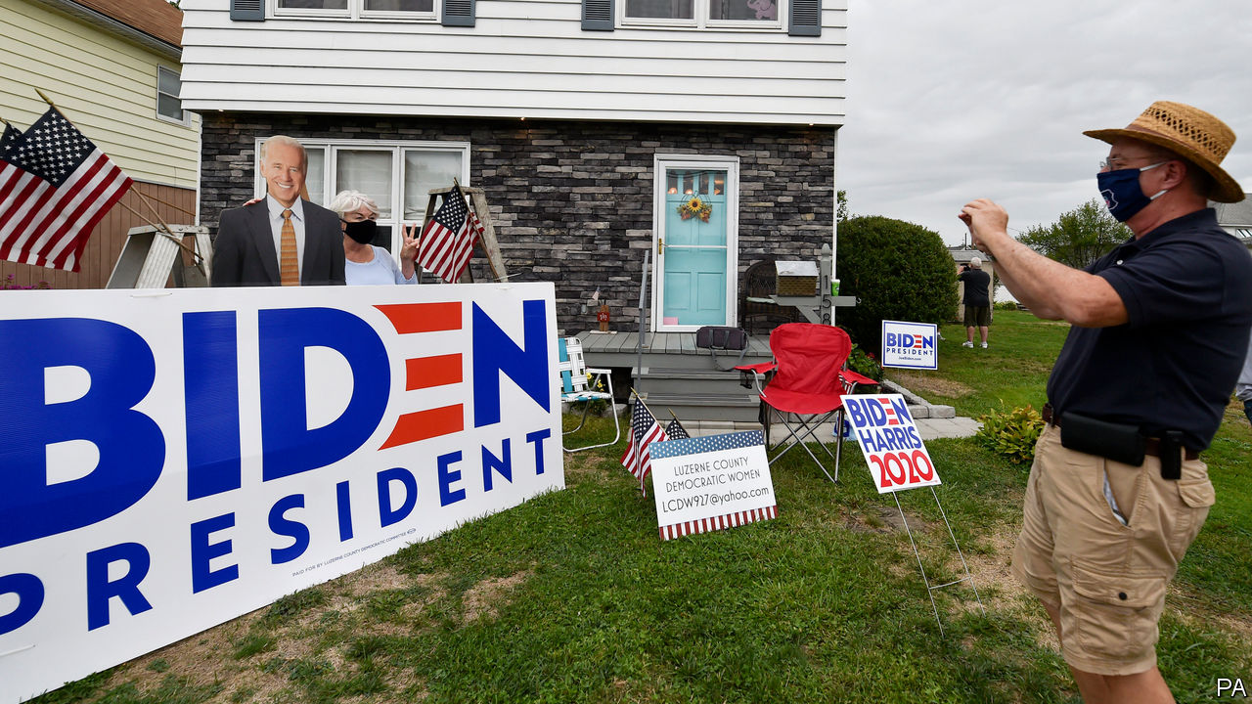

THERE’S A REASON that the period from Labor Day to election day is considered the home straight in a presidential contest. Robert Erikson and Christopher Wlezien, two political scientists at Columbia University and the University of Texas at Austin, have studied the history of American election-polling since 1952 and found that the leader in the polls one week after the second party convention has always won the popular vote. Two candidates have trailed in the polls around Labor Day, then won in the electoral college: George W. Bush in 2000 and Donald Trump in 2016. In both cases the polls were much tighter than they are now. Joe Biden therefore has past performance on his side.

Mr Trump’s odds have improved in betting markets, suggesting that many think the combination of the Republican National Convention and the protests in Portland, Kenosha and elsewhere are working in his favour. That in turn suggests they expect a lot more volatility in the polls than has ever been seen before.

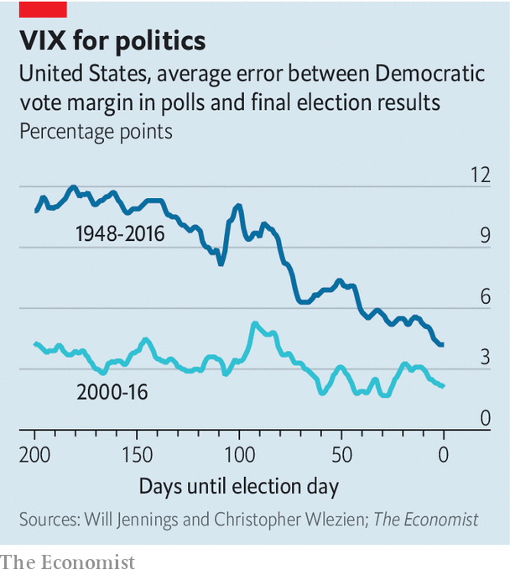

Going back to 1948, how wildly polls have changed in the first seven months of the election cycle helps explain how much they vary in the last three. The standard deviation of the average of national polls—a measure of how much they jump around from day to day—over the first two-thirds of the election cycle has explained 50% of the variance in the last third (a perfect relationship would be 100%). Polls in the last third of the campaign have tended to be about 40% as volatile as the first two.

Mr Trump’s poll numbers have been low and stable. Mr Biden’s numbers have moved with a historically low standard-deviation of 0.9 percentage points so far. Mr Trump is a known quantity. Few voters are yet to make up their minds about him and political polarisation has decreased the share of true swing voters in the electorate. A bet on volatility in the polls is therefore highly contrarian. History is on the side of the herd.

Dig deeper:  
Read the [best of our 2020 campaign coverage](https://www.economist.com/us-election-2020) and our [presidential-election forecast](https://projects.economist.com/us-2020-forecast/president), then sign up for Checks and Balance, our [weekly newsletter](https://www.economist.com/checksandbalance/) and [podcast](https://www.economist.com/podcasts/2020/08/28/checks-and-balance-our-weekly-podcast-on-american-politics) on American politics.

This article was downloaded by calibre from <https://www.economist.com/united-states/2020/09/05/how-much-do-polls-move-after-labor-day>

|  |  |  |  |
| --- | --- | --- | --- |
| Previous | Articles | Sections | Next |

|  |  |  |  |
| --- | --- | --- | --- |
| Previous | Articles | Sections | Next |

#### Vitrix ludorum

# The battle over trans athletes in American schools heats up

Inclusivity bumps up against fairness

Sep 3rd 2020 | WASHINGTON, DC



ESMEE SILVERMAN feels unusually nervous about the prospect of trying out for her high-school girls’ tennis team this autumn. That is not surprising: last year, she played for the boys’ team. For the past ten months the 18-year-old has been taking a combination of oestrogen and testosterone blockers as she transitions to becoming a woman. “It’s a big emotional shift going from one team to another,” she says, adding that she expects it to be made easier by the kindness she has been shown by girls her age.

Ms Silverman is fortunate to live in Massachusetts, where transgender students can play sports as the gender with which they identify. Policies on this vary from state to state. While more than a dozen have introduced guidelines like those in Massachusetts, which also allow trans students to shower and change with members of their chosen gender, 11 states have policies that prevent this. Some say birth certificates are the final arbiters of sex; others, that transgender students must first have had gender reassignment surgery (which is generally restricted to over-18-year-olds). As an increasing number of teenagers reject the sex they are born with, these clashing approaches are sparking court cases.

In Idaho, the American Civil Liberties Union is battling a statewide law that bans transgender women and girls from female sports teams. They are representing Lindsay Hecox, a transgender woman who was denied a chance to join the women’s cross-country team at Boise State University. Last month, a federal judge issued a temporary injunction on that law.

In Connecticut, three female high-school athletes are challenging the policy of the state’s interscholastic athletic conference, which allows transgender girls to compete against females. They argue that it violates Title IX, a law passed to protect equal educational opportunities for the sexes, including in sports. In March the civil-rights division of the Department of Education said it did violate Title IX.

These cases highlight the often irreconcilable nature of transgender rights and women’s rights. Those opposed to the inclusion of transgender women in women’s sports argue that it is unfair to allow people who have gone through puberty as men, and who tend to be bigger, stronger and faster, to compete against women.

Connecticut offers a vivid example of this. Since 2017 two transgender athletes—biological males who identify as women—have between them won 15 state championships that were once held by nine different girls. When they started racing as girls they had not begun hormone treatment. But research suggests that even those who have gone through testosterone suppression retain advantages of strength and muscle mass. “It is so demoralising, running for second place,” says 16-year-old Alanna Smith, a highly competitive sprinter and one of the girls challenging the state policy. “I worry that women are going to become spectators of their own sports.” Transgender boys, meanwhile, often attest that it becomes easier to compete against males once they have had “top surgery” (a mastectomy) and taken testosterone.

Yet transgender activists argue that the law should regard transgender men and women as members of the gender with which they identify. They say it is discriminatory to exclude transgender women from women’s sports as well as deeply hurtful, especially for those at school. “This debate frames these high-schoolers as Olympians,” says A.T. Furuya, the youth programmes manager at GLSEN, which campaigns for the rights of LGBT school students. Furuya, a former high-school sports coach and one of a handful of people in America to have obtained “non-binary” as their legally designated gender, adds that “These are kids who just want to play.”

## American exceptionalism

A similar debate is raging across the rich world. World Rugby, which currently follows the International Olympic Committee guidelines that allow transgender athletes to compete in women’s events if their testosterone levels are below a certain level, is considering banning trans women from the women’s game. That is partly because of fears that transgender women players could injure their teammates.

Strikingly absent from the discussion in America are women’s groups standing on the women’s side of the issue. Instead, many long-established women’s groups have aligned themselves with the transgender movement. “Transgender girls are girls and transgender women are women,” reads a statement from several rights groups in Connecticut, including the state chapter of Planned Parenthood. “They are not and should not be referred to as boys or men, biological or otherwise”.

Doriane Coleman, a law professor at Duke University, observes that it is “extremely difficult” to get the support of any civil-rights group for an agenda that does not include trans women in its definition of women. That is why the female athletes in both Connecticut and Idaho are represented by the same conservative Christian organisation, the Alliance Defending Freedom (ADF). (Ms Coleman points out that the ADF also has first-class lawyers.) In Britain, by contrast, the battle to preserve women’s spaces, from lavatories to prisons, is largely being fought by feminists.

The fact that progressives appear to have largely ceded this issue to conservatives reflects the way such issues have become polarised in America. In many countries, those who suggest that the law should not regard trans women as women in all respects are denounced as transphobic; in America, such attacks are particularly aggressive. Though polls suggest that a majority of Americans believe that trans women should not play in women’s sports teams, this is a view that is rarely heard publicly.

“Our discussion about this topic is insane—you can’t talk about it at all,” says Natasha Chart, a board member of Women’s Liberation Front, which describes itself as a “radical feminist organisation”. “You face so much social opprobrium for speaking out that people don’t want to touch it.”

How will the courts adjudicate? A landmark ruling on LGBT rights by the Supreme Court may offer a clue. In June, America’s highest court ruled in Bostock v Clayton County that gay, lesbian and transgender people were protected under Title VII of the Civil Rights Act, which bars discrimination in employment because of sex. That has raised the question of whether this reasoning could also be applied to Title IX.

Several lower courts have suggested it could. In August the judge who issued a temporary injunction on Idaho’s ban on trans athletes in women’s teams, cited Bostock. The same month, a federal appeals court ruled that school policies that forbid transgender students to use the lavatory of their gender identity violate the law. That judge said Bostock had guided his evaluation of claims under Title IX, because Congress had intended it and Title VII to be interpreted similarly.

Yet in Bostock, the Supreme Court explicitly said it was ruling only on discrimination in employment; it was not attempting to address “bathrooms, locker rooms, or anything else of the kind”. This qualification suggested that the justices expect to consider such questions in the future. However the courts in Connecticut and Idaho rule, the issue seems likely to end up at the Supreme Court. ■

This article was downloaded by calibre from <https://www.economist.com/united-states/2020/09/03/the-battle-over-trans-athletes-in-american-schools-heats-up>

|  |  |  |  |
| --- | --- | --- | --- |
| Previous | Articles | Sections | Next |

|  |  |  |  |
| --- | --- | --- | --- |
| Previous | Articles | Sections | Next |

#### Train wreck

# America’s biggest transit system is in trouble

As the MTA flounders, so New York City will struggle to recover

Sep 3rd 2020 | NEW YORK



BEFORE THE pandemic, packed subway cars were signs of the vitality of New York City. Squeezing into a packed carriage just as the doors closed was the norm until mid-March. By the time a train reached Manhattan people would be wedged in, shoving past each other to leave. It is difficult to imagine anyone enduring that crush now. Yet it is also hard to see New York truly bouncing back without it. “The subway is the barometer of New York,” says Tom Wright, head of the Regional Plan Association. “If the transit system falls apart, New York will not recover.”

The system is on the verge of financial collapse. Pat Foye, chairman of the Metropolitan Transportation Authority (MTA), the state entity in charge of the subway, buses and regional commuter lines as well as some bridges and tunnels, painted a bleak picture at a recent board meeting. The agency is losing $200m a week because fare revenues, tolls and subsidies are all down, while the MTA is shouldering new pandemic-related expenses (mostly shutting down the normally 24-hour subway for nightly cleaning). Passenger numbers collapsed as covid-19 spread and have risen only modestly as New York City has reopened. On August 31st 1.4m straphangers rode the subway, but that was still 75% below a typical weekday in 2019. The pandemic has taken a greater toll even than the Great Depression; passenger numbers declined by only 12% in 1929-33.

The MTA hopes for $12bn in federal funding to get through this year and next. Without help, Mr Foye will be obliged to take “draconian measures”, which will be felt across the city and the region for decades. He spoke of a 40% reduction in subway and bus journeys and a probable reduction of up to 50% in services to the suburbs. Long-promised capital projects will be delayed or suspended. Fares and tolls will go up and the agency will lay off 8,400 employees, who have already had a tough time. Thousands of MTA workers were infected with covid-19, more than 130 died and many lost family members to the virus. Mr Foye repeatedly drew parallels with the 1970s, when New York City sought a federal bailout to avoid fiscal collapse and hundreds of thousands of residents fled.

When, and if, office workers will return to Manhattan is uncertain. Many have not swiped their MetroCard for six months. Most are afraid to use the subway, despite the transit authority’s aggressive disinfecting. Service cuts could deter them from commuting regularly. There is anecdotal evidence that those who fled from the city are not returning. Many may drive back in, increasing congestion. A decrease of 10% in subway passengers means an increase of more than 30% in road traffic, says Nicole Gelinas of the Manhattan Institute, a New York think-tank. “If you are not investing in your capital asset, if you are driving away ridership with service cuts, you are just accepting much, much lower revenues for a long time,” she adds. All that leaves people who depend on the transit system, such as shift workers and shop workers, to bear the brunt of higher fares.

The system has long had fiscal problems. Little more than a decade after it opened in 1915, it faced a crisis when inflation raised operating expenses for the private companies then running the subway. After the second world war, New Yorkers abandoned the subway for cars. During the 1960s and 1970s the system was not well maintained, which caused delays and disruption. Every surface was covered in graffiti. Crime was rife. Even before the pandemic the MTA was paying nearly 20% of its operating budget on debt service and its infrastructure was crumbling, with some of its signal systems dating back to the 1930s.

In the past few months the MTA has been downgraded by various credit agencies, which makes borrowing more expensive. The agency is not allowed to file for bankruptcy and is required by law to balance its books. In the past it has turned to the city and state for help, but they are cash-strapped, too. New York’s officials say Congress should help, since if New York does not recover, the whole country will suffer. Senate Republicans have not been sympathetic, however. Congress gave the beleaguered agency $4bn in May as part of the CARES Act, but the MTA had spent all that by July 24th.

It may start to make cuts in November. If Joe Biden wins, it may get a little more time. But delaying track upgrades and signal systems will cause problems fast, which will further hobble the city’s recovery. “New York without its subway system,” says Philip Plotch, author of “Last Subway” and a political scientist at Saint Peter’s University in Jersey City, “is like a skyscraper without an elevator.”■

Editor’s note: Some of our covid-19 coverage is free for readers of The Economist Today, our daily [newsletter](https://my.economist.com/user#newsletter). For more stories and our pandemic tracker, see our [hub](https://www.economist.com/news/2020/03/11/the-economists-coverage-of-the-coronavirus)

This article was downloaded by calibre from <https://www.economist.com/united-states/2020/09/03/americas-biggest-transit-system-is-in-trouble>

|  |  |  |  |
| --- | --- | --- | --- |
| Previous | Articles | Sections | Next |

|  |  |  |  |
| --- | --- | --- | --- |
| Previous | Articles | Sections | Next |

#### Lexington

# It’s the covid-economy, stupid

Contrary to what some fearful Democrats believe, law-and-order looks unlikely to decide this election

Sep 5th 2020 |

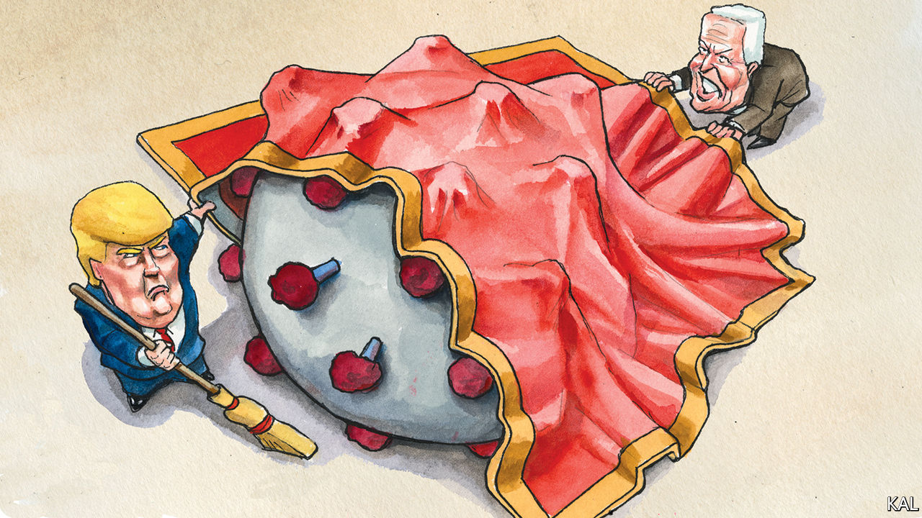

SHORTLY AFTER George Floyd was killed by a Minnesotan policeman last May, Joe Biden condemned the riots that his killing had sparked. “Protesting such brutality is right and necessary,” he said. “Burning down communities and needless destruction is not. Violence that endangers lives is not.” He repeated his denunciation several times over the next few days. President Donald Trump meanwhile accused him of ignoring the issue.

So it has continued. Though Mr Biden has more often expressed support for the ongoing racial-justice protests against police brutality, he has not failed to condemn the violent fringe that, in Oregon, Illinois and now Wisconsin, continues to haunt them. “There is no justification whatsoever for violence, looting,” he said last week, after the shooting of Jacob Blake in Kenosha sparked yet more rioting. The following day—at the Republican convention—Mr Trump for the umpteenth time accused him of failing to condemn what Mr Biden had just condemned.

The hammering the former vice-president has taken on this issue—every evening on Fox News as well as from Mr Trump—has unnerved some of his supporters. Some suggest a 1968-style silent majority, sickened by the violence, is building against the Democrats. It sounds plausible. But there is no strong evidence for it yet. That means the Democrats anxiously demanding that Mr Biden issue ever more and louder denunciations of the street violence are essentially taking their cues from Mr Trump and Tucker Carlson, who do not have their interests at heart.

The evidence of the past three months is that Republicans do not want to set Mr Biden straight on law-and-order. They want to see him hopelessly entangled in the issue—bullied into expressing ever more forceful denunciations of the riots (as he did again this week, in a speech in Pittsburgh), which they will duly dismiss as “too little too late”. A better course for Mr Biden’s advisers would be to consider what the canny Mr Trump does not want his Democratic opponent to talk about. Could it be a public-health catastrophe, for which a majority of voters blame the president, which is predicted to take a quarter of a million lives by election-day? That is a likelier conjecture.

Especially when you consider the promise of Mr Biden’s recent efforts to recast the politics of the coronavirus catastrophe: by treating it as not merely a public-health crisis, but also an inextricably connected economic one. “We will never get our economy back on track…until we deal with this virus,” the former vice-president told the Democratic convention last month.

That was shrewd on two counts. First, because it linked the two issues that voters care about most—notwithstanding Mr Trump’s fiery rhetoric, even Republicans are more worried about the pandemic and the economy than they are about violent crime. Second, because Mr Biden is in effect trying to use Mr Trump’s biggest weakness, his acknowledged failures on the coronavirus, to undercut his biggest remaining strength: a diminished, but somehow enduring, reputation for effective economic management.

The economy is the only issue on which Mr Trump outpolls Mr Biden. For that matter, it is the only issue on which he has consistently out-performed his low approval ratings ever since his inauguration. Founded upon his years as a TV boardroom titan, as well as his more recent success in spinning the strong economy he inherited as his creation, Mr Trump’s reputation for economic wizardry was the single main reason he had looked highly competitive before the coronavirus struck, despite his unpopularity.

With the unemployment rate now at 10%, the gap between how Americans rate the president on the economy and overall has shrunk significantly. According to Gallup, 48% of Americans approve of him on the economy, while 42% approve of him overall. That is the main reason he now looks much less competitive. Yet in a closer election than the polls currently predict, this residual strength could still save him. At the least, it appears to be Mr Trump’s best hope.

A survey of suburban voters in the swing states of Arizona, Michigan, North Carolina, Pennsylvania and Wisconsin—published last month by Third Way, a think-tank—underlines that. Though only 39% approved of Mr Trump, 48% said he was still making a decent fist of the economy. That might look like a losing hand. But the survey suggested that even a fairly modest uptick in the economy could move opinion in Mr Trump’s favour pretty dramatically. The respondents chose Mr Biden over Mr Trump by a nine-point margin. But asked how they would feel if the unemployment rate were to drop to 8%, they split their vote between the two candidates. Given how likely that order of economic improvement is over the next two months, this should worry Biden strategists rather more than the spectre of a 1968-re-run.

## From boardroom to bust

At the same time, the survey suggests Mr Biden’s effort to blunt Mr Trump’s economic edge—by offering a more expansive definition of the coronavirus crisis—could succeed. A small majority of Third Way’s suburbanite voters already attributed the economic crisis in part to Mr Trump’s poor management of the epidemic. A much larger majority said the economy could not be fixed until the virus had been brought under control. Both views are anathema to Mr Trump, who has shirked responsibility for the health crisis, even as he claims to have a recovery from the economic crisis in hand. They appear to represent a clear opening for Mr Biden’s claim that the president is not only culpable for the crisis but incapable of leading America out of it.

It is his strongest attack-line and, though it is never wrong to denounce violence, he should not be swayed from it. With apologies to James Carville, this election is about the covid-economy, stupid. (Albeit that, with additional apologies to Bill Clinton’s oft-quoted strategist, Mr Biden must not forget law-and-order.) ■

Dig deeper:  
Read the [best of our 2020 campaign coverage](https://www.economist.com/us-election-2020) and our [presidential-election forecast](https://projects.economist.com/us-2020-forecast/president), then sign up for Checks and Balance, our [weekly newsletter](https://www.economist.com/checksandbalance/) and [podcast](https://www.economist.com/podcasts/2020/08/28/checks-and-balance-our-weekly-podcast-on-american-politics) on American politics.

This article was downloaded by calibre from <https://www.economist.com/united-states/2020/09/05/its-the-covid-economy-stupid>

|  |  |  |  |
| --- | --- | --- | --- |
| Previous | Articles | Sections | Next |

|  |  |  |
| --- | --- | --- |
| United States | Sections | Asia |

The Americas

Brazil: An increasingly prickly partnership

.

Canada and the United States: Frontier friendship

.

|  |  |  |
| --- | --- | --- |
| United States | Sections | Asia |

|  |  |  |  |
| --- | --- | --- | --- |
|  | Articles | Sections | Next |

#### A prickly partnership

# Brazil’s president and his economy minister start to disagree

In the pandemic, Jair Bolsonaro sees merit in busting the budget. Paulo Guedes has reservations

Sep 5th 2020 | RIO DE JANEIRO

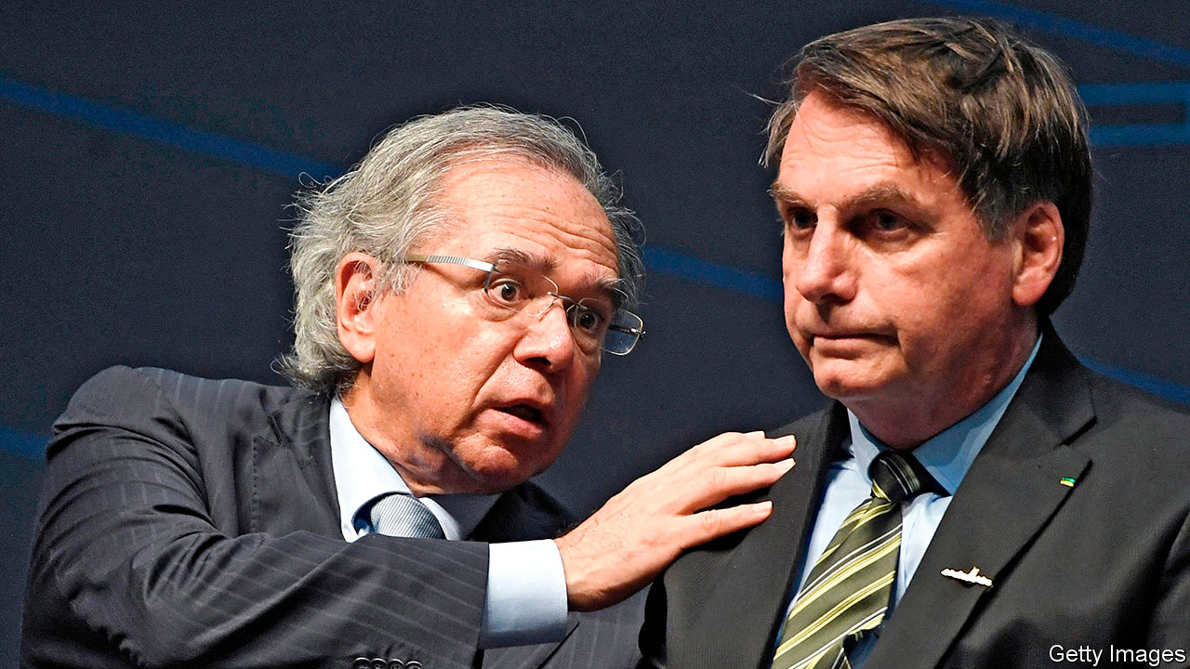

Editor’s note: Some of our covid-19 coverage is free for readers of The Economist Today, our daily [newsletter](https://my.economist.com/user#newsletter). For more stories and our pandemic tracker, see our [hub](https://www.economist.com/news/2020/03/11/the-economists-coverage-of-the-coronavirus)

JAIR BOLSONARO, Brazil’s president, ought to be in trouble. His is one of the countries worst affected by covid-19. It has had nearly 4m confirmed cases, second only to the number in the United States, and 123,780 known deaths. That is largely the president’s fault. He has downplayed the pandemic, railed against lockdowns and promoted unproven cures.

A crusader against corruption before he became president, Mr Bolsonaro is surrounded by scandal. One of his sons is the target of a corruption investigation. The justice minister, Sérgio Moro, quit in April, accusing the president of interfering with the probe. And yet Mr Bolsonaro is gaining political strength. The share of Brazilians who deem his performance “good” or “great” is 37%, its highest since he took office at the beginning of last year, according to Datafolha, a pollster.

This is a side-effect of covid-19. While Mr Bolsonaro has done little to contain it, he has spent generously to shield poor Brazilians from its economic effects. At the same time, he has strengthened his weak position in Congress. His tiny Alliance for Brazil, formed last November, has teamed up with the centrão, a big bloc of centre-right parties. That will help the government pass legislation and, perhaps, shield him from impeachment. The centrão is blocking 49 impeachment motions stemming from the scandals and the mishandling of the pandemic.

But as Mr Bolsonaro grows stronger, his commitment to keeping his promises becomes weaker. The alliance with the centrão employs the grubby dealmaking that Mr Bolsonaro once denounced. Friends of centrão politicians have got plum government jobs. Also in doubt is Mr Bolsonaro’s pledge to reform the economy, which had encouraged some bankers and businessmen to overlook his authoritarian views.

Mr Bolsonaro, a former army captain, is not an economic reformer by instinct. Economic liberals have put their faith in Paulo Guedes, the economy minister (pictured left), who favours small government and free markets. He justified their confidence last year by helping to reform the pension system, whose lavish benefits would have led to crippling debt. But Mr Guedes is visibly uneasy about the spending provoked by the pandemic. In late August two of his top aides quit, prompting a fall in the stockmarket and pushing the real to its lowest level against the dollar since May.

Whatever happens to Mr Guedes, Mr Bolsonaro’s presidency has entered a new phase. In its proneness to scandal, its cynical deal with Congress and its generosity to poor voters, it is coming to resemble past administrations. Mr Bolsonaro’s government has “some similarities” to that of the left-wing Workers’ Party (PT), which governed from 2003 to 2016, says Arminio Fraga, a former head of the central bank.

No one would have said that before the pandemic. The government had trimmed Bolsa Família, the PT’s flagship welfare programme, which transfers cash to families that promise to send their children to school and to clinics for check-ups. Last year the Bolsonaro government cut the number of families enrolled by 1.2m to 13m.

With the pandemic the penny-pinching has stopped. The government has spent 213bn reais ($39bn), about 2% of GDP, on an emergency handout of 600 reais a month to Brazilians who earn the minimum wage of 1,045 reais a month. That benefits 67m people, a third of the population. The payout lifted out of extreme poverty 72% of families in that condition. Among the beneficiaries are recipients of Bolsa Família, who get a much larger sum than the programme’s minimum payment of 89 reais. In the poor north-east, the PT’s heartland, the share of people who call the government’s performance “bad” or “terrible” fell from 52% in June to 35% in August.

The government has extended to December the emergency benefit initially meant to last three months (but will reduce it by half). Mr Bolsonaro wants to replace Bolsa Família with his own Renda Brasil (Brazil Income), a benefit that will unify all social programmes. Its details are still vague. To give the economy an extra boost Mr Bolsonaro wants to borrow 5bn reais more this year to build infrastructure.

Pro-poor spending makes sense. The economy shrank by 9.7% in the second quarter. It is the same size as it was 11 years ago. Without the relief programme it would have shrunk more. The jobless rate climbed to 13.3% in the second quarter from 12% in the same period last year.

But the prospect of big deficits worries Mr Guedes. The government is set to smash through a ceiling on spending, which is inscribed in the constitution. (A workaround can probably be found.) The primary deficit, ie, before interest payments, jumped to $94bn in July from $6.5bn the year before. It is expected to reach $147bn for the full year, 11% of GDP.

Disagreement between president and minister flared in late August, when Mr Guedes said the government should pay for Renda Brasil by cutting back other welfare programmes. Mr Bolsonaro rebuffed him. He would “not take away from the poor to give to the poorest”, he said.

The two men seem to have reached a truce. Mr Guedes may accept a breach of the spending cap if Congress acts to control future spending, says Chris Garman of Eurasia Group, a political-risk consultancy. His other demand is reform of the tax system, which is among the most complex in the world. A mid-sized Brazilian firm typically spends 1,500 hours a year dealing with tax, compared with 175 for an American firm, according to the World Bank.

But reforming tax is as complex as taxation itself. One of Mr Guedes’s ideas—replacing two taxes on company turnover with a 12% VAT—would anger farmers, who have a powerful lobby, notes Marcos Cintra, the chief of the federal revenue service until September. Consumers would also object. Reform, if it happens, will be “a very noisy process”, says Mr Garman.

Mr Guedes has apparently decided he can still do some good. After tax reform could come measures to reduce public-sector employment and benefits. Perhaps. But Mr Bolsonaro has now seen that enlarging the state is more popular than shrinking it. As the presidential election approaches in 2022, the salience of that lesson will grow. Brazil’s experiment with economic liberalism may prove short-lived. ■

This article was downloaded by calibre from <https://www.economist.com/the-americas/2020/09/05/brazils-president-and-his-economy-minister-start-to-disagree>

|  |  |  |  |
| --- | --- | --- | --- |
|  | Articles | Sections | Next |

|  |  |  |  |
| --- | --- | --- | --- |
| Previous | Articles | Sections | Next |

#### Frontier friendship

# The closure of Canada’s border with Alaska has split a remote community

The people of Hyder, Alaska, and Stewart, British Columbia, want to be able to come and go

Sep 5th 2020 | VANCOUVER



FEW AMERICAN towns are as remote as Hyder, a settlement of 65 people in the panhandle that juts south from the rest of Alaska between Canada and the Pacific. Its only road connection passes through Stewart, British Columbia, 2km away. For generations, Stewardites and Hyderites paid little attention to the border. They celebrate Canada Day on July 1st in Stewart, then move the party to Hyder, “the friendliest ghost town in Alaska”, for the United States’ Independence Day three days later. Activities include an ugly-vehicle contest and the “chicken-shit board”, in which bets are placed about which square in a grid a chicken will defecate on. Hyderites buy petrol and groceries in Stewart. Their telephone numbers use Canadian area codes (250 or 778).

The back-and-forth between the former gold-mining towns stopped in March when the border between the two countries closed because of covid-19. Under a special dispensation, Canada allows Hyderites to go to Stewart once a week for four hours. That is not enough. Wes Loe, Hyder’s postmaster and unofficial mayor, would normally drive to Terrace in British Columbia, 300km away, to stock up for winter, but the lockdown rules don’t allow that. Soon, the roads will be too dangerous. “Things are deteriorating, and I mean emotionally and mentally,” says Mr Loe.

The border is lightly policed. There is no American post. The Canadian guard’s shift ends at 4.30pm. Cameras and a telephone connection to an agent somewhere else in Canada keep watch after that. If Hyderites break the rules, “an alarm and sirens would be set off and the RCMP [Royal Canadian Mounted Police] will be notified, and that’s just not the thing we would do,” says Mr Loe.

Most Canadians are eager to keep Americans out. The United States’ covid-19 infection rate is five times Canada’s. Canadians post pictures of suspected American intruders on social media. Some in cars with American plates affix signs to their windows saying they’re Canadians returning home. From March 21st to August 19th Canada turned away 14,000 Americans from its borders. It allows Alaskans to travel home across Canada from the lower 48 states, but they can enter in only five places and must take the most direct route.

But Hyderites and Stewardites value togetherness. Mr Loe and Gina McKay, Stewart’s mayor, want the towns to be able to form a bubble that would let their citizens mingle freely. Alaska’s governor, Mike Dunleavy, and Taylor Bachrach, the Canadian MP who represents Stewart, have lobbied the Canadian security minister to let that happen. So far, they have had no luck. “We’re two countries, two communities but for as long as anyone can remember, we’ve essentially operated as one,” says Ms McKay. “We’re used to isolation up here but we don’t want to be isolated from each other.”

Editor’s note: Some of our covid-19 coverage is free for readers of The Economist Today, our daily [newsletter](https://my.economist.com/user#newsletter). For more stories and our pandemic tracker, see our [hub](https://www.economist.com/news/2020/03/11/the-economists-coverage-of-the-coronavirus)

This article was downloaded by calibre from <https://www.economist.com/the-americas/2020/09/05/the-closure-of-canadas-border-with-alaska-has-split-a-remote-community>

|  |  |  |  |
| --- | --- | --- | --- |
| Previous | Articles | Sections | Next |

|  |  |  |
| --- | --- | --- |
| The Americas | Sections | China |

Asia

Japanese politics: A new story at last

.

Feminism in Pakistan: No shrinking violets

.

Covid-19 in India: Double whammy

.

Taiwan: Unambiguously dangerous

.

Banyan: Three-finger salute

.

|  |  |  |
| --- | --- | --- |
| The Americas | Sections | China |

|  |  |  |  |
| --- | --- | --- | --- |
|  | Articles | Sections | Next |

#### A new story at last

# Abe Shinzo has left an impressive legacy

But his successor has a mountain to climb

Sep 3rd 2020 | TOKYO

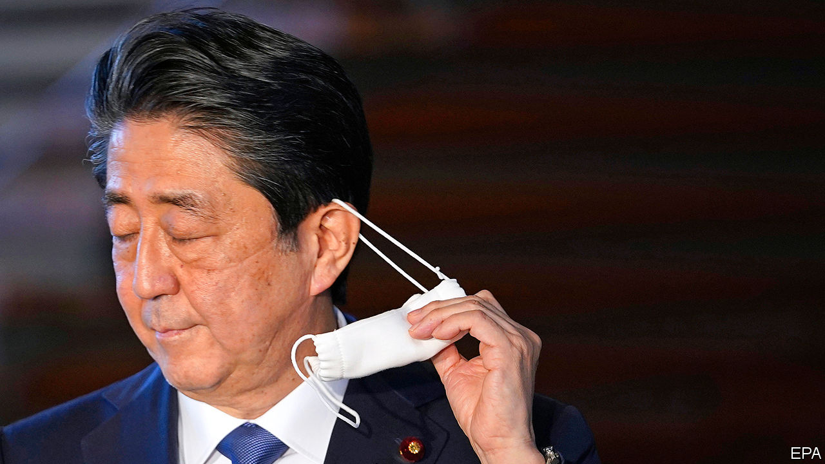

WHEN HE WAS a boy, Abe Shinzo aspired to make films. His family history—he is the grandson of a prime minister and the son of a foreign minister—set him on a different path (see Books & arts section). Yet as a politician, he strived to change the stories that Japan tells about itself. “If the Japanese need one thing now, that thing is confidence—the ability to turn our faces to the sun, like the sunflower does when it blooms at the height of summer,” Mr Abe said after becoming prime minister for the second time, in 2012.

His departure did not follow the script. Mr Abe announced his resignation on August 28th, citing a bout of ulcerative colitis, a chronic intestinal disease. Instead of leaving in the afterglow of the Olympic Games, he is departing amid a pandemic. His successor will inherit the fight against the virus, along with other challenges: an economy battered by covid-19, a shrinking population, the growing assertiveness of China and an unpredictable ally in America. Yet Mr Abe will be remembered as transformative, not least because, after the doldrums of the “lost decades”, when the economy stagnated, he fostered hope that Japan’s problems could be solved. “Abe changed the narrative,” says Mireya Solís of the Brookings Institution, a think-tank. Although his government’s approval rating had been dire, in a poll after he resigned 74% of Japanese gave it their approval.

Mr Abe’s first stint as prime minister, starting in 2006, lasted little more than a year and was also ended by ill health. In the next five years Japan cycled through five prime ministers. Mr Abe’s Liberal Democratic Party (LDP) fell out of power for only the second time since his grandfather helped found it in 1955. By the time Mr Abe returned to power, he had concluded that he must have a convincing economic agenda to provide the popular support he needed to pursue his foreign- and security-policy priorities.

Mr Abe moved first to centralise the machinery of the state. He created a personnel bureau that gave politicians power to appoint bureaucrats, and set up a national security council. He increased the size of the cabinet secretariat that directly supports the prime minister by more than half. Japan had 16 prime ministers between 1989 and 2012, with an average tenure of 538 days; Mr Abe’s second term stretched for more than 2,800 days. His ability to balance factions in his party and command the civil service gave him a longevity that bred credibility at home and abroad.

The trust Mr Abe earned from foreign leaders enabled Japan to play a bigger role in the world, while upholding the post-war liberal order that has bolstered Japan’s prosperity. He faced down the powerful farm lobby and joined the Trans-Pacific Partnership, a big regional trade pact, promoting it even after America pulled out. He inked an Economic Partnership Agreement with the European Union and a bilateral deal with America. That, along with lots of golf and flattery, kept him in Donald Trump’s good books. “If not for Abe, we’d be treated like Moon Jae-in or Merkel,” says a former adviser.

Mr Abe also dealt deftly with China (see article). When he took office, the two countries were close to conflict over disputed islands. Mr Abe had hoped Xi Jinping would visit Japan this year, before covid-19 intervened. But he also encouraged neighbours to stand up to China. Under the banner of a “Free and Open Indo-Pacific”, Japan has tried to uphold freedom of navigation in Asian waters and liberal principles in Asian markets. He built security ties with Australia, India and countries in South-East Asia. He created a strategy to link Japan’s piecemeal aid projects, quietly promoting “quality infrastructure” as an alternative to China’s Belt and Road Initiative. “No other [Japanese] politician has such a sixth sense in foreign policy,” says Miyake Kunihiko, a former diplomat.

Mr Abe failed in his efforts to revise the pacifist constitution that America imposed on Japan after the war. But he strengthened the armed forces, reinterpreting the constitution and passing national-security and secrecy laws that, in practice, make it possible for Japan’s “self-defence forces” to deploy abroad. Were it to attack Taiwan, China would have to “assume it would face a common US-Japan front”, notes Michael Green, a former director for Asia on America’s National Security Council.

Such changes were controversial, but Abenomics kept voters happy. Mr Abe installed a new governor at the Bank of Japan, Kuroda Haruhiko, who unleashed a “bazooka” of monetary easing (see [Free exchange](https://www.economist.com/node/21791407)). That helped reverse years of deflation, even if a 2% inflation target was never hit. Unemployment fell to its lowest rate in decades. Reduced corporate taxes and a weaker yen boosted firms’ profits. The Nikkei stockmarket index has reattained levels last seen in the early 1990s.

Mr Abe’s government introduced corporate-governance codes that led to more outside directors on boards. Nicholas Benes, who helped draft them, calls the changes “unstoppable”. Japan’s state pension fund, the world’s largest, shifted towards investing in stocks rather than government bonds. A new index, the JPX400, focused on good governance and high returns on equity, helped spur corporate reform. “The bluest of blue-chip companies were vehemently opposed,” says Kathy Matsui of Goldman Sachs, an investment bank. But investors swooned. In a research note, Morgan Stanley, another investment bank, compared Mr Abe’s legacy to those of Ronald Reagan and Margaret Thatcher.

Mr Abe sought to lessen the damage caused by Japan’s swiftly ageing population. His government expanded parental leave and child-care services. Female labour-force participation grew from 63% to 71%, higher than in America. “Abe mainstreamed the whole concept of gender diversity,” shifting the context from human rights to economic growth, says Ms Matsui. Mr Abe also allowed in more immigrants. The number of foreign workers in Japan more than doubled during his tenure.

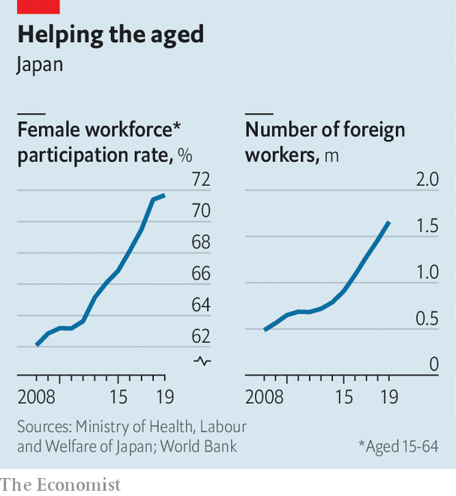

Critics see plenty of shortcomings in Mr Abe’s economic policies. Until covid-19, his time in office was largely free from external shocks. The biggest injuries were self-inflicted: two ill-timed increases in the consumption tax, in the name of fiscal probity, both of which pushed the economy into recession. As a result, his government mustered only meagre economic growth of 1.1% a year on average during his eight years in office, less than the 2% he promised. Companies saw their profits rise, but many sat on them. Women got more jobs, but not enough promotions. Average wages fell after accounting for inflation.

Despite the increases in the consumption tax, Mr Abe also leaves behind a massive public debt, currently 238% of GDP. Markets seem unworried: the yield on many government bonds is negative. But the debt mountain may nonetheless burden future generations. “People assume this is free money but it’s not: it will have to come back in terms of higher taxes or smaller services,” says a former official at the Bank of Japan.

Although Japan has suffered a relatively small number of deaths from covid-19, especially relative to its population, the public is unhappy with Mr Abe’s handling of the pandemic. The national government was slow to adopt measures to curb its spread, leaving local leaders such as the governor of Tokyo, Koike Yuriko, to lead. A string of corruption scandals also dented his standing. Shortly before his resignation the approval rating of Mr Abe’s government was 34%, the lowest since he returned to office. In his resignation speech, Mr Abe lamented that he was unable to amend the constitution or solve a territorial dispute with Russia. Many Japanese feel he put more energy into his ambition to reverse these legacies of the second world war than he did into tending to the economy.

His successor will presumably have less interest in fighting these old battles. Managing the effects of covid-19 will come first: the economy shrank by a record 7.8% in the second quarter of this year. That makes it no bigger than when Mr Abe became prime minister in 2012. The government has propped up companies and given cash to consumers; bankruptcies are down this year. But as the slump persists, a painful restructuring will have to take place, says Hoshi Takeo of the University of Tokyo.

Japan needs a “productivity revolution”, says Ms Matsui. The tax code and the labour market stifle startups and innovation. The government uses archaic computer systems. No one in Japan was surprised to find fax machines being used to tally covid-19 test results. “We have to erase all of the inefficiencies and redundancies,” says a member of a government economic advisory council.

The next prime minister cannot, however, ignore foreign affairs. China is expanding its presence at sea. Japan is at odds with South Korea; Mr Abe could never muster the patience with Moon Jae-in, its president, that he showed with Mr Trump. Japan’s pro-coal stance and the closure of its nuclear reactors after a disaster in 2011 have made it a climate laggard.

The LDP will choose its next president on September 14th, in a vote of its members of the Diet and some regional representatives. In the interests of continuity most of the main factions have endorsed Suga Yoshihide, the chief secretary of the cabinet. If he wins, he would serve out the remainder of Mr Abe’s term, which was due to end in September next year. Then a party-wide election will be held, which should attract a broader crop of candidates.

The son of a farmer from rural Akita Prefecture in the north of Japan, Mr Suga has a reputation for diligence (in a country known for overwork) and as a master of the bureaucracy. His instincts appear less nationalist than Mr Abe’s. He has advocated more immigration and freer trade. He urged Mr Abe to focus on the economy instead of visiting the Yasukuni Shrine, a controversial war memorial, in 2013.

Mr Suga has little experience on the world stage. He is not especially popular among either the LDP’s broader membership or among Japanese at large. He will have many rivals in the party. “A lot of people are chomping at the bit,” says Sheila Smith of the Council on Foreign Relations. Ominously, long-serving prime ministers have typically been followed by strings of short-lived, unpopular governments.■

This article was downloaded by calibre from <https://www.economist.com/asia/2020/09/03/abe-shinzo-has-left-an-impressive-legacy>

|  |  |  |  |
| --- | --- | --- | --- |
|  | Articles | Sections | Next |

|  |  |  |  |
| --- | --- | --- | --- |
| Previous | Articles | Sections | Next |

#### No shrinking violets

# A TV series about female vigilantes breaks taboos in Pakistan

Shows on streaming services can tackle topics that television channels avoid

Sep 3rd 2020 | ISLAMABAD



“NOT ALL heroes wear capes,” declares the trailer for a new Pakistani television series. Some wear burkas. The stars of “Churails”—which means “Witches” in Urdu—are a gang of female avengers who wield fists and hockey sticks in anger. They dispense rough justice to abusive and philandering men.

Sara is a lawyer who gives up her career for her husband before discovering that the rotter has sent explicit messages to scores of women. Jugnu plans weddings for rich couples, and happens to be an alcoholic. Batool served 20 years in prison for murdering her husband, who was a paedophile. Zubaida has long suffered under a domineering and violent father.

Thrown together by chance, the quartet run a secret agency that aims to help wronged women exact revenge. They use a clothes shop in Karachi as a front for their activities. The heroines drink, swear and take drugs. There are lesbian characters and a trans one.

Female characters in Pakistan’s television dramas are often depicted as helpless damsels. Their conflicts are usually with children, mothers-in-law or rivals in romance. Lately TV producers have sought to introduce more challenging themes, such as rape and child abuse, but advertisers and channel bosses are not keen. “The most refreshing thing about ‘Churails’ was that it was completely uncensored,” says Aamna Haider Isani, a journalist who covers entertainment for The News, a Pakistani daily. One enthusiastic reviewer called it a “feminist masterpiece”. Another hailed “a monumental moment for representation”.

Asim Abbasi, the show’s creator and director, who lives in Britain, explains that he “wanted to tell a story that was authentic to women I know and to the society I know”. He is able to do so because “Churails” is airing over a web-streaming service, instead of a television channel. It was created for the Urdu-language unit of Zee5, an Indian video-on-demand service. Going digital “allows us to take risks”, says Mr Abbasi.

Pakistan has no domestic streaming services, but Zee5, Netflix and Amazon are all gaining users. Lockdowns imposed to fend off covid-19 have helped to boost subscriptions. Ms Isani says her children no longer watch conventional television channels. “They say, ‘Why are you watching the same woman cry day after day?’” That TV-streaming youngsters are now watching completely different things to channel-hopping elders may explain why “Churails” has not provoked more of a backlash. Many conservative Pakistanis have yet to discover it.

This article was downloaded by calibre from <https://www.economist.com/asia/2020/09/03/a-tv-series-about-female-vigilantes-breaks-taboos-in-pakistan>

|  |  |  |  |
| --- | --- | --- | --- |
| Previous | Articles | Sections | Next |

|  |  |  |  |
| --- | --- | --- | --- |
| Previous | Articles | Sections | Next |

#### Breaking the wrong sort of record

# India’s economy shrinks by a quarter as covid-19 gathers pace

The record-breaking contraction comes at the same time as record numbers of new infections

Sep 3rd 2020 | DELHI

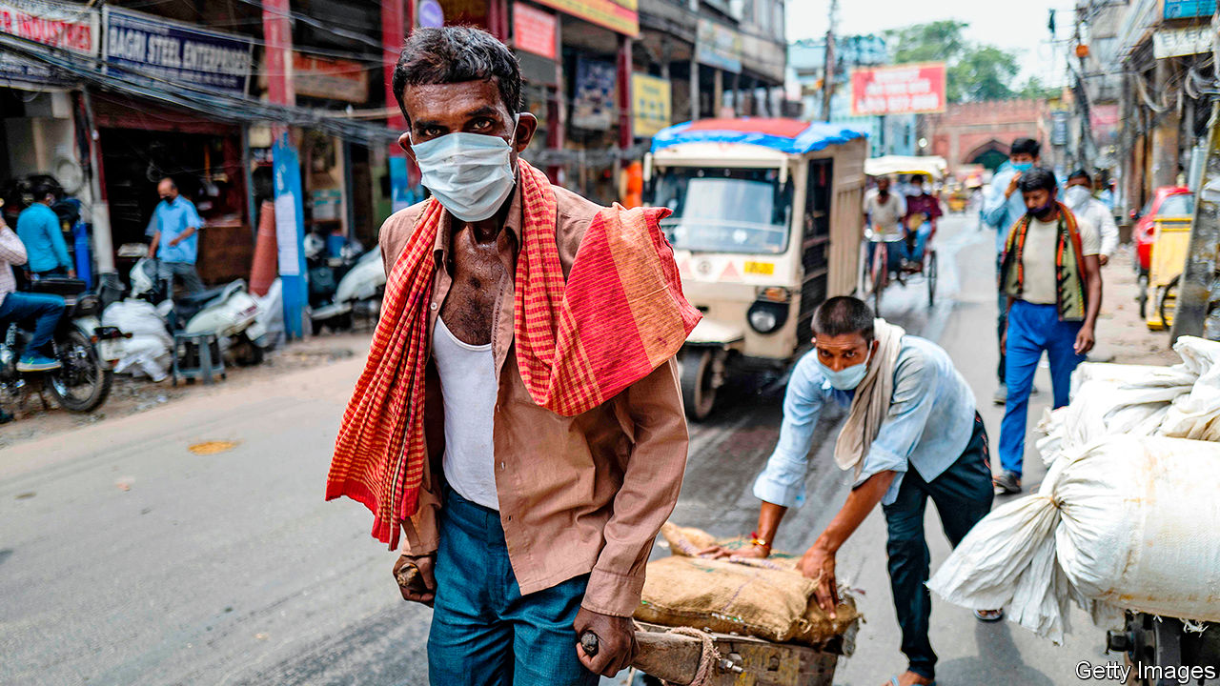

THE STATISTICS landed like fists in a one-two punch. First came the news that India had counted 78,000 new cases of covid-19 on August 30th alone—more than any other country has tallied in a single day since the pandemic began. The next day came the bill for the two-month lockdown that the government imposed in late March at only four hours’ notice. The National Statistical Office said that India’s output between April and June was 23.9% lower than in the same period the year before.

India had never recorded a quarter of negative growth since it began issuing such data publicly in 1996. No other big economy has shrunk so much during the pandemic. In the same period America’s GDP fell by 9.1%. India’s economy had been stumbling before covid-19. But what had seemed a dismally low rate of growth in 2019 is now the stuff of fond memory.

In hindsight, India’s government may have locked down too soon. The country had detected barely 600 cases of covid-19 by March. The ban on commercial activity and movement outside of the home was nearly total for two months. Test-and-trace programmes worked in some areas, notably the southern state of Kerala, but nationwide they have fallen far short of the standards set by some East Asian countries. Hospitals rushed to get ventilators and free up beds in intensive care, but they were starting from a woefully low level. India had 0.7 hospital beds per 1,000 people; South Korea had more than 16 times as many. Lacking health care, people resorted to makeshift remedies. Around 140m people were thrown out of work. Millions trudged on foot to ancestral villages.

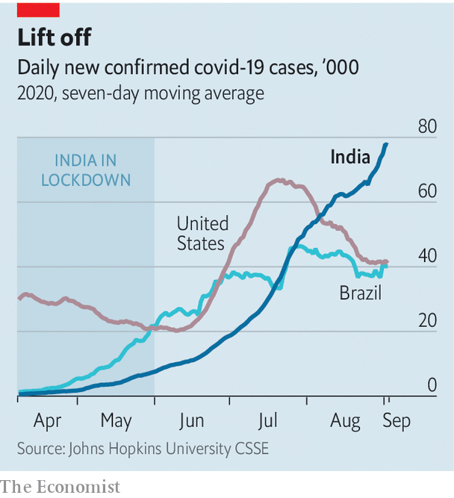

The pain was so great that hardly anyone can stomach the thought of reimposing strict controls, even though infections are rising more swiftly than ever. Public transport is resuming this month. Public gatherings are to be subject to looser rules. Eventually schools will reopen. An edict declares that state and municipal governments may no longer impose stricter rules than the central government. Kerala, once a model for the rest of the country, has been unable to stop travellers from other Indian states bringing the virus with them. It is now counting over 1,000 new cases a day.

The number of Indians dying of the virus appears to be lower than might be expected, given the number of infections. The country’s 3.8m detected cases have led to just 67,000 known deaths. That is a low rate by global standards, although many covid-related deaths are thought to be going unrecorded around the world, making comparisons unreliable. A paper by Minu Philip, Debraj Ray and S. Subramanian of the National Bureau of Economic Research suggests that few Indians are dying because its covid-19 sufferers are younger than those elsewhere. After taking patients’ ages into account, the difference all but disappears.

More startling are the results of surveys that analyse blood serum. They suggest that a fairly high proportion of urbanites may have already had covid-19. The relevant antibodies were detected in 41% of samples collected in Mumbai in July and in nearly 57% of samples from its slums. They were also found in 23% of tests in Delhi in June and in more than 28% in August. In Pune, a prosperous city of 7.4m in Mumbai’s hilly hinterland, the proportion of those with antibodies was more than half.

Many in India are growing stoical about the virus’s spread. The national media are once again full of celebrity tittle-tattle. When Pranab Mukherjee, a former president, died on August 31st, the government declared a seven-day period of mourning. That he had been on a ventilator suffering from covid-19 for the last three weeks of his life was barely mentioned.■

Editor’s note: Some of our covid-19 coverage is free for readers of The Economist Today, our daily [newsletter](https://my.economist.com/user#newsletter). For more stories and our pandemic tracker, see our [hub](https://www.economist.com/news/2020/03/11/the-economists-coverage-of-the-coronavirus)

This article was downloaded by calibre from <https://www.economist.com/asia/2020/09/03/indias-economy-shrinks-by-a-quarter-as-covid-19-gathers-pace>

|  |  |  |  |
| --- | --- | --- | --- |
| Previous | Articles | Sections | Next |

|  |  |  |  |
| --- | --- | --- | --- |
| Previous | Articles | Sections | Next |

#### When unambiguity is ambiguous

# To China’s alarm, America modestly upgrades ties with Taiwan

But the island still cannot be sure of American help if China resorts to force

Sep 3rd 2020 |

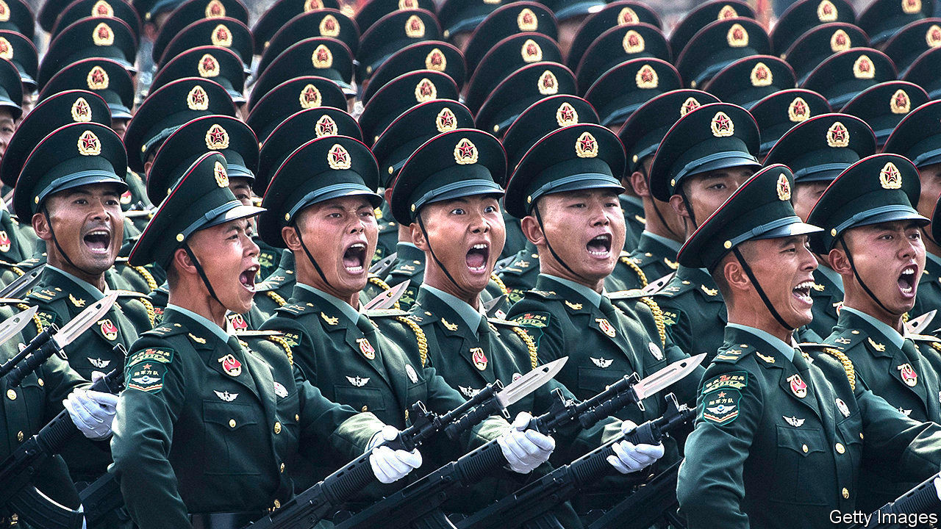

CHINA HAS never renounced what it says is its right to “reunify” Taiwan by force if peaceful means are thwarted. So armies on both sides have to prepare for war, however remote it may seem. Of late the number of naval exercises China has conducted has caused alarm—all the more so at a time of worsening relations between China and America on a number of fronts, including American policy towards Taiwan. The delicate status quo, in which China insists Taiwan is part of its territory but the island functions as an independent country, is fraying. As the Global Times, a tub-thumping official Chinese tabloid, puts it: “The possibility of peaceful reunification is decreasing sharply.” Mercifully, that does not mean war is imminent.

A big reason for that is America’s support for Taiwan. Yet it has no formal alliance or clear-cut commitment to defend the island. A law passed in 1979 obliges it only to provide Taiwan with “arms of a defensive character”, and to take seriously any effort to determine the island’s future other than by peaceful means. This vagueness has been dignified with a clever-sounding euphemism, “strategic ambiguity”. Critics of the policy worry that ambiguity increases the risks of a disastrous strategic miscalculation. Its supporters argue that, for the four decades since America switched diplomatic relations from Taiwan to China, it has worked. It has provided enough reassurance to Taiwan that America would not let China invade unpunished, but not so much as to embolden those who favour a formal declaration of independence—something China has always warned would mean war.

On August 31st America’s position became a touch less ambiguous. It made public classified cables from 1982 in which its government gave Taiwan six supposedly secret but widely known “assurances”. These included not to repeal the 1979 law, and not to set a date for ending arms sales. The declassification went a tiny way to meeting recent calls from some American politicians and former officials to clear up the ambiguity. Ted Yoho, a Republican representative from Florida, for example, is promoting a “Taiwan Invasion Prevention Act”, to authorise military intervention.

The issue has seemed more urgent following a recent series of menacing Chinese military drills, including “realistic” exercises in the Taiwan Strait, at both the north and south ends of the island. No doubt carrying the same message, on August 10th Chinese fighter jets crossed the median line in the strait, the unofficial air border.

The drills serve as a reminder of just how seriously China treats its “sacred mission” of bringing Taiwan back under its sovereignty. They also serve to flaunt China’s fast-improving military capability. It is hard not to see this as part of a more assertive approach to the region. That has been evident in the South China Sea, where China has been steadily building up a military presence in contested waters, although its claims have been rejected both by an international tribunal in 2016 and, just last month, by America. To the north, off China’s east coast, Japan has accused China in recent months of a “relentless” campaign to seize control of the tiny, uninhabited, Japanese-administered Senkaku islands (known in China as Diaoyu). And on August 29th Chinese and Indian soldiers became embroiled in the latest of several stand-offs in a remote part of their long border in the western Himalayas, where India accuses Chinese troops of trying to move the de facto border.

Meanwhile, China’s ruthless approach to Hong Kong has also held a message for Taiwan. The imposition at the end of June of a national-security law in effect ended the autonomy promised under the “one country, two systems” arrangement that was supposed to pertain in Hong Kong until 2047. That deal was a modified version of one on offer to Taiwan. For a time, it seemed China hoped Hong Kong might serve as an advertisement to Taiwan of the benefits of “peaceful reunification”. These days Hong Kong is less an advertisement than a grim warning. That is one reason to worry that China might conclude that its patient approach to Taiwan has failed.

Another reason is China’s concern about America’s upgrading of its ties with Taiwan, which China insists can only be “unofficial”. Those fears have been especially acute under the presidency of Donald Trump, who raised hackles in Beijing by accepting a congratulatory call from Tsai Ing-wen, Taiwan’s president, after his election in 2016. In recent weeks Alex Azar, America’s health secretary, visited Taiwan and met Ms Tsai (apparently provoking the big war-game and the fighter-jet incursion). America has also announced new high-level economic talks with Taiwan.

All of this will annoy China, which will complain loudly. But it is probably relieved that the steps are so modest, and confident that if the ambiguity is resolved under Mr Trump, it will be in its favour. In a memoir published this year, John Bolton, one of Mr Trump’s discarded national security advisers, speculates that Taiwan may well be the next American ally to be jettisoned by his former boss. As a Global Times commentator put it this month: “Taiwan for the US is only a tradable chess piece.” After all, Mr Trump has always put “America first”. Trade concessions have always seemed to matter more to him than alliances, or even the abstractions Taiwan so proudly embodies, of freedom and democracy.■

This article was downloaded by calibre from <https://www.economist.com/asia/2020/09/03/to-chinas-alarm-america-modestly-upgrades-ties-with-taiwan>

|  |  |  |  |
| --- | --- | --- | --- |
| Previous | Articles | Sections | Next |

|  |  |  |  |
| --- | --- | --- | --- |
| Previous | Articles | Sections | Next |

#### Banyan

# Young Thais mount a remarkable challenge to their government

Some demand that the monarch be brought under the constitution

Sep 3rd 2020 |



THE LAST time Thailand saw protests of the size now roiling the country was nearly seven years ago. Then, pro-establishment types declaring love for the king, the late Bhumibol Adulyadej, and for the armed forces that protected him, came out in Bangkok, the capital. They opposed the elected government of Yingluck Shinawatra, which seemed to threaten their interests. Among the children parents pulled out of classes to attend these “yellow shirt” demonstrations were friends of a prominent protest leader today, Yanisa Varaksapong, an 18-year-old undergraduate.

The turmoil the yellow shirts created enabled an army-led coup in 2014 that shoved all politics back into a box and slammed shut the lid. Today, Ms Yanisa says, those same friends are protesting alongside her—against the very establishment for which they once marched.

The dissatisfaction is understandable. The coup leaders promised a technocratic government to end corruption and spread prosperity, and a swift return to civilian rule. Instead, the constitution they wrote, the country’s 20th, entrenches the political power of the armed forces and their allies. The current prime minister is the general who led the coup, Prayuth Chan-ocha. As for the economy, there is neither cleanliness nor competence. Thailand has managed the pandemic well in terms of stemming infections, but the economy will shrink by over 8% this year, according to the central bank.

The government has immense powers to suppress dissent, including laws against sedition and lèse-majesté. So the protests by school pupils and university students took many by surprise, especially as young Thais rarely pay much attention to politics. Thitinan Pongsudhirak, a political scientist at Chulalongkorn University in Bangkok, saw a change on campus last year: “In classes, nobody was on their phone, nobody was sleeping.”

Students poured into the open after the ban in February of the Future Forward Party, which advocated real democracy and won 81 seats in last year’s general election. Flash-mob protests spread until the pandemic brought an end to them. Ms Yanisa describes the lockdown as a time of social-media ferment. In July demonstrations burst out again. Protesters waved three fingers in the air, mimicking a salute used by young rebels in “The Hunger Games”, a dystopian series of novels and films. The demands were clear: a new constitution, the dissolution of parliament and an end to the persecution of government critics.

By August the demands began to take aim at the late king’s successor, Maha Vajiralongkorn. Challenging the cult of the monarchy breaks a taboo. But the 68-year-old king is widely (if quietly) reviled as extravagant, capricious and cruel. He has seized control of vast royal assets and meddled in political and military appointments. He usually isn’t even in Thailand but in Germany, where he has a floor at an upscale hotel near Munich. He shuttles to his queen in Switzerland in one of the Boeing 737s at his disposal. Though he once threw a consort, a nurse turned military pilot, into prison, he has recently rehabilited her, Europe’s tabloid press reports, to serve in his harem of “sex soldiers”. No word of sympathy has crossed the king’s lips over his subjects’ hardship during the pandemic.

The next big student protest is planned for September 19th, the anniversary of an earlier coup, against Ms Yingluck’s brother, Thaksin Shinawatra. The establishment has tried to paint the students as puppets of the exiled Mr Thaksin and his “red shirts”. Ms Yanisa laughs dismissively: the earlier strife was “ages ago for us...Right now it’s something else.”

A large number of the protesters would like to see the king act like the constitutional monarch he is supposed to be. They benefit from growing support from ordinary Thais, from a surreal chasm between royalist propaganda and the king’s comportment, and from a certain vacillation on the part of the authorities. On the one hand they arrest protesters to intimidate the movement: this week the head of the Student Union of Thailand was charged. On the other, Mr Prayuth seems reluctant to order a bloody crackdown. His government even claims a willingness to talk.

In this atmosphere, Mr Thitinan says, the parameters for open expression have been stretched wider than in a long time. The stakes are high, because the parameters could snap cruelly tight again. For the young protesters who, like Ms Yanisa, see the chance to craft a country in which they have a place, there is no going back.

This article was downloaded by calibre from <https://www.economist.com/asia/2020/09/03/young-thais-mount-a-remarkable-challenge-to-their-government>

|  |  |  |  |
| --- | --- | --- | --- |
| Previous | Articles | Sections | Next |

|  |  |  |
| --- | --- | --- |
| Asia | Sections | Middle East & Africa |

China

Education reform: Testy times

.

Inner Mongolia: Mongolingualism

.

Chaguan: Keeping a grip

.

|  |  |  |
| --- | --- | --- |
| Asia | Sections | Middle East & Africa |

|  |  |  |  |
| --- | --- | --- | --- |
|  | Articles | Sections | Next |

#### Testy times

# Schools in China are trying to make pupils’ lives easier

Why do some parents object?

Sep 5th 2020 | NANJING

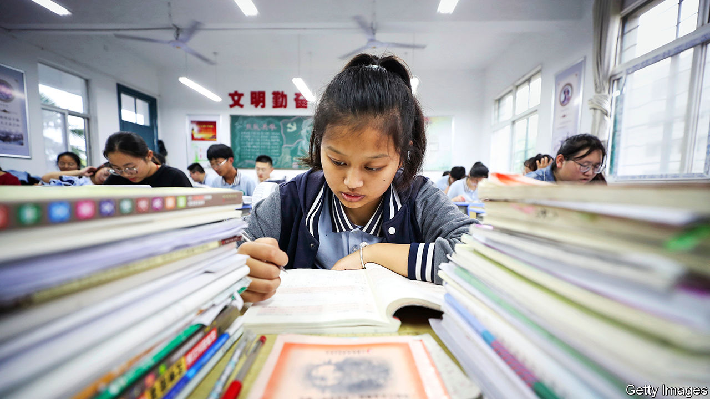

THE LARGEST museum commemorating the gruelling examination system China used in imperial days to select civil servants opened in 2017 in Nanjing. It would not seem an obvious destination for a fun family outing in the eastern city. As visitors walk into it down a grey ramp—130 metres long to symbolise the test’s 1,300-year history—a sign tells them they will “experience the hardships of the journey to success” for those who sat the keju before its abolition in 1905. Bamboo slips affixed to towering walls represent the “myriad” books that candidates had to read.

Yet on a recent weekday afternoon, there were as many youngsters filling the museum’s cavernous halls as there were attentive adults. A mother from the city of Xi’an, hundreds of kilometres inland, had brought her four-year-old son in order to inspire him. “He likes the dioramas,” she said brightly, “even though he doesn’t know what an exam is yet.” A coalmine engineer from Ordos, a city in distant Inner Mongolia, was there with his nine-year-old son whose “fate” he hoped to alter through their visit. “Xiangshi, huishi, dianshi,” his son piped up, naming three levels of the ancient test that inspired the creation of civil-service exams in the West.

In terms of the awe it inspires, the keju has a modern rival: the gaokao, a punishingly hard university-entrance exam which is taken by over 10m students every year. For those from poor families, a good score is often their only chance to escape a life toiling on farms or in factories. As a result, Chinese education has long involved little more than rote learning, aimed purely at the gaokao. Pupils attend late-night cram sessions and shoulder twice as much homework as the global average.

But the deep reverence for tests expressed by the museum and its visitors is not shared by reformist educators and some head teachers, who want to downplay them. They have a radical vision—of reducing study loads, expanding the curriculum and encouraging students to take up hobbies. Nanjing, a former imperial capital, is the centre of their experiments.

In 2016 Nanjing Number One Secondary School, the city’s oldest and among its most competitive, began to let students borrow points from a “marks bank” to boost a low grade. These are repaid by deducting points scored in a later test, or earned from good classwork. The aim is to take a bit of pressure off exams. At the school, teachers and students are encouraged to be “on an equal footing”, an appreciative former pupil wrote in an online forum. Nanjing Number One has a vibrant student union, a literary society and other clubs. Its university-acceptance rate this year was 95%, a record for the school.

Yet the scene outside Nanjing Number One in late July, soon after the gaokao results were released, was not of jubilation. Dozens of angry parents brandished placards demanding that the head teacher step down. They blamed their children’s lower-than-expected scores on what they saw as his attempts to make light of tests. More traditional schools in Nanjing, they noted, churned out more top-scorers. Nanjing Number One mollified the protesters by extending compulsory revision sessions to 10pm for final-year students. On social media theories circulated that officials who advocated a less demanding curriculum really just wanted to make it harder for students from humbler families to get ahead.

The tussle highlighted a bitter divide over how to educate China’s teenagers, whose summer holidays ended this week. In Nanjing many locals sympathise with the protesters. Xu Wuqing, waiting for his granddaughter outside the school gates with homemade pigeon soup, said that “less pressure” on students was “simply not okay”. In a complaint last year to Nanjing’s education bureau, which was widely shared online, a mother griped that the city’s children were being turned into “slackers”, too weak to cope with exams.

Many in China once supported what schools such as Nanjing Number One are trying to do. In the early 2000s a bestseller about raising a child in the West, “Education for Quality in America”, popularised the idea of suzhi jiaoyu. The term refers to a well-rounded education that attaches importance to building character as much as knowledge. It guides most of Nanjing’s more liberal teaching. The author, Huang Quanyu, became a household name among the middle class, writes Teresa Kuan, an American academic, in “Love’s Uncertainty: The Politics and Ethics of Child Rearing in Contemporary China”. In 2010 China published a ten-year plan on education which admitted that the country’s teaching was “relatively outdated” and that people had “strong yearnings” for suzhi jiaoyu.

Some reforms have seemed fanciful. In 2018 the central government called for “30 burden reductions”, including a limit of 90 minutes of homework a day and an end to the parental habit of comparing their offspring to others. This year, to prevent cram schools from racing too far ahead with the syllabus, it published lists of subjects suitable for certain age groups. For example, under-nines are not to study how to add and subtract with numbers comprising four or more digits.

From next year a tweaked gaokao will give students leeway to pick and choose some subjects, beyond the compulsory ones. But China is reluctant to overhaul a test that remains remarkably meritocratic. “By sticking with the exam, we waste students with other talents. By moving too far away from it, we disadvantage poor kids,” says Wang Tao of East China Normal University. It is not that loving parents do not want their children to have fun. Rather, as one mother in Nanjing puts it, relaxed classrooms are “just no use” if they do not get a pupil into a good university.

So quasi-military cram schools—“gaokao factories”, as they are known—still thrive. One such is Hengshui Secondary School in the northern province of Hebei. It has 18 branches across China, some of which reward students who get into top universities with tens of thousands of dollars. In 2018 one of them bought two decommissioned army tanks to flank its entrance, apparently to instil a sense of toughness among its students.

Mr Wang says he is glad to see “so much negotiation” under way, with educators pushing forward and policymakers following cautiously, even if parents are still resisting. Observant children at the museum in Nanjing will find, in addition to statues of prominent men who aced the keju, a bronze one of a person who failed it repeatedly: Wu Cheng’en, who was educated in Nanjing in the 16th century. Wu went on to write “Journey to the West”, one of China’s most celebrated novels. ■

This article was downloaded by calibre from <https://www.economist.com/china/2020/09/05/schools-in-china-are-trying-to-make-pupils-lives-easier>

|  |  |  |  |
| --- | --- | --- | --- |
|  | Articles | Sections | Next |

|  |  |  |  |
| --- | --- | --- | --- |
| Previous | Articles | Sections | Next |

#### Mongolingualism

# China’s efforts to boost Mandarin-use in schools angers ethnic Mongols

Some parents have been staging rare protests

Sep 5th 2020 |

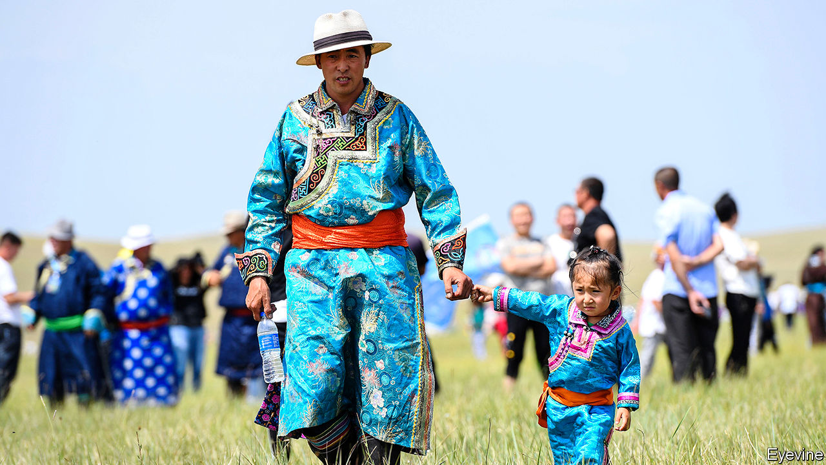

ON THE FIRST day of the school year in Inner Mongolia, a northern province of China, some teachers in schools using the Mongolian language found their classrooms empty. To show their anger at an official order that Mandarin be used to teach history, politics and literature, parents had kept their children at home. In recent years the government has stepped up repression in parts of China with large ethnic-minority populations, making widespread protests all but impossible. In Inner Mongolia ethnic tensions have seldom reached levels seen in Tibet or Xinjiang, so the school boycott is especially remarkable.

The Communist Party has never been as fearful of unrest among Inner Mongolia’s ethnic Mongols as it is of protests by ethnic Tibetans, or Uighurs in Xinjiang. One reason is that a massive influx of ethnic-Han Chinese over the past few decades has reduced ethnic Mongols to less than a fifth of the province’s population of nearly 25m people. Their separate identity has long since been eroded. Most (unlike some Tibetans and Uighurs) are bilingual. But ethnic Mongols often still cherish their traditional culture and language. By requiring more use of Mandarin in schools, the party risks fuelling dissent.

The boycott has affected many schools across Inner Mongolia. Protesters have submitted thousands of petitions to the government, some using a traditional Mongolian format that involves signatories putting their names in a circle to avoid any one of them being perceived as a ringleader. Videos circulated online show parents singing Mongolian songs outside schools. In one clip, high-school students shout, “Mongolian is our mother tongue! We are Mongolian until death!”

Fearful of police reprisals, protesters have posted messages online warning against the use of violence, and even against any action on the streets. “We’ve all agreed to stay united by keeping our children at home,” says a herder from Xilingol League, a prefecture in Inner Mongolia. “But we know that if we take to the streets in protest, we will be thrown into jail.”

The changes under way in Inner Mongolia’s schools were rolled out in Xinjiang in 2017 and in Tibet the following year. They will eventually affect students in Inner Mongolia throughout their nine years of compulsory education. This academic year they apply only to those in the first year of secondary school and first year of primary. Parents worry that their children will lose fluency in Mongolian and grow up unable to use the classical Mongolian script. They take particular pride in this form of writing. Mongolia, an independent country to the north, more commonly uses the Cyrillic script—a hangover from its days as a satellite of the Soviet Union.

The authorities are already cracking down. The herder says two of her relatives who had spoken out against the new language policy disappeared on August 31st. Users of Inner Mongolia’s only Mongolian-language social-media platform, Bainu, have found that access to their feeds has been blocked. Censors have erased posts about the protests from other social media. Local officials have ordered teachers to press parents to send their children to school. Ethnic-Mongol party members, civil servants and teachers have been told that if they join the boycott they may lose their jobs and party membership. Tibetans and Uighurs have long been familiar with such bullying. Ethnic Mongols will have to get more used to it. ■

This article was downloaded by calibre from <https://www.economist.com/china/2020/09/05/chinas-efforts-to-boost-mandarin-use-in-schools-angers-ethnic-mongols>

|  |  |  |  |
| --- | --- | --- | --- |
| Previous | Articles | Sections | Next |

|  |  |  |  |
| --- | --- | --- | --- |
| Previous | Articles | Sections | Next |

#### Chaguan

# To buy peace, officials in China tolerate some forms of disobedience

Their goal, though, is the maintenance of power

Sep 5th 2020 |

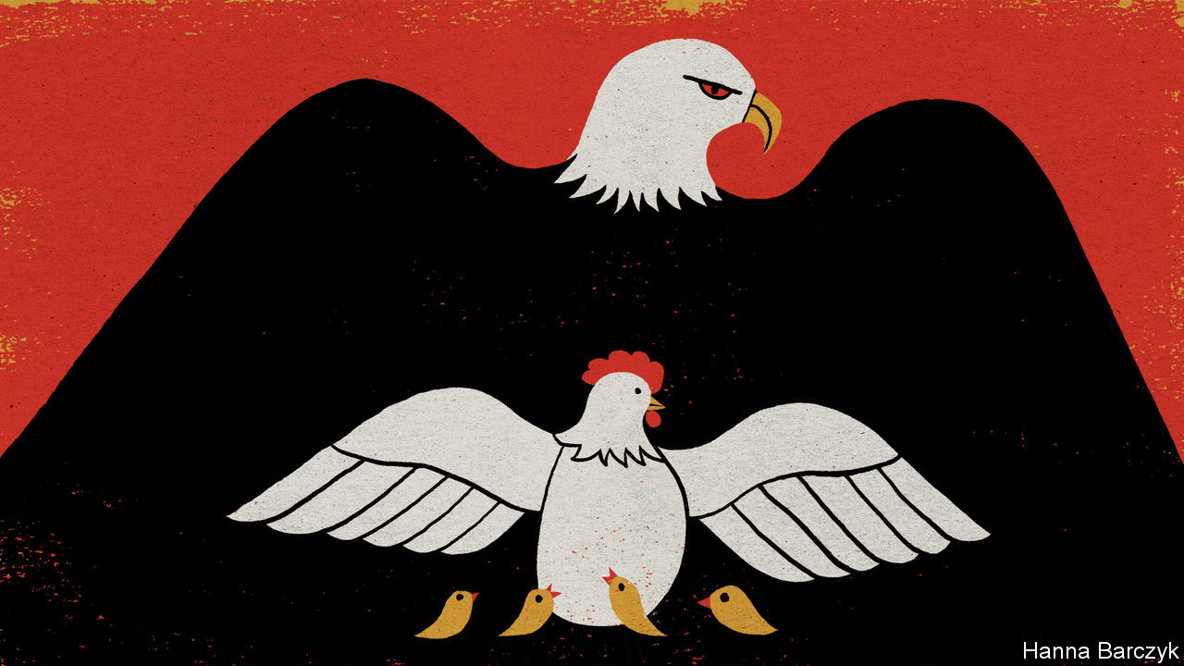

FOR A BUSINESS that flouts the law in a police state, Mrs Hu’s pancake cart is not hard to find. A tiny, unlicensed kitchen on wheels, her pushcart appears each night between 11pm and dawn on a road junction in central Beijing, between a centuries-old temple and a bus station. Neither summer heat nor snow deters Mrs Hu. Only rain keeps her at home, because it clears the streets of customers. On a recent night, diners munching her egg and onion pancakes, perched outdoors on low plastic stools, ranged from young hipsters to a bus driver still in her uniform.

It is not the romance of the night that inspires Mrs Hu’s hours. Working by day would increase the risks of trouble from the chengguan—poorly paid, widely disliked city-management officers who enforce local regulations in urban areas. In Beijing the rules are ever-less tolerant of street food, deemed unhygienic and unworthy of a capital city. There has been one positive change: less than five years ago chengguan were often violent, grabbing stallholders’ goods and demanding money. Now chengguan shoo vendors away but do not hit them. Mrs Hu ascribes their improved manners to a government campaign for “civilised law-enforcement”.

A migrant from central China, she remains an outsider with few rights although she has lived in Beijing for 24 years. She and her husband once worked legally from a rented market stall. Then two markets in a row were demolished in the name of modernity, forcing the couple onto night-time streets with separate pancake carts. Worldly wise, the pair stayed calm when the prime minister, Li Keqiang, suggested this summer that encouraging street traders might boost a covid-battered economy. Food carts may be welcomed by smaller cities but not in Beijing, says Mrs Hu. Indeed, the capital is currently closing markets and sweeping away vegetable-sellers from its streets. So she and her husband survive by keeping their heads down and working hard. Like many, they live on the margins of society, navigating an authoritarian system that wields its powers more selectively than outsiders may suppose.

There is nothing kindly about that security machine, which crushes all hints of political, religious or ethnic dissent or open challenges to the Communist Party. The machine is bent on abolishing privacy, with surveillance cameras on every corner and censors and algorithms scouring the online world for forbidden ideas. Yet when public-security agencies encounter non-political rule-breakers or even protesters, they can be unexpectedly willing to turn a blind eye or make concessions to offenders.

Such haggling is common at the lowest levels of law-enforcement, where the chengguan work. As luck would have it, a remarkable documentary about these para-police has just secured a limited release in Chinese cinemas. “City Dream”, directed by Chen Weijun, follows chengguan from the central (and, since then, virus-hit) city of Wuhan, as they match wits with Wang Tiancheng, a 70-year-old street trader with a genius for staging the sorts of noisy protests that win the sympathy of a watching crowd, while humiliating officers sent to demolish his sprawling, unlawful street stall.

Cities created chengguan in the late 1990s to tackle non-criminal forms of disorder, after the dismantling of the planned economy left urbanites less dependent on the state and triggered a wave of rural migration into cities. The documentary begins in 2014, shortly after Wuhan announced a revolution in city management as part of a development drive. At the time chengguan had a grim reputation across China, following a number of deaths caused by officers as well as fatal attacks on them as they were carrying out raids to demolish homes or clear informal markets.

High-ups in the city-management bureau loathe “Old Wang”, as everyone calls him. “Close the gates! Old Wang is on his way!” they yelp, as the former farmer heads to the chengguan offices, barrel-chested, shirtless and demanding to see the boss. Sure that he makes more money than he lets on, officials send patrolmen to spy on his fruit sales (an undercover officer returns in tears, after Old Wang grabs his notebook). A senior chengguan declares that the street trader, who moved to Wuhan 14 years earlier from the central province of Henan, should be renting a clean, respectable shop. “That’s the real life of a city dweller,” the officer sniffs. In contrast, street-level chengguan are grudgingly impressed by Old Wang’s flair for drama. During several raids on his stall, the trader tells gawking onlookers about his disabled son and cancer-stricken wife. He slaps a chengguan, tears up legal notices, accuses officers of taking bribes to leave his competitors alone, threatens to commit suicide and—in an astonishing moment—appeals to his tormentors as fellow outcasts at the bottom of society. “Where is your conscience?” Old Wang asks chengguan who have penned him within a square formed of their riot shields. “A second ago you were just like me. A man with no job.” None can meet his gaze.

## The power of the powerless

At one point Old Wang’s son compares his father to a hen, frantically trying to protect chicks from an eagle. It is a revealing image. In the end Old Wang loses, for he is thrashing around in the grip of a much stronger beast. But he gains a concession, too: the city’s help to stay and work in Wuhan for three more years, until his granddaughter, a good student, finishes secondary school. The price is apologising in writing for his earlier defiance. Later a chengguan is rebuked by a superior for suggesting that the Wang family are sincerely grateful. Their emotions are not of interest, snaps the official: “What we want is their obedience to our management.”

This brilliant film explains a seeming puzzle: the hard men who run China are capable of both brutality and pragmatism. The key is their obsession with social stability. To buy peace, China’s autocrats tolerate and even reward some forms of disobedience, so long as the game ends with displays of deference to their authority. Their goal, though, is the maintenance of power. Like an eagle adjusting its grip, the party is not guided by mercy. ■

This article was downloaded by calibre from <https://www.economist.com/china/2020/09/05/to-buy-peace-officials-in-china-tolerate-some-forms-of-disobedience>

|  |  |  |  |
| --- | --- | --- | --- |
| Previous | Articles | Sections | Next |

|  |  |  |
| --- | --- | --- |
| China | Sections | Europe |

Middle East & Africa

United Nations peacekeeping in Congo: Blue helmet blues

.

Rwanda’s celebrated hotel manager: We don’t need another hero

.

Elections in Burkina Faso: Sacking the voters

.

Lebanon: The sultan et le président

.

Egyptian politics: Defendant number 54,000,000

.

|  |  |  |
| --- | --- | --- |
| China | Sections | Europe |

|  |  |  |  |
| --- | --- | --- | --- |
|  | Articles | Sections | Next |

#### All helmet and no mettle

# The UN’s peacekeepers are under pressure to quit Congo

The peacekeeping mission has struggled to bring peace, but leaving could make things even worse

Sep 3rd 2020 | BENI

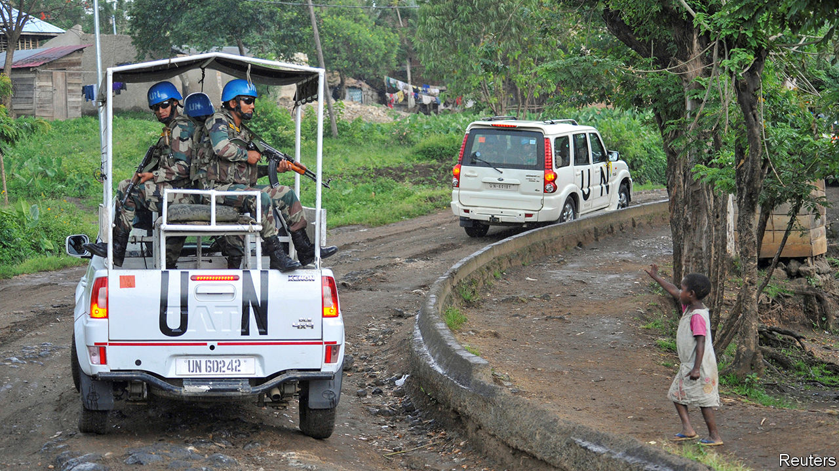

ON THE EDGE of Beni, a city in north-eastern Congo, a field is strewn with bricks and broken glass. Three Malawian soldiers, working for the UN’s peacekeeping mission, known as MONUSCO, lounge under a tree amid the rubble. It is all that is left of MONUSCO’s offices after they were burned down in November by locals furious that the mission had failed to protect them from rebels. “We have suffered years of massacres,” says one of those who took part in the burning. “We see UN soldiers all over town, but when the rebels are killing us they never come.”

The peacekeeping mission in Congo, with over 16,000 soldiers and police, is the largest and third most expensive in the world. UN troops have been in Congo since 1999, when they arrived to oversee a ceasefire in a civil war that had left between 1m and 5m people dead, thanks to bullets, machetes and disease. For two decades the mission has tried to pacify the country’s embattled east. Yet more than 100 armed groups still hide there in the forests. They survive by smuggling minerals, looting and extorting cash from the locals.

This year alone about 1m Congolese have been displaced by violence. Some of the bloodiest fighting has taken place in Ituri province, where two rival tribes have been clashing. Rebels have hacked at least a thousand people to death with machetes, attacking 60 schools and raping children.

Even though the violence still rages (see map), MONUSCO is under pressure from the UN Security Council to pack up and go. A report commissioned by the council last year says MONUSCO should aim to be out by 2022, largely because it is too expensive and has sputtered on for so long. President Donald Trump’s decision to cut America’s contributions to UN peacekeeping has squeezed MONUSCO’s budget to $1bn a year, almost a third less than in 2016. Yet conditions for the mission’s total withdrawal will plainly not be met by 2022, when Congo’s army is supposed to be largely back in control. So MONUSCO will probably be shrunk but will not leave altogether.

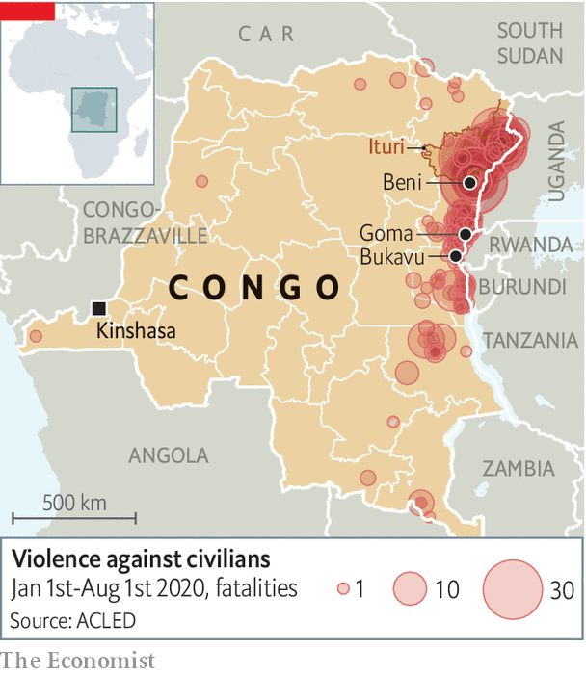

The peacekeepers are far from fulfilling their mandate to disband militias, protect civilians and stabilise the state. Armed groups are multiplying. Few Congolese civilians think the mission really protects them. According to a poll in 2018 by peacebuildingdata.org, an American NGO, only 15% of those surveyed said they trusted MONUSCO to keep their neighbourhood or village safe. Still, with nobody else to turn to, displaced people do often huddle around MONUSCO bases.

At the best of times, bringing peace to eastern Congo is a very tall order. The eastern provinces are ten times the size of Switzerland. Much of the land is jungle. Murder and mayhem can occur quickly at night, so by the time UN soldiers arrive—if they do at all—the rebels have invariably melted back into the bush. “Whenever I see the bloodshed, I always ask, where were we?” says Leila Zerrougui, MONUSCO’s head. “We can never do enough.”

In any case, MONUSCO can stay only as long as the Congolese government wants it to. It is meant to work alongside the national army. Whereas Congo’s former president, Joseph Kabila, routinely threatened to kick it out, his successor, Félix Tshisekedi, is keener to co-operate with it. Yet working with the army is tricky. Its unruly, underpaid soldiers often collaborate with rebels, selling them guns and tipping them off. Sometimes they kill and loot together. Many former rebel warlords have been given senior posts in the army in exchange for surrendering their weapons. Their thugs tend to go on pillaging as before—but in army uniforms.

“We cannot trust our soldiers and we do not know who the enemy is,” says a villager near Beni whose eight neighbours were rounded up and shot outside their houses last year. He says the killers were uniformed Congolese soldiers speaking Lingala, the language of the capital and the army. These murders took place barely a mile from MONUSCO’s offices, sparking the protests in which they were burned down. “Nobody came to help. We were forgotten.”

To make matters worse,UN troops in Congo have themselves often been accused of violence. Dozens of women say they have been raped by blue-helmeted soldiers in eastern Congo. Posters in MONUSCO’s barracks remind UN troops not to have sex with under-age women.

Yet for all MONUSCO’s faults, Congo would probably be worse off without it. Its soldiers are more trusted than the Congolese army. “In many places, peacekeepers are the only ones who are actually trying to protect people,” says Séverine Autesserre, author of “The Trouble with Congo”. MONUSCO’s civilian staff have documented abuses by rebels and the army that would have gone unnoticed. Aid agencies rely on MONUSCO’s planes and armed escorts to help them reach remote, beleaguered places. If MONUSCO leaves in a rush it will leave a gaping hole that is bound to be filled by rebels and predatory soldiers. ■

This article was downloaded by calibre from <https://www.economist.com/middle-east-and-africa/2020/09/03/the-uns-peacekeepers-are-under-pressure-to-quit-congo>

|  |  |  |  |
| --- | --- | --- | --- |
|  | Articles | Sections | Next |

|  |  |  |  |
| --- | --- | --- | --- |
| Previous | Articles | Sections | Next |

#### The hero of “Hotel Rwanda”

# Rwanda arrests the man who shielded people from genocide

Paul Kagame’s authoritarian regime grows more brazen in attacking its critics

Sep 5th 2020 |

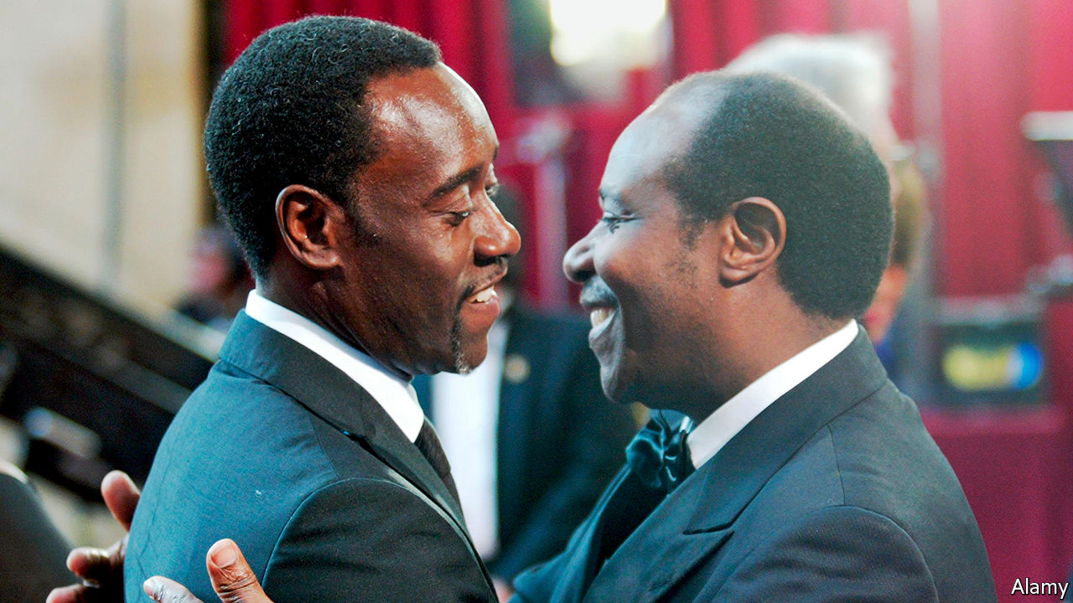

THE LAST time Trésor Rusesabagina spoke to his father was on his birthday, when the latter called from his home in San Antonio, Texas, to wish his son well. “He hadn’t been anywhere for ages because of lockdown and I thought he was just hanging out, watering his plants.”

On August 31st Trésor woke up to a welter of messages on his phone, asking if he’d heard the news. Paul Rusesabagina had just appeared in handcuffs at a press conference in Kigali, Rwanda’s capital, hosted by the Rwanda Investigation Bureau. The authorities accuse him of founding and leading “armed extremist terror outfits” fighting the Rwandan state. Mr Rusesabagina had told his wife he was flying to Dubai for a meeting. How he ended up in Rwanda’s capital remains unclear.

For the former manager of the Hotel des Mille Collines, the rendition is a nightmare come true. Since moving his family to Belgium in 1996, where he applied for asylum before relocating to America, he had lived in anticipation of just such an event. “He’s always been paranoid about them arresting him, shutting him down, because he had a voice,” said his son, Trésor. “In Rwanda, to have an opinion is a crime.”

The film “Hotel Rwanda”, which starred Don Cheadle, made Mr Rusesabagina (pictured on the right) a celebrity in the West. It showed how during the genocide of 1994 that claimed some 500,000 lives he sheltered 1,268 terrified Tutsis and moderate Hutus in the Mille Collines. A Hutu on jocular terms with the army generals and militia leaders who masterminded the genocide, Mr Rusesabagina used charm, cigars and booze to buy time for the hundreds of Tutsis who had taken refuge under his roof.

## Silencing the critics

Mr Rusesabagina’s pragmatic heroism won him a Hollywood film deal, international praise and an admiring audience in America, which became a donor to the new government established by Paul Kagame, a former rebel leader. But the regime chafed at Mr Rusesabagina’s outspoken criticism of the Tutsi elite now running the country. He poured scorn on Rwanda’s rigged elections and mocked what he saw as token attempts at ethnic reconciliation. “We have changed the dancers but the music remains the same,” he wrote in a memoir.

On social media Mr Kagame’s backers are circulating a clip filmed in 2018 which appears to mark the moment when Mr Rusesabagina came out in favour of armed struggle. “The time has come for us to use any means possible to bring about change in Rwanda,” he said, calling on Rwandans to support the National Liberation Front, the armed wing of a coalition of opposition groups which included his own. “All political means have been tried and failed.”

His family insist the 66-year-old grandfather never actually intended to incite violence, which he abhorred. Anyway, the much-hyped opposition coalition he was part of has largely collapsed since he made the statement, suggesting he posed no real security threat to Rwanda.

This makes Mr Rusesabagina’s rendition all the more surprising, given the international condemnation it courts. The real motive may have been jealousy, says a former confidant of Mr Kagame: “There can only be one post-genocide hero in Rwanda and that’s Kagame. He wasn’t going to share the limelight with anyone.”

The operation is the most brazen that his government has launched against perceived enemies abroad. Quick to remind the international community that it did nothing to stop the genocide, Rwanda’s leaders see Israel as a model and inspiration. This extends to the efforts of the Israeli security services to track down and abduct or kill those deemed enemies of the state abroad.

Ever since a former Rwandan interior minister, Seth Sendashonga, was shot dead in Nairobi in 1998—an assassination for which disillusioned members of Mr Kagame’s intelligence apparatus have since admitted responsibility—the government has shown the same readiness to ignore borders. In South Africa at least three attempts have been made on the life of an exiled former army chief-of-staff, Kayumba Nyamwasa, prompting the government to expel Rwandan diplomats suspected of arranging the attacks. In early 2014 Patrick Karegeya, a former external intelligence chief, was found strangled in a Johannesburg hotel. Mr Kagame, who had known both men since childhood, denies responsibility. But the magistrate at Karegeya’s inquest ruled that the attackers were “directly linked” to Rwanda’s government.

In February Kizito Mihigo, a gospel singer, died in Rwandan police custody. Friends reject official claims that the young man hanged himself. Last month a Congolese gynaecologist, Denis Mukwege, who won the Nobel peace prize for his work with rape victims, said he had had a stream of death threats after calling for those responsible for human-rights abuses in the east of the Democratic Republic of Congo to be held accountable. UN reports accuse the Rwandan army of committing mass atrocities there in the late 1990s.

A Rwandan human-rights campaigner, Rene Mugenzi, who describes Mr Rusesabagina’s arrest as a “kidnapping” since no extradition hearing was held, sees the latest operation as evidence of extreme intolerance by a regime whose impressive economic development has never been matched by a respect for human rights: “The risk Rusesabagina represented to Kagame was reputational, not military. He could reach places in the American establishment that matter to Kigali. Now they want to destroy his reputation in court.” ■

This article was downloaded by calibre from <https://www.economist.com/middle-east-and-africa/2020/09/05/rwanda-arrests-the-man-who-shielded-people-from-genocide>

|  |  |  |  |
| --- | --- | --- | --- |
| Previous | Articles | Sections | Next |

|  |  |  |  |
| --- | --- | --- | --- |
| Previous | Articles | Sections | Next |

#### Sacking the voters

# Burkina Faso says its poll will be valid, whatever the turnout

Rising jihadist violence may keep millions of voters from the polls

Sep 3rd 2020 |

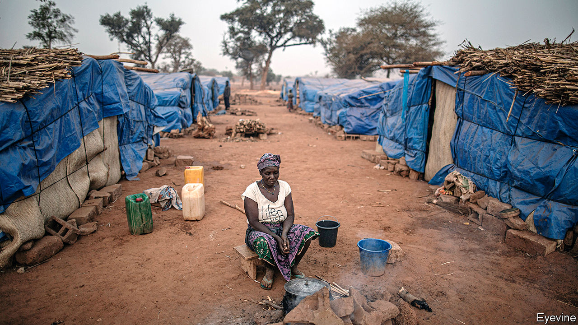

WHAT MAKES a national election national? One answer is that everyone is able to vote. But politicians in Burkina Faso disagree. With little consultation, the main political parties have voted to change the electoral code so that presidential and legislative elections to be held in November will be deemed valid even if people are unable to vote in the vast tracts of the country that are plagued by jihadists.

One MP, Aziz Diallo, describes the change as an “attack on democracy”. Another, Alexandre Sankara, says it “violates the constitution”. It is but the latest worrying sign in a country at the heart of the fight against violent extremists in the Sahel.

Only a few years ago Burkina Faso looked on the road to democracy after a popular uprising toppled its longtime dictator, Blaise Compaoré, leading to free elections in 2015. The first big setback was a spillover of jihadist violence from neighbouring Mali that has intensified since 2018. More than 1,700 people were killed in the first half of this year in fighting that often involved ethnic militias, up from about 300 in the whole of 2018. Roughly half the country (mainly rural areas) has been overrun by armed groups, says Héni Nsaibia of Menastream, a research consultancy. Over 1m people, of a population of 20m or so, have been forced to flee their homes.

Many more than that may struggle to vote. In July 52 of 127 MPs said it was not safe to campaign in their constituencies. Voters in the countryside are the most likely to be left out. In almost a fifth of villages no voters have been registered at all. Polling stations will probably be abandoned in many more villages on election day, when the security forces will be stretched thin. Mr Sankara reckons that people may be disenfranchised across five of Burkina’s 13 regions.

In July politicians ruled out delaying the elections because they feared that would deprive the government of legitimacy. But ignoring the rights of millions may be no better, particularly since those who will be unable to vote because of insecurity are precisely those who have most reason to be angry with incumbent politicians.

What with widespread accusations of atrocities by the security forces, Burkina Faso’s government could soon face a crisis of legitimacy much like the one that is tearing Mali apart. There, too, jihadists have overrun swathes of the countryside. Dodgy parliamentary elections with a paltry turnout earlier this year were followed by massive anti-government protests and then a coup. ECOWAS, the regional bloc, has told the soldiers running Mali to hand back power to a civilian administration and hold elections within a year. But the men in uniform want to stay in power for three years. When democracy falls, it is hard to restore. Burkina beware. ■

This article was downloaded by calibre from <https://www.economist.com/middle-east-and-africa/2020/09/03/burkina-faso-says-its-poll-will-be-valid-whatever-the-turnout>

|  |  |  |  |
| --- | --- | --- | --- |
| Previous | Articles | Sections | Next |

|  |  |  |  |
| --- | --- | --- | --- |
| Previous | Articles | Sections | Next |

#### The sultan et le président

# Old colonial powers are bidding for influence in Lebanon

Their efforts may drag the country into yet more conflict

Sep 3rd 2020 | BEIRUT

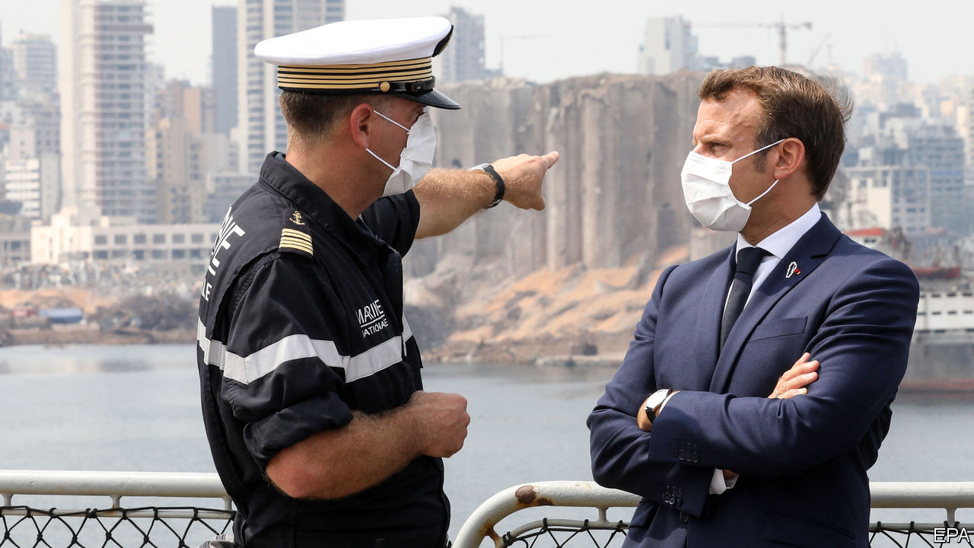

AS CELEBRATIONS GO, it was sombre. A century earlier French officials stood in Beirut’s imposing Résidence des Pins (the French ambassador’s villa) and carved Lebanon out of their mandate in Syria. On September 1st Emmanuel Macron travelled there to mark the event—and to lecture the politicians who have helped turn Lebanon into a failed state.

Lebanon has always been a plaything for foreign powers. America, Iran, Israel, Saudi Arabia and Syria have all meddled in the tiny country’s tortured politics. As Lebanon sinks into economic and humanitarian crisis, two of its old colonial masters, France and Turkey, are making worrying bids for renewed influence.

This was Mr Macron’s second visit since a massive explosion at Beirut’s port on August 4th killed almost 200 people. The prime minister, Hassan Diab, resigned soon afterwards. For weeks the president, Michel Aoun, declined to consult parliament about a successor. But he abruptly summoned MPs to meet on August 31st. Wags likened him to a child rushing to finish his homework before daddy returned.

Mr Macron speaks for many when he calls for political change in Lebanon, ruled for decades by a coterie of ageing, corrupt men who deploy fear and exploit sectarian loyalties to stay in power. “The objective of this visit is clearly to mark the end to a political chapter,” Mr Macron said. Yet the man who will lead this new beginning is hardly a break from the past. The unexpected choice for prime minister was Mustapha Adib, Lebanon’s ambassador to Germany, who won the support of 90 MPs out of 128.

For many, that very support makes Mr Adib suspect. He is a political unknown, but hardly an outsider. He advised Najib Mikati, a billionaire businessman who served two stints as prime minister and is battling corruption charges. Mr Adib won the backing of Saad Hariri, another billionaire ex-prime minister and the country’s leading Sunni politician. The two main Shia parties, Hizbullah and Amal, and Mr Aoun’s Christian allies are also behind him. A man handpicked by the establishment is unlikely to confront it.

Even a genuine reformer would be overwhelmed by Lebanon’s problems. Its economy has collapsed. The currency has lost 80% of its value on the black market since October. Annual inflation hit 112% in July; food prices leapt fourfold. Over half of Lebanese live in poverty.

In years past Lebanon might have turned to the Gulf for a bail-out. Saudi Arabia was a longtime patron of Lebanon’s Sunni community. But, frustrated with Lebanon’s politics, in recent years the kingdom has stepped back.

That has left an opening for Recep Tayyip Erdogan, Turkey’s president, who has cultivated ties with Sunnis in neglected areas. Turkey’s foreign-aid agency has built cultural centres and funded other projects. Thousands of Lebanese have received scholarships to study in Turkey. Thousands more have gained citizenship based on Turkish ancestry. Turkey’s vice-president visited Beirut after the explosion and offered to help rebuild the port.

Unlike the Saudis, Mr Erdogan has not thrown his support behind a political party. But he and his confidants have made powerful friends. Hakan Fidan, the Turkish spy chief, has built a relationship with his influential Lebanese counterpart, Abbas Ibrahim. Mr Hariri was a guest at the wedding of Mr Erdogan’s daughter in 2016.

Turkey’s growing clout worries many. The dying days of Ottoman rule were not a pleasant chapter in Lebanon’s history: the famine that began in 1915 killed half the people in the mountainous heartland. Particularly nervous are members of the large Armenian community, many descended from refugees who fled the Ottoman-era genocide in eastern Turkey a century ago, which Lebanon is one of the few Arab states to recognise.

There was a telling incident this summer, when Nishan Der Haroutounian, a Lebanese-Armenian TV presenter, called Mr Erdogan an “obnoxious Ottoman” on air. Mr Der Haroutounian now faces prosecution. His words sparked protests outside the studio and insults on social media from Lebanese of Turkish origin. One member of that community proclaimed himself “proud of the massacre that our Ottoman ancestors carried out”.

At the moment, Lebanon is desperate for help, regardless of its source. Mr Macron, who is planning a donors’ conference, gave Mr Adib two months to enact reforms. France is being “demanding, not interfering” and trying to “unblock” Lebanon’s politics rather than impose an alternative, says Mr Macron. But things are rarely so simple in Lebanon. Its politicians are loth to reform, and their foreign patrons often treat the country as a zero-sum struggle.

France and Turkey may find themselves at odds as well. The two are already sparring in the eastern Mediterranean. A greater Turkish role in Lebanon could draw in the United Arab Emirates, a small but powerful state that views Mr Erdogan’s brand of political Islam as an existential threat. Lebanon’s next chapter may become a new struggle between its old rulers. ■

This article was downloaded by calibre from <https://www.economist.com/middle-east-and-africa/2020/09/03/old-colonial-powers-are-bidding-for-influence-in-lebanon>

|  |  |  |  |
| --- | --- | --- | --- |
| Previous | Articles | Sections | Next |

|  |  |  |  |
| --- | --- | --- | --- |
| Previous | Articles | Sections | Next |

#### Defendant number 54,000,000

# Egypt looks to prosecute millions of non-voters

Low turnout for a sham election has made the government bristle

Sep 5th 2020 | BEIRUT

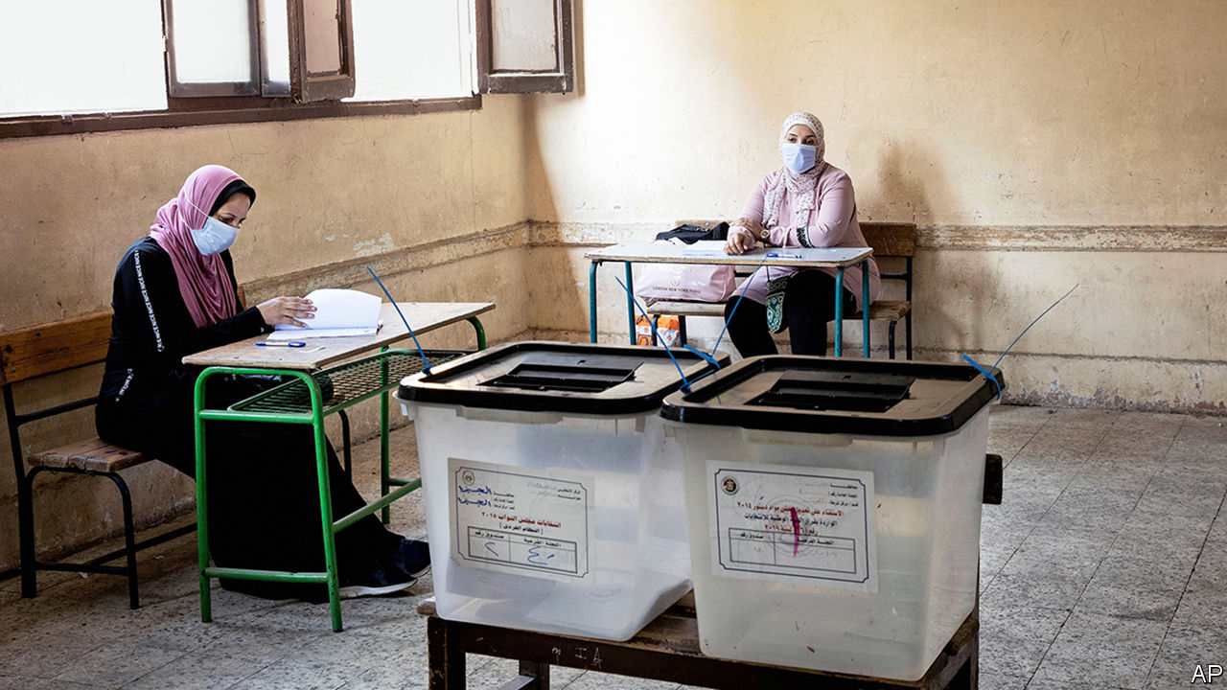

ASSEMBLY-LINE justice is nothing new to Egypt. Since 2013, when Abdel-Fattah al-Sisi led a coup against an elected government, judges have presided over trials with enough defendants to fill a jumbo jet. At a hearing in 2014 more than 500 people were sentenced to death for killing one policeman. But that exercise is Lilliputian compared with the latest labour of Egypt’s judiciary. On August 26th the state referred 54m people for prosecution over a single case.

The defence might rise here to object: surely that number is in error. But Egypt has indeed opened a case against more than half its population, and fully 86% of the electorate. Their crime—one rarely punished—was failing to vote last month in elections for the upper house of parliament. (Compulsory-voting laws are not unique to Egypt: Australia, Belgium and others have them too.)

A lawyer for the defence would surely focus on mitigating factors. Sweltering August is not a pleasant time to be queuing outdoors, especially for the elderly or infirm. Nor should people be gathering amid a pandemic. Though far from their June peak, covid-19 cases are rising; officials warn of a second wave.

Most defendants would just plead apathy. The upper house, formerly called the Shura Council, was abolished after the coup but reinstated in a referendum last year. Rebranded as the Senate, it has no legislative powers. A third of its 300 members are directly elected. Another third are elected via party lists, of which there was exactly one on offer: a pro-government bloc. Mr Sisi appoints the last third. Little about this stirred the souls of Egyptian voters.

Arab autocrats have a touching attachment to the trappings of democracy. Some use elections as shows of power. Saddam Hussein was re-elected with an impressive 100% turnout and not a single No vote in an up-or-down referendum in 2002. Others use elections as safety valves. Hosni Mubarak, who ruled Egypt for 30 years, kept a firm grip on parliament but allowed a measure of competition and opposition.

Elections serve neither purpose for Mr Sisi. The lower house has deteriorated into a rubber stamp and the Senate will be more feckless still. Paltry turnout undermines his claims of popular support. Over half of Egyptians voted in the parliamentary election of 2011-12, a genuinely democratic exercise. In 2015 turnout fell to 28%. Mr Sisi’s own election in 2014 was scheduled as a two-day affair. When turnout looked low, officials abruptly added a third day so they could drag more bodies to the polls.

Mr Sisi may hope that the threat of punishment spurs Egyptians to vote in November, when the lower house is up for grabs. Many citizens cannot afford to pay the fine of up to 500 pounds ($32). (Prosecuting 54m people could net the state 27bn pounds, 1% of its annual budget.) But threats only work if they are credible. Egypt’s judiciary lacks the resources for such an undertaking. A better way to increase turnout would be to hold elections that matter.

This article was downloaded by calibre from <https://www.economist.com/middle-east-and-africa/2020/09/05/egypt-looks-to-prosecute-millions-of-non-voters>

|  |  |  |  |
| --- | --- | --- | --- |
| Previous | Articles | Sections | Next |

|  |  |  |
| --- | --- | --- |
| Middle East & Africa | Sections | Britain |

Europe

France: The man with le Plan

.

Belarus and Russia: A distorted picture

.

Germany’s envoy to Poland: Not much of a welcome

.

Animal rights in the Netherlands: Not fur sale

.

Charlemagne: Politicians or technocrats?

.

|  |  |  |
| --- | --- | --- |
| Middle East & Africa | Sections | Britain |

|  |  |  |  |
| --- | --- | --- | --- |
|  | Articles | Sections | Next |

#### The man with le Plan

# Emmanuel Macron revives a post-war institution for a post-covid era

And announces a huge new stimulus as well

Sep 5th 2020 | PARIS

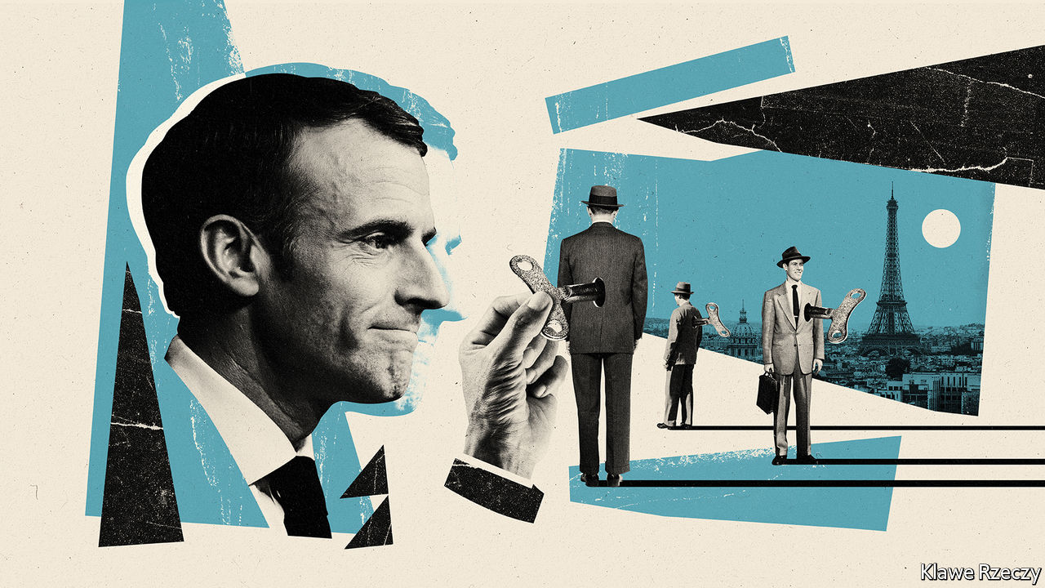

Editor’s note: Some of our covid-19 coverage is free for readers of The Economist Today, our daily [newsletter](https://my.economist.com/user#newsletter). For more stories and our pandemic tracker, see our [hub](https://www.economist.com/news/2020/03/11/the-economists-coverage-of-the-coronavirus)

IN 1946, AS France emerged from the horrors of war, Charles de Gaulle devised le Plan to rebuild his battered country. Centred on the theme “Modernisation or Decadence”, the first five-year plan identified six industries—coal, electricity, steel, transport, mechanised agriculture and cement—on which France would construct a modern economy. “Modernisation”, declared Jean Monnet, the first commissioner of the Plan (and later co-architect of European integration), is a “state of mind”. Indeed in the French mind, the Plan was in large part to thank for the 30 years of prosperity—les trente glorieuses—that followed.

The office of the Plan was not formally abolished until 2006, but France has not drawn up a five-year plan for nearly 30 years. A successor body, known as France Stratégie, scarcely mentioned the word Plan at all. From the mid-1980s, the forces of liberalisation and globalisation increasingly turned the former institution and its focus on planning into a quaint historical relic. Until now.

On September 3rd, as The Economist went to press, the French government was set to announce the resurrection of the mighty Plan. The first commissioner of the revived bureaucratic body will be François Bayrou. A veteran centrist, he is the leader of MoDem, a party that is crucial to President Emmanuel Macron’s governing majority in parliament. Mr Bayrou will not join the government, but will report to it.

State planning and the desire for autonomy in strategic industries have a long history in France, reaching back to Jean-Baptiste Colbert, Louis XIV’s finance minister. In more recent times, as liberal orthodoxy prevailed globally, it became the preserve of diehard French dirigistes, often to the disapproval of their German friends. The covid-19 pandemic, however, is now shifting the debate well beyond France. Shortages of masks have called into question the wisdom of relying on global supply chains. Overwhelmed hospitals have strengthened the case for investment in public health. Home-working and a fear of crowds have reset the discussion about the geography and greening of the city, just as border closures have thrown the travel, tourism and aerospace industries into disarray.

The point of resurrecting the Plan, says Mr Macron, is “to rediscover the sense of the long-term” and make sure that government is not only about crisis management. To the relief of many, five-year plans will not make a comeback. But Mr Bayrou will set out how France should prepare for 2030: how to move towards a lower-carbon economy, invest in the right skills for tomorrow’s world of work and strengthen local industries across the country.

“The French Plan was never a Soviet-style plan,” says Jean Pisani-Ferry, an economist and former head of France Stratégie, who cautions against caricature. In its early guise, the Plan was indeed about public investment in roads, railways, electricity and telecoms. But it also relied heavily on private-sector firms as well as on public planning. The uncertainties of the post-covid-19 world, argue the new Plan’s defenders, require new thinking. “Planning hasn’t become part of the new orthodoxy,” says Mr Pisani-Ferry; “but it’s no longer taboo.” Mr Bayrou’s role will be one of reflection rather than execution. Bruno Le Maire, the finance minister, remains firmly in charge of public spending.

Which is why it was no coincidence that Jean Castex, the new prime minister, was due to launch the Plan on the same day that he unveiled his €100bn ($119bn) stimulus package. This will be spent over two years, with two-fifths of the sum coming from the new European Union recovery fund. Part of the idea is short-term: to keep businesses afloat and people in jobs during a deep recession. The French economy shrank by a massive 13.8% in the second quarter—less than in Spain but more than in Germany—and is forecast to contract by 11% during 2020. The government has already said, for example, that it will extend for two years its generous furlough schemes, which have covered up to 12m people, albeit with a decreased state contribution. It has promised tax cuts for business. And Mr Castex has made an “absolute commitment” not to raise any taxes.

Yet the idea is also to turn the crisis into an opportunity to increase and redirect public investment. On the one hand, there will be plenty of green measures (insulation of buildings, investment in hydrogen and research), as well as the expansion of high-speed broadband and local infrastructure. On the other, there will be a boost for skills, apprenticeships and training, particularly for the young. Unlike Germany, France will focus less on demand-led stimulus than on supporting businesses and investment. Thanks in part to government help, French consumers built up savings during lockdown and incomes were broadly preserved. The hope is that, if confidence returns, they will now start to spend them.

Does all this add up to a U-turn for Mr Macron, a liberal centrist elected on a promise to disrupt France? The word planning was unuttered during his election campaign. Now, he has put reforms to benefits and pensions on hold and a bureaucrat, Mr Castex, in charge of the government. Mr Macron says he is using the moment to “accelerate” his transformation of France, not abandon it. The reforms, he insists, will eventually resume. It may be that the old-fashioned feel of the Plan is deliberate: not because it heralds a return to five-year plans, but because it aims to tell the French that, despite the pandemic, the government is still in control. “My philosophy,” says Mr Macron, with a nod to Monnet, is “the transformation, the modernisation of the country; it cannot stop.” ■

This article was downloaded by calibre from <https://www.economist.com/europe/2020/09/05/emmanuel-macron-revives-a-post-war-institution-for-a-post-covid-era>

|  |  |  |  |
| --- | --- | --- | --- |
|  | Articles | Sections | Next |

|  |  |  |  |
| --- | --- | --- | --- |
| Previous | Articles | Sections | Next |

#### A distorted Muscovite picture

# The information war over Belarus hots up

Russia rules the airwaves but not social media

Sep 5th 2020 | MINSK

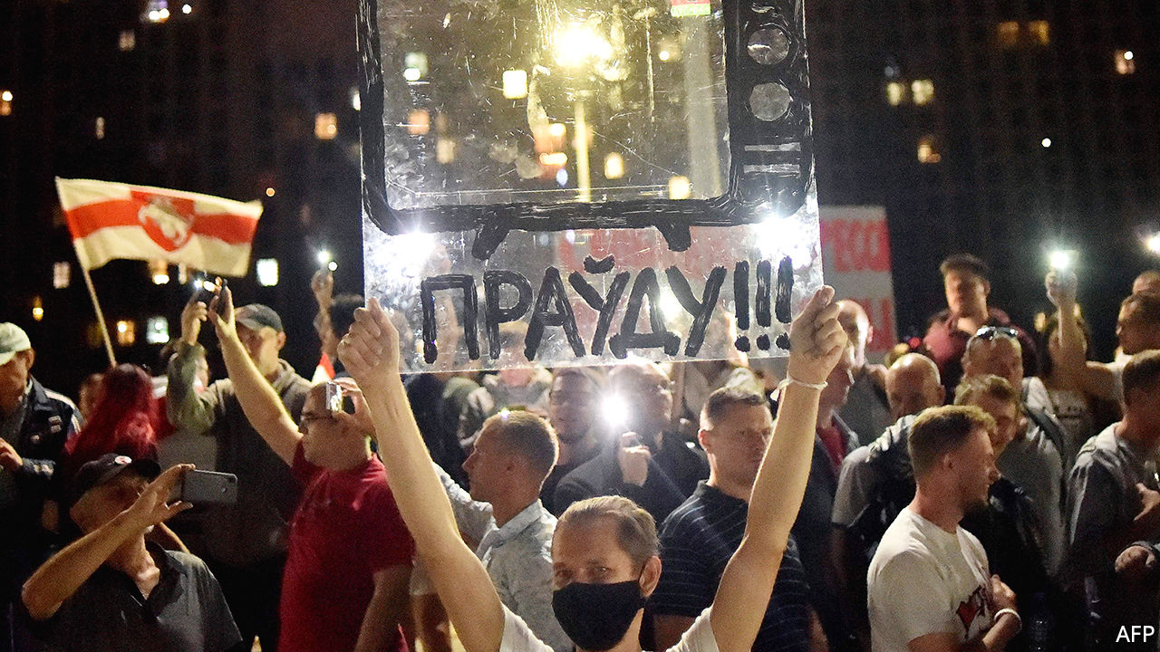

IT WAS THE cables that gave them away. As foreign and local journalists in Belarus scrambled to report on the latest crackdown on peaceful protesters, one film crew was always in prime position. Its members were untouched whenever police hounded other journalists, stripping them of their accreditation and deporting them. The camera cables that stretched past several unmarked police minibuses led to the source of their protection: a white and green van belonging to Russia Today.

Russia’s “green men”, unbadged soldiers sent to Ukraine after its revolution in 2014, are yet to make an appearance in Belarus. But the Kremlin’s propaganda warriors have already occupied its airwaves. Their invasion was solicited by Alexander Lukashenko, Belarus’s embattled dictator, who has lost any claims to legitimacy first by rigging the recent presidential election, then by unleashing terror against the large numbers of his people who protested.

Shocked by the violence of the security services, workers in state-owned factories, who were once Mr Lukashenko’s most solid backers, went on strike. Journalists for state television, normally obedient servants of the regime, walked out of their studios in protest. Desperate to look more in control, Mr Lukashenko appealed to Russia’s president, Vladimir Putin, for help.

Mr Putin cannot afford to let Mr Lukashenko be overthrown by popular protests. He does not want to set a dangerous precedent. The attempt to kill Russia’s main opposition leader, Alexei Navalny, shows just how nervous the Kremlin is feeling. But Mr Putin has little desire to incur new Western sanctions by sending soldiers to save Mr Lukashenko. (Sanctions may be forthcoming anyway, following Germany’s confirmation on September 2nd that Mr Navalny was poisoned with a nerve agent similar to ones used in other Russian-sponsored assassinations, to which only state operatives could have access.) Helping Belarus improve its propaganda is more deniable and less provocative than sending troops.

The change in programming wrought by Russia is glaring. Before the information takeover, Belarusian state TV offered a largely ineffective diet of Soviet and second world war mythology—more Belarus Yesterday than Russia Today. The newly arrived propagandists from Moscow have wheeled out an arsenal of aggression and divisiveness. Breathless news reports have started to warn of the havoc caused by protests in France and Syria. Coverage also seeks to discredit and sneer at the local protests as creations of the West. Selective editing depicts them as feebly supported yet violent—and doomed to failure. A new legion of experts warns of the dangers of a split in Belarusian society.

Mr Lukashenko, who has spent the past two years rallying Belarusians around the flag and feeding his army and security services a yarn about Russia’s threat to the country’s sovereignty, has abruptly changed his tune. He talks these days about one fatherland stretching from Brest, a city in Belarus’s west, to Vladivostok in Russia’s far east. “We now have no other choice but to fasten our boat to the eastern shore,” one senior and somewhat disoriented government official says, landlocked Belarus being conspicuously lacking in shores.

But sprucing up state television’s news reports in this way may not have the intended effect. The change is so sudden and so obvious that it risks further alienating citizens who have experienced a national awakening in the past few weeks. The rush of Russian-made propaganda might persuade some wavering Belarusians against taking to the streets, but it seems unlikely to change the minds of the hundreds of thousands who are already there.

The Belarusians who brave police violence do not watch state television, but rely instead on social media and messenger groups, such as Nekhta (Someone), a Telegram channel run by young Belarusians from neighbouring Poland. It has quickly clocked up over a billion page views. Being told by Russia that they are mere extras in a Western plot will make the protesters all the more determined to prove themselves leading actors in an historic drama. ■

This article was downloaded by calibre from <https://www.economist.com/europe/2020/09/05/the-information-war-over-belarus-hots-up>

|  |  |  |  |
| --- | --- | --- | --- |
| Previous | Articles | Sections | Next |

|  |  |  |  |
| --- | --- | --- | --- |
| Previous | Articles | Sections | Next |

#### Not much of a welcome

# A low point in German-Polish relations

The new German ambassador’s father loomed large over his appointment

Sep 5th 2020 | BERLIN

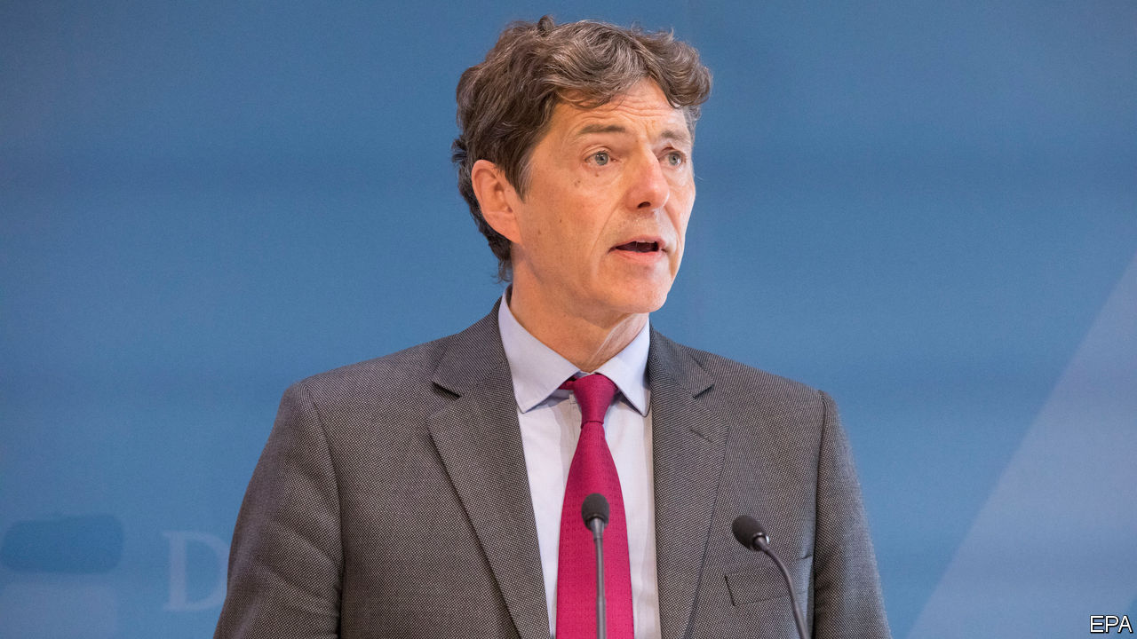

EVEN JACEK CZAPUTOWICZ, the outgoing Polish foreign minister, called the delay “strange” in an interview on August 31st with Rzeczpospolita, a Polish daily. For three months Arndt Freytag von Loringhoven was waiting in his apartment in Berlin for his agrément (official diplomatic approval) as German envoy to Warsaw, usually a swift formality. The order to procrastinate came reportedly from high up: Jaroslaw Kaczynski, chairman of the ruling Law and Justice (PiS) party, and Poland’s de facto leader, opposed Mr Freytag von Loringhoven’s appointment because his father served as a military officer in Hitler’s bunker during the last months of the second world war. (Bernd Freytag von Loringhoven was never charged with any war crime.)

It is not the first time Mr Kaczynski has sought a confrontation with Poland’s neighbour and biggest trading partner. He has accused Germany of scheming to recover land it lost to Poland after the war and Angela Merkel, the German chancellor, of being a pawn of the Stasi, the former East German secret police. Radek Sikorski, a former Polish foreign minister whose tenure was marked by improved relations with Germany, says Mr Kaczynski’s party called him a “junior German foreign minister” after he said in a speech in 2011 in Berlin that German inaction was scarier than Germans in action. (The speech was an appeal to save the euro.) The PiS, which was then in opposition, also tried to get Mr Sikorski sacked from his job.

In the past few months Andrzej Duda, Poland’s recently re-elected president, joined in, with tantrums fanning anti-German feeling that play well with older voters in the less prosperous eastern provinces of Poland, a pivotal PiS constituency. Mr Duda railed against German interference in the presidential election campaign in favour of his opponent, in particular by Fakt, a tabloid owned by Ringier Axel Springer, a German-Swiss publisher. He singled out Philipp Fritz, a correspondent for Die Welt, a German daily, who had suggested that Rafal Trzaskowski, Mr Duda’s rival, would bring calm to German-Polish relations because he was unlikely to make astronomical demands for reparations for the ravages of the war.

The German government did not withdraw the appointment of Mr Freytag von Loringhoven, one of the country’s most experienced diplomats, who had previously served as a well-liked ambassador to the Czech Republic. The standoff started to attract international attention. On the evening before the 81st anniversary of the Nazi invasion of Poland on September 1st the Polish government at last held out an olive branch. Szymon Szynkowski vel Sek, Poland’s deputy foreign minister, announced the agrément of the new envoy, but not without referring to a special Polish sensitivity related to “a great unhealed wound in the minds of the Polish nation” caused by the crimes of the second world war.

Mr Freytag von Loringhoven will not have an easy start in Warsaw. He will deal with Zbigniew Rau, the new foreign minister, an ardent supporter of PiS who has virtually no experience in foreign policy. They will need to work through complex disputes such as Nord Stream 2, a gas pipeline from western Russia to north-eastern Germany backed by the Germans but bitterly opposed by the Poles. He will also try to revive the French-German-Polish “Weimar triangle”, once a constructive forum for political and military discussions. And he will clearly have to set aside a lot of time to be hectored about the horrors that Germany once inflicted on Poland. ■

This article was downloaded by calibre from <https://www.economist.com/europe/2020/09/05/a-low-point-in-german-polish-relations>

|  |  |  |  |
| --- | --- | --- | --- |
| Previous | Articles | Sections | Next |

|  |  |  |  |
| --- | --- | --- | --- |
| Previous | Articles | Sections | Next |

#### Not fur sale

# Covid-19 ends Dutch mink farming

An unexpected win for animal-rights activists

Sep 5th 2020 | AMSTERDAM



ANIMAL-RIGHTS activists often complain that cute beasts get more sympathy than equally deserving ugly ones. If so, one would think a cuddly critter like the mink would be easy to protect. Yet in the Netherlands, mink are the only animal that can still legally be farmed for their fur. That is about to change. On August 28th the government brought forward to March a ban on mink-farming that had been scheduled to take effect in 2024. The timetable was sped up not because mink had become more adorable, but because they can contract covid-19 and spread it to humans.

Dutch farmers normally raise about 2.5m mink a year, making the Netherlands the world’s fourth-largest producer after Denmark, China and Poland. In April a clutch of mink and the farm hands who tended them were diagnosed with covid-19. Genetic tracing showed that at least two workers had probably been infected by mink, rather than the other way around. The contaminated animals were destroyed and stricter hygiene rules imposed, but by summer the virus had spread to a third of the country’s farms. In June parliament voted to shut down the industry as soon as possible, and the cabinet agreed.

That was a win for the Netherlands’ Party for the Animals, which has four seats in the 150-member parliament. In 2013 it helped pass the law that gave mink farmers until 2024 to get out of the business. Now the party and its allies object to the lavish compensation the government has offered for bringing forward the deadline: €150m ($178m), or €1m-€1.5m per farmer. Some MPs allege that the compensation paid for destroying the infected minks was higher than the market price for their fur.

Fur farmers say modern standards allow mink to be raised humanely, and that they are not a big reason for the spread of the virus. But mink are solitary predators; animal-rights advocates say they cannot be raised humanely in stacked cages. As for covid-19, the worry is that mink could serve as a reservoir for it to evade human immunisation programmes. The industry’s turnover is modest (farmers put it at €150m-200m, activists at under €100m), and polls show the public overwhelmingly opposes it. “In a democratic country, that widespread conviction has to translate into a political decision to ban fur farming,” says Esther Ouwehand, leader of the Party for the Animals. The farmers accept they are shutting down. The remaining argument is over money.

Editor’s note: Some of our covid-19 coverage is free for readers of The Economist Today, our daily [newsletter](https://my.economist.com/user#newsletter). For more stories and our pandemic tracker, see our [hub](https://www.economist.com/news/2020/03/11/the-economists-coverage-of-the-coronavirus)

This article was downloaded by calibre from <https://www.economist.com/europe/2020/09/05/covid-19-ends-dutch-mink-farming>

|  |  |  |  |
| --- | --- | --- | --- |
| Previous | Articles | Sections | Next |

|  |  |  |  |
| --- | --- | --- | --- |
| Previous | Articles | Sections | Next |

#### Charlemagne

# The contradiction at the heart of the European Commission

Are the people in charge of the EU’s bureaucracy politicians or technocrats?

Sep 5th 2020 |

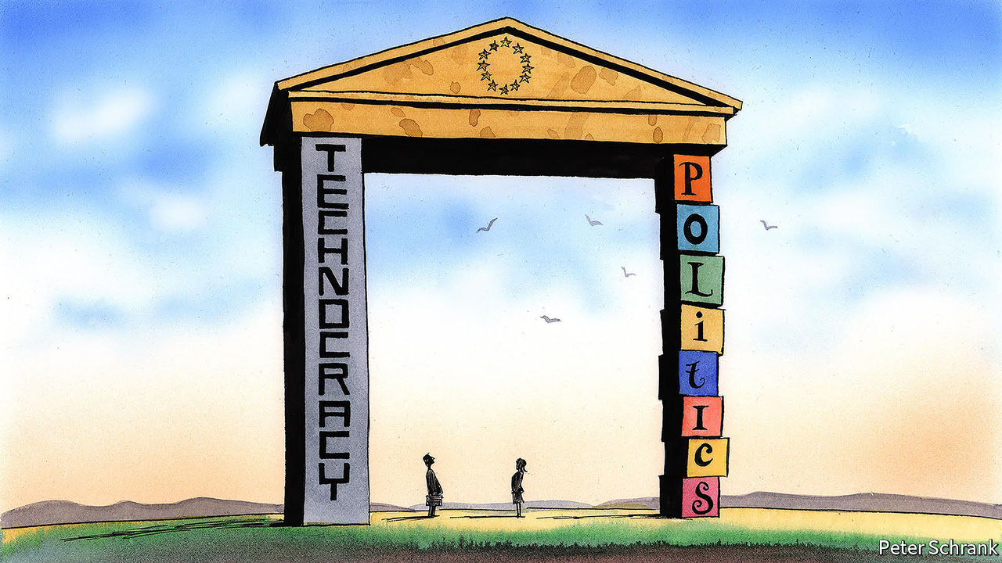

THE ECONOMIST is fond of handy descriptions. Sometimes, we admit, they can be a bit obvious (“Xi Jinping, the president of China”; “Goldman Sachs, a bank”). Occasionally, they aim to amuse (“Homer Simpson, an American philosopher”, or “Popeye, a sailor man”). But coming up with one for the European Commission is distinctly tricky.

After all, the commission does a bit of everything. It is the closest thing the EU has to a government, putting forward legislation (which then has to be approved by the European Parliament and national ministers). It has the trappings of one, too: Ursula von der Leyen, its president, will give a state-of-the-union address in front of the Parliament later this month. At times the commission is a referee, ensuring both business and governments follow EU rules. Sometimes it is a broker, forging compromise between sparring member states. From the perspective of some national capitals, it is a civil service, following the agenda of the European Council, the club of EU leaders which settles the political direction of the bloc. Bureaucrats in Brussels should be little more than dry technocrats, in this view. Different descriptions lead to different expectations—and different types of annoyance when they are not met. Boiled down, it is an issue of politics versus technocracy.

These tensions came to a head in the case of Phil Hogan, Ireland’s commissioner and the EU’s trade chief, who resigned last month. During a trip home, Mr Hogan attended a lockdown-busting dinner with lots of golf-loving Irish bigwigs. For a political body, such as Ireland’s government, the response was obvious: voters were baying for blood and had to be sated. An Irish minister who attended the banquet resigned, while guilty senators lost the whip. For a technocracy, it was more complicated. Brussels is supposed to be above national politics: Irish voters may have been upset about the actions of “Big Phil”, but most Europeans could not pick the six-foot-five-inch politician out of a line-up. Commissioners such as Mr Hogan can be sacked only by Mrs von der Leyen. If she had heeded Irish calls, the commission’s independence would have been damaged; if she had ignored them, she would have looked contemptuous of voters. Luckily, Mr Hogan jumped, sparing Mrs von der Leyen a difficult choice.

Such problems are common in a body that cannot decide whether it is a political entity or a technocratic one. It often ends up doing an awkward impression of both. What began as an independent monitor overseeing the dreary business of coal and steel production now helps to determine its members’ budgets. The politicisation of the commission became more explicit under Jean-Claude Juncker, its previous head. This mindset still prevails internally. Decisions such as whether to punish a country for overspending are inherently political, runs the argument. Pretending that they can be dealt with by neutral technocrats is absurd. “There has to be political ownership,” says one official. “It can’t be about numbers into a calculator.” At the same time, there are some areas, such as competition policy, that are for the most part left untouched by politics—a status that must be taken on trust by voters and national governments.

Not all are happy with this compromise. During the long negotiations over a €750bn ($890bn) recovery fund for the EU this summer, one of the main sticking-points was a lack of trust in the commission. Allowing countries such as France, Portugal and Spain leeway in their budgets may have been popular in Europe’s south, but it upset Dutch politicians, for whom the calculator approach is just fine. Politicisation throws up conflicts of interest, critics argue. The commission is the first responder if a member state shows signs of drifting from democratic norms. Yet Viktor Orban, Hungary’s prime minister, who has enthusiastically dismantled checks and balances, has been sheltered in part by belonging to the European People’s Party (EPP), the same European political alliance as Mrs von der Leyen and her two predecessors.

Though the principle of the commission’s independence is constantly proclaimed, party politics is never far from the surface. Mrs von der Leyen owes her job to her membership of the EPP. Jobs in the commission are carefully divided along partisan and national lines. But if this is acknowledged, complaints follow. In July a two-second appearance by Mrs von der Leyen in a political video for Croatia’s centre-right governing party—part of the EPP—triggered a row in Brussels. When the commission is involved, European politics resembles a scene in “Doctor Strangelove”: “Gentlemen, you can’t fight in here! This is the War Room!” Nationality still matters, too. Commissioners are supposed to leave their passports at the door, but the subtle scrap among member states for Mr Hogan’s powerful job (and Irish despair at having potentially lost it) suggests otherwise.

## On a commission

Those who dream of a return to technocracy are out of luck. If politics follows money, then the commission will become more political. It will oversee the issuance of €750bn in collective debt and monitor how the proceeds are spent. That will leave the EU itself with a bigger stack of debt than any of its member states bar Italy, France and Germany. But politics without democracy is not ideal. The experiment of allowing the European Parliament to pick the commission’s president, in effect, was aborted last year after EU leaders balked at Manfred Weber, the German MEP the system put forward. Instead, Mrs von der Leyen got the job after much haggling, as was customary when the commission was a more technocratic institution. When appointing the head of a civil service, the lack of a democratic mandate does not matter; when selecting the head of a de facto government, it does. Working out which role to embrace is essential if the commission wants to avoid impossible expectations. Until then, it will have to live with an unflattering description: a contradiction. ■

This article was downloaded by calibre from <https://www.economist.com/europe/2020/09/05/the-contradiction-at-the-heart-of-the-european-commission>

|  |  |  |  |
| --- | --- | --- | --- |
| Previous | Articles | Sections | Next |

|  |  |  |
| --- | --- | --- |
| Europe | Sections | International |

Britain

Boris Johnson: Could do better

.

Dog-walking: Parading the pooch

.

Brexit negotiations: Deal or no deal?

.

Covid-19 in England: A summer break

.

The housing market: Flatlining

.

5G: Moobile networks

.

Rave revival: Third summer of love

.

Bagehot: The Lib Dems might just fly again

.

|  |  |  |
| --- | --- | --- |
| Europe | Sections | International |

|  |  |  |  |
| --- | --- | --- | --- |
|  | Articles | Sections | Next |

#### Boris Johnson

# Competence matters, and Johnson hasn’t got it

Support for the government remains strong, but it has gained a dangerous reputation for incompetence

Sep 5th 2020 | BARNARD CASTLE

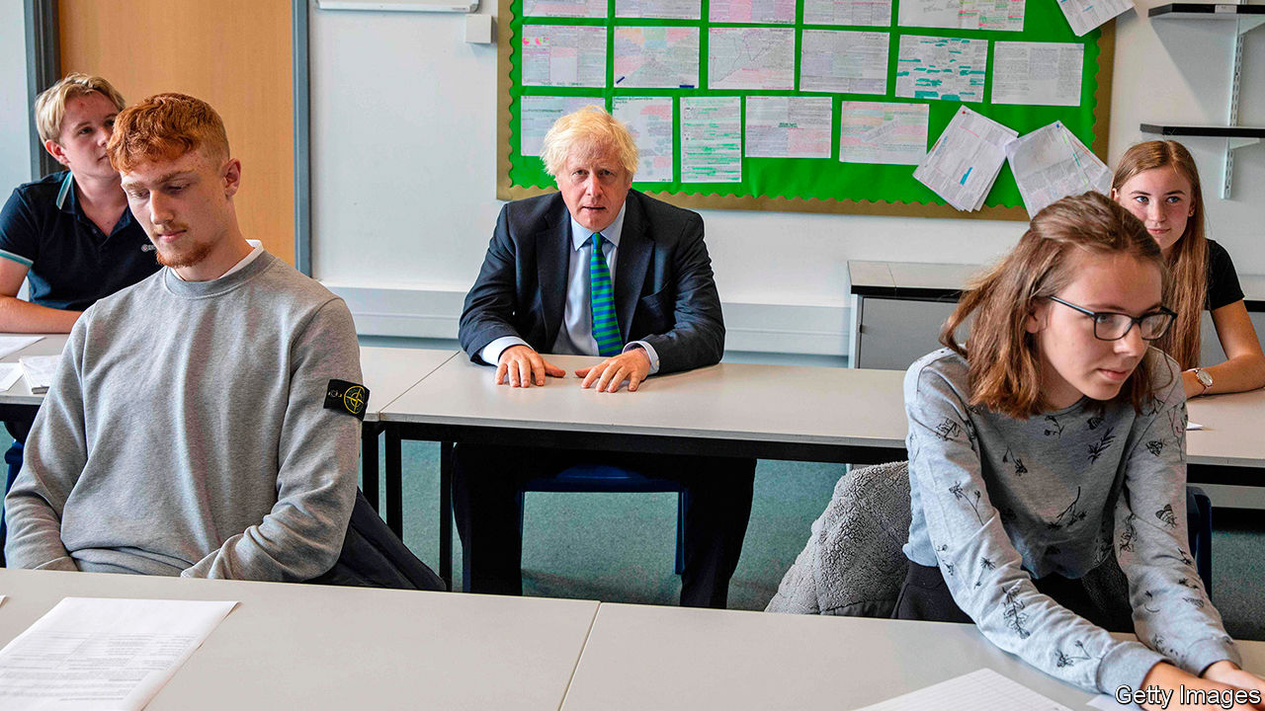

“I THOUGHT BORIS had a bit more authority about him,” says Rob Westley, a teacher. Mr Westley voted Conservative for the first time in the election last December but now he’s unsure who he would go for. The prime minister, he reckons, was too slow to respond to the coronavirus pandemic, and the exam-results mess created misery for his students. “He fluffed it,” he says. Leanne Rooney, a waitress, also voted Conservative for the first time last year, and is also having second thoughts. “I did like Boris’s ideas, but now I question his leadership,” she says. “He has been so flippant, and you can’t have that in a pandemic.”

Barnard Castle, in northern England, does not yet feature much in the great histories of the Conservative Party, but it will be prominent in the chronicles of the Johnson administration. It contributed to Mr Johnson’s greatest victory last December, as the constituency of Bishop Auckland elected 26-year-old Dehenna Davison as its first Conservative MP in a wave that unseated Labour from former mining and mill towns. It was also the scene of an infamous blunder, when his chief aide Dominic Cummings made a day trip to the town with his family during the long coronavirus lockdown.

Poor management of the pandemic followed by series of U-turns has damaged the government. It had insisted the algorithmically-set exam results were robust and dependable, but scrapped them after an outcry. It has changed its mind on whether face masks should be worn in shops and schools, months after they became commonplace elsewhere. The government has switched policy on providing free children’s meals during the school holidays, whether foreign NHS employees should pay a health-care levy, and when a moratorium on evictions should be lifted. The test-and-trace system to control the virus took months to work. “We’ve had more unforced errors this summer than I’ve seen in 30 years,” says an exasperated Tory.

Conservative MPs, who returned from their summer breaks on September 1st, blame an over-centralised Downing Street, an over-reliance on focus groups and a weak cabinet which lacks the confidence or foresight to predict problems. “We’ve got to stop talking about ‘world beating’,” says Charles Walker, a Tory MP, who likens Mr Johnson to a star football striker let down by a poor team. “What we need is ‘effective’—just workmanlike success.”

The Tory unease was fuelled by a poll on August 29th which found the Conservatives and Labour on 40% each, the first time the Conservatives had not been in front since July 2019. That was a fall from a peak of 55% in April. Yet this figure reflected a “rally round the flag” effect often found in democracies at times of crisis, which invariably subsides.

A better benchmark is the Tory result of 44% secured in the election in 2019. Excluding those like Mr Westley who are undecided, polls conducted in August found the Tories averaging 42% to Labour’s 37%. “The Tories have been in power for a decade, and for the opposition to still be behind at that point is extraordinary,” says Ben Page, chief executive of Ipsos MORI, a pollster. Voters—including Labour supporters—approve of the package of interventions to support workers and businesses designed by the chancellor of the exchequer, Rishi Sunak. A programme of weekday subsidies for restaurants “was a fantastic idea”, says Ms Rooney.

Tory MPs think their vote is holding up largely because Mr Johnson is aligned with the values of his base, much as “Teflon” Tony Blair could brush off scandal as long New Labour was attuned to the public mood. Folk in Barnard Castle credit Mr Johnson with pushing on with Brexit. When in trouble, he has tickled the country’s cultural divisions, claiming that Winston Churchill’s statue and the patriotic songs sung at the Proms are under threat from censorious forces.

But competence matters, and acts as a leading indicator of support. In “The Politics of Competence”, a 2017 study, Jane Green and Will Jennings show that new governments invariably enjoy a honeymoon, before errors accumulate, dragging a party’s polling lower like a yacht taking on water. Once gained, a reputation for incompetence is hard to shift.

Reversals are particularly harmful to Mr Johnson, who cast himself as the barnstorming antidote to Theresa May’s caution and paralysis. Johnsonism promised to “Get Brexit Done”—and other things, too, through large cheques, vim and can-do spirit. The attention to detail and patience that good governance demands are not part of the narrative.

All this works well for Sir Keir Starmer, Labour’s leader. Unlike his ideologically driven predecessor, Jeremy Corbyn, Sir Keir wants every government policy to be a test of competence. It suits his lawyerly, professional image and distracts from the splits in Labour’s electorate: to ask whether the Dover customs checks will be ready is to sidestep whether leaving the European Union is a good idea at all.

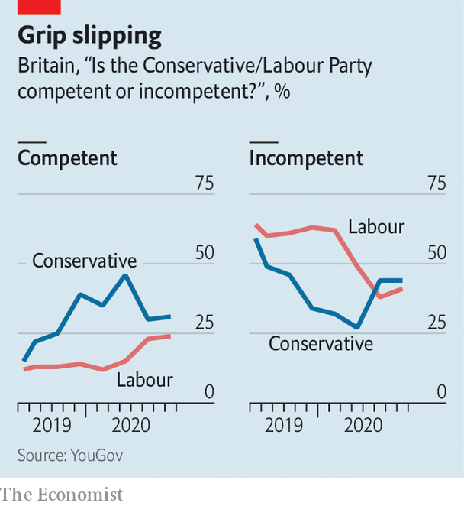

The strategy is paying off (see chart). Some polls show Sir Keir ahead of Mr Johnson as “best prime minister”. Mr Johnson stirs much more animosity in Labour voters than mild-mannered Sir Keir provokes in Tories. (“He has his head screwed on,” says Andrew Alderson, a Tory-voting retired firefighter in Barnard Castle, of Sir Keir). Overall, voters disapprove of the government’s handling of the pandemic and do not trust its ability to get a grip in the future. Most voters, including more than quarter of Tories, say Britain is “going in the wrong direction”.

Although the virus is now being effectively suppressed and GDP will bounce back strongly after the shutdown, winter will be hard. Mr Sunak is determined to end the furlough scheme next month. That will drive unemployment sharply upwards and may erode the goodwill his largesse to date has garnered. Mr Johnson is determined to help the economy recover by getting people back into their offices, but in other European countries increased mobility has pushed infection rates up. Whether or not Mr Johnson secures a Brexit trade agreement, leaving the EU’s single market and customs union on New Year’s Day will disrupt trade. His party is quarrelsome: he faces a rebellion over plans to build more houses in wealthy constituencies, and the prospect of tax rises to repair the public finances have alarmed his MPs. Mr Johnson’s marks in his first year have been poor, and he has more tough tests to sit.■

This article was downloaded by calibre from <https://www.economist.com/britain/2020/09/05/competence-matters-and-johnson-hasnt-got-it>

|  |  |  |  |
| --- | --- | --- | --- |
|  | Articles | Sections | Next |

|  |  |  |  |
| --- | --- | --- | --- |
| Previous | Articles | Sections | Next |

#### Dog-walking

# Why Britons walk their dogs so much

Parading the pooch

Sep 3rd 2020 |

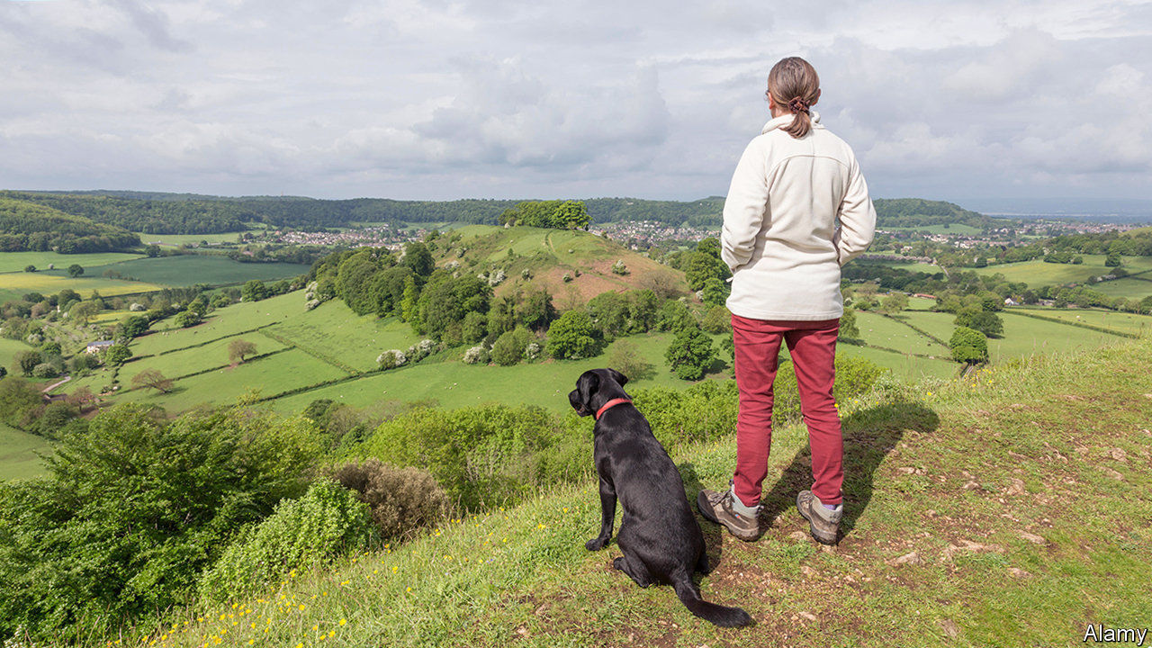

“WHEN I THINK of England, I think of the queen taking her dogs for a walk in the countryside,” says Carsten Haferkamp, a dog-owning German architect working in London. There may be something in the stereotype. Data from Tractive, a firm that provides GPS tracking for pets, show that Britons walk their dogs more than their European neighbours do.

British dogs get 177 minutes of activity a day, compared with 160 minutes for slack German pooches and 170 minutes for the average French mutt. That could be why they are slimmer than their European cousins: the average British labrador weighs in at 28kg, compared with 29kg and 31kg for its German and French counterparts. And it’s not just Europeans that British dog-owners outpace. Research by Carri Westgarth of Liverpool University has established that they are beating the footpaths more than Americans or Australians as well.

That continental European pooches are on the porky side has not gone unnoticed on the mainland. “Obesity among dogs is acknowledged as a problem,” says Fleur-Marie Missant of France’s Société Centrale Canine. James Serpell, professor of animal ethics and welfare at the University of Pennsylvania, suspects that excessive pampering, as well as under-walking, may contribute to the problem. “The French are super-indulgent with their dogs. They tolerate them in restaurants. I’ve been nudged by strange dogs under the table in France.” The German government is determined to get the country’s dogs—and dog-owners—off their sofas. Last month the agriculture minister announced plans to require dog-owners to walk their dogs twice a day.

The British devotion to dog-walking may have more to do with the walking than the dogs. Britons are big walkers—they came fifth in the world in a study in 2017, the highest in Europe. Dogs provide walkers with company and a purpose, so it may be that walking encourages dog-ownership, rather than vice versa.

But Julien Dugnoille, an anthropologist at Exeter University, suspects dog-walking has a deeper significance. Dogs, he suggests, are a useful aid to a socially awkward nation. “British people…tend to see dog-walking as a rare opportunity to socialise with strangers, to have a chat and exchange a few jokes and comments about the weather without putting themselves in danger (ie, without being too committed in their interaction).” The French, a nation of flâneurs, have no need of canine props.

A tradition among the British aristocracy of owning and training dogs also leads Dr Dugnoille to speculate that dog-walking retains some of its ancient kudos. When people in the park say “Max is very well-behaved,” says Dr Dugnoille, “that is a way to demonstrate mastery in the art of taming, an elevation above those dog owners who are ‘not in control of their own dog’, which is the ultimate faux-pas in public spaces.” But it’s not just about showing off, in his view. A Belgian who has lived in both Britain and France, he reckons the British are closer to their dogs than the French. Walking with one’s best friend “creates a time and space where dogs and humans meet as species and connect as individuals”.

Still, the British should not congratulate themselves too much on their behaviour towards their canine companions, for they are guilty of a universal hypocrisy. According to Dr Westgarth, “people say that a dog needs a walk every day, but they will find reasons why their dog doesn’t need a walk. They’ll say: he’s got company indoors, he’s nervous or he doesn’t like the rain.” Paw show. ■

This article was downloaded by calibre from <https://www.economist.com/britain/2020/09/03/why-britons-walk-their-dogs-so-much>

|  |  |  |  |
| --- | --- | --- | --- |
| Previous | Articles | Sections | Next |

|  |  |  |  |
| --- | --- | --- | --- |
| Previous | Articles | Sections | Next |

#### Brexit

# Fears grow of a December Brexit without a trade deal

The French will be the toughest negotiators

Sep 5th 2020 |



ON JUNE 15th Boris Johnson promised to put “a bit of oomph” into trade talks between Britain and the European Union so as to reach an outline agreement in July. Yet September has come with no sign of a deal. Little progress is expected when the talks resume in London next week. Indeed, Michel Barnier, the EU’s chief negotiator, says negotiations are going backwards and a deal by year-end (when the standstill transition period ends) seems unlikely. The end-October deadline, to allow time to draft and ratify a treaty that will run to hundreds of pages, is just eight weeks away.

This does not make no deal inevitable. Brinkmanship on both sides is often for domestic consumption. Progress has been nugatory because the sticking points are political and cannot be resolved within current negotiating mandates. This applies especially to the two hottest issues—fisheries and rules to stop one side using state subsidies to undercut the other. Heads of government have not engaged in the detail; since they want a deal, many analysts expect a last-minute agreement when they do. After all, this happened last year when Mr Johnson signed the withdrawal treaty.

Yet this may be optimistic. Fisheries, which account for less than 0.1% of GDP, might not scupper a deal, but rules to limit state aid go to the heart of the new relationship. Mr Johnson is allergic to EU constraints on his freedom of action, and his government has not set out its plans for state subsidies. For its part, the EU detects an existential threat in opening up to an untrammelled and competitive neighbour. Never mind that Britain has in the past resorted to state aid less than most countries, or that EU rules against it have been suspended during covid-19.

As Sam Lowe of the Centre for European Reform, a think-tank, notes, the economic difference between a barebones trade deal and no deal is not all that large. A deal would avoid tariffs in sensitive sectors like cars, but in either case disruption from customs checks, lorry queues and intrusive non-tariff barriers would be substantial. The biggest difference might be that, under no deal, Mr Johnson’s team could try to blame disruption not on the deal it had done but on the EU’s obstinacy.

Some argue that Mr Johnson’s growing reputation for incompetence makes him more likely to accept any trade agreement he can get. If he cannot secure the “oven-ready” Brexit deal he promised last year, what can he do? Yet a weakened prime minister who is again seen to be giving in to Brussels bullies would also be vulnerable to attacks from his own party hardliners. Many now claim to be unhappy with the withdrawal treaty, especially the customs border it is erecting between Northern Ireland and Great Britain.

The parallel with Mr Johnson’s last-minute deal with Leo Varadkar, the Irish taoiseach, on the withdrawal agreement in October 2019 does not really work. The timetable is tighter this time. Rejigging the Northern Irish piece of the withdrawal treaty was simpler and quicker than writing a new trade agreement. Last year, unlike today, Mr Johnson was prevented by Parliament from going for the alternative of no deal. And as Georgina Wright of the Institute for Government, another think-tank, says, both sides are now better prepared for the consequences.

Moreover, instead of the friendly Irish in 2019 Mr Johnson now faces the implacable French. They have the most to lose from reduced access to British fishing waters, and are also the most exercised about state aid. Bilateral relations have been strained by rows over asylum-seekers crossing the Channel and covid-19 quarantine rules. Emmanuel Macron faces a tight presidential race in early 2022; being seen to help Mr Johnson would hardly boost his cause. This week his foreign minister, Jean-Yves Le Drian, accused Britain of taking an intransigent and unrealistic attitude.

The talks are likely to go to the wire. Mujtaba Rahman of the Eurasia Group, a consultancy, says that officials are resigned to them drifting into November or even later, assuming a way can be found to avert a cliff-edge crash on December 31st. The currency markets seem relaxed. Yet they may underprice the risk of no deal, which would be hard to pull back from. The bigger paradox is the sight of a supposedly radical Tory government driven not by the urge for post-Brexit deregulation but by an atavistic fondness for 1970s-style state support for industry: a model that looks rather more like China than Singapore.■

This article was downloaded by calibre from <https://www.economist.com/britain/2020/09/05/fears-grow-of-a-december-brexit-without-a-trade-deal>

|  |  |  |  |
| --- | --- | --- | --- |
| Previous | Articles | Sections | Next |

|  |  |  |  |
| --- | --- | --- | --- |
| Previous | Articles | Sections | Next |

#### A summer break

# In England, reopening has not been the disaster many feared

But schools and universities returning presents a new challenge

Sep 3rd 2020 |

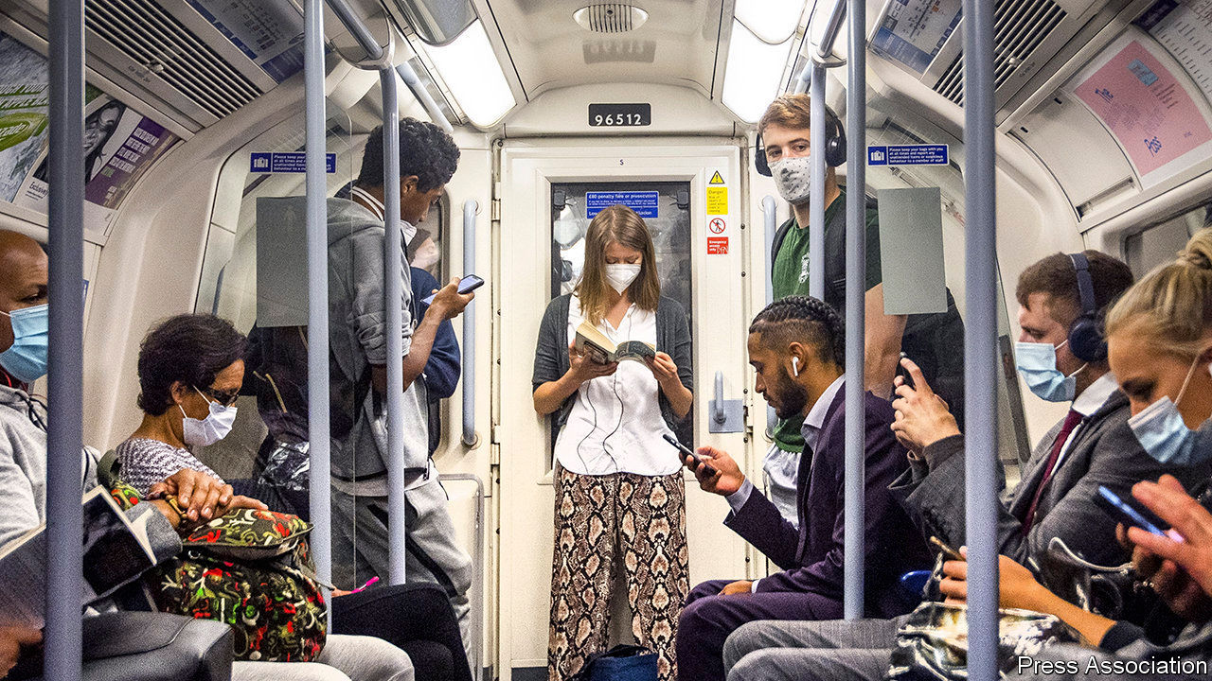

AT THE START of June, when England took a big step out of lockdown, many observers were nervous. Dissenting members of the official Scientific Advisory Group for Emergencies (SAGE) warned the government that allowing people to mingle risked another flare-up. The new test-and-trace system, intended to squash outbreaks, had only just been established. Polling found that the public believed ministers were being insufficiently cautious.

The government’s decision to ease restrictions was a gamble, but one that has paid off. Following a small rise in July, the Office for National Statistics’ infection survey, which tests a sample of people in England and Wales each week, finds that the number of cases has since remained flat. Although there has been a gradual rise in the number of positive test results, much of this is accounted for by the fact that the number of tests has increased, meaning more asymptomatic cases are found and false positives recorded. Hospital admissions remain very low.

England has so far avoided the spikes seen recently in France and Spain, meaning it is now in a similar position to Germany (see chart). A recent study found that 6% of people in England have antibodies, which may offer some protection against the virus. There is huge uncertainty about the level at which herd immunity kicks in, but even London—where the study found 13% of people had antibodies—appears short of the most optimistic estimates.

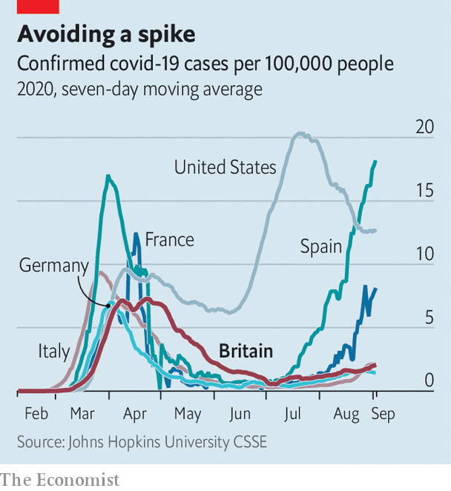

The state has begun to do a better job at preventing covid-19’s spread. The test-and-trace system still has flaws, not least in the time it takes to get results from tests. But there is now a functioning system, which helps suppress the growth of cases, as do local restrictions where necessary. After a weak start, Britain is now a testing heavyweight. Over the last week for which there is data, it carried out 2.5 tests per 1,000 people, compared with 1.7 in Spain and Germany, and 1.8 in France.

Public caution has played a part in keeping cases down, too. According to Google’s mobility statistics, Britons are less likely to have returned to work than those in other big European countries; something the government, concerned by the economic implications, is now trying to change. John Edmunds, an epidemiologist at the London School of Hygiene and Tropical Medicine, and one of the dissenting SAGE members when restrictions were eased, notes that cross-country data imply “the release from lockdown has resulted in larger changes to at-risk behaviour [in Europe] than here.” It is unclear why this is.

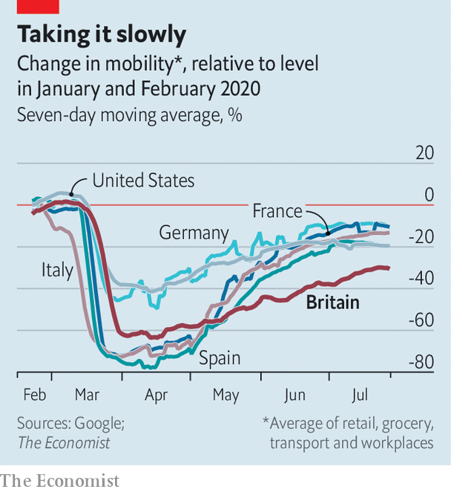

With children returning to school and students to university, and people moving indoors as the weather cools, keeping cases down will soon become trickier. “I think although we’ve got a lot of testing going on, we probably don’t have anywhere near as much as we will need to manage the next month or so,” says Sir John Bell of the University of Oxford. There has been a worrying jump in cases in Scotland, and it will be difficult to avoid importing cases from parts of Europe that are currently seeing spikes, given the volume of summer travel. Removing restrictions went better than expected in England. That does not mean some will not have to be reimposed over the coming months. ■

Editor’s note: Some of our covid-19 coverage is free for readers of The Economist Today, our daily [newsletter](https://my.economist.com/user#newsletter). For more stories and our pandemic tracker, see our [hub](https://www.economist.com/news/2020/03/11/the-economists-coverage-of-the-coronavirus)

This article was downloaded by calibre from <https://www.economist.com/britain/2020/09/03/in-england-reopening-has-not-been-the-disaster-many-feared>

|  |  |  |  |
| --- | --- | --- | --- |
| Previous | Articles | Sections | Next |

|  |  |  |  |
| --- | --- | --- | --- |
| Previous | Articles | Sections | Next |

#### The housing market

# Demand for apartments is flatlining in Britain

People want more space, so houses are in

Sep 3rd 2020 |

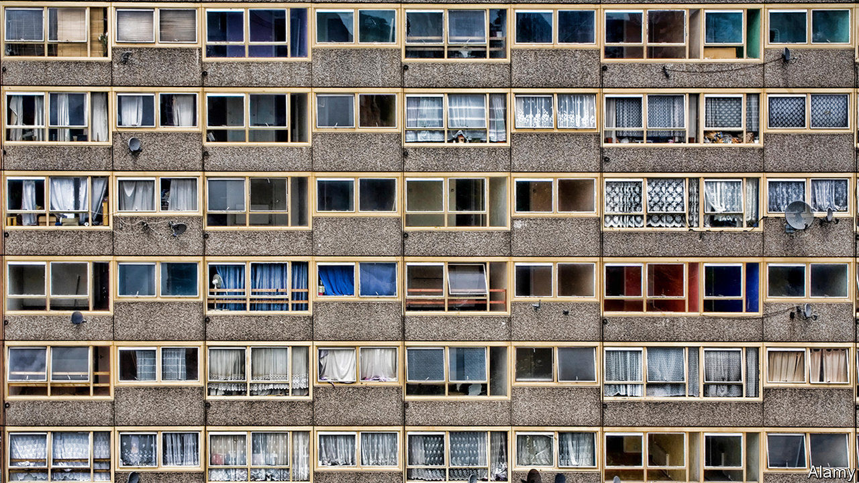

SHUT DOWN between March and May, the housing market has roared back to life. Nationwide, a lender, reckons prices hit a record high in August. Pent-up demand and a temporary cut in stamp duty have helped propel interest, but a bigger factor, according to estate agents, is that people are reassessing their housing needs. Spending weeks trapped indoors gave them a chance to think hard about their living quarters, while the rise in working from home is already having an impact. Richard Donnell, the research director of Zoopla, a property website, thinks that Britain has undergone a “once in a lifetime re-evaluation of housing requirements”.

People want more space. Price rises are positively correlated to size (see chart) and the value of one-bed flats has slipped since the market reopened. According to Zoopla, the time taken between the listing of a home and its receiving an accepted offer has fallen across the board but the larger the property, the bigger the fall. Five-bedroom houses, which in 2019 took an average of 48 days to attract an offer, are now being snapped up in 32 days, faster than one-bedroom flats. Three-bedroom houses, the category most in demand, are going in just 24 days. Renters as well as buyers are becoming less keen on flats. Apartments have fallen out of the top five categories searched for by potential tenants on Rightmove, another property website, in favour of smaller houses. Access to a garden or a nearby park are much more highly prized than a year ago.

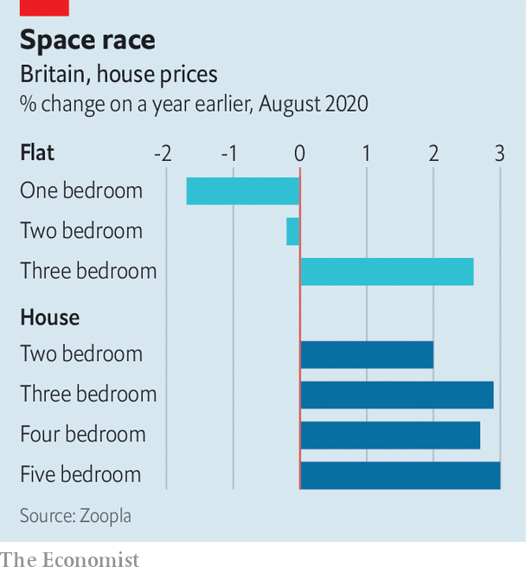

Rightmove is advising estate agents who advertise on its website to emphasise different factors these days. Whereas in the past proximity to a train or tube station was much in demand, that “isn’t going to be such an important selling point for those buyers expecting to work from home more”, according to Miles Shipside of Rightmove. It is now, he explains, “all about showcasing a spare room in the best way”. He advises sellers to buy some cheap office furniture and put it in smaller bedrooms to demonstrate their potential as home offices.

The decline in the appeal of flats is a challenge for London. While flats represent only around a fifth of Britain’s housing stock, they make up just over half of London’s. According to Rightmove, after the lockdown, 54% of property searches by London residents have been for areas outside the capital, compared to 45% a year ago—the biggest fall in interest in any city. But the turn away from flats is a problem elsewhere, too. Flats make up about two-fifths of new properties built over the past decade, and housebuilders worry that the stereotypical block of converted flats in a former warehouse in London’s East End, Manchester’s Northern Quarter or Newcastle’s Quayside will see a permanent fall in value. “If you’re a prosperous two-earner couple in your late 20s you might now decide to skip the two-bed flat that used to be the first rung on the ladder and go straight to the three-bed semi in the suburbs,” says a housing boss.

The foreigners aren’t helping. They mostly buy newly built flats and, except in Hong Kong, where a change in the status of British Overseas National Passport holders is resulting in some interest, international demand for flats in Britain is slack, as investors wait to see where rental yields settle. But the big question is domestic: is homeworking for ever, not just for covid?■

This article was downloaded by calibre from <https://www.economist.com/britain/2020/09/03/demand-for-apartments-is-flatlining-in-britain>

|  |  |  |  |
| --- | --- | --- | --- |
| Previous | Articles | Sections | Next |

|  |  |  |  |
| --- | --- | --- | --- |
| Previous | Articles | Sections | Next |

#### So-so networks

# Britain’s 5G rollout faces myriad obstacles

Geography, policy and economics all play a role

Sep 3rd 2020 |

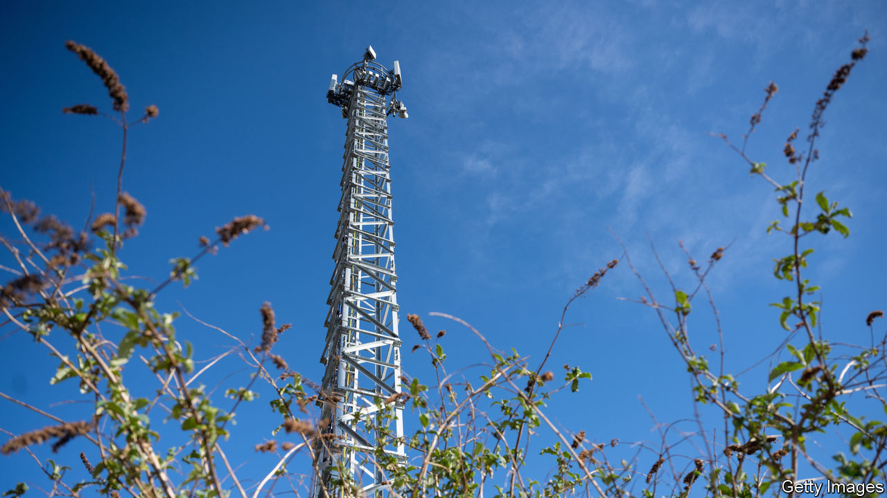

BRITONS HAVE long complained about their mobile networks. A report from the National Infrastructure Commission in 2016 compared Britain’s 4G coverage, unfavourably, to Albania’s. At that time, a much-hyped new technology was on the cards: 5G, or the fifth generation of networks, would offer superfast speeds and lots more capacity. The network went live last year, making Britain one of the first countries to offer it to consumers.

A new report from Opensignal, a network-analytics firm, compares the experience of using 5G in a dozen countries where it is available. Britons have little reason to cheer. British 5G users spend less than 5% of their time on the new network, compared with nearly 20% for Americans; 5G download speeds are in the bottom third; overall average download speeds are the lowest in the set (see chart).

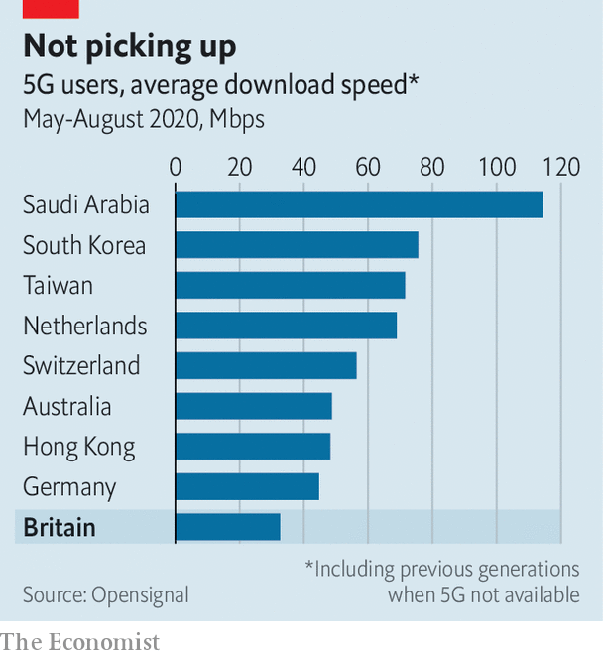

One culprit is geography. The countries on Opensignal’s list that perform best are either small, such as Taiwan, or very big but with most people concentrated in a few urban areas, such as Saudi Arabia and Australia. Britain, like Germany, has some dense areas but also many sparsely populated rural areas where building lots of cell-towers is expensive, and returns slim. The lay of the land matters too. Hills and trees interfere with mobile signals. A second reason is planning. Other European countries have more liberal planning laws, says Karen Egan, a telecoms analyst with Enders Analysis, a research firm. Councils present one obstacle. The farmers on whose land towers need to go present another.

The way in which spectrum is allocated also affects the quality of the service. Just as more water flows through a broader pipe, the more spectrum an operator has, the better the service it can provide. Many countries have just three networks. Britain has four. That means more competition and lower prices, but also less spectrum for each. Moreover, only half of the 5G spectrum has so far been auctioned. When the next chunk is bought up, networks may find themselves with fragmented bits of spectrum. Ms Egan describes the operators’ spectrum as “barcode-like: rather slim slivers of it, rather than large bands”.

That might be fixable. Ofcom, the telecoms regulator, is open to facilitating swaps between networks, says Greig Paul, a networks expert at the University of Strathclyde. But new problems have arisen, such as the government’s decision to ban equipment manufactured by Huawei, a Chinese company, from 5G networks. That will slow its roll-out and increase its cost. Conspiracy theories linking 5G to covid-19 and other ailments do not help either.

This matters—not just for consumers but also for industrial and agricultural uses. The real promise of 5G is in vastly increased capacity. The new network can handle up to 1m connections per square kilometre, compared with some 2,000 for 4G. That is why much of the hype surrounding 5G has been about filling factories full of sensors or connecting cows to the internet. But uncertain rules slow progress and raise costs. As Mr Paul puts it, “you cannot possibly charge £10 per cow” per month. Operators will have to find a way to spend on infrastructure, control prices and greatly increase the number of connections all at the same time if they are to milk 5G.■

This article was downloaded by calibre from <https://www.economist.com/britain/2020/09/03/britains-5g-rollout-faces-myriad-obstacles>

|  |  |  |  |
| --- | --- | --- | --- |
| Previous | Articles | Sections | Next |

|  |  |  |  |
| --- | --- | --- | --- |
| Previous | Articles | Sections | Next |

#### Nightlife

# Why raves are enjoying a revival

Britons are partying like it’s 1988

Sep 3rd 2020 |

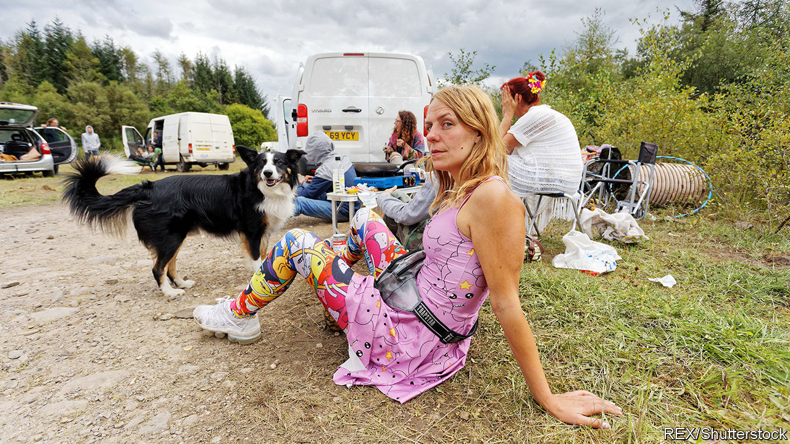

IT’S GROUNDHOG DECADE in Banwen, a small village in Wales. When the makers of the film “Pride” needed a location for an embattled Welsh mining community in the 1980s, they chose the tiny village on the edge of the Brecon Beacons. When 3,000 ravers arrived last weekend, that dubious decade seemed to be making a comeback.

Headlines about illegal raves recall the “second summer of love” in 1988, fuelled by the rise of dance music and party drugs such as ecstasy. The closure of clubs has revived that spirit this year, despite coronavirus restrictions banning gatherings of more than 30 people outdoors. The Metropolitan Police has recorded more than 1,000 raves (which it defines as unlicensed music events with more than 20 people) in London since the end of June. Between 2015 and 2018, the most raves reported to the Met in a single year was 133.

Even before the pandemic, raves were making a comeback. A combination of expensive rents in big cities and precarious operating licences has changed Britain’s nightlife. Big venues have passed their costs on to clubbers—entry to Printworks, a factory-turned-club in south-east London, can cost £40 ($54)—and drugs are less tolerated. In 2016 authorities revoked the licence of Fabric, a famous club in London, after two drug-related deaths. It reopened five months later, but with stricter rules, including ID-scanning and lifetime bans for anyone caught asking for drugs.

Smaller venues have taken advantage of big venues’ problems, and so have rave organisers. “You’ve got block parties, hippies in the woods, and London ones with middle-class people, thrown in a professional manner,” says James Morsh, who runs PillReport, a group that encourages people to rave responsibly. In May Mr Morsh organised the first socially distanced legal rave, with permission from Nottingham council. He had over 750 requests to attend, but could only allow 40 people to take part. He admits that it’s “not really what partying should be like”, although the arrival of 12 police officers gave the event an authentic feel. Once the police were satisfied that the revellers were not breaking any rules, they let them carry on.

Tougher punishments were introduced last month to deter people from partying. Eight organisers of the rave in Banwen were given fines of up to £10,000 each under the new regulations. But stopping determined ravers is hard, when locations are kept secret until the last minute and details shared through WhatsApp and Instagram. Mr Morsh thinks that the new penalties will have little effect: “The people throwing parties are going to keep throwing parties.”

The consequences for Banwen were not as grim as some feared. “When that many people turn up it’s a bit like ‘Oh shit, what have they come to do? Have they come to ruin the village?’,” says Alun, who lives nearby. But on checking it out, he found a fairly civilised event. Some attendees were even using hand sanitiser.

This article was downloaded by calibre from <https://www.economist.com/britain/2020/09/03/why-raves-are-enjoying-a-revival>

|  |  |  |  |
| --- | --- | --- | --- |
| Previous | Articles | Sections | Next |

|  |  |  |  |
| --- | --- | --- | --- |
| Previous | Articles | Sections | Next |

#### Bagehot

# Could Ed Davey lead a Lib Dem revival?

There’s life in the corpse

Sep 5th 2020 |

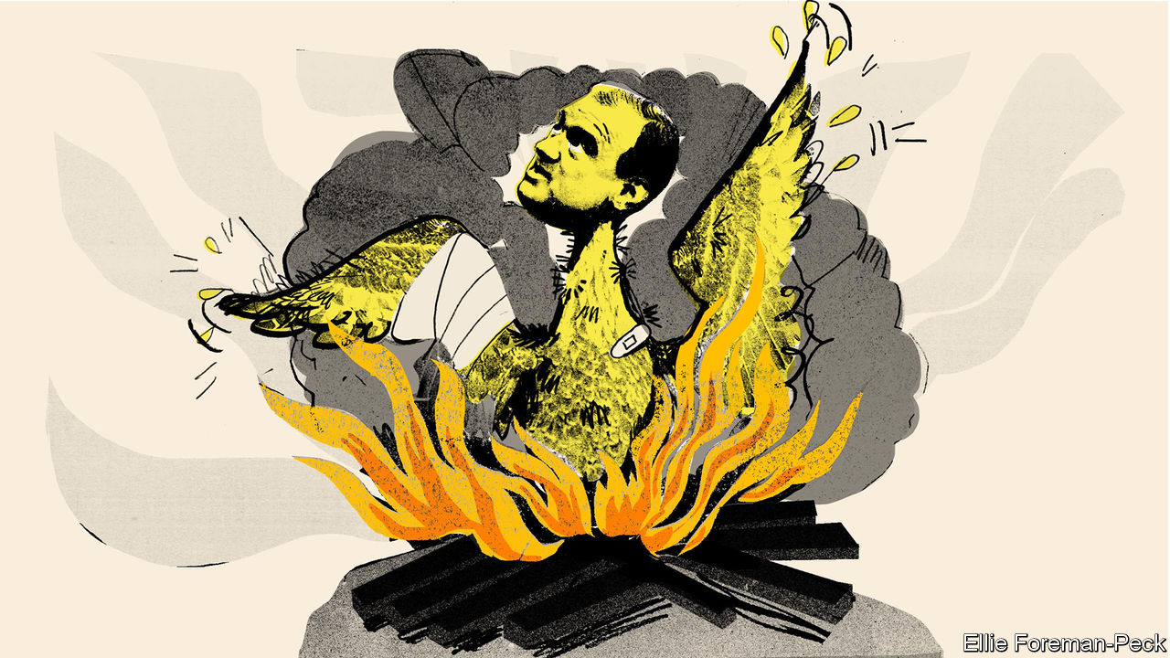

THE MOOD in Westminster, as MPs return from their long break, is one of general frustration. Conservatives are frustrated with Boris Johnson’s inept leadership. Labour MPs are frustrated by their failure to translate that ineptitude into a clear lead. And Scottish Nationalists are frustrated that the one thing that they want, another independence referendum, is in the gift of a man who has no reason to give it. Still, when it comes to frustration nobody can compete with the Liberal Democrats.

The Lib Dems went into the last election hoping for a realignment that would boost their numbers and turn them into powerbrokers. They ended up with their seats reduced from 21 to 11 and their dream of remaining in the EU shattered. The party now has a new leader, Sir Ed Davey, who has tried to rouse them with the battle cry “wake up and smell the coffee”. This is hardly the stuff of Lloyd George, the last Liberal prime minister, whom John Maynard Keynes called a “goat-footed bard” on account of his eloquence. But Sir Ed is at least right that his party is sleeping rather than dead.

One of the Lib Dems’ greatest strengths is that, third-placed in a first-past-the-post system, they are masters of disappointment. Humiliation is part of their brand, as is the hope of a revival just around the corner. Peter Sloman, of Churchill College, Cambridge, points to a historical parallel with 1970-74. They went into the 1970 election with high hopes and ended up with just six seats. But then they picked themselves up, winning a succession of by-elections and taking almost 20% of the vote in February 1974, thus helping eject Edward Heath from office. There are reasons to think that they can repeat the trick.

The party’s new leader inherits some significant institutional strengths. The Lib Dems came second in 91 constituencies in 2019, compared with 38 in 2017 and 66 in 2015. They have more members than they have had for decades—120,000 compared with the Tory Party’s 150,000. There are about 90 Lib Dem peers, many of them with long experience in either central or local government or both, who can act as an ermine-clad think-tank. Sir Ed can also profit from a couple of long-term trends.

The first is the Labour Party’s move to the centre under Sir Keir Starmer. A centrist Labour Party sounds like bad news for the Lib Dems, but historically the opposite has been true. The Lib Dems do best when Labour has “safe” leaders, such as Tony Blair, because otherwise they are vulnerable to the charge that “a Lib Dem vote lets in Labour”. Paddy Ashdown, a former party leader, maintained there is a Labour-acceptability threshold below which wavering Tories will not vote Lib Dem. In 2019, thus, they would have had a better chance of taking Dominic Raab’s Esher and Walton seat and Sir John Redwood’s Wokingham seat had disillusioned Tories not been terrified of putting Jeremy Corbyn into Downing Street.

Sir Ed’s second advantage is the decontamination of the Lib Dem brand. The party managed to do as badly as it did in 2019 by pulling off a remarkable trick: despite not having run the country since 1922, it persuaded voters it was the party of the establishment because it gave its blessing to austerity as part of the coalition government in 2010-15 and sided with the “hidden state” in determination to overturn Brexit. Correcting this impression will not be easy given its leader’s knighthood and its legion of lords. But time will dull the memory of the coalition, and failure might revive the party’s image as a scrappy underdog.

The Lib Dems’ biggest problem in recent decades has been their lack of what politicos call a “core vote strategy”. Their voters have come from two incompatible groups: on the one hand, cosmopolitan liberals in suburbs and university towns who support the “double liberalism” of free markets and progressive values; on the other, provincial liberals, particularly in the Celtic fringe, who are motivated by local issues and dislike one or both parts of the liberal formula. Twenty-six of the 57 constituencies which elected Lib Dem MPs in 2010 voted leave in 2016.

A recent shift in voting patterns has solved this problem by accident: the party has strengthened its support in knowledge-intensive areas (particularly London and the south-east) while losing its old heartlands. This should make it much easier to produce a coherent programme. The current leadership will no doubt bang the drum on green issues (which Sir Ed is keen on) and civil rights (which Sir Keir is reluctant to embrace). And it has even more to gain from the problem of over-centralisation. The Lib Dems’ traditional enthusiasm for local government sits well with the rising concern that Britain is a dangerously unbalanced country.

## Dreaming of Keir

Who cares? Even the Lib Dems’ strategists don’t expect more than 30 seats at the next election. Yet the possibility of a Lib Dem revival matters, for the party is likely to take votes from the Tories. The Lib Dems have always been at their happiest when engaged in ground wars with the Conservatives. Their new profile pits them even more directly against their old enemy. They have captured several Tory seats in a “yellow halo” around London such as Twickenham, St Albans and Richmond Park. Tim Bale, of Queen Mary College, London, calculates that, in 23 of the 29 seats that they are well positioned to win, they are the main challenger to the Conservatives, with every other party a distant third.

Sir Keir and Sir Ed have a lot in common other than their rather embarrassing knighthoods: both recognise that they have a mountain to climb and both are keen on the politics of competence rather than culture wars. They also have much to gain from working together, at least informally. Labour needs the Lib Dems more than ever because, having lost its base in Scotland, it is unlikely to form a government on its own. The Lib Dems see their future in detaching the educated bourgeoisie from the Conservatives. Old-fashioned liberals have been dreaming of a Lib-Lab rapprochement for decades. That vision—or mirage—is taking shape once more. ■

This article was downloaded by calibre from <https://www.economist.com/britain/2020/09/05/could-ed-davey-lead-a-lib-dem-revival>

|  |  |  |  |
| --- | --- | --- | --- |
| Previous | Articles | Sections | Next |

|  |  |  |
| --- | --- | --- |
| Britain | Sections | Business |

International

The digitisation of government: Paper travails

.

|  |  |  |
| --- | --- | --- |
| Britain | Sections | Business |

|  |  |  |  |
| --- | --- | --- | --- |
|  | Articles | Sections | Next |

#### Paper travails

# Covid-19 is spurring the digitisation of government

It has accelerated the adoption of online services for everything from welfare to weddings

Sep 1st 2020 |

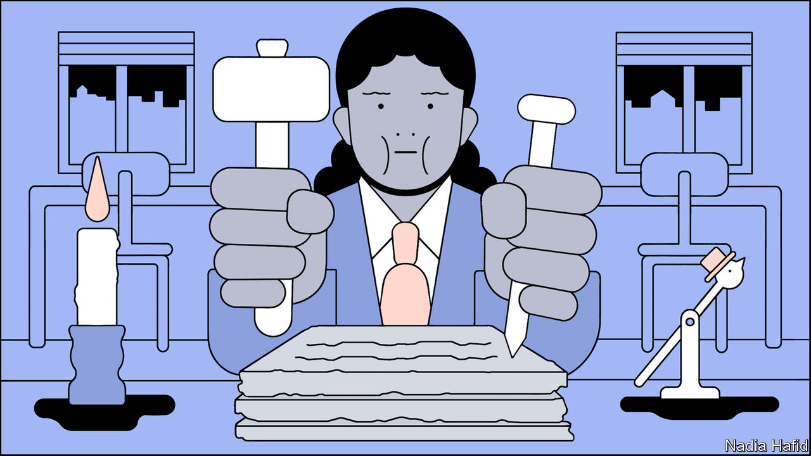

Editor’s note: Some of our covid-19 coverage is free for readers of The Economist Today, our daily [newsletter](https://my.economist.com/user#newsletter). For more stories and our pandemic tracker, see our [hub](https://www.economist.com/news/2020/03/11/the-economists-coverage-of-the-coronavirus)

FOR KARINA CELIS and her fiancé James, covid-19 could not have come at a worse time. The couple planned to marry in May and to move from London to Salisbury, a small English city whose cathedral impresses Russian tourists. In July they had a baby, their first. The wedding has been postponed indefinitely. Moving house during lockdown was surprisingly straightforward. But having the child proved a nightmare of bureaucracy.

In Britain pregnant women are often given a paper folder containing their medical records, which they must haul to their appointments. Ms Celis’s notes were not transferred properly from her hospital in London to a new one in Salisbury. She had to start a new folder—and to repeat all her appointments. Absurdly she and her fiancé had to listen again to an hour-long talk about what to do when expecting a baby.

For Ms Celis, a software-engineering manager, the lack of digitisation was shocking. “At almost every appointment I have been to, either in London or here, the staff mentioned their struggles with tech,” she says. Some maternity services have moved online, but mostly health care in Britain, as elsewhere, has stubbornly resisted digitisation. The National Health Service (NHS) remains among the world’s biggest purchasers of fax machines. A plan to create a unified digital system of patients’ records was abandoned almost a decade ago, after £10bn ($12.5bn) was spent on it. No further attempts have been made.

Neither health care nor Britain is unique in relying heavily on paper. By preventing face-to-face meetings and closing the offices where bureaucrats shuffle documents, the pandemic has revealed how big a problem that is. In many countries, it has been impossible to get a court hearing, a passport or get married while locked down, since they all still require face-to-face interactions. Registering a business has been slower or impossible. Elections are a worrying prospect.

Governments that have long invested in digitising their systems endured less disruption. Those that have not are discovering how useful it would be if a lot more official business took place online.

Covid-19 has brought many aspects of bureaucratic life to a halt. In England at least 73,400 weddings had to be delayed—not just the ceremony, also the legal part—reckons the Office for National Statistics. In France courts closed in March for all but essential services, and did not reopen until late May. They are still not operating at full capacity. Most countries have extended visas for foreigners trapped by the pandemic, but consular services stopped almost everywhere, meaning that people living abroad could not renew passports or register births. In America green-card applications were halted in April; they restarted in June. In Britain appointments to take biometric details of people applying for permanent residency ceased in March and resumed only partly in June.

Some applications cannot be delayed. As Florida was locking down, huge queues formed outside government offices to get the paper forms needed to sign up for unemployment insurance. In theory the state has a digital system, but it was so poorly constructed that many could not access it. At the start of the pandemic the website crashed for days. Even several months later people trying to apply had to join a digital queue and wait for hours before being able to log in. When government offices in Montgomery, the capital of neighbouring Alabama, reopened, people camped outside, hoping to see an official who might help with their claims.

Where services did exist online, their inadequacies became apparent. Digital unemployment-insurance systems collapsed under a wave of new claimants. At the end of March the website of the INPS, the Italian social-security office, received 300,000 applications for welfare in a single day. It crashed. Some of those who could access it were shown other people’s data. The authorities blamed not just the volume of applicants but also hackers trying to put in fraudulent claims. Criminals were a problem in America, too. In the worst-affected state, Washington, $550m-650m, or one dollar in every eight, was paid out to fraudsters who took advantage of an outdated system of identity verification (about $300m was recovered).

## Purposely pointless paperwork

In America such problems were inevitable, says Michele Evermore of the National Employment Law Project, a think-tank, because the country has invested very little in modernising its unemployment-insurance systems. Spending on administration has fallen since 2001, even before accounting for inflation. Some states, including Florida, deliberately designed their systems to be difficult to use to discourage workers from applying. In August Ron DeSantis, Florida’s Republican governor, admitted that the state’s system was designed with lots of “pointless roadblocks”.

Yet elsewhere the pandemic has revealed how effective digitising government services can be. Governments have for the most part been able to transfer money into the accounts of hundreds of millions of people without queues at government offices or banks. In Britain the previously unloved Universal Credit system, which distributes welfare benefits, proved its worth when almost 1m people signed up to it in two weeks without having to go to a job centre. Britain has no national identity card or citizenship register—a problem in keeping track of people. But a digital workaround, whereby people were able to prove their identity by scanning the electromagnetic chip in their passports with a mobile phone, seems to have been effective. Though people had to wait five weeks for payments—a political decision—they mostly got them.

Governments that have embraced the idea of digitising their services—and invested in them—have performed admirably. In Estonia, a country where digital government is so advanced that it is possible to vote online, all citizens have a digital ID linked to their bank account and the tax system. That meant that working out which Estonians were furloughed and getting benefits to them was fairly straightforward. Taiwan, another digital pioneer, adapted its health-insurance system to implement an economic stimulus intended to help face-to-face businesses, says Audrey Tang, Taiwan’s digital minister. After paying at a restaurant, for example, citizens can use their insurance card at an ATM to reclaim cash from the government.

Covid-19 will probably accelerate a shift online. During the pandemic the governors of New York and California legalised digital marriages. When New Jersey’s leaders realised the extent of the shutdown, they invested in putting more services online, says Beth Noveck, the state’s chief innovation officer. Her office created a single government website through which residents can find information on the coronavirus and book tests for it, among other things. Other states have followed suit. Her office is also trying to find ways to streamline the awkward process of verifying people’s identities online in America, which like Britain has no national ID cards. In France social-security paperwork, which previously had to be sent by post, can now be submitted electronically.

Some think that a bonanza of digital investment may be coming. “Everyone now can see that the digitisation that will take place will be enormous and billions and billions will be spent,” says Daniel Korski, who runs Public, a venture-capital firm that invests in the digitisation of public services. He points to various government IT contracts that are nearing renewal. Britain’s NHS is among the services most likely to change. Harpreet Sood, a practising GP who is also in charge of technology for the NHS, says that before the pandemic 7% of his consultations were done remotely. During lockdown the figure jumped to 90%. Not everything can be diagnosed over the phone, he says, but a lot can.

Not everything works well digitally. At the height of the pandemic almost all family-court hearings in Britain stopped except for the most urgent cases, such as the removal of children from abusive parents. Those were put online, with judges expected to make decisions based on evidence delivered over sometimes patchy internet connections. But the backlog has forced some people to deal with the problems outside the courtroom. Couples going through contested divorces have not been able to get judgments on their financial disputes, so arbitration has thrived, says Samantha Woodham, a British barrister who runs the Divorce Surgery, which provides legal advice to spouses breaking up.



The pandemic has not just drawn attention to more efficient ways of operating; it has also required governments to do new things. Track-and-trace systems work only if governments know who their citizens are and can contact them reliably. Estonia’s officials can do so easily; Britain’s and America’s cannot. In China in order to board public transport or enter their own apartment buildings people have to show QR codes on their phones to verify that they have not been to a virus hotspot recently.

In Britain and America the lack of ID cards means that different government records are isolated in different departments. Health-care records do not identify where somebody works and vice versa. Local administrations do not always have access to central-government records. With no simple way of connecting names and addresses, Britain’s government has had to rely on data from credit checks to verify people’s identities before posting them covid-19 tests. When its track-and-trace system was being built, contact tracers were not able to connect swiftly clusters of cases linked to workplaces because local government did not have the data. As a result some local outbreaks were not spotted quickly enough to stamp out the spread.

Tony Blair, a former prime minister, is among those who have called for Britain to invest in a citizenship register like the one in Estonia. Such projects take time and money but could prove a worthwhile investment. Sharing information can help with more than stopping the virus. Better data-sharing would allow governments to improve even mundane services such as rubbish collection or managing street parking. Better digital identities would not just help track patients—they would also reduce the risk of digital fraud, one of the few industries to have thrived under lockdown. If Americans had digital identities like Estonians, organising November’s presidential election would be easier.

Such changes will not be cheap. And the implications for privacy must be taken seriously. Implemented badly, new digital systems could create new opportunities for fraud, instead of making it more difficult. A state that gathers more and more granular information ought to be able to make better policy—but it will also find it easier to snoop on citizens. Not all governments can be trusted with such powers. ■

This article was downloaded by calibre from <https://www.economist.com/international/2020/09/01/covid-19-is-spurring-the-digitisation-of-government>

|  |  |  |  |
| --- | --- | --- | --- |
|  | Articles | Sections | Next |

|  |  |  |
| --- | --- | --- |
| International | Sections | Finance & economics |

Business

Prosus: Winner’s curse

.

Wizz Air: Rising in the east

.

Japanese business: Rebalancing act

.

Berkshire Hathaway’s Japanese bet: Buffett bets on Japan

.

Bartleby: After the fall

.

Indian business: Over-Reliance

.

TikTok: Limbo dance

.

Schumpeter: Reconstituted

.

|  |  |  |
| --- | --- | --- |
| International | Sections | Finance & economics |

|  |  |  |  |
| --- | --- | --- | --- |
|  | Articles | Sections | Next |

#### Winner’s curse

# What is Prosus, Europe’s consumer-internet star, for?

Investors question the purpose of the old continent’s fourth-biggest company

Sep 3rd 2020 | PARIS

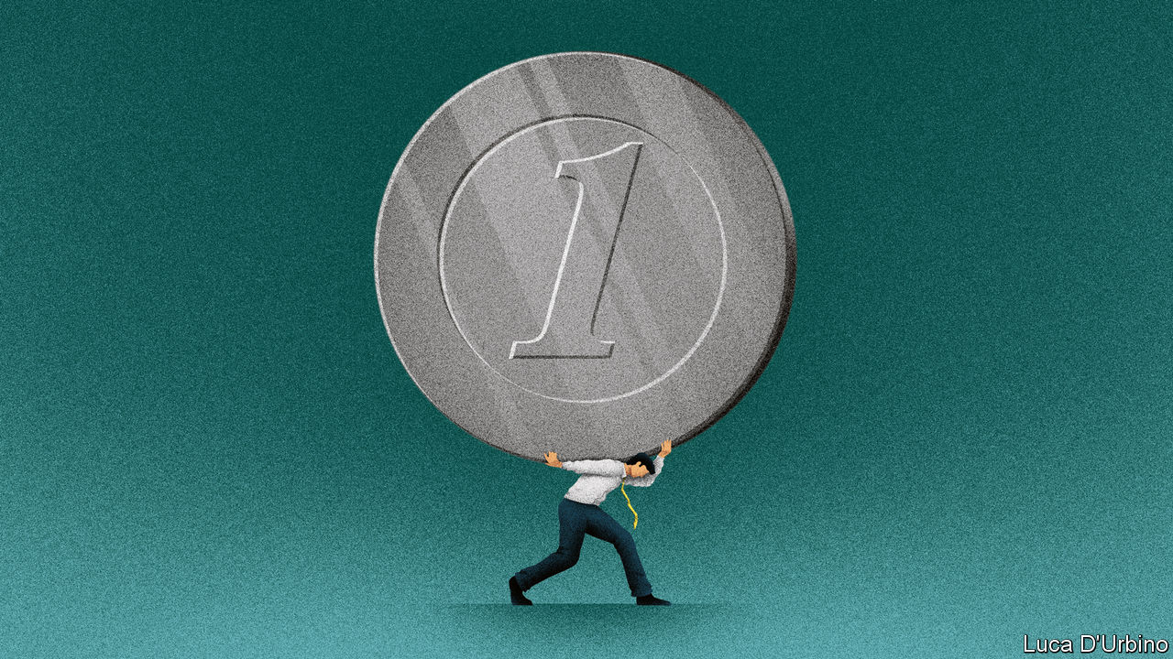

FEW FIRMS struggle with too much success. One is Naspers, a South African media group founded in 1915. In a prescient bid to diversify away from newspapers in 2001 it paid $32m for a large stake in a piddly Chinese startup. Tencent, the startup in question, has since morphed into a gaming and messaging behemoth worth over $670bn. Dealing with the windfall presents unique management headaches.

The unexpected upshot of a South African investment in China is a European consumer-internet giant. A year ago Naspers listed Prosus, a vehicle for its online bets, in Amsterdam. By dint of owning 31% of Tencent, worth about $208bn, as well as other investments made since, Prosus is the EU’s fourth-most-valuable firm. It is also the closest that Europe has to the global tech stars that dominate the world’s stockmarkets. Its boss, Bob van Dijk, acknowledges the firm’s model may be unusual in the tech world. But, he argues, it can still deliver value.

Prosus has invested billions—and has ever more billions to invest, thanks to Tencent’s continued success—into all manner of online ventures, from e-commerce to food delivery, distance learning and classified ads. Though run from the Netherlands, much of its empire lies in emerging markets, a nod to its African heritage. Deep pockets let it build online businesses or aggregate local players into global platforms.

As exciting as that sounds, Mr van Dijk has a more prosaic problem: proving to the outside world the firm needs to exist. He insists Prosus has found a distinctive approach. Unlike venture capitalists, it does not need to return money to investors. It can back businesses for the very long term and, because it runs some of them, has “an operator’s DNA”. Few of its investments have been busts.

Investors are sending mixed signals. Its market capitalisation of $167bn is about a fifth less than the value of its Tencent shares. Add the other firms it has stakes in, some of which are listed, as well as $4.5bn of net cash on its balance-sheet, and the discount rises to 33%—a gap of $80bn or so (see chart). Its share price has risen of late, but not as fast as those of its holdings. Markets seem to be valuing the portfolio of companies which Prosus has spent over $12bn building at less than nothing.

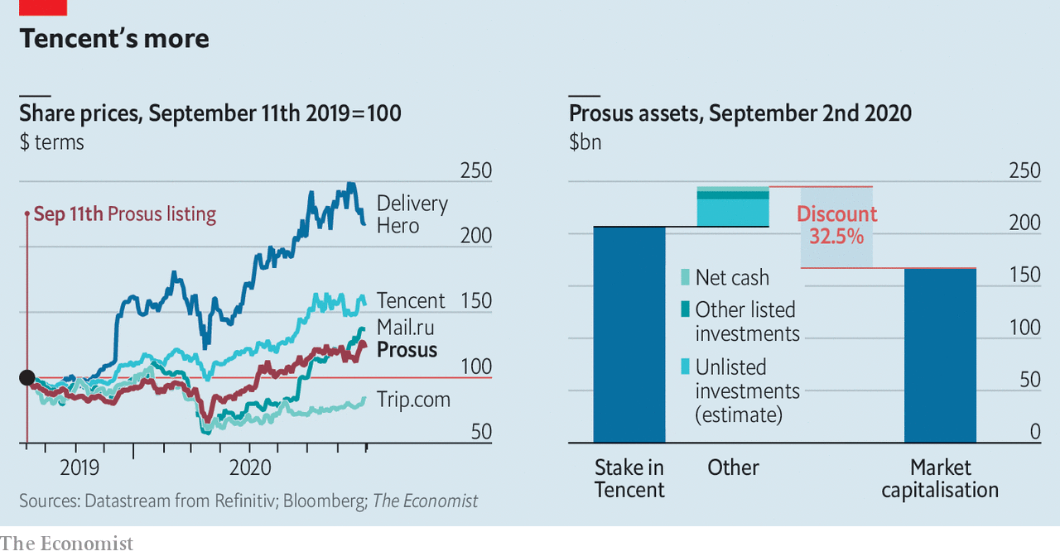

That looks unduly harsh. The management of what is now Prosus has made bets which, though less spectacular than Tencent, would not shame most venture capitalists. The classifieds business it built up, OLX, has 300m monthly users in 22 markets. PayU, a payments arm, has grown rapidly, notably in India. An Indian e-commerce investment, Flipkart, generated a return of $1.6bn when it was sold to Walmart in 2018. Prosus’s minority stakes in Delivery Hero, a food-delivery service active in 40 countries, and Mail.ru, a Russian social-media firm, are worth much more than what it paid.

But challenges abound. Many Prosus bets have tricky economics, promising jam tomorrow with fruit and sugar nowhere to be seen today. Adjusted for its stakes, its food operations lost $624m in the year to March, on revenues of $751m. Of the businesses it runs, only the classifieds turn a (small) operating profit. Some of its investments are in industries likely to be profitable only if mergers create winners that could attract the gaze of trustbusters.

Continuing to grow fast will require buying rivals with heady valuations. In the past year Prosus has narrowly lost out on Just Eat, an $8bn food-delivery business, and eBay’s classified-ads business, which fetched $9bn. “On the one hand, you do want to be disciplined and not overspend on acquisitions,” says Ken Rumph of Jefferies, an investment bank. “On the other, if you keep on finishing second you don’t get to execute your strategy.”

Of 2020’s vagaries, covid-19 should help lure new customers online. But the ongoing trade skirmishes between America and China pose a risk for owners of Chinese assets. Last month President Donald Trump gave Americans 45 days to stop doing business with WeChat, Tencent’s messaging app (as well as with TikTok, a video app—see [article](https://www.economist.com/node/21791418)). Tencent shares tumbled, dragging Prosus down with it.

Potential investors may also be put off by Prosus’s corporate structure. Naspers still owns 73% of the shares, and the two firms are essentially run as one. Even if the parent sold down its stake, its shares would carry 1,000 times more voting power than anyone else’s. Naspers itself has similar super-voting shareholders, who are seen as close to management. They call the shots.

Naspers’s dual voting structure was put in place to protect editorial independence and carried over to Prosus, though it owns no media assets. Tech founders often use dual shares to protect their legacy. But Prosus is a subsidiary of a century-old firm. Whatever the rationale, the effect is to shield executives from being held to account. A strong board might rein them in. But its chairman, the former Naspers chief executive who pulled off the Tencent deal, is no counterweight. When two-thirds of ordinary shareholders in 2017 voted against the pay deals of Mr van Dijk and others, their gripes were mostly ignored.

Other firms have grappled with the curse of success. Yahoo struck gold with Alibaba, another Chinese tech titan—only to be undone by it when activist shareholders pushed the American search pioneer to spin off other operations in 2017, leaving mainly the Alibaba stake, which was sold off in 2019. SoftBank, a Japanese group which also made a bundle off Alibaba, took a different route. Its boss, Son Masayoshi, parlayed his windfall into a complex empire of telecoms, property and venture capital. Whether that has been a wise use of Alibaba’s riches is an open question; Mr Son has had some big blow-ups. Investors have recently nudged him to sell some assets to cut back debt.

Mr van Dijk need not worry about debt or activist investors, who would no doubt campaign to offload the Tencent stake. Yet not cashing in has borne handsome rewards. By trimming the lucrative stake bit by bit—it sold about 2% of the firm in 2018, raising $10bn—Prosus can indulge its bosses’ empire-building instincts while giving shareholders access to Tencent’s growth. Listing in Amsterdam was meant to give global investors a chance to buy into Mr van Dijk’s broader vision, boosting Prosus’s value and crushing the conglomerate discount. So far this has not happened. Unless shareholders have a real say in what Prosus is for, it may never do. ■

This article was downloaded by calibre from <https://www.economist.com/business/2020/09/03/what-is-prosus-europes-consumer-internet-star-for>

|  |  |  |  |
| --- | --- | --- | --- |
|  | Articles | Sections | Next |

|  |  |  |  |
| --- | --- | --- | --- |
| Previous | Articles | Sections | Next |

#### Rising in the east

# Can Wizz Air soar amid the pandemic?

The Hungarian low-cost carrier looks better placed than rivals to thrive

Sep 3rd 2020 |

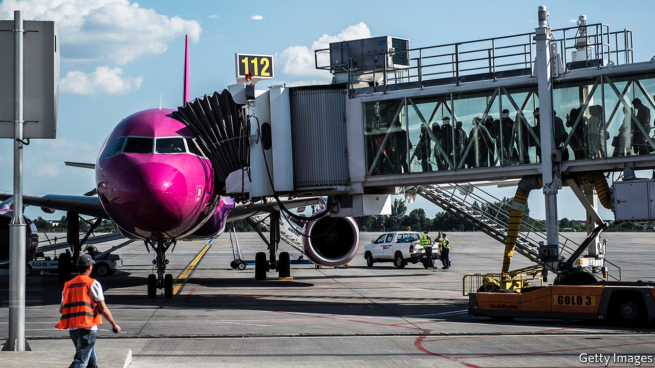

THE MOOD among airline bosses can seem uniformly bleak. For good reason: air travel may not return to pre-pandemic levels until 2024. Not a week goes by without an airline sacking thousands of workers. Against this gloom, Jozsef Varadi, who runs Wizz Air, cuts an audacious figure. While other airlines cancel and defer orders for new planes and put expansion plans on ice, he wants to increase his fleet from 127 planes to 160 by 2022 and double passenger numbers to 80m by 2025. He believes the Hungarian low-cost carrier, founded 17 years ago and now Europe’s third-biggest behind Ryanair and EasyJet, will not only survive covid-19 but thrive.

Can the plan fly? “The odds are it will,” says Keith McMullan of Aviation Strategy, a consultancy. Wizz Air managed to report a 19% rise in revenues in the 12 months to March, to €2.8bn ($3.1bn). Net profits doubled year on year, to €281m. Despite unavoidable losses this year, it has sustained less covid-19 damage than rivals.

Luck played a role. Wizz Air’s customers are on average 32 years old—younger than those of rivals and less fearful of the virus. It caters to many central and eastern Europeans working in the west, who are keen to fly home frequently. Wizz Air’s smaller fleet, less than a third the size of Ryanair’s and half of EasyJet’s, meant it could keep a bigger share of its aircraft in the air.

Wizz Air’s resilience is not all down to good fortune. Mr Varadi’s focus on costs helped, too. He claims Wizz Air’s are the lowest in the business, thanks mainly to the industry’s largest fleet of super-efficient Airbus A321s (though he got lucky here, too, by not picking Boeing’s rival 737 MAX jets, the grounding of which after two fatal crashes has delayed deliveries to big buyers like Ryanair). Using the biggest version of the single-aisle workhorse has helped to spread expenses among more passengers. One estimate put Wizz Air’s unit costs at half those of EasyJet, an airline that increasingly resembles the legacy carriers it once sought to subvert. And Mr Varadi has pulled this off without irritating passengers or gaining a Ryanair-like reputation for stinginess.

Now, thanks to mass lay-offs of pilots, cabin crew and other staff, labour costs are tumbling. Empty airports are wooing carriers with cheap landing slots and discounts on other charges. That has allowed Wizz Air to set up ten new bases in the past three months, including at London’s Gatwick airport, as well as in Germany, Albania and Russia. Plans to serve the Persian Gulf in a joint venture with Abu Dhabi’s sovereign-wealth fund remain on track.

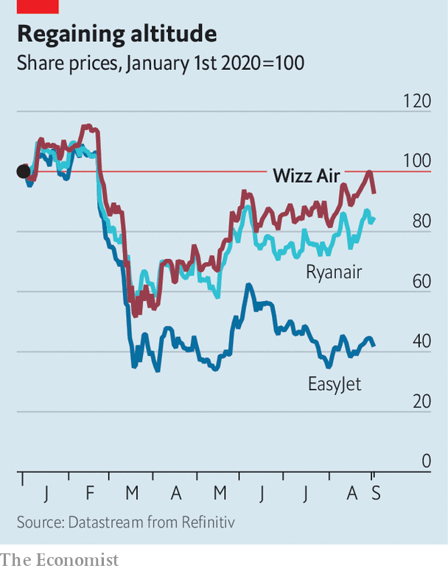

Things could still go wrong. On September 1st, as European countries reimposed travel restrictions, Wizz Air tempered its plans to return to 80% capacity next quarter. It is now aiming for 60%, still better than 45% or so for most European rivals. Its share price is below its peak in mid-February, but back where it was at the start of the year (see chart). Mr Varadi says Wizz Air’s €1.5bn in cash would last 20 months even if all its planes stop flying. He relishes the chance to “sort winners from losers”. No points for guessing which group he thinks his firm belongs to.■

Editor’s note: Some of our covid-19 coverage is free for readers of The Economist Today, our daily [newsletter](https://my.economist.com/user#newsletter). For more stories and our pandemic tracker, see our [hub](https://www.economist.com/news/2020/03/11/the-economists-coverage-of-the-coronavirus)

This article was downloaded by calibre from <https://www.economist.com/business/2020/09/03/can-wizz-air-soar-amid-the-pandemic>

|  |  |  |  |
| --- | --- | --- | --- |
| Previous | Articles | Sections | Next |

|  |  |  |  |
| --- | --- | --- | --- |
| Previous | Articles | Sections | Next |

#### Rebalancing act

# Can Japan Inc navigate the rift between China and America?

Japanese companies cannot afford to anger either a big market or a big ally

Sep 3rd 2020 | TOKYO

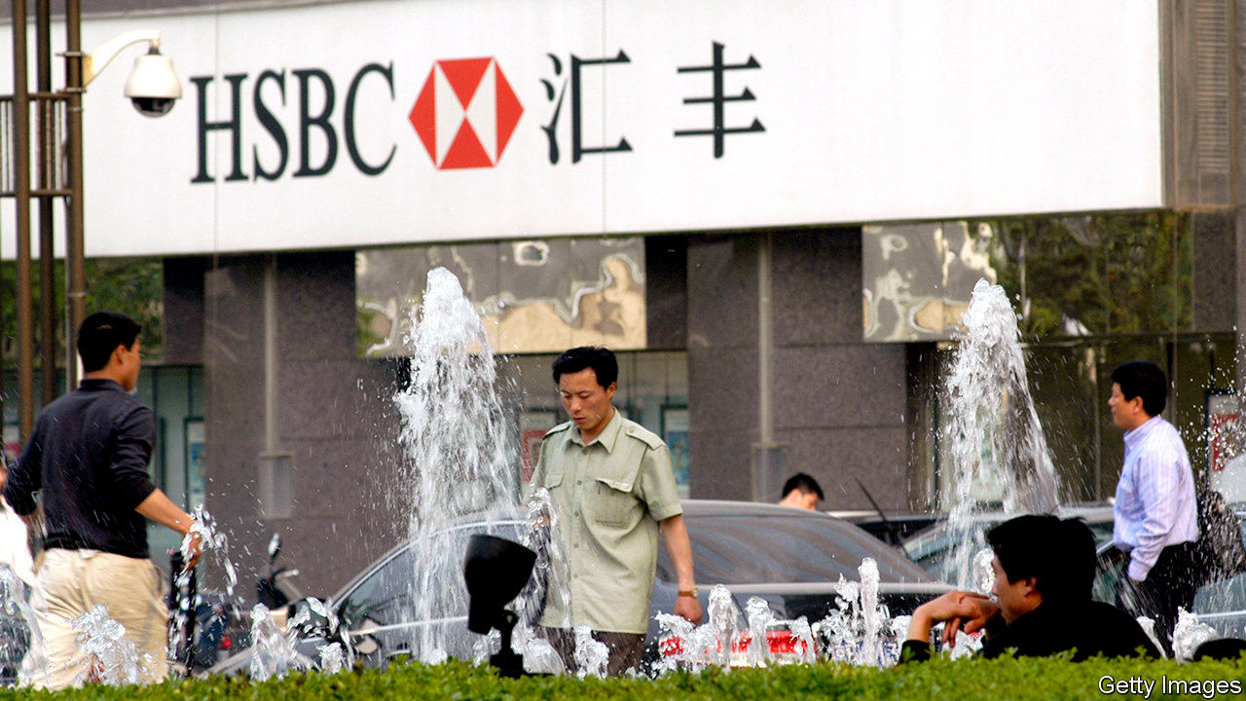

WHEN ABE SHINZO became Japan’s prime minister for a second time in 2012, relations with China were on the skids. Tensions over disputed islands brought the two countries to the brink of conflict. Japanese car dealerships in China were set ablaze. Protests at a Panasonic factory turned violent.

After that, tempers cooled and relations warmed. Mr Abe had planned to host Xi Jinping for a state visit in Tokyo this spring, the first by a Chinese leader since 2008. Japan Inc, too, has been dining out on the bonhomie. Annual trade between China and Japan, the world’s second- and third-biggest economies, amounts to more than $300bn. Japanese firms accumulated over $130bn in assets in China. The flow of Japanese foreign direct investment there hit an all-time high of $14.4bn last year.

According to Morgan Stanley, an investment bank, listed Japanese firms derived only 4% of revenues from China. But 26% of their profits were tied to China through suppliers or customers, more than depended on America, calculates Jesper Koll, a Tokyo-based economist. He reckons this profit share shot up to 63% in the second quarter, as the Chinese economy recovered faster than others from covid-19.

Now the mood seems once again to be souring. Covid-19 put paid to Mr Xi’s visit. His crackdown on democracy in Hong Kong and the economic cold war between Beijing and Washington have led senior Japanese officials to speak of risks rather than opportunities in China. Earlier this year Mr Abe’s government imposed new restrictions on foreign investment to protect certain industries, battered by covid-19, from Chinese bargain-hunters. The pandemic and the spectre of further American sanctions against Chinese companies such as Huawei, a telecoms-equipment giant, are making Japanese companies think about the stability of their supply chains, not just efficiency, says Ke Long of the Tokyo Foundation for Policy Research, a think-tank. Mr Abe’s sudden resignation on August 28th over ill health has added to the uncertainty (see [article](https://www.economist.com/node/21791382)).

Closer inspection reveals a more nuanced picture, however. One source close to the government says its aim is to focus on “several strategic choke-points” in China (such as medical supplies), while “keeping many areas open for commercial activity”. Not so much a great decoupling, then, as a quiet rebalancing.

Mr Abe’s ¥244bn ($2.2bn) programme to induce Japanese firms to diversify their supply chains away from China is a case in point. In July 57 companies, including Iris Ohyama, a big plastics producer, and Sharp, a maker of electronics, received a combined ¥57bn to invest in production at home; others got help to build factories in South-East Asia. But of the 87 winning projects, 60 will be producing masks, disinfectants, drugs or other medical supplies.

Having business in China was not a precondition for the handouts; many companies, especially small and medium-sized ones that made up the bulk of applicants, had little or none. An executive at Novel Crystal Technology, a producer of materials for semiconductors, says his firm applied for the subsidy to reduce overconcentration—in the American market. The sums on offer are far too small to spur all-out decoupling, says Onishi Yasuo, a former official at the Japan External Trade Organisation, an independent government agency.

Most Japanese firms with lots of exposure to China are in “wait and see” mode, says Mr Ke. America may have a new government soon. The scope and enforcement of American sanctions is vague. Even if tensions keep rising, Japan Inc is unlikely to behave as a monolith. Makers of niche products for export may decamp from China. Firms with a large Chinese business, such as carmakers, will be loth to leave.

In the long run the risk for corporate Japan is less geopolitics than competition. China already transformed once, from a land of cheap labour into a booming consumer market; more than 70% of what Japanese companies’ affiliates produce in China is sold there. Now a second shift is under way, from consumer market to rival in sophisticated technology.

The latest annual survey of 74 technology products and services by Nikkei, a Japanese business newspaper, found that last year Chinese companies overtook Japan in market share for liquid-crystal displays installed in smartphones and insulators for lithium-ion batteries used in electric vehicles. As an adviser to a large Japanese bank observes, that is what really makes Japanese firms nervous. ■

This article was downloaded by calibre from <https://www.economist.com/business/2020/09/03/can-japan-inc-navigate-the-rift-between-china-and-america>

|  |  |  |  |
| --- | --- | --- | --- |
| Previous | Articles | Sections | Next |

|  |  |  |  |
| --- | --- | --- | --- |
| Previous | Articles | Sections | Next |

#### Safe as houses

# What does Warren Buffett want with Japanese trading houses?

Berkshire Hathaway gambles on five businesses that look a lot like his own

Sep 3rd 2020 |

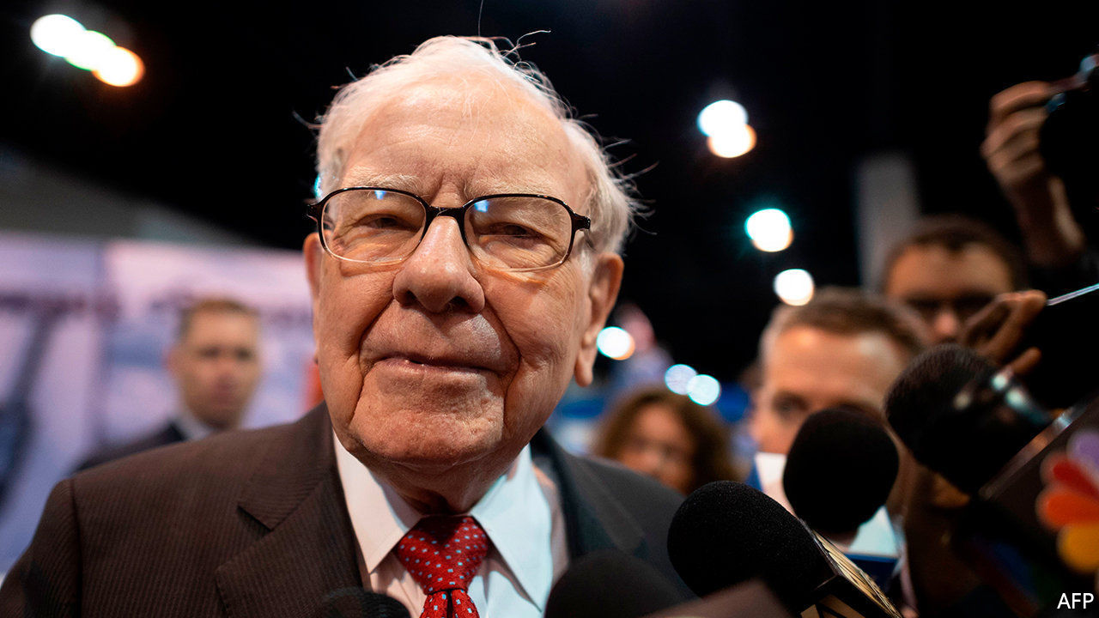

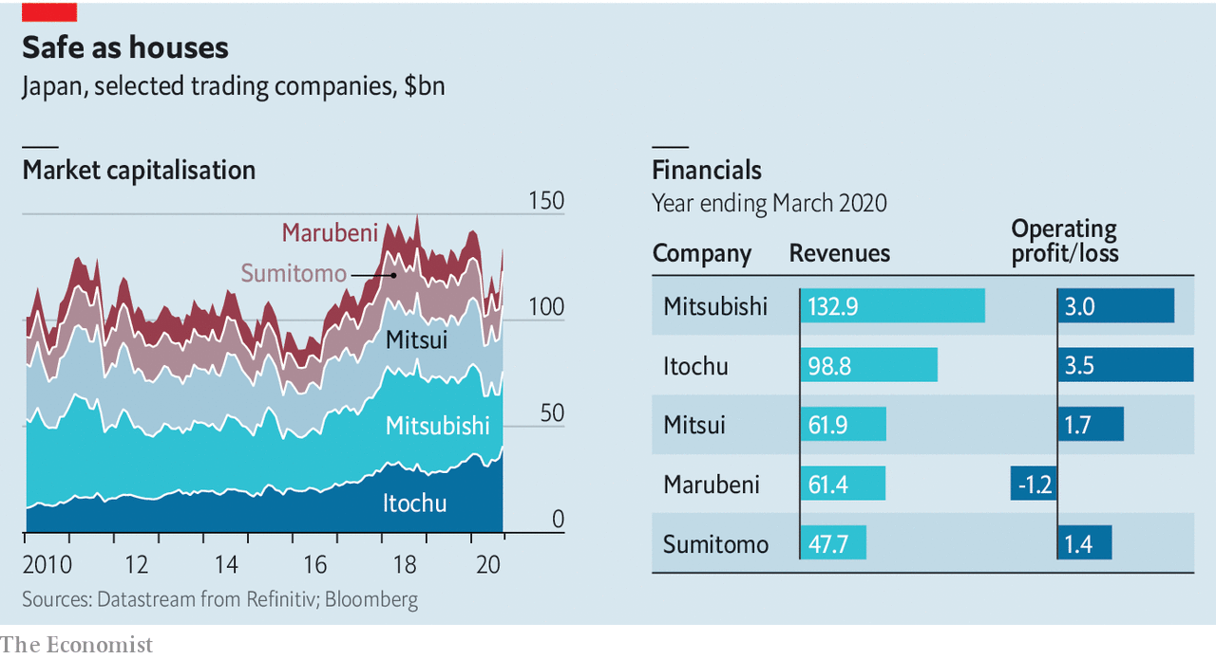

WARREN BUFFETT famously likes his businesses simple to understand and transparent. Why, then, has his conglomerate, Berkshire Hathaway, poured $6bn into 5% stakes in Japan’s five biggest trading houses? Mitsubishi, Itochu, Mitsui, Marubeni and Sumitomo do not appear to meet either criterion. They run a bewildering array of subsidiaries in most sectors of the economy. In that they bear a passing resemblance to Berkshire itself. Perhaps more important, though, they satisfied two other Buffett must-haves: their shares, dented by covid-19, looked cheap, and they pay reliable dividends.■

This article was downloaded by calibre from <https://www.economist.com/business/2020/09/03/what-does-warren-buffett-want-with-japanese-trading-houses>

|  |  |  |  |
| --- | --- | --- | --- |
| Previous | Articles | Sections | Next |

|  |  |  |  |
| --- | --- | --- | --- |
| Previous | Articles | Sections | Next |

#### Bartleby

# How has humans’ relationship with work changed over millennia?

An anthropologist examines the world of work

Sep 3rd 2020 |

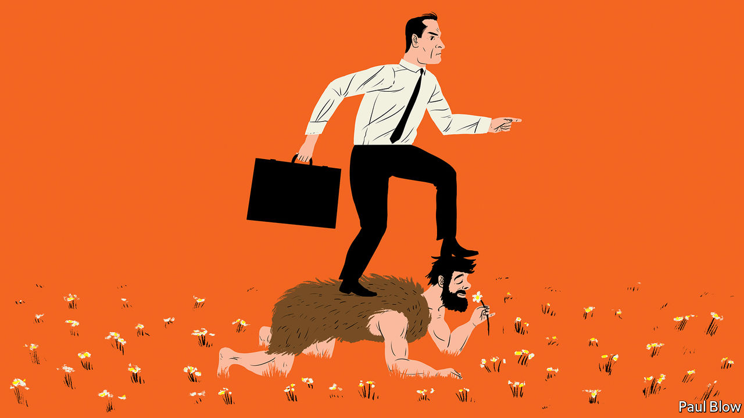

THE STUDY of working life tends to be dominated by economists, management consultants and business-school professors. So it is nice to get a new perspective. James Suzman, an anthropologist, provides that fresh appraisal in an ambitious new book called “Work: A History of How We Spend Our Time”.

Mr Suzman’s interpretation has a quasi-Biblical feel in which hunter-gatherers, like the Ju/’hoansi tribesmen of southern Africa whom he has studied, lived in the garden of Eden. They worked only 15 hours a week and shared their provisions equally. Then came “the fall” and the arrival of agriculture, which brought with it hierarchical societies, inequality, harder work and poorer diets. Farming’s only, but crucial, advantage was that the pastoralists were able to outbreed the hunter-gatherers and eventually displace them from the land.

Farming also brought a change of mentality. Hunter-gatherers may occasionally go short of food but they are rarely short of time. Agriculture is more driven by the calendar: a time to plant and a time to harvest. It also requires regular maintenance: weeding of plants, milking of cows and mending of fences. Human life became more regimented.

The seasonal nature of agriculture also had implications. Grain needed to be stored and those who controlled the stores became the elite. This led to the development of writing, as the surplus was traded and rations allocated. As well as grain silos, some agricultural societies built monumental edifices like the pyramids. That, too, required new professions like stonemasons and carpenters. In time, humans gathered in towns and cities, which also created specialist occupations like shopkeepers.

Perhaps the development of sophisticated societies was inevitable. As Mr Suzman notes, humans’ complex brains expend a lot of energy processing information. When you are awake you constantly seek out stimulation and engagement, and when you are deprived of information you suffer from boredom.

This analysis helps explain modern habits. The efficiency of agriculture and the exploitation of energy sources such as coal and oil has allowed people in the developed world to meet their basic needs of food and warmth. But human brains need to be kept active. People created tasks for themselves. First there was the Industrial Revolution, which sent workers into factories. Automation subsequently made manufacturing more efficient, at the cost of many jobs.

The rise of the service sector, Mr Suzman suggests, is a way for people to keep themselves busy, even though many individuals are dissatisfied with work they feel is meaningless. Another sign of the human need for activity is that people now undertake what was once considered work (fishing, gardening, baking) as hobbies.

The result of this process, he argues, is an unsatisfactory relationship between humans and their jobs. “The work we do also defines who we are; determines our future prospects, dictates where and with whom we spend most of our time; mediates our sense of self-worth; moulds many of our values and orients our political loyalties,” he writes.

Humans have come to view idleness as a sin and industriousness as a virtue, and teach children that hard work will pay off. In today’s developed economies, though, there is little correspondence between time worked and monetary reward. Indeed, Mr Suzman questions “why we are content to let our markets reward those in often pointless or parasitic roles so much more than those we recognise as essential”.

This familiar criticism may strike a chord with many readers. However, Mr Suzman’s view of modern society gives little credit to economic growth. Thanks to prosperity, fewer mothers die in childbirth or infants in their early years. People in general are taller and live longer; they have a higher level of education and more choices than before.

Economic growth also brings innovation. Bartleby’s mother was particularly grateful for the invention of the washing machine, which saved her a day a week of scrubbing and wringing wet clothes through the mangle.

If humankind had stuck to hunting and gathering, there would be a lot fewer humans. Even if Mr Suzman had been alive in such a world, he would have been unable to study anthropology or write books. Modern work can indeed be boring—and so, as the pandemic has shown, can sitting at home. Not many people would want to live their lives back in the year 1020, or even 102000 BC.

This article was downloaded by calibre from <https://www.economist.com/business/2020/09/03/how-has-humans-relationship-with-work-changed-over-millennia>

|  |  |  |  |
| --- | --- | --- | --- |
| Previous | Articles | Sections | Next |

|  |  |  |  |
| --- | --- | --- | --- |
| Previous | Articles | Sections | Next |

#### Over-Reliance

# Can India’s biggest company keep getting bigger?

Reliance Industries buys Future Group, its closest competitor in bricks-and-mortar retail

Sep 3rd 2020 |

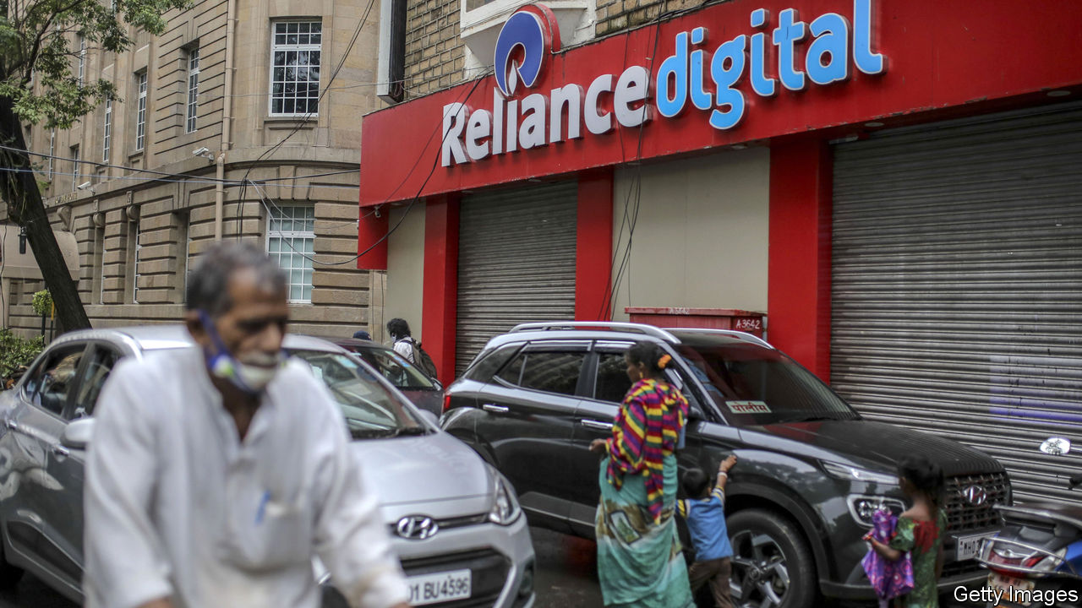

A FEW YEARS ago Future Group was seen as, well, the future of Indian retail. From humble beginnings making trousers in the 1980s, Kishore Biyani, its founder, built 2,000 shops in 400 cities across India, selling all manner of consumer goods. That is second only to the 3,700 retail outlets run by Reliance Industries, India’s largest conglomerate, which peddles everything from motor fuel to mobile phones. Future’s Big Bazaar supermarkets or Foodhall, a posh grocer, are enviably large and modern, as is its logistics network.

So enviable, in fact, that on August 29th Reliance said it would pay $3.4bn for most of the company. The combined group would account for one in three formal shops in India. “This transaction takes into account the interest of all stakeholders including lenders, shareholders, creditors,” said Mr Biyani in a statement.

Amazon might beg to differ. Last year the American e-empire struck a complex deal to provide Future, whose expansion had left it deeply indebted, with cash in exchange for an option to buy it later—law permitting. Despite fiddly visits from India’s regulators and trustbusters, Amazon’s hope was that the deal would go ahead. No such luck. On the contrary, India’s government has been making it harder for foreigners to own Indian warehouses and delivery fleets. It has tightened restrictions further amid the covid-19 pandemic.

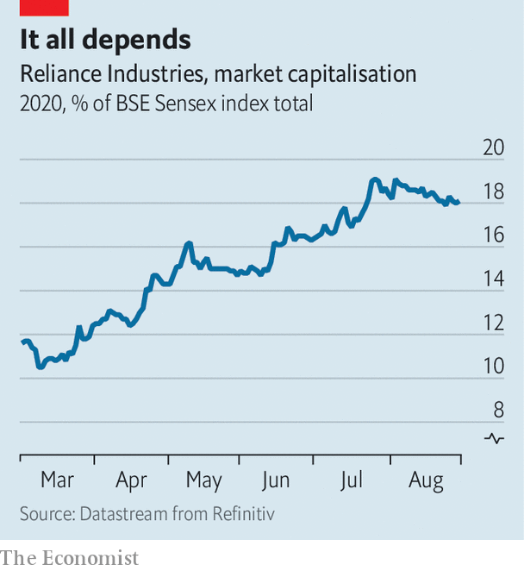

As an Indian firm, Reliance faces no such obstacles. In the past year it has emerged as India Inc’s undisputed champion. It now accounts for 18% of the market value of India’s 30 biggest firms (see chart) and has secured $20bn in foreign investments in Jio, its mobile-network-turned-digital-platform. Investors including Facebook, a social-media giant, and KKR, a private-equity one, appear to have concluded that the best way to get a piece of India’s future is through a piece of its biggest player.

Mr Biyani may have had no choice but to find a buyer for his group. In a securities filing in March he said Future Group was investigating “baseless and false” rumours about the finances of subsidiaries that were undermining their share price. On August 31st a subsidiary defaulted on some bonds held by mutual funds run by Franklin Templeton, a big American asset manager. The debt is supposed to be repaid from the proceeds of the sale to Reliance, Franklin Templeton said. Still, being part of Mr Ambani’s empire may not have been the sort of future Mr Biyani had in mind.■

This article was downloaded by calibre from <https://www.economist.com/business/2020/09/03/can-indias-biggest-company-keep-getting-bigger>

|  |  |  |  |
| --- | --- | --- | --- |
| Previous | Articles | Sections | Next |

|  |  |  |  |
| --- | --- | --- | --- |
| Previous | Articles | Sections | Next |

#### Doing the limbo

# Will Beijing derail the TikTok deal?

Chinese export restrictions throw a spanner in the American bidding war for the hit short-video app

Sep 5th 2020 |

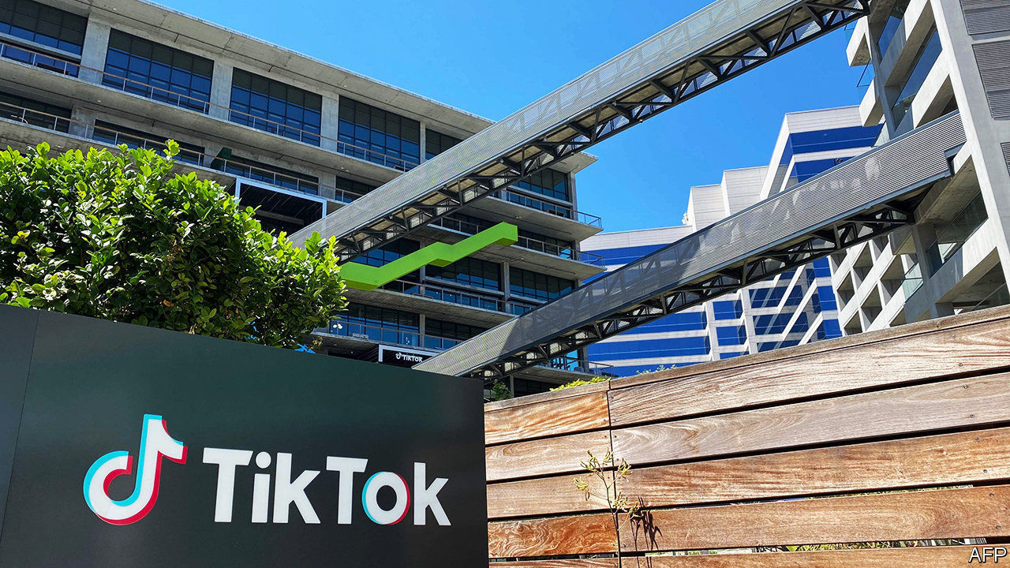

INVESTORS IN BYTEDANCE have got used to being caught between superpowers. They were still taken aback on August 28th, when an update to China’s export-licensing regime blocked the sale of the hot Chinese technology firm’s prize asset—the American arm of TikTok, a short-video app—to American firms and investors.

A Chinese riposte to President Donald Trump’s campaign against TikTok was inevitable. He contends it could give China’s Communist Party means to spy on Americans and conduct disinformation campaigns. TikTok’s assurances that it does not censor content unflattering to Beijing orsend personal data to China have fallen on deaf ears. Last month Mr Trump issued two executive orders aimed at TikTok, the most recent of which will ban it in the United States if it is not in American ownership by November 12th.

Microsoft and Oracle, two software giants, put in rival bids of around $25bn-30bn for TikTok’s operations in four markets—America, Canada, New Zealand and Australia. Oracle enlisted some American venture-capital backers of ByteDance, including Sequoia Capital and General Atlantic. It would be more hands-off than Microsoft and could let ByteDance or its founder, Zhang Yiming, reinvest in TikTok later on. A strategic sale to Microsoft would be more definitive. But Mr Zhang favoured it, according to people close to ByteDance. He once worked at Microsoft and is said to admire its chief executive, Satya Nadella. Microsoft also beefed up its bid by teaming up with Walmart, a retail colossus.

Then came the Beijing bombshell. China’s commerce ministry added certain types of artificial intelligence, as well as personalised information-push technology and data analysis, to a list of products critical to national security. These can no longer be sold abroad without official permission. They are also what makes TikTok tick. ByteDance quickly said it would obey the new rules.

There was always ambiguity as to whether the app’s American suitors would get its algorithm. They might have bought only the brand, its users, ad-buying platform and less advanced software. But ByteDance’s recommendation engine is a big part of TikTok’s appeal. It has been honed for years with data from millions of users around the world and displays an uncanny ability to divine peoples’ viewing tastes.

So Microsoft and Oracle structured their bids to keep access to ByteDance’s code. According to a shareholder, both are offering ByteDance $5bn-10bn upfront, then another $5bn or so a year for a few years depending on TikTok’s revenues and performance. In exchange, ByteDance would provide technological enhancements and updates every six months or so.

“ByteDance is over a barrel, so it has to earn the price,” says the shareholder. Trying to write a brand-new TikTok algorithm in America is out of the question, says another investor. It would be as difficult as starting a new company, he says. The Trump administration appeared to accept that TikTok would keep technology ties with ByteDance, so long as data security was ensured by an American owner and the link did not last for ever.

Now Microsoft and Oracle await ByteDance’s decision. They may withdraw their bids or amend them, to take account of the fresh uncertainty over what they would be getting. Once ByteDance signals its intentions and any revised bids are in, it could take 30 days to get China’s go-ahead. ByteDance could then request an extension to Mr Trump’s November deadline, perhaps hoping that he loses to Joe Biden in elections on November 3rd.

The risk of TikTok being blocked in America remains substantial. The Chinese government may refuse to grant an export licence and buyers could walk away. This would deprive ByteDance of billions. But that may be a price China is willing to pay to prevent America from setting a bad precedent by forcing the sale of a Chinese technology to American interests.

As for Mr Zhang, taking a stand against Mr Trump would earn him kudos, and possible rewards, at home. State approval is not something the independent-minded entrepreneur has sought. He may yet have little choice but to accept it.■

This article was downloaded by calibre from <https://www.economist.com/business/2020/09/05/will-beijing-derail-the-tiktok-deal>

|  |  |  |  |
| --- | --- | --- | --- |
| Previous | Articles | Sections | Next |

|  |  |  |  |
| --- | --- | --- | --- |
| Previous | Articles | Sections | Next |

#### Schumpeter

# Could you build a better TikTok?

The short-video app offers its putative American buyers a chance to rethink social-media business and governance models

Sep 5th 2020 |

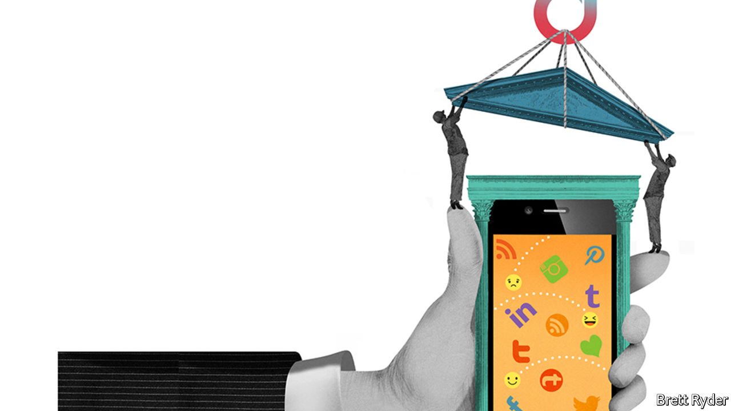

“A MAINSTREAM GIANT goes countercultural.” That is how the technology press described the decision in the early 2000s by IBM, then a paragon of corporate IT, to back Linux, an obscure operating system written by a ragtag collection of activist coders. In the event, the unnatural combination wound up being a match made in computing heaven. It turned Linux into a serious rival to Microsoft’s Windows, then the dominant operating system, and justified the decentralised way that Linux had been developed. This benefited IBM and fuelled the rise of cloud computing, which is mostly powered by Linux and similar “open source” software.

The tech industry may soon witness a similarly curious pairing. Microsoft and Oracle, a big software firm, are—along with other, less serious suitors—fighting over TikTok, a Chinese-owned short-video app. Its sale is far from assured (see [article](https://www.economist.com/node/21791418)). But if a deal were struck it too could prove momentous, this time as a chance to redefine how big online platforms are run. TikTok could become the Linux of social media—and a model for others.

The current debate over platform governance centres on two options, neither of them appealing. Governments tell firms what to do (in part already the case in Germany). Or firms can regulate themselves (as happens in most other places, including America). In a recent paper Dipayan Ghosh and Josh Simons of Harvard University propose a third way, more fitting for what the authors call “algorithmic infrastructure”—utilities for the digital public square. Governments should set a broad framework and let platforms experiment within it, the authors suggest.

TikTok could become just such an experiment. It is a young service unburdened by an ingrained business model or governance structure. ByteDance, its Chinese owner, has barely begun building these for the American market. None of TikTok’s wooers, including Oracle and Microsoft, has much experience running a social-media platform. So each could try something new as TikTok takes on social media’s incumbents, notably Facebook and Google.

Start with the business model. Social-media firms make almost all their money from advertising. This pushes them to collect as much user data as possible, the better to target ads. Critics call this “surveillance capitalism”. It also gives them every reason to make their services as addictive as possible, so users watch more ads.

The new owner is unlikely to do away with advertising in favour of subscriptions; teenagers are notoriously unwilling to pay for online content. But the new TikTok could offer an ad-free version for those who prefer to pay with cash rather than attention. It could also consider other revenue sources, for example taking a cut from enabling seamless sales of something users see in a clip or charging professional influencers once they have reached a certain prominence (1m followers should be worth at least $100 a month to TikTok stars). As for ads, TikTok could target only broad categories of users instead of individuals, much as firms once bought ads in newspapers. Advertisers, who love microtargeting, need not necessarily object, so long as TikTok remains popular with its coveted young demographic group.

Respectful management of data offers another business opportunity. TikTok could give users more control, telling them how much their data are worth and managing information on their behalf, as a data trust of sorts. Other firms could tap your TikTok “data account” if you agree and they pay—a model pioneered by startups like digi.me and CitizenMe, which pocket a share of the proceeds from the data deals.

Perhaps most important, the new owner could turn TikTok from a social-media service to a digital commonwealth, governed by a set of rules akin to a constitution with its own checks and balances. User councils (a legislature, if you will) could have a say in writing guidelines for content moderation. Management (the executive branch) would be obliged to follow due process. And people who felt their posts had been wrongfully taken down could appeal to an independent arbiter (the judiciary). Facebook has toyed with platform constitutionalism: it once let users vote on privacy changes (mostly as a PR stunt) and now has an “oversight board” to hear user appeals (a more serious effort). But the social network introduced these only in response to mounting criticisms. Drafting rules at the outset might make them more credible.

## Linux lessons

Why would any company limit itself this way? For one thing, it is what some firms say they want. Microsoft in particular claims to be a responsible tech giant. In January its chief executive, Satya Nadella, told fellow plutocrats in Davos about the need for “data dignity”—ie, granting users more control over their data and a bigger share of the value these data create. Brad Smith, Microsoft’s president, last year wrote a book in which he argued that technology firms “must accept greater responsibility for the future”.

Governments increasingly concur. In its Digital Services Act, to be unveiled later this year, the European Union is likely to demand transparency and due process from social-media platforms. In America, ideas for making them more accountable appear on both sides of the partisan divide. “Citizens who are using these platforms every day should have a say in what content is acceptable,” says Johnnie Moore, an evangelical leader who has the ear of President Donald Trump. Andrew Yang, a former Democratic presidential candidate, has launched a campaign to get online firms to pay users a “digital dividend”. Getting ahead of such ideas makes more sense than re-engineering platforms later to comply.

Today’s social-media titans will resist change. But they may reconsider, as Microsoft did with Linux. Mr Nadella’s predecessor, Steve Ballmer, once called open-source software “a cancer”. Today, Microsoft is one of the biggest users of and contributors to such projects. Surreal as it sounds, 20 years from now Facebook and Google may have reconstituted themselves for the better, too.■

This article was downloaded by calibre from <https://www.economist.com/business/2020/09/05/could-you-build-a-better-tiktok>

|  |  |  |  |
| --- | --- | --- | --- |
| Previous | Articles | Sections | Next |

|  |  |  |
| --- | --- | --- |
| Business | Sections | Schools brief |

Finance & economics

Financial coupling in China: Present tense, future market

.

The Federal Reserve: New job description

.

Indian finance: Silent no more

.

Campaign finance: Wall Street’s money

.

World Bank: Unease of Doing Business

.

Buttonwood: Impaired visibility

.

Free exchange: Parting shot

.

|  |  |  |
| --- | --- | --- |
| Business | Sections | Schools brief |

|  |  |  |  |
| --- | --- | --- | --- |
|  | Articles | Sections | Next |

#### Present tense, future market

# Is Wall Street winning in China?

As America tries to cut links, China is opening its door to foreign capital and firms

Sep 5th 2020 | SHANGHAI

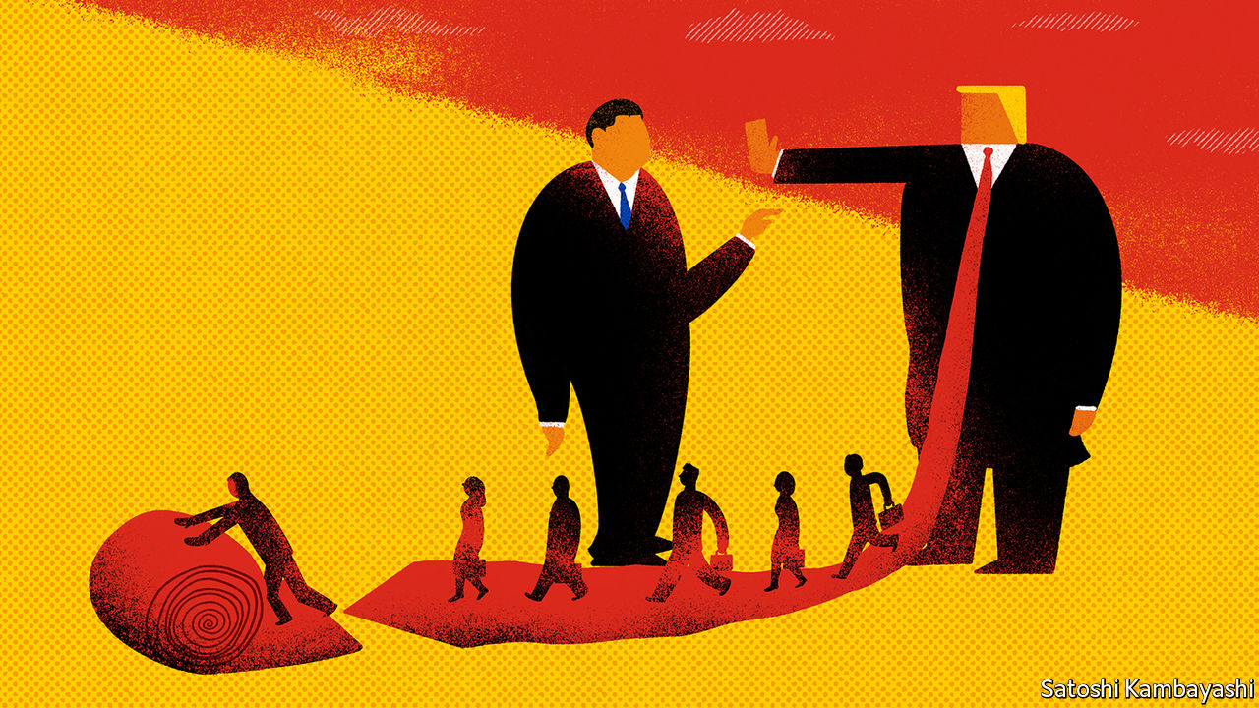

IF YOU WANT a sure-fire way to get rejected, try asking Western financial firms for interviews about how geopolitical tensions have affected their strategies in China. “This topic carries some sensitivities,” one bank demurs. “We don’t want to end up in a Trump tweet,” says another. The Economist sought interviews with 15 global banks, insurers and asset managers. All declined to speak—except on background.

Such bashfulness from the swaggering titans of finance is revealing in itself. They are on unfamiliar ground. For years the American government called on China to open up to foreign capital, while China dragged its feet. Suddenly, these roles have been reversed. President Donald Trump’s administration wants global financiers to pull back from China. But China is enticing them in, creating opportunities that few had expected to come so quickly, if ever.

It has made for a disconnect between the political and the financial realms. Many observers focus on the decoupling between America and China. Yet for those managing the trillions of dollars that flow through global markets every day, the main trend looks more like coupling. Consider these moves by investment and commercial banks in the past half-year alone. Goldman Sachs and Morgan Stanley took majority control of their Chinese securities ventures. HSBC acquired full control of its Chinese life-insurance venture. Citi received a coveted custody license to serve institutional investors in China. Among asset managers, BlackRock received approval to sell its own mutual funds in China and Vanguard decided to shift its Asian headquarters to Shanghai.

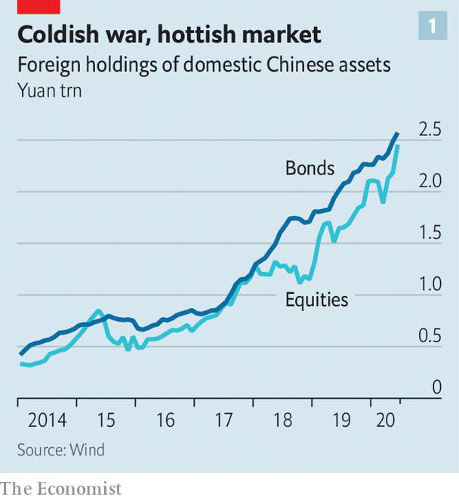

Even more astonishing are the money flows. Roughly $200bn has entered China’s capital markets from abroad over the past year. Foreign holdings of Chinese stocks and bonds at the end of June were, respectively, 50% and 28% higher than a year earlier (see chart 1). Some of this reflects an inevitable pull as global index compilers such as MSCI add Chinese assets to their benchmarks; fund managers that passively track these benchmarks must allocate cash in line with the new weightings. But it is more than that. China has made it much easier for foreigners to enter its markets, and it offers two things that are rare in the world at the moment: GDP growth and interest rates higher than zero.

Despite talk of a new cold war, there are two reasons to think that coupling, not decoupling, will remain the better description of Sino-American financial ties. The first is China’s own actions. It is pursuing what Yu Yongding, a prominent economist, has described as a “linking strategy”, seeking to create more connections with foreign companies. Since late 2019 the government has lifted foreign ownership caps on asset managers, securities firms and life insurers. It has belatedly allowed MasterCard and PayPal to enter its payments industry. And it has let foreign ratings agencies cover more Chinese firms.

Even without the linking strategy, China has ample incentive to open its financial system more widely. Its current-account surplus has steadily narrowed as a share of GDP over the past decade (though it will soar this year because of the covid-19 impact); that puts pressure on it to attract more inflows through its capital account. At the same time reformist officials want greater foreign participation in the financial system. Zhou Xiaochuan, China’s former central-bank governor, has argued that just as competition from abroad helped make Chinese manufacturers world-class, so it can elevate the finance industry. Regulators also want companies to raise more funding by issuing bonds and stocks, to lessen reliance on bank lending.

China’s regulatory relaxation dovetails with the second factor: the interests of foreign financial firms. The Chinese market is simply too big to ignore. The investable wealth of retail clients is projected to grow from about $24trn in 2018 to $41trn by 2023, according to Oliver Wyman, a consultancy. And few sophisticated, globally minded asset managers operate in China today.

Foreign institutions know better by now than to assume that the economy’s scale will directly translate into business for them. In the early 2000s China began opening its commercial-banking industry to foreigners, but their share of the market, always tiny, has shrunk over time, dipping to just about 1% of domestic-banking assets. They are bit players.

Yet foreigners may fare better in the sectors newly open to them. No global bank can compete for deposits against the likes of Industrial and Commercial Bank of China, which boasts some 15,700 branches. Success in investment banking and asset management, however, is more related to experience than to sheer heft. Can an adviser help structure a cross-border acquisition? Can an asset manager offer the right interest-rate swaps to hedge currency exposure? “These are the areas where foreign firms feel they have an advantage,” says Mark Austen, head of the Asia Securities Industry and Financial Markets Association, a group that represents many of the world’s biggest financial institutions.

Not that China is going to make it easy. A taste of the potential complications came in the approval granted to BlackRock for a fund-management company. Unlike prior approvals for Chinese-owned entities, the regulator added a condition, demanding adherence to the Internet Security Law. BlackRock will need to store client data within China and authorities could demand access, likely forcing it to segregate its Chinese and global systems.

Foreign firms will also face a ferocious battle with domestic firms on a playing field that is tilted against them. “They’ll never just completely open and be fine with us crushing the locals,” says one banker. State-owned firms will reserve their juiciest deals for domestic banks. The government is engineering mergers to create what it calls an “aircraft-carrier” investment bank to repel foreigners. And global asset managers will have little choice but to distribute their products through domestic banks and tech platforms. Chantal Grinderslev, founder of Majtildig, a Shanghai-based advisory firm, sees a split between foreign firms that commit capital to China for the long haul and those that are less patient. “If you have to be profitable in three years or less, this is not the market to enter,” she says. JPMorgan Chase, she notes, is on track to buy out the local partner in its asset-management venture for $1bn, a 50% premium over fair value. That is expensive, but it also testifies to the weight that Jamie Dimon, the banking colossus’s chief, places on China. “He is looking to build a real business,” she says.

The political tussle with America looms over these corporate decisions. “Global headquarters asked us to develop optimistic, realistic and pessimistic scenarios,” says the CEO in China of an American bank. “I laughed because there’s no point thinking of things getting better. It’s binary. Either we can continue in China or we can’t.” So far things have clearly remained on the remain-in-China side of the equation. America’s financial measures against China have thrown some sand in the gears but have not stopped them from turning.

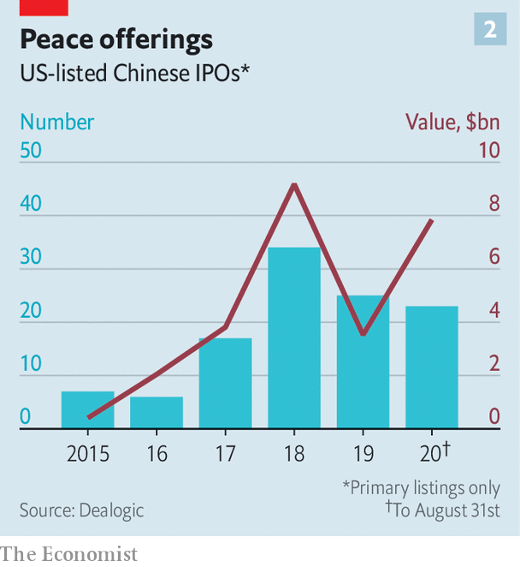

The Trump administration has blocked a federal-government pension plan from investing in Chinese stocks. It has threatened to delist Chinese firms from American stock exchanges. And it has placed sanctions on Chinese officials in Hong Kong and Xinjiang. All three moves are, in the grand scheme, mild. The government pension plan that now excludes Chinese stocks represents just 3% of American pension assets. China has until 2022 to stave off the threatened delistings, and has already proposed a compromise, giving American auditors more access to its companies’ books. In the meantime, the value of Chinese listings on Wall Street has risen this year (see chart 2). As for the sanctions, they can be painful for individuals, but would have harmed China much more if they had named entire banks.

It is only prudent for firms to prepare for America to take a tougher line against China. But the implications in the financial sector are different from, say, the industrial sector. Factories require a large fixed investment and carefully configured supply chains. Investments in bonds or equities are, by contrast, much easier to adjust—at least so long as China lets investors move cash out of its markets. Even for firms building up brokerages or asset-management operations in China, the investments are small compared with their global footprints. The Chinese securities firm controlled by UBS, for instance, held just 5bn yuan ($730m) in assets at the end of 2019—bigger than any other foreign-owned securities firm in China but barely 0.2% of UBS’s global investment-banking assets.

The one American action that could almost instantaneously derail financial coupling would be to block China from the dollar-payments system. The administration could do so by pressuring SWIFT, a Belgium-based messaging system that underpins most cross-border transfers, to boot out Chinese members. Or it could order the big banks which clear dollar payments in America to stop serving Chinese banks.

Chinese officials, alarmed by these once-unthinkable possibilities, have held meetings in recent months to discuss how they might respond. They have talked about promoting the yuan as an alternative to the dollar and home-grown payment networks as alternatives to SWIFT. In practice, neither would help much. The yuan, constrained by capital controls, remains a weakling in global finance, while China’s would-be SWIFT replacements have failed to gain traction.

The biggest constraint on America is the damage that it would suffer itself. Cutting China off from the dollar would undermine not just Chinese banks but also China-based companies that account for more than a tenth of the world’s exports. This would trigger a collapse in international trade, massively disrupt supply chains and, quite possibly, deepen the global recession. The fact that American policymakers must contemplate such consequences is an argument in favour of China’s linking strategy. “The only option is more openness,” says Larry Hu, head of China economics at Macquarie Group in Hong Kong. “You must create a situation where your counterpart has more to lose.” For foreign financiers in China, that, oddly enough, is music to their ears.■

This article was downloaded by calibre from <https://www.economist.com/finance-and-economics/2020/09/05/is-wall-street-winning-in-china>

|  |  |  |  |
| --- | --- | --- | --- |
|  | Articles | Sections | Next |

|  |  |  |  |
| --- | --- | --- | --- |
| Previous | Articles | Sections | Next |

#### New job description

# Will the Fed’s policy shift start a trend?

A weaker dollar may force other central banks to follow

Sep 5th 2020 | WASHINGTON, DC

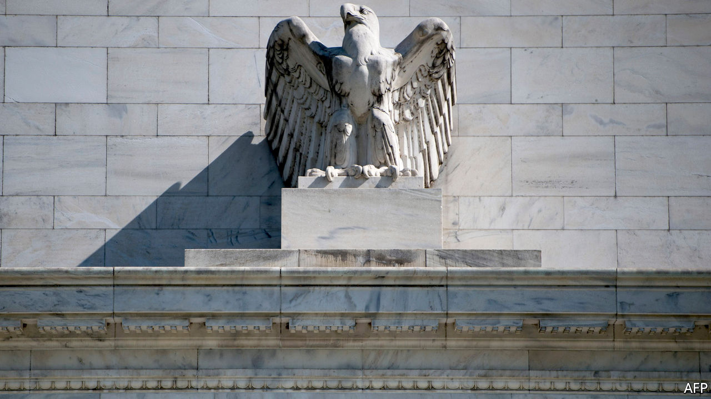

IN 2018, WHEN America’s long recovery from the 2007-09 financial crisis pushed the unemployment rate below 4%, the Federal Reserve had a simple message for American workers: do not get used to it. The central bank’s economic projections revealed that its officials believed 4.5% to be the lowest sustainable jobless rate, to which America would need to return to stop inflation surging upwards. If higher interest rates and slower growth were needed to achieve that, so be it.

On August 27th Jerome Powell, the Fed chairman, acknowledged what common sense suggested two years before: that an intentional increase in unemployment is an odd thing to pursue after nearly 20 years of depressed labour-market conditions. Speaking at an annual central-banking shindig, Mr Powell unveiled the conclusions of a monetary-policy strategy review begun in 2019. The coming changes to Fed policymaking could initiate an important global shift in central-bank practice.

The Fed’s old framework was forged by the inflationary tumult of the 1970s. Post-war economists understood there to be a negative relationship between inflation and unemployment—known as the Phillips curve—such that policymakers could push unemployment as low as they liked, provided they were prepared to accept more inflation. But soaring prices persuaded many that this relationship did not hold below some minimum sustainable level of unemployment. Attempts to push joblessness lower would yield higher inflation, but at best only a temporary reduction in unemployment. By the 1990s, most central banks had resolved to target a low level of inflation, generally around 2%.

But since the embrace of inflation targeting in the 1990s, the relationship between employment and inflation has weakened. Soaring joblessness during the Great Recession failed to produce the expected plunge in prices. Neither have low levels of unemployment since then ended an era of historically low inflation. Precisely why the relationship between inflation and joblessness changed is uncertain. Some economists reckon central banks’ credibility in managing inflation anchored the public’s expectations too well. Others point to a decline in workers’ bargaining power, which has eased the pressure on firms to raise prices in order to cover the cost of expensive pay packets. Still others point to technological change and globalisation, which expand consumer options and allow firms to respond to increased demand without raising prices. Whatever the cause, the flattening Phillips curve biased monetary policy in an overly hawkish way, eventually prompting the Fed rethink.

The changes to its framework may seem modest. Because the maximum sustainable level of employment cannot be measured, the Fed will give up worrying about overshooting it and focus only on employment shortfalls. The 2% inflation target remains a constraint, but a more flexible one than before. It should be hit on average, Mr Powell explained, meaning that periods of below-target inflation can be offset by at least some time with inflation above the target as well.

But the conceptual change—abandoning the notion of a minimum sustainable unemployment rate—is significant. And the practical effects could be large. Had the Fed enjoyed more freedom in recent years, it could have raised interest rates more gradually, or not at all, enabling a faster and more complete labour-market recovery.

Whether policy will change much in practice is as yet unclear. Markets, for their part, appear not to see a radical change of regime in the offing. Market-based measures of inflation expectations are around 1.7%, below the Fed’s 2% target. American stockmarkets, which seem to soar at the gentlest of nudges, have rallied, some hitting record highs in the past week. More important is the reaction in foreign-exchange markets. The greenback has slipped nearly 1% against a basket of major currencies since Mr Powell’s speech, bringing its total decline since May to about 8%. A weakening dollar could indicate that markets see more room for policy divergence between the Fed and other central banks, most notably the European Central Bank, whose mandate does not explicitly require it to minimise joblessness.

Under any circumstances, the macroeconomic developments which led the Fed to revise its strategy would no doubt have influenced other central banks to adjust their own policies. But in weak advanced economies with interest rates close to zero, currency appreciation against the dollar places a drag on spending which cannot easily be offset by further easing. The Fed may thus find that its modest adjustment encourages imitators elsewhere in surprisingly short order. ■

This article was downloaded by calibre from <https://www.economist.com/finance-and-economics/2020/09/05/will-the-feds-policy-shift-start-a-trend>

|  |  |  |  |
| --- | --- | --- | --- |
| Previous | Articles | Sections | Next |

|  |  |  |  |
| --- | --- | --- | --- |
| Previous | Articles | Sections | Next |

#### Silent no more

# Two damning portrayals of Indian finance

A pair of former central bankers spill the beans

Sep 5th 2020 |

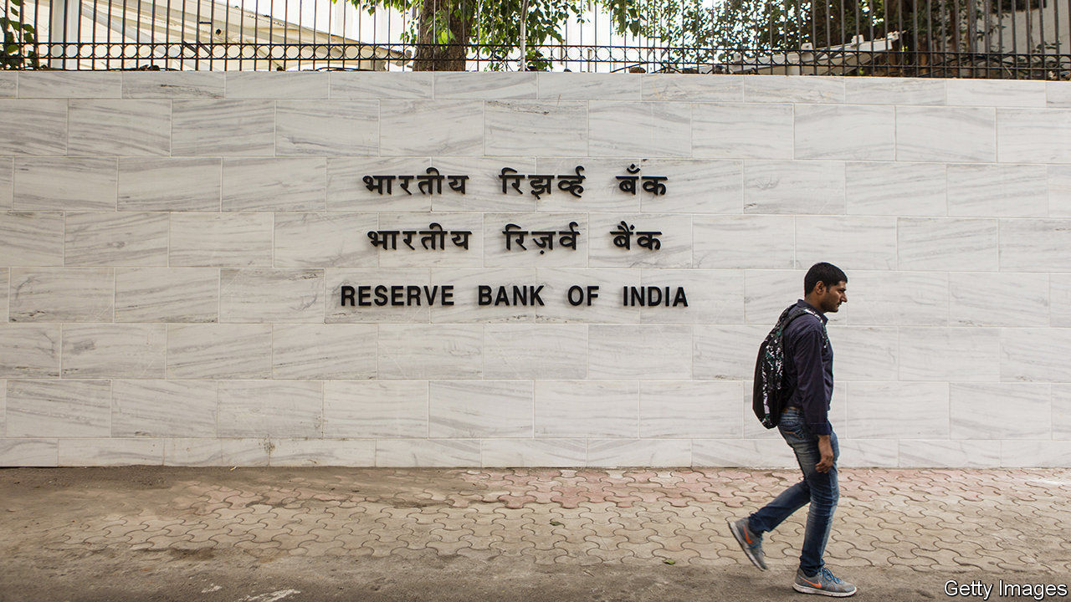

CENTRAL BANKERS who leave office often write memoirs. Few are as damning of the financial system they once served as Urjit Patel, the governor of the Reserve Bank of India (RBI) in 2016-18, and Viral Acharya, its deputy governor in 2017-19, who is now an academic at NYU Stern School of Business. In separate books, they tell stories of rampant government meddling in the banking system. Both stood down before their terms ended. Their books suggest why.

Mr Patel does not directly address his departure. But he appears to have reached breaking point when the government of Narendra Modi tried to dilute new bankruptcy rules that it had once championed to tackle the problem of zombie corporations.

In a chapter titled “The Empire Strikes Back”, he relates how the government lobbied the RBI to extend repayment times for companies with 2trn rupees ($27bn) in aggregate exposure. “Instead of buttressing and future-proofing the gains thus far”, he writes, the atmosphere became one of going “easy on the pedal”.

Mr Patel describes how Indian savers, to whom he dedicates his book, see their funds used by government-controlled banks and other financial institutions for “vague (and extraneous) objectives”, such as supporting politically connected states and companies and, sometimes, the stockmarket. The distortions undermine banks’ incentives to apply the scrutiny needed to properly allocate credit. Price signals become confused; interest rates for viable private companies must remain high to offset the ones that don’t pay.

Mr Acharya documents other forms of interference. These include constant pressure to provide stimulus, raids on the central bank’s reserves to cover budget deficits, and even threats to invoke a long-buried clause in the RBI’s enabling legislation, allowing the government to give directions to the central bank when it was in “the public interest”. Suggesting sympathy for Mr Patel, he says the ex-governor’s battle to defend financial stability made his job untenable.

Mr Acharya grimly concludes that a “silent crisis” has been unfolding in India’s banking system, with borrowers prevented from defaulting only because the government is presumed to prop everything up. That works until the government’s “solvency is itself considered to be on the brink”. With the economy shrinking by 24% in the April-June quarter, compared with the same period in 2019, and public finances under pressure, the strains are only likely to get worse. But at least with these two brave books the silence has been broken.■

Urjit Patel, Overdraft, Saving the Indian Saver. Viral Acharya, Quest for Restoring Financial Stability

This article was downloaded by calibre from <https://www.economist.com/finance-and-economics/2020/09/05/two-damning-portrayals-of-indian-finance>

|  |  |  |  |
| --- | --- | --- | --- |
| Previous | Articles | Sections | Next |

|  |  |  |  |
| --- | --- | --- | --- |
| Previous | Articles | Sections | Next |

#### Campaign finance

# Who does Wall Street back for president?

Neither presidential candidate is bringing in the big bucks

Sep 5th 2020 | NEW YORK

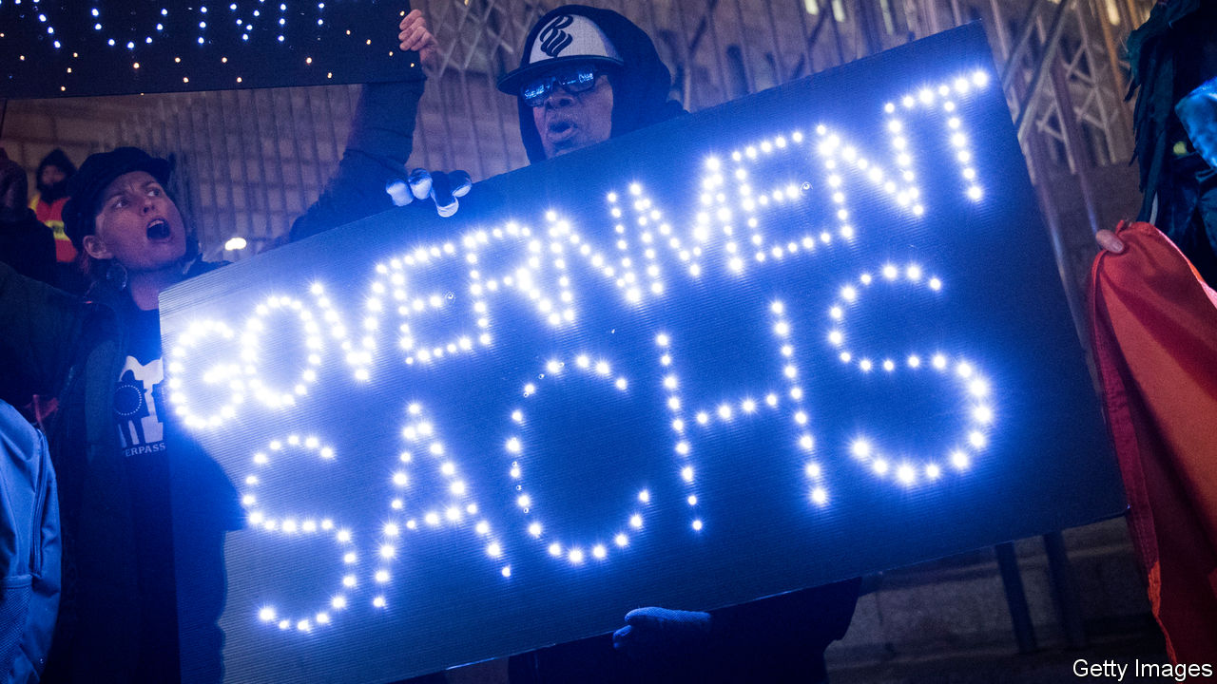

THE TIES between Wall Street financiers and politicians are the subject of a lot of scrutiny. Not for nothing is Goldman Sachs, a bank, sometimes nicknamed “Government Sachs”. But how important are the moneybags in New York to political success in Washington, DC? Quantifying the relationship can be done using the extensive data collected about campaign donations. It’s not an uplifting exercise.

The first task is to decide who counts as Wall Street’s elite. As well as encompassing the bosses of banks like JPMorgan Chase and Morgan Stanley, they also include the heads of some hedge funds, private-equity shops, asset managers and wealth-management firms in New York, New Jersey and Connecticut. In addition are billionaire New Yorkers on the Forbes list, who have earned their wealth via some form of finance, such as Michael Bloomberg of the eponymous financial-information firm. Totted up this way, the financiers amount to 68 people. Of these, 52 have given money to political campaigns in at least one of the two most recent general-election cycles (2015-16 and 2019-20). Together they are worth $310bn and manage firms with assets of over $32trn.

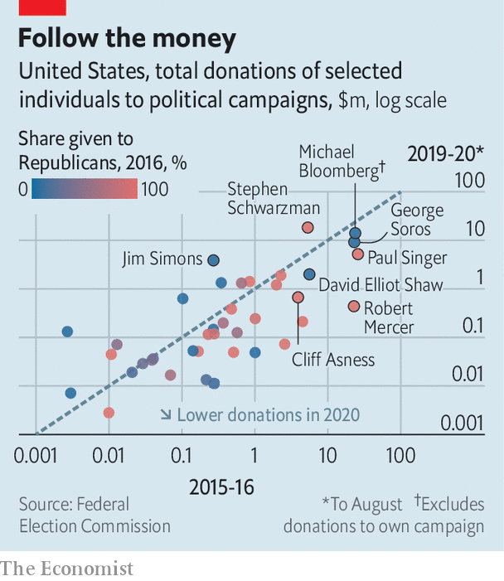

Estimates of their political contributions are drawn from campaign-finance data on individual donations* in the Federal Election Commisson, a regulator. The Economist has attempted to contact larger donors to verify them. Not all have responded. Most of these Wall Street donors hedge their bets; they give to campaigns from both parties. But the biggest contributors have, in the past, tended to be one-party loyalists (see chart). Eight of the 52—including Cliff Asness of AQR Capital Management, an investment-management firm; Robert Mercer, then co-CEO of Renaissance Technologies, a hedge fund; and Paul Singer of Elliott Management, an activist-investment firm—gave exclusively to Republican campaigns in the 2016 election cycle. Nine—including Mr Mercer’s then-colleague Jim Simons, who founded Renaissance, George Soros, a hedge-fund veteran, and David Elliot Shaw of D.E. Shaw, another hedge fund, gave only to candidates of the Democratic Party.

In the intervening years, the pro-Republicans have appeared to grow less partisan. Just three of them have remained Republican-only, including Mr Singer and Mr Mercer. Total donations went mostly to Republicans in 2016, but are now evenly split.

Political leanings aside, much else has shifted since the last election. Firstly, the sums given have fallen. In 2016 the financiers provided $130m to political campaigns, or 1.4% of the total raised. So far this cycle, their share is just 0.5%. Strikingly, many appear to be sitting 2020 out; around a fifth of those who gave meaningfully in the last election have given nothing in 2020. This decrease is largely the result of a drop in contributions to the presidential campaign, particularly that of Donald Trump. Stephen Schwarzman of Blackstone, a private-equity firm, who has given more than $18m this year, compared with around $5m last time, is the only titan who has increased his share to the president. Mr Mercer gave more than $15.7m to Trump-affiliated committees in 2016. This time he has given less than $400,000.

It is a similar story with Joe Biden, the Democratic challenger. His two biggest Wall Street supporters are Mr Soros and Mr Shaw, both of whom have given around $500,000 each—less than they had given to Hillary Clinton at this point in her race against Mr Trump in 2016.

The congressional races are attracting more attention. The Wall Street group has given over $8m to Senate races and $19m to House races, triple the total contributed to congressional races at this point in 2016. The “Senate Majority PAC” (SMP) is particularly popular with Democratic donors. Mr Shaw has given more to Senate campaigns than he has to Mr Biden. Mr Simons has given $3.5m to the SMP.

The Senate race is of keen interest because it is considered particularly tight. But the lowly sums in the presidential battle may reflect a dispiriting reality—that neither Mr Trump nor Mr Biden generates much enthusiasm. At least those worried that Wall Street has Washington in its pocket can console themselves that so far the financiers are not providing the sort of sums that can help define the race. ■

*Donors may also give money through charitable organisations, which are not always required by the Federal Electoral Commission to disclose their individual donors. A spokesperson for George Soros confirms that his political donations through his charitable organisation, Fund for Policy Reform, for the 2019-20 electoral cycle are significantly larger than his individual contributions.

Dig deeper:  
Read the [best of our 2020 campaign coverage](https://www.economist.com/us-election-2020) and our [presidential-election forecast](https://projects.economist.com/us-2020-forecast/president), then sign up for Checks and Balance, our [weekly newsletter](https://www.economist.com/checksandbalance/) and [podcast](https://www.economist.com/podcasts/2020/08/28/checks-and-balance-our-weekly-podcast-on-american-politics) on American politics.

This article was downloaded by calibre from <https://www.economist.com/finance-and-economics/2020/09/05/who-does-wall-street-back-for-president>

|  |  |  |  |
| --- | --- | --- | --- |
| Previous | Articles | Sections | Next |

|  |  |  |  |
| --- | --- | --- | --- |
| Previous | Articles | Sections | Next |

#### Global red tape

# The World Bank’s business-rankings mess

The data may have been fiddled

Sep 5th 2020 |

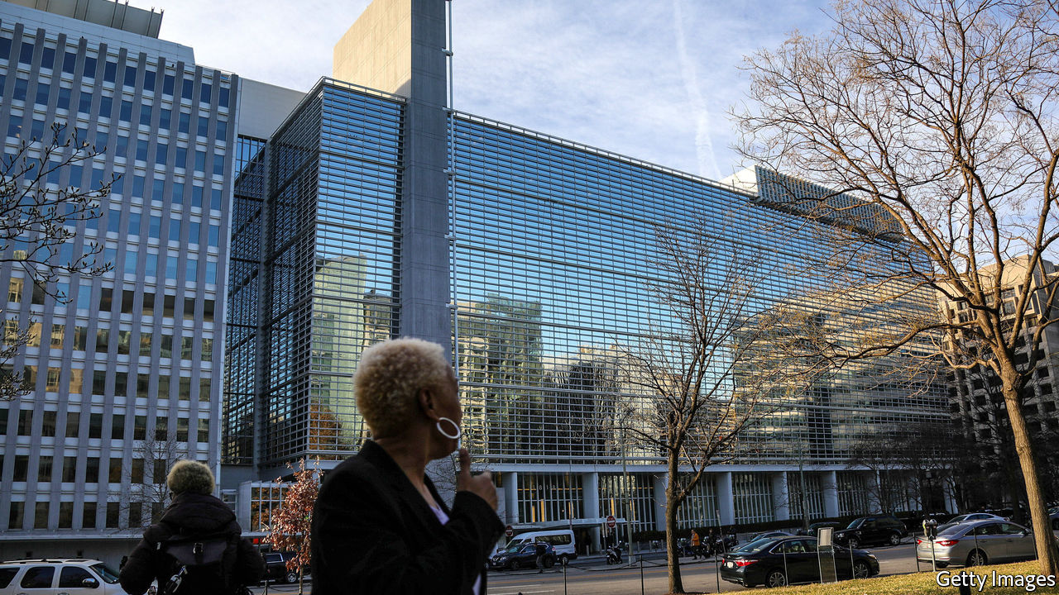

RUNNING A BUSINESS is hard in many parts of the world. So the World Bank gives governments an incentive to make it easier, and ranks them according to where the burden of regulation is lightest. This year, though, its Doing Business (DB) index has itself been ensnared in procedural problems. On August 27th the Bank said that publication of the next set of rankings would be delayed. It comes in a year when, The Economist understands, China was going to be ranked one of the biggest improvers. On that the Bank had no comment.

Some cheered the postponement because they think the index is counterproductive, specious, or both. Many critics worry that it encourages PR-attentive technocrats and politicians to slash regulations excessively and that it ignores how rules are applied in practice. A study in 2015 found “almost zero correlation” between the DB results and what businesses say when directly surveyed by the World Bank.

Still, the recent suspension happened not because of methodological concerns, but because of questions about data integrity. Nine World Bank whistle-blowers have alerted management to alleged “irregularities” in the indices published in 2017 and 2019, including for Azerbaijan, China, Saudi Arabia and the United Arab Emirates.

It is not hard to see why countries might want the figures to be fiddled. Falling down the rankings is politically embarrassing. The World Bank, meanwhile, may have an incentive to keep relations with important members sweet. In 2017 its leaders grew concerned that China’s DB ranking would fall, which led the bank to double check the results, an ex-insider says. After fixing a coding error and tweaking a judgment call, its ranking did not drop.

A further source of uneasiness comes from countries paying the World Bank for advice on how to rise up the DB rankings. China, Saudi Arabia and the United Arab Emirates all pay for such Reimbursable Advisory Services (RAS), which in the past were delivered by some DB staffers themselves. (The use of DB officials in this way was stopped in 2019.)

Some performance improvements defy logic. An email seen by The Economist suggests that Azerbaijan’s rise to attain the top score globally for legal rights when obtaining credit last year was particularly controversial. Its overall score declined.

The World Bank is doing a thorough audit of its processes, including those relating to the RAS. Whatever the investigation uncovers, the saga highlights the tension between the institution’s different roles. The Bank likes to think that its diplomatic and research functions are complementary. If only things were so simple.■

This article was downloaded by calibre from <https://www.economist.com/finance-and-economics/2020/09/05/the-world-banks-business-rankings-mess>

|  |  |  |  |
| --- | --- | --- | --- |
| Previous | Articles | Sections | Next |

|  |  |  |  |
| --- | --- | --- | --- |
| Previous | Articles | Sections | Next |

#### Buttonwood

# Can private equity’s numbers be trusted?

More transparency is needed as the industry attracts new investors

Sep 3rd 2020 |

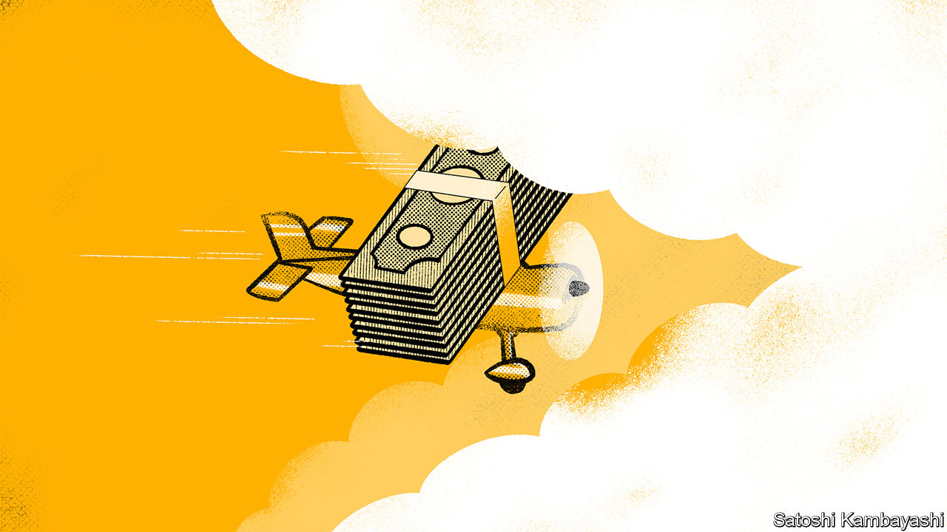

IN “THE BLACK ISLAND”, Tintin, the quiff-sporting boy reporter, uses a plane to chase a pair of forgers flying over Scotland. As he closes in on them, they suddenly disappear into a bank of clouds. “Just as I feared,” says his pilot. “Running into cloud.” After crashing into a dyke, Tintin emerges bruised but impressed by the itchy feel of Scottish fashion and his first pint of stout.

Running into cloud is a good description of the sustained rush into private equity. Sophisticated investors—pension funds, insurers and the like—have poured money into the asset class in recent years. Soon, in America at least, they may have more company. On August 26th the Securities and Exchange Commission, America’s markets watchdog, broadened the pool of “accredited investors” deemed savvy enough to play in private markets. They may include some retail investors.

But veterans and novices alike face the same visibility problem. Working out how much money is channelled into private equity, how much it makes and whether the adventure is worth it is fiendishly tricky. That is because, even if private equity today is not all that private—its biggest firms are listed, and they routinely buy and sell companies and securities in public markets—the data leave a lot to be desired.

Three areas of fuzziness stand out. First is the amount of money allocated to the industry. Some pension funds specify the proportion of their assets that they intend to invest in private equity but few reveal their precise disbursements. Reports by third-party researchers that calculate aggregate fundraising are “directionally suggestive” at best, says one. He confesses their estimates often prove wrong six months on, sometimes by as much as 25%. Between data-crunchers, discrepancies arise. Pitchbook, one of them, says private-equity funds raised $474bn globally last year; Preqin, another, reckons they collected $595bn.

Assessing the returns the industry generates is the next headache. Investors commit money to private-equity funds. They provide it when it is called upon to buy assets. The favourite performance indicator of such funds is the “internal rate of return” (IRR), which calculates returns on the capital deployed to buy the assets, but ignores the rest of the committed money. For investors, immobilising money carries an opportunity cost, all the more so in an environment where idle cash, in real terms, earns you nothing or worse. IRRs can be easily manipulated by altering the timing of payments and by using leverage. They also assume that when private-equity firms return capital to investors, it can be reinvested at the same rate that the rest of the fund is earning. That is hardly guaranteed.

The third shortcoming is the industry’s lack of a widely accepted benchmark—the equivalent, say, of the S&P 500 index in America’s public stockmarkets. Recently investors have developed measures dubbed “public-market equivalents” (PMEs), which compare the results of investing in private markets with public ones. But PMEs often resemble fiddly do-it-yourself accounting devices rather than something dependable. The industry, which attracts some of the world’s shrewdest investors, has yet to come up with a way to measure the riskiness of an investment. Public markets have had the Sharpe ratio, which is used to gauge the risk-adjusted return of assets, for over 50 years.

The industry continues to attract newcomers who buy into its claims that it is a profitable form of investment and a good way to diversify. It insists that investors who stay in for the long haul have enjoyed buoyant returns. But the flimsiness of the data makes it disturbingly hard to verify these claims and means the critics of the industry and its defenders rarely fight on common ground. Ludovic Phalippou, an Oxford University academic, claimed in July that the numbers were “a myth perpetuated by thousands of clever people”, mainly because of misuse of IRRs. KKR, a private-equity giant, retorted that his arguments were based on “flawed assumptions and selective engagement with the facts”. Because of the deficiencies in the data, it was hard to say whose claims carried more weight.

Mysteriousness has long added to private equity’s elite status. But the more money the industry raises and prepares to deploy and the more it is open to ordinary investors, the more pressure it will come under from regulators to improve transparency. It doesn’t take a Tintin to work that out.

This article was downloaded by calibre from <https://www.economist.com/finance-and-economics/2020/09/03/can-private-equitys-numbers-be-trusted>

|  |  |  |  |
| --- | --- | --- | --- |
| Previous | Articles | Sections | Next |

|  |  |  |  |
| --- | --- | --- | --- |
| Previous | Articles | Sections | Next |

#### Free exchange

# Did Abenomics work?

And what did the world learn from it?

Sep 3rd 2020 |

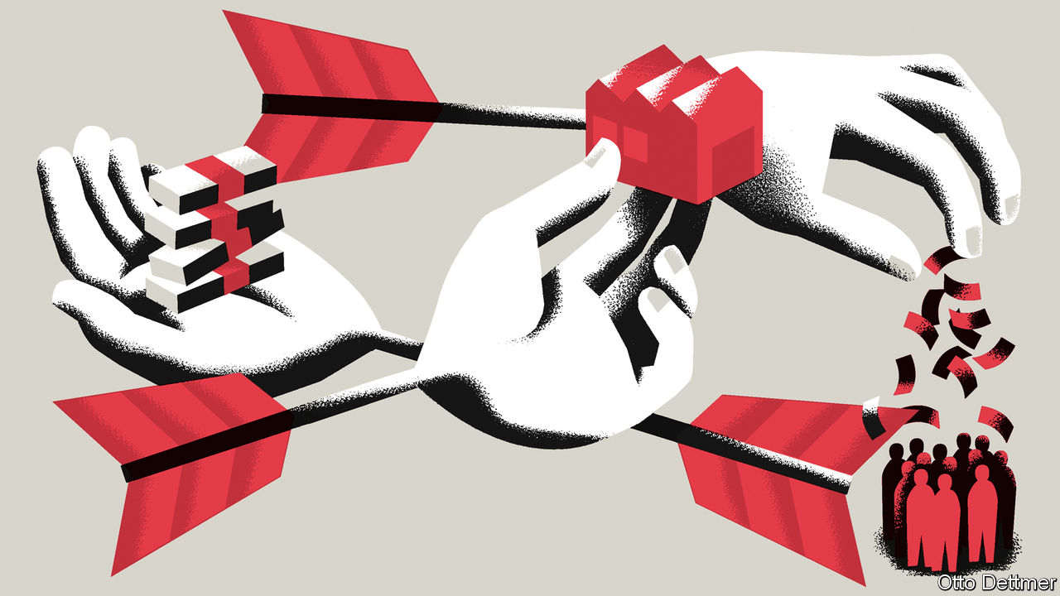

AS AN EXERCISE in political branding, Abenomics has been an unusual success. When Abe Shinzo returned to power as Japan’s prime minister in December 2012, he said he would revive the economy by loosing off three “arrows”. The first, expansive monetary policy, would banish deflation. The second, flexible fiscal policy, would restrain public debt without jeopardising the recovery. The third arrow, structural reform, would revive productivity and lift growth. The image stuck, even after the government tired of it.

Mr Abe’s archery excited keen interest elsewhere. Many other mature economies, after all, look a little Japan-ish. They combine greying populations, faltering growth, high public debt and stubbornly low inflation, despite miserly interest rates. “Yes, we are probably all Japanese now,” concluded Jacob Funk Kirkegaard of the Peterson Institute for International Economics, an American think-tank, last year, even before the covid-19 pandemic added to the debt, disinflation and despair. As Mr Abe departs after almost eight years in charge, what lessons can others draw?

The first lesson is that central banks are not as powerful as hoped. Before Abenomics, many economists felt Japan’s persistent deflationary tendencies stemmed from a reversible mistake by the Bank of Japan (BoJ). It had combined fatalism with timidity, blaming deflation on forces outside its control, and easing monetary policy half-heartedly. In 1999 Ben Bernanke, later a Fed chairman, called on the BoJ to show the kind of “Rooseveltian resolve” that America’s 32nd president showed in fighting the Depression.

Sure enough, in April 2013, the BoJ made a display of new determination, promising to buy enough assets, including government bonds and equities, to raise inflation to 2% within about two years. In 2016 it introduced negative interest rates, a cap on ten-year bond yields and a promise to let inflation overshoot its target (which the Federal Reserve emulated last month). These efforts stopped persistent deflation, a feat that is often forgotten. But they could not lift inflation close to the central bank’s target (see left-hand chart).

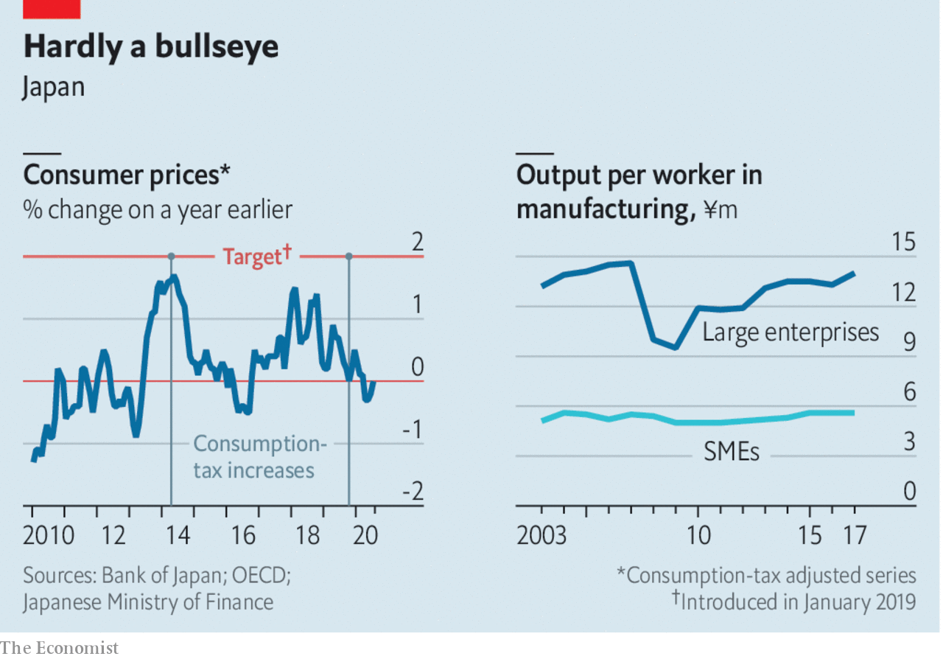

One reason may be peculiar to Japan: its regular workers are economically monogamous, enjoying long-term employment relationships with a single firm. They are almost impossible to fire but also difficult to poach. Thus, although Abenomics lowered unemployment to just 2.2% by the end of last year, regular workers did not benefit from a bidding war for their talents. Firms instead spent more on part-time workers. Yet because these recruits collect a relatively small share of the country’s wages, their improved pay put little upward pressure on prices.

Another threat to the power of central banks could recur elsewhere. Japan’s public became so accustomed to unchanging prices, it assumed the future would mirror the past. That assumption, which shaped pay negotiations between unions and employers, then became self-fulfilling. This was a difficult legacy for Abenomics to overcome. Proponents of monetary activism were right to criticise the BoJ for not fighting this mindset earlier. They were wrong to think those past mistakes were easily reversible once Abenomics began. “I was too optimistic and too certain about the ease with which a determined central bank could conquer deflation,” admitted Mr Bernanke in 2017.

## Big is beautiful

As well as showing that monetary policy is less powerful than hoped, Abenomics has shown that high public debt is less dangerous than feared. Japan’s gross government debt was almost 230% of GDP when Mr Abe took charge and is even higher now. But the cost of government borrowing has remained negligible. Indeed, yields for five-year bonds are negative.

Fiscal scolds point out that yields on bonds are low because the central bank is buying so many of them: its holdings now amount to 99% of GDP, whereas the Fed’s equal about 20% of American GDP. The term “financial repression” gets bandied about, as if Japan’s central bank is conspiring to let the government spend more than it should, at the expense of the private sector. But that gets things backwards. The central bank is doing everything it can to revive private spending. Until it succeeds, though, the government has to fill whatever gap in demand remains. The shortfall in private spending is what makes government deficits necessary. It is also what makes them so cheap to finance.

What about the third arrow of Abenomics? Before its lost decades, Japan taught the world how to raise productivity in big firms, through “lean manufacturing”, just-in-time delivery, and so on. Unfortunately, the country also shows how badly productivity can lag in small firms. Many operate in service industries, where productivity is notoriously low. Yet even in manufacturing, small enterprises are less than 40% as productive as their larger counterparts, according to the Ministry of Finance (see right-hand chart).

Just because a firm is small does not mean it is new or particularly entrepreneurial. In Japan, three-quarters of small firms are over ten years old and two-thirds of the owners of small and middling enterprises will be 70 or older by 2025, according to the OECD. The government provides plenty of support to small firms. It guaranteed loans worth 4.4% of GDP in 2016, compared with an average of just 0.1% in the OECD, a group of mostly rich countries. In a report last year, the group expressed concern that such guarantees weaken the incentive for banks to monitor their borrowers and push them to improve.

For the many countries that have expanded similar guarantees in response to the covid-19 pandemic, Japan thus provides a useful lesson. Governments must be careful to ensure that this necessary effort to ensure the survival of small firms in the short term does not permit stagnation in the long term.

Abenomics will almost certainly outlast the prime minister who introduced it. None of Mr Abe’s potential successors, including Kishida Fumio, his party’s head of policy, Ishiba Shigeru, a former defence minister, or Suga Yoshihide, the chief cabinet secretary, are likely to renounce it. They may, however, be tempted to rebrand it. Suganomics, for example, has a nice ring to it. ■

This article was downloaded by calibre from <https://www.economist.com/finance-and-economics/2020/09/03/did-abenomics-work>

|  |  |  |  |
| --- | --- | --- | --- |
| Previous | Articles | Sections | Next |

|  |  |  |
| --- | --- | --- |
| Finance & economics | Sections | Science & ... |

Schools brief

A social turn: Hard work and black swans

.

|  |  |  |
| --- | --- | --- |
| Finance & economics | Sections | Science & ... |

|  |  |  |  |
| --- | --- | --- | --- |
|  | Articles | Sections | Next |

#### Hard work and black swans

# Economists are turning to culture to explain wealth and poverty

As a result, the ideas of the earliest economists are being revised and improved

Sep 5th 2020 |

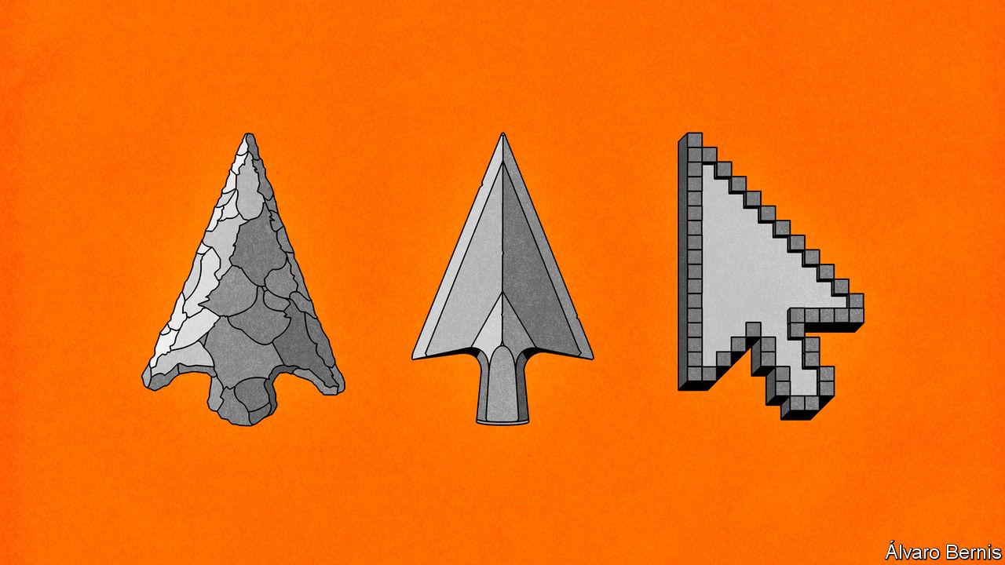

THE EMERGENCE of the discipline of economics in the 18th century was the result of people trying to explain something that had never happened before. At the time a handful of countries were becoming fabulously rich, while others remained dirt-poor. In 1500 the world’s richest country was twice as well-off as the poorest one; by 1750 the ratio was five to one. It is no coincidence that the most famous book in economics, published in 1776, inquired into “the Nature and Causes of the Wealth of Nations”.

In order to explain such a divergence between rich and poor countries, the early economists were obsessed with culture, a catch-all term encompassing a society’s beliefs, preferences and values. Adam Smith, the author of “The Wealth of Nations”, explored the ways in which culture helped or hindered capitalism. He argued that certain norms were required in order for market economies to thrive—most importantly, that people would be self-interested, but that they would satisfy their self-interest by adapting to the needs of others. Karl Marx, a few decades later, worried that a culture of “oriental despotism” prevented the emergence of capitalism in Asia.

The speculations of Smith, Marx and others were often vague. Max Weber’s “The Protestant Ethic and the Spirit of Capitalism”, published in 1905, made them concrete. Weber argued that Protestants, in particular Calvinists, drove the emergence of capitalism due to a strong work ethic.

In the middle of the 20th century such cultural explanations began to fall out of favour. The rapid rise of Japan’s economy in the 1950s, and later of the Asian “tigers”, quashed the Marxist-Weberian notion that Western culture alone was conducive to industrialisation. At the same time the increasing availability of data with which to do statistical analysis meant that economists’ attention went elsewhere. Why bother with hard-to-measure matters such as morals, when it is possible to plug hard data such as capital accumulation, wages or employment into a regression model? In 1970 Robert Solow, a Nobel prizewinner, quipped that attempts to explain economic growth with reference to culture ended up “in a blaze of amateur sociology”.

But an interest in culture remained—and indeed is now making a comeback. Since the 1980s datasets such as the World Values Survey and the General Social Survey have made it easier to quantitatively measure cultural preferences and relate them to economic outcomes. Top economic journals now regularly include papers on the importance of culture. Even many hardline wonks have come to realise the limits to pure economic reasoning.

Perhaps the most influential text in the revival of cultural economics was “Making Democracy Work”, a book from 1993 by Robert Putnam. Mr Putnam tried to understand why for many decades northern Italy had been richer than the south, folding the explanation under the catch-all term “social capital”. People in the south were fiercely loyal to their family, but more distrustful of outsiders—whereas in the north people were happier to form connections with strangers, Mr Putnam argued. In the north people read more newspapers, were more likely to participate in sports and cultural associations, and voted more frequently in referendums. This, the theory went, contributed to better local government and more efficient economic transactions, which in turn produced greater wealth—though Mr Putnam was not clear about the precise mechanism by which one thing led to the other.

A group of researchers, largely dominated by Italians who were inspired by Mr Putnam’s work, has since extended his ideas, seeking cultural explanations of why some areas are rich and others poor. A paper from 2004 by Luigi Guiso, Paola Sapienza and Luigi Zingales, also looking at Italy, finds that in high-social-capital areas, households invest less in cash and more in stocks, and make less use of informal credit. In areas where people do not really trust those outside their family, it may be hard to form large business organisations which can benefit from economies of scale and which can drive the adoption of new technologies. This suggests that it is no coincidence that the average business in Lombardy, a rich northern region in Italy, has 13 employees, compared with five in Calabria, a poor southern one.

Others look beyond Italy. In “A Culture of Growth”, published in 2016, Joel Mokyr of Northwestern University puts the “principle of contestability” as the reason why some countries industrialised but others did not. Organisations such as the Royal Society, founded in London in 1660, were forums for the exchange of ideas, where people put forward their discoveries and fiercely interrogated the theories of others. Crucially, too, over time the goal of western European science shifted from one concerned with the “mindless piling up of empirical facts”, as Mr Mokyr puts it, towards discoveries which could be put to use in the real world. Scientific inquiry laid the groundwork for European economic exceptionalism. Nothing quite comparable happened in other parts of the world.

## Culture club

The revival of cultural explanations for wealth and poverty seems to be a methodological step forward. Yet it raises two big questions. The first concerns the origins of cultural traits: where do they come from? The second is why people from apparently similar cultures sometimes have very different economic outcomes. To answer these questions, economists have come to appreciate the importance of history—and, in particular, historical accident.

Take first the question of the origin of cultural traits. Some research suggests that they are the product of changes which took place hundreds of years ago. A 2013 paper by the late Alberto Alesina and two of his colleagues looks at why countries have very different rates of female labour-force participation. Egypt and Namibia are about as rich as each other, but the share of Namibian women in the labour force is more than twice that of Egyptian women. The paper puts such differences largely down to differences in pre-industrial agriculture and environmental conditions. Plough cultivation, common in Egypt, required lots of upper-body strength—so men were at an advantage. Shifting cultivation, more common in Namibia, used hand-held tools like the hoe which suited women better. The effect of these agricultural technologies echoes in statistics today.

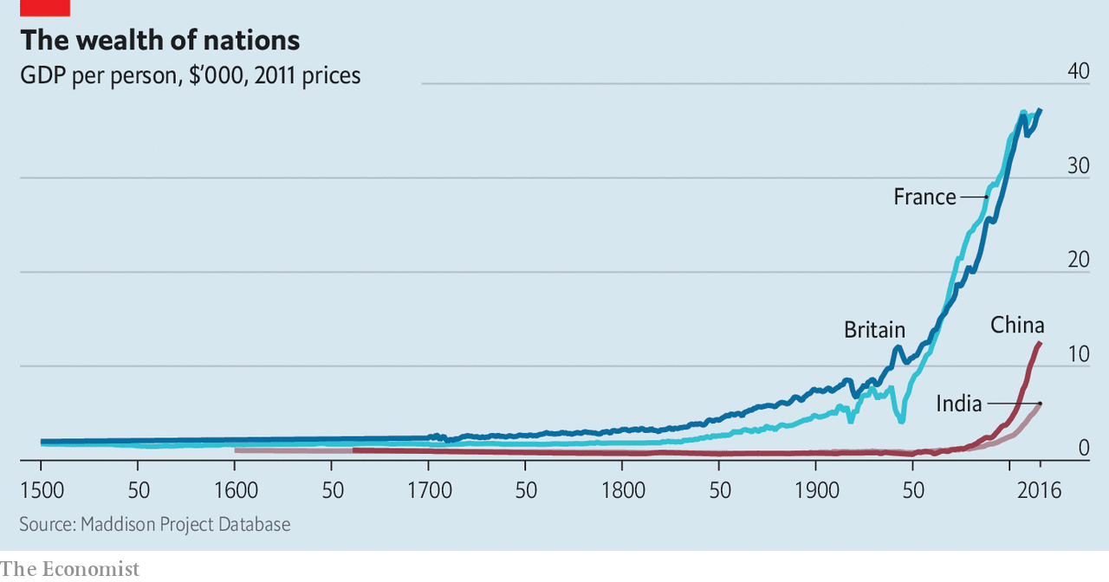

Other economists look to the distant past to explain contemporary disparities in income and wealth. A paper from last year by Benjamin Enke of Harvard University finds evidence that pre-industrial ethnicities which were exposed to a high local prevalence of pathogens exhibited tighter kinship systems—meaning, in effect, that people were strongly loyal to their extended family but suspicious of outsiders. In a place threatened by disease, tight family ties were beneficial because they reduced the need to travel, and therefore the risk of being exposed. Places which had tighter kinship systems hundreds of years ago tend to be poorer today, a relationship which first emerged during the industrial revolution. Other research has looked even further back, suggesting that contemporary cultural traits are the result of genetic variation. But this remains a niche pursuit, and most economists turn queasy when it comes to talking about genetics.

A separate body of research focuses on cases where culture is not a sufficient explanation for economic outcomes. Take the case of Guatemala and Costa Rica. “The two countries had similar histories, similar geographies and cultural inheritance, and were faced with the same economic opportunities in the 19th century,” write Daron Acemoglu and James Robinson in “The Narrow Corridor”, a book published last year. But today the average Costa Rican is more than twice as rich as the average Guatemalan. The cause of the divergence initially appeared random, according to Mr Acemoglu and Mr Robinson. Eventually it became clear it was down to coffee. In Costa Rica the development of coffee plantations for the European market led to a more balanced relationship between state and society, possibly because the country had more marginal land and more smallholders. In Guatemala, by contrast, it led to the emergence of a rapacious government.

In addition to culture, therefore, a growing band of economists is looking at “institutions”, often taken to mean the legal system and regulations. Some cultural economists argue that the focus on institutions proves their point: what are institutions if not the product of norms, values and preferences? Americans’ and Europeans’ differing beliefs about the causes of inequality, for instance, go a long way towards explaining why European welfare states are more generous than America’s.

But in many cases the emergence of different institutions may have nothing to do with a country’s culture. Sometimes it is just luck. Mr Mokyr shows that Europe, which was fragmented into lots of states, was the perfect setting for innovation: intellectuals who challenged received wisdom and incurred the wrath of the authorities could move elsewhere (Thomas Hobbes wrote “Leviathan” in Paris). By contrast in China, Mr Mokyr argues, free thinkers had few escape routes. Europeans did not plan such a system. It just happened.

Other work by Mr Acemoglu and Mr Robinson, along with Simon Johnson of MIT, has found a further element of randomness which may explain contemporary patterns of wealth and poverty—namely, which countries are more prone to certain diseases. The mortality rate of settlers was low in some colonised countries, such as New Zealand and Australia, in part because the kinds of diseases that were there were less virulent. In others, such as Mali and Nigeria, mortality rates were far higher. Colonisers did not want to settle in countries with a high risk of disease, even as they wanted to take those countries’ raw materials. So in countries such as Mali and Nigeria, rather than permanently settling, they set up systems which enabled the maximum of resource extraction with the fewest boots on the ground. That, say Messrs Acemoglu, Johnson and Robinson, produced rapacious political systems which have endured to this day.

Are economists any closer to answering the foundational question of their science? Far from the simplistic certainty of Weber, it seems likely that some countries are rich and others poor because of a messy combination of economic incentives, culture, institutions and chance—which is most important remains unclear. In 1817 Thomas Malthus, one of the early economists, wrote in a letter to David Ricardo, another, that “the causes of the wealth and poverty of nations [were] the grand object of all enquiries in Political Economy”. The revival of cultural economics two centuries on has helped in that quest, but it is not over yet. ■

This article was downloaded by calibre from <https://www.economist.com/schools-brief/2020/09/05/economists-are-turning-to-culture-to-explain-wealth-and-poverty>

|  |  |  |  |
| --- | --- | --- | --- |
|  | Articles | Sections | Next |

|  |  |  |
| --- | --- | --- |
| Schools brief | Sections | Books & arts |

Science & technology

Military strategy: What motivates the dogs of war?

.

Brain-computer interfaces: And pigs may drive

.

Forensic botany: Murder will out

.

Psychology: Lucid dreams

.

|  |  |  |
| --- | --- | --- |
| Schools brief | Sections | Books & arts |

|  |  |  |  |
| --- | --- | --- | --- |
|  | Articles | Sections | Next |

#### Predicting pugnacity

# How to forecast armies’ will to fight

What motivates the dogs of war?

Sep 5th 2020 |



IN JUNE 2014 around 1,500 partisans of Islamic State (IS) attacked Mosul, a city in northern Iraq. They were outnumbered almost 15 to one by government troops defending the place. The result was a rout. But not in the direction those numbers might have suggested. In the face of the enemy, the government soldiers ran away. Reflecting shortly thereafter on America’s failure to foresee what would happen, James Clapper, then Director of National Intelligence (and thus America’s top spy) described a force’s will to fight, or lack thereof, as an unpredictable “imponderable”.

Many in the past have felt the same. Military history is, as a consequence, littered with disastrously wrong assumptions about belligerents’ will to fight. America, for instance, famously underestimated the determination of Vietnam’s National Liberation Front when it involved itself in that country’s civil war in the 1960s and 1970s. Similarly, in 1916, during the first world war, Germany underrated France’s will to defend its fortress at Verdun against what the Germans hoped would be a war-winning assault. Casualties in that battle exceeded 300,000 on each side.

Assessing enemy morale is crucial to warcraft. Bruce Bueno de Mesquita, a political scientist at New York University, reckons human will matters enough for four wars in ten to be won by what starts off, in strict military terms, as the weaker side. Behavioural scientists are now, however, bringing the power of modern computing to bear on the question. Defence planners have long used computers to forecast the results of conflicts by crunching data on things like troop numbers, weapons capabilities, ammunition supplies and body- and vehicle-armour. The next step is to extend the idea into the area of morale, by quantifying the psychological variables that determine whether troops will flee, or stand and fight.

One leader in the field of morale research is Artis International, a think-tank in Arizona that is supported by America’s defence department. To understand better what has been going on in Iraq, for example, Artis’s researchers have interviewed Iraqi-government soldiers, Sunni militiamen, Peshmerga fighters (pictured) defending the autonomy of Iraqi Kurdistan, and also captured IS troops. Participants were asked about their willingness to further their causes by doing various things. These ranged from protesting in the street and donating money to torturing or killing opponents, volunteering as a suicide-bomber, or even sacrificing one’s family.

## Brothers in arms

The researchers charted participants’ responses on a seven-point scale of ascending willingness. The responses suggested that, among other things, those who declared themselves willing to sacrifice the most were the ones who also seemed least interested in material comfort and economic prospects. The researchers then embedded themselves with troops from the interviewed groups (save the IS prisoners), in part to seek differences between stated and actual willingness to fight. The bits of action they witnessed, and post-battle mapping of where (and when) casualties were suffered, broadly confirmed the findings from the interviews.

Crucially, this fieldwork revealed much about the casualties various types of units can take before survivors lose the will to fight. A typical fighting force, it is generally thought, will collapse sometime before a third of it has been destroyed. Some Kurdish and IS units in Iraq, however, fought on in a co-ordinated fashion after sustaining far more grievous losses. Artis therefore tried to classify and measure the belief systems behind such remarkable bravery.

One finding was that a fighter’s identity must have fully “fused” with those of his brothers in arms. The top priority of such fighters must, says the think-tank’s boss, Richard Davis, have shifted from family to another cause, a transcendental ideal that has become so “sacralised” that it would not be traded away for anything. Artis’s researchers identified fighters who had mentally downgraded their families to second or third place. Some were Peshmerga, who most valued “Kurdeity”—a love for the homeland steeled with commitment to fellow Kurds and Kurdish culture. Many IS captives, for their part, had shunted their families into third place behind the caliphate and sharia. Units girded with those beliefs had fought on effectively even after seven-tenths of their comrades had fallen.

The broad outline of this analysis would, of course, be familiar to any student of military history. Fanaticism has long been recognised as a plus in a soldier, be it the Zealots of ancient Israel, the Roman Catholic conquistadors of the Americas, or the Nazis’ 12th SS “Hitler Youth” Panzer Division. What is different about the Artis approach is its attempt to quantify, or at least to approximate, what is going on. That should help both in assessments of an enemy’s performance on the battlefield, and in designing training and indoctrination programmes for your own side.

Based on their work in Iraq, Artis’s 45 or so behavioural scientists have now led studies on willingness to fight and die for customers in 21 countries as diverse as Britain, Egypt and Guatemala. The goal is to incorporate such insights into predictive software. One organisation working on doing this is the United States Air Force Academy’s Warfighter Effectiveness Research Centre (WERC), in Colorado. WERC’s researchers are using Artis’s data to quantify how different levels of the will to fight alter the performance of tasks. For example, according to Lieutenant-Colonel Chad Tossell, WERC’s director, aircraft pilots whose wills are flagging are unlikely to buckle completely, but their reaction times typically slow down. His team is developing equations that reflect this. These are then fed into a version of “Far Cry”, a video game that the air force is modifying to incorporate will-to-fight calculations into combat simulations.

Comparing how unblooded cadets play the game with the approach taken by combat veterans will permit WERC to compile data on how experience, sex, age and other factors affect the speed with which players do things like throwing their virtual selves onto a grenade to save their comrades. How much a willingness to perform such an action in a game translates into behaviour on the battlefield remains to be seen. But the hope, Lieut-Colonel Tossell says, is that this study will, within two years, help the air force to nudge recruits into combat positions that make the most of their level of will to fight. The research, he adds, has already led to greater emphasis in training on the transcendental ideals that underpin America’s support for its own driving ideological creed: liberal democracy.■

This article was downloaded by calibre from <https://www.economist.com/science-and-technology/2020/09/05/how-to-forecast-armies-will-to-fight>

|  |  |  |  |
| --- | --- | --- | --- |
|  | Articles | Sections | Next |

|  |  |  |  |
| --- | --- | --- | --- |
| Previous | Articles | Sections | Next |

#### Brain-computer interfaces

# Elon Musk’s vision of the future takes another step forward

A pig now has one of his implants in its brain

Sep 2nd 2020 |

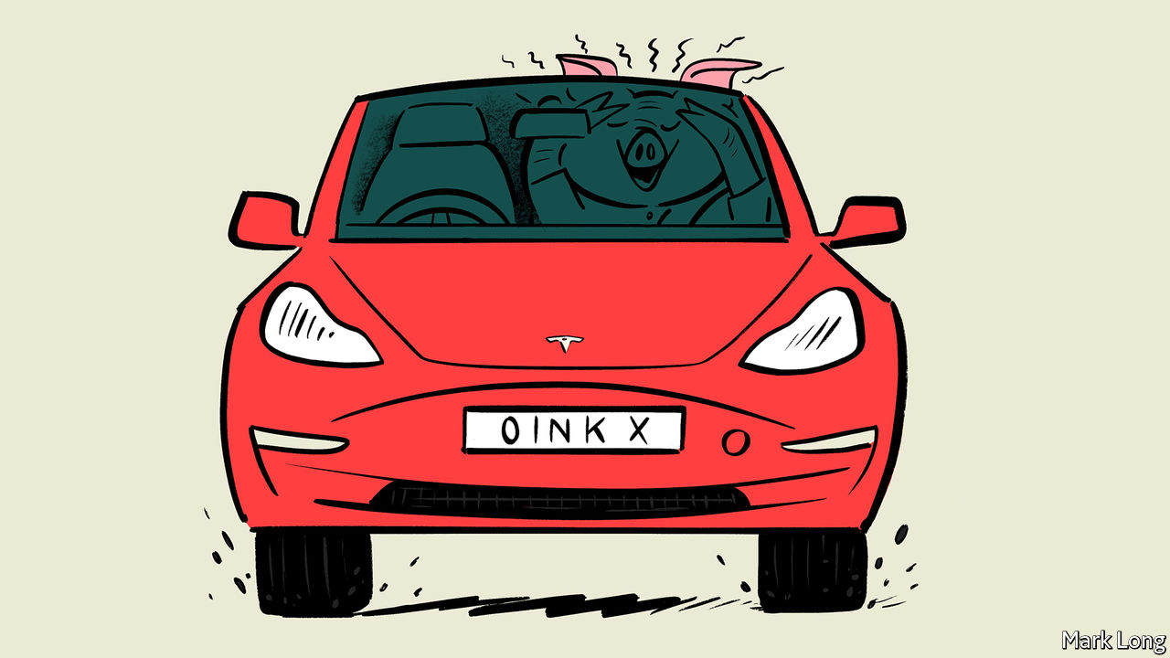

IN IDLE MOMENTS, people sometimes dream about the future. Of cars that can drive themselves. Of travelling to other planets. Of moving objects by the power of thought. Whichever particular dream you have, though, Elon Musk is probably trying to make it real. Self-driving cars and travel to Mars are the provinces of two of his firms, Tesla and SpaceX respectively. Moving objects by the power of thought is the province of a third, Neuralink. And on August 28th, at a presentation broadcast over the internet, Mr Musk showed off the firm’s progress. The highlight was the appearance of Gertrude, a pig with a chip implanted into her brain.

Reading the brain’s electrical signals, a technique called electroencephalography (EEG), started more than 100 years ago and is now routine. It generally involves placing electrodes non-invasively on the scalp, though it sometimes requires the invasive insertion of wires into the scalp or the brain itself.

Non-invasive EEG provides useful information, and can even be employed to do things like playing simple computer games via software which interprets the signals received and turns them into instructions. It is, though, a crude approach to monitoring the activity of an organ that contains 85bn nerve cells and trillions of connections between them. Invasive EEG offers higher resolution readings from those nerve cells, albeit at greater risk because of the surgery involved. The device Gertrude carries, known technically as a brain-computer interface (BCI), carries invasiveness one stage further still by making the EEG recorder a potentially permanent implant.

Signals from implants such as this might be employed to control a prosthetic limb, or even a real one that brain or spinal-cord injury has deprived of its normal nerve connections. They might also be used to control non-medical machinery, if someone thought it worth the risk of having a BCI implanted to do this. And it is possible to use them to send signals in the opposite direction, too, to give instructions to the brain rather than receive them. That might be used to generate signals which suppress an incipient epileptic seizure.

Neuralink’s BCI, the size of a British tuppenny piece, carries 1,000 flexible electrode threads, each of which has a diameter less than a quarter of that of a human hair. This flexibility is important because the brain moves around in the skull and the electrodes must be able to accommodate this movement while continuing to work. The device communicates wirelessly, and is recharged by induction. This means that, unlike many previous attempts to build BCIs, it requires no skin-penetrating cable that might admit infections to the body.

Along with this improved interface Neuralink has built a robot that will implant it. To do so, the robot first takes a high-resolution scan of the recipient’s brain. Using this, it is able to sew the electrode threads into place with a precision that avoids any blood vessels in the area. That, Mr Musk said, reduces the risk of damage during surgery. The robot can put the interface in place in less than an hour, he said, though it cannot yet open the skull in order to do so. General anaesthesia is not, he said, needed for the procedure.

The highlight of the show, though, was not Mr Musk’s presentation but rather the arrival of Gertrude. Her BCI is connected to nerve cells in a part of her brain called the olfactory bulb. As she snuffled around her pen searching for food, and also sniffed her handler’s hand, a display showed the electrical activity which those cells were manifesting in response to these stimuli.

Not everyone is impressed. Andrew Jackson, a professor of neural interfaces at Newcastle University, commented that there was not anything “revolutionary” in the presentation, saying it was “solid engineering but mediocre neuroscience”. Mr Musk replied, in a tweet, that it was common for academia to undervalue the benefits of bringing ideas to fruition.

## Pig headed

Admiration will surely increase if and when Neuralink performs on people a similar procedure to that which Gertude has undergone. The firm received a “breakthrough device designation” from America’s Food and Drug Administration (FDA) in July. This means the FDA thinks the gadget shows promise (in this case for the treatment of paraplegia), and offers it a faster pathway for regulatory review.

The next challenge the firm wants to tackle is that of sending electrical signals into the brain. Mr Musk says this will require a range of inputs, as some brain areas require delicate stimulation while others take a “lot of current”. The point of doing so will be to establish two-way communications. This could allow entirely new areas of treatment to be explored. Besides epilepsy suppression, some think that such brain stimulation might also work to treat depression and anxiety. More important in the long run, it is also essential to Mr Musk’s vision of widespread engagement, at a neurological level, between people and machines. This, he hopes, will result in a future in which memories can be downloaded and stored elsewhere, and human beings can form a “symbiosis” with artificial intelligence.

Critics worry that Neuralink is too secretive, and that Mr Musk’s vision promises more than he can deliver. He does, though, have a record of doing what he says he is going to, albeit sometimes not as rapidly as he says he will. He more-or-less single-handedly introduced battery-electric cars to the market and he built a successful space-rocket business out of nothing. Brains are a lot more complicated than cars, and even than rocket science. But do not bet against the coming into being at some point of the Musk vision of brains and computers collaborating directly. ■

This article was downloaded by calibre from <https://www.economist.com/science-and-technology/2020/09/02/elon-musks-vision-of-the-future-takes-another-step-forward>

|  |  |  |  |
| --- | --- | --- | --- |
| Previous | Articles | Sections | Next |

|  |  |  |  |
| --- | --- | --- | --- |
| Previous | Articles | Sections | Next |

#### Forensic botany

# Finding bodies in forests

Buried corpses may change the colours of surrounding plants

Sep 5th 2020 |

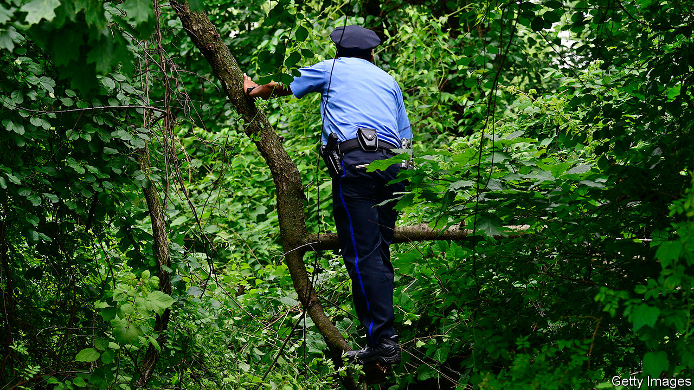

THE BODY FARM, known officially as the University of Tennessee Anthropological Research Facility, is a gruesome place. It is a hectare of land near Knoxville, cut off from the rest of the world by razor wire, that has, for more than three decades, been at the forefront of forensic science. It is both a laboratory which examines how corpses decay in different circumstances, so that matters such as time of death can be established more accurately, and a training facility for those whose jobs require an understanding of such processes.

To study a body forensically, though, you first have to find it. For a corpse dumped in a city this is hard enough. If the burial site is a forest it can be nigh impossible. Searchers must cover huge amounts of ground, and may therefore not do so as thoroughly as might be desirable. Vegetation broken by people burying bodies is easy to overlook. And soil perturbed by digging tends not to remain perturbed for long once it has been exposed to wind and rain.

For homicide detectives, then, woodlands are a problem. At least, they have been until now. For Neal Stewart, co-director of the Tennessee Plant Research Centre, another part of the university, reckons that a bit of botanical thinking brought to bear on the matter may turn trees from being cover for the disposal of bodies to signposts showing just where they are hidden. To pursue this idea, he has organised a group of researchers from various departments of the university, one of whom is Dawnie Steadman, the head of the Body Farm. And, as they write this week in Trends in Plant Science, this group has come up with three ways in which vegetation might flag up illicit burials.

The most obvious is fertilisation—for bodies are good fertilisers. Calculations suggest that a decaying adult human body releases about 2.6kg of nitrogenous compounds (mostly ammonia) into the surrounding soil. That, the researchers found when they looked through the relevant literature, is 50 times the average annual recommended level of nitrogenous fertiliser for trees and shrubs native to temperate North America.

Such an overdose would surely have consequences for nearby plant life. In particular, it would increase chlorophyll production, and thus cause a perceptible greening of plants near a buried body. In principle, this would be true of the decay of the body of any large animal. But the remains of wild creatures, left on the surface, are usually scavenged quickly. People with a human body to dispose of generally prefer to inter it so that it cannot be seen.

A more subtle change in the foliage near a buried body would be brought about by any cadmium present within its flesh and bones. Cadmium is rare in nature, but not in some human bodies. Smokers, and also those who work in industries involving welding or electroplating, have high concentrations of this metal. Cadmium is easily taken in by plants through their roots and, once present in their leaves, affects the structure of a molecular complex called photosystem two, which houses chlorophyll. That changes the way this complex absorbs and reflects light. This, in turn, affects the colour of the leaves.

A third change which might be detectable in foliage is induced by the artificial polymers found in clothing and shoes. These can be taken up by plants, too—ending up in their leaves and sometimes altering those leaves’ colour.

Crucially, all these effects would be visible from above. Drones fitted with spectroscopes that seek abnormal colours in foliage are already used by farmers to check crops for disease and drought. Dr Stewart, Dr Steadman and their colleagues are now investigating whether a similar approach can be used to scan woodlands for telltales of buried bodies.■

This article was downloaded by calibre from <https://www.economist.com/science-and-technology/2020/09/05/finding-bodies-in-forests>

|  |  |  |  |
| --- | --- | --- | --- |
| Previous | Articles | Sections | Next |

|  |  |  |  |
| --- | --- | --- | --- |
| Previous | Articles | Sections | Next |

#### Psychology

# Do dreams reflect reality?

Computer analysis brings closer an understanding of what dreaming is about

Sep 5th 2020 |



THAT DREAMS contain hidden meanings is an old idea. The Biblical Book of Genesis, written down about 2,500 years ago, describes how Joseph, son of Jacob, interpreted the Egyptian pharaoh’s dreams of fat and thin cattle as predicting years first of plenty and then of famine. In China, meanwhile, the most popular work on dream interpretation has long been the “Zhougong Jie Meng”, a dictionary of explanations for weird and wonderful dreams written 500 years earlier still. It is, however, only since the publication of Sigmund Freud’s treatise “The Interpretation of Dreams”, in 1899, that dreams have become a subject of serious scientific scrutiny.

Things have moved on since Freud’s day. His emphasis on violent urges and sexual repression as the roots of dreaming now looks old-fashioned. Instead, the premise is that dreams reflect a dreamer’s quotidian experience—either because they are an epiphenomenon of the consolidation of memories or because they are a mental testing ground for ideas the dreamer may have to put into practice when awake. This resemblance between dreams and reality is dubbed the continuity hypothesis by psychologists. Data supporting it, however, are sparse. Such as exist come from clinical studies rather than examinations of people with healthy minds. And the numbers of participants involved tend to be small.

That is not true, though, of the latest investigation into the matter. As they describe in Royal Society Open Science, Alessandro Fogli of Roma Tre University, in Italy, and Luca Maria Aiello and Daniele Quercia of Nokia Bell Labs, in Cambridge, Britain, have analysed thousands of reports of dreams experienced by mentally healthy people. Using these, they have tested several predictions based on the continuity hypothesis and found support for all of them.

## And not make dreams your master

The most common way of assessing dreams is the Hall and Van de Castle dream scale. This uses written reports of the characters appearing in a dream and of those characters’ social interactions, as well as the dream’s emotional content, to yield a set of scores that can be employed to create indices of things like the proportion of friendly, sexual and aggressive encounters in a dream.

Scoring dreams this way is, though, both time-consuming and subject to observer bias—meaning scores assigned by different people may not be properly comparable. The breakthrough made by Dr Fogli, Dr Aiello and Dr Quercia was to automate things using a language-processing algorithm called a parsed tree. This deals with reports by the thousand, rather than the dozen, and does so consistently.

Their source of supply was the DreamBank, a repository of 24,035 reports of dreams that is maintained by the University of California, Santa Cruz. All the reports are in English. They span the period between 1910 and 2017. And most are from America. In addition to a dream’s contents, each report includes the age and sex of the dreamer and a brief biography. The predictions the three researchers looked at were that the sexes dream differently in pertinent ways; that people’s dreams change as they age; that life-altering personal experiences change patterns of dreaming; and that perceived levels of everyday aggression are reflected in dreams.

As to sex differences, men—the more violent sex in the waking world—also had (as predicted) more violent dreams than women did. On the question of ageing, Dr Fogli, Dr Aiello and Dr Quercia were able to show that the dreams of individuals do indeed change as they move through adolescence and into young adulthood. In particular, they drew on 4,352 dreams recorded by “Izzy”, an anonymous woman who, between the ages of 12 and 25, systematically documented her dreams. Their algorithm showed that from 14 and 17 Izzy’s dreams usually involved negative social interactions and confrontation. From 18 to 25 those interactions became friendlier. Though it is dangerous to generalise from a single case, this pattern will no doubt be familiar to anyone who has watched a teenager grow up.

Waking experience, the algorithm showed, shapes dreams in other ways as well. A veteran of the Vietnam war, who had had intense exposure to violence during that conflict, dreamed more frequently of violence and aggression than did those with no military background. Conversely, the dreams of the blind, who often rely on the good offices of others to assist their everyday lives, were the friendliest and least violent of all.

Perhaps the most intriguing result came when the researchers let their algorithm loose on the broad sweep of history by dividing the DreamBank into decades. Lack of data meant they were able to do this meaningfully only from 1960 onwards. But when they did so they found that levels of violence and aggression in dreams were highest during the 1960s, and have subsequently declined in each decade since.

Why that should be is unclear, but they posit that, from an American viewpoint, the 1960s was a particularly violent decade, rife with political assassination, the threat of nuclear annihilation and the Vietnam war—a conflict fought with conscripts, and which therefore had especial resonance.

By these tests, then, the continuity hypothesis seems to pass muster. None of them, admittedly, seeks to answer the deeper question of what dreams are actually for. Whether a computational approach like this can investigate that matter as well remains to be seen. In the meantime, perhaps remember to stock up the larder if you dream of thin cattle. Just in case.■

This article was downloaded by calibre from <https://www.economist.com/science-and-technology/2020/09/05/do-dreams-reflect-reality>

|  |  |  |  |
| --- | --- | --- | --- |
| Previous | Articles | Sections | Next |

|  |  |  |
| --- | --- | --- |
| Science & ... | Sections | Economic & ... |

Books & arts

Violence and music: Drilling down

.

Johnson: Lost in dictation

.

Myrmecology: A bug’s life

.

Abe Shinzo: Family man

.

Home Entertainment: Assassin’s creed

.

|  |  |  |
| --- | --- | --- |
| Science & ... | Sections | Economic & ... |

|  |  |  |  |
| --- | --- | --- | --- |
|  | Articles | Sections | Next |

#### Hip-hop music

# An ethnographer’s study of drill music and gang violence in Chicago

Forrest Stuart embedded with rappers on the city’s South Side for over 18 months

Sep 5th 2020 |

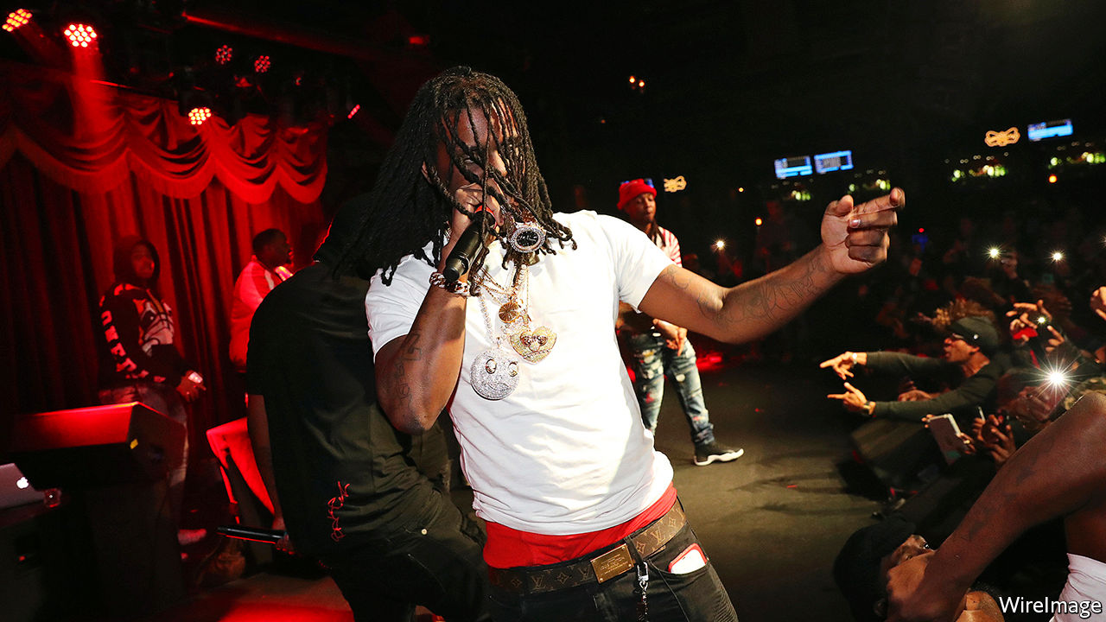

Ballad of the Bullet: Gangs, Drill Music and the Power of Online Infamy. By Forrest Stuart.Princeton University Press; 288 pages; $27.95 and £22.

TWO CARS, one silver and one black, pulled up in a busy shopping street in the Gold Coast, Chicago’s glitziest neighbourhood, one afternoon last month. Four passengers, weapons drawn, stepped between shoppers and fired off a hail of bullets. Their target was a chubby man in a blue tracksuit who stood outside a luxury-goods boutique. The 26-year-old slumped to the ground as shop windows shattered behind; his two companions were wounded. Passers-by filmed the aftermath of the shooting, posting footage online as he lay dying in the road.

The murder was unusual. Gun deaths have surged of late: by the end of August 500 killings had been counted in Chicago, as many this year already as in all of 2019. Overwhelmingly these occur when gang members intrude on each other’s turf in troubled districts on the South or West sides. Bullets rarely fly in Gold Coast. For participants in gang conflict, excursions to such wealthy, central places had previously seemed relatively safe.

Nor was the victim run-of-the-mill. Carlton Weekly was a minor celebrity who performed drill, a form of rap music that arose in Chicago a decade ago and became popular in London, New York and beyond. Performing under the moniker FBG Duck, his tracks were ominous, repetitive and catchy; his last music video, “Dead Bitches”, released in July, has 11m views on YouTube. As with many drill videos, the star posed in a shadowy room, flanked by gun-toting friends, smoking joints while waving wads of cash.

Some speculate FBG Duck was killed for the music, as that last song was a “diss track”. His lyrics crudely celebrated the murders of several members of an infamous Chicago gang, the Black Disciples. Insulting other rappers—and the gangs they associate with—is not new, nor unique to drill. It is a means to digital notoriety, though it may invite a bloody response. Such musical clashes online are amplified by bloggers who relish details of these verbal conflicts because they mirror real-world gang confrontations. FBG Duck had abused others in song for years, beginning with insults of Chief Keef (pictured), an early star of the drill scene.

Social media probably helped cause FBG Duck’s death. Chicago’s mayor, Lori Lightfoot, suggested his enemies monitored his posts on Facebook as he carelessly bragged to fans about his shopping sprees. Rivals routinely “lurk on” others—studying their social-media feeds and hoping, in the words of gangster rappers, to “catch opps lacking”. That means getting a chance to shoot or humiliate a rival, for example by forcing him, on camera, to diss his own gang or fellow rappers.

For years police in Chicago have said this online sparring, often expressed through music, spurs deadly violence. Confirming that is hard. How could anyone prove FBG Duck’s songs directly led to his death, asks Forrest Stuart, an ethnographer at Stanford University who embedded with drill rappers on Chicago’s South Side for over 18 months. The musician had ties with the Tooka gang, an outfit linked to the Gangster Disciples, which has long vied with the Black Disciples. His elder brother, another drill rapper who worked as FBG Brick, and a cousin were shot dead on the same day in 2017. As a rapper he was a tempting target, but he would have been one anyway, even without uttering a word.

Mr Stuart’s recent book, “Ballad of the Bullet”, is an often gripping account of what he learned from his association with teenage members of an up-and-coming drill group—he dubs them the Corner Boys—desperate to win fame, status and money from rapping. He shows how their musical and lyrical talent is only a minor part of what determines success. As important are attempts to win a reputation online as authentic gangsters, despite their sometimes feeble efforts to acquire weapons, cash or other props essential for building credibility.

Aspiring stars must at least pretend they are heavily involved in conflict. “It is a hyper-violent context,” says Mr Stuart; even conducting research was risky at times. A young rapper mishandling a gun nearly shot him. He describes learning how the Corner Boys lurked on the social-media feed of a rival driller, here called Smoky-P, fond of posting selfies. They identified a shop where he regularly bought alcohol, drove by and fired at him several times, apparently as he prepared to take a photograph of himself.

The author is reluctant to simply blame his subjects for such appalling acts. For many characters he uses pseudonyms to avoid stirring more conflict, or inviting attention from police. Most such young men, he notes, are traumatised by street shootings they have experienced from early childhood. Broken families produce ill-educated men who go on to choose between menial service jobs or drug dealing. Youngsters have few role models to follow.

In slums, favelas and shantytowns elsewhere, ambitious people dream of getting out by playing football. In Chicago drill, despite its gang ties, serves that end. For a few rappers who earn enough online notoriety, such as Chief Keef, record contracts and wealth follow. More interesting is the fate of larger numbers of smaller fry like the Corner Boys. Their relatively modest musical success delivers paltry financial rewards, which mostly go to pay technicians. But the artists earn in other ways: higher status on the street, the attention of women, respect from other would-be rappers and adoration from some online fans.

Who then is responsible for the violence? Not one actor alone. But one conclusion is that consumers of drill—mostly more affluent folk far from the South Side—encourage it through the digital economy. They reward (by sharing and clicking) videos of artists who are the most authentically antagonistic and boastful about their violent crimes. “I want to implicate all of us,” says Mr Stuart. “Too often we leave ourselves, as consumers, out of the equation.” Rappers respond to consumer demand. If their content “is not egregiously violent, then they are irrelevant”. ■

This article was downloaded by calibre from <https://www.economist.com/books-and-arts/2020/09/05/an-ethnographers-study-of-drill-music-and-gang-violence-in-chicago>

|  |  |  |  |
| --- | --- | --- | --- |
|  | Articles | Sections | Next |

|  |  |  |  |
| --- | --- | --- | --- |
| Previous | Articles | Sections | Next |

#### Johnson

# Is it possible to “write” using speech-to-text software?

Turning the spoken word into clear prose requires more planning than the human brain is capable of

Sep 5th 2020 |



VOICE TECHNOLOGY has come a long way. Just a few years ago, it would’ve been unusable, so much so that many people gave up on it in the early years.

But now, those who follow the technology know that it has gotten considerably better over the last five to ten years. Truly effective voice technology promises many good things. Not only does it allow you to command devices like smartphones or use wired home devices without the use of hands, but also many other applications. For example, you can identify someone by their voice if you need to know who they are over the phone. Your bank will find this very useful.

What about writing with your voice? This could be a great boon for people who lack mobility for one reason or another. But not only that. Busy people who type badly, and find it easier to talk, might find it much easier to dictate their messages than they would find to sit and type them. Everyone remembers the bosses in old movies who shout things like quotation mark Ms Johnson! Take a memo. Rotation marked.

But writing with your voice raises several interesting questions. How easy is it actually? Human speech involves a lot more starting and stopping with errors and the need for repairing mangling sentences than you may think. Writing may be an unnatural act, but once it is learned, the first draft of a piece of writing is a lot more usable than the “first draft” of a bit of speech. Anyone tempted to doubt this proposition might try listening to an interview, even one with a highly articulate speaker, and transcribing every single word that that person says. It will quickly become obvious that even gifted speakers make lots of mistakes. That’s not usually a problem when we talk to each other, but it makes for extraordinarily messy looking writing.

To make turning the spoken word into coherent writing requires lots of planning. You’ll need some kind of notes or other organiser to make it work, which only brings us back to the original problem. Those who need to write with their voice will first need to write a structure to then write from. If you are unable to write, this does not solve the problem.

Another question turning speech into writing raises is one of style. How would writing change it more people spoke their writing rather than typing? Chances are that at the very least they would come up with many more short sentences and more concrete language, which is good. But they would probably also rely on pre-assembled phrases and clichés a lot more often, which would definitely be a bad thing. Good writing requires slow thought, which is not available when you are speaking at full clip.

To test this proposition this column has been not written but dictated. It was composed from brief notes written down for structure only. It has been edited for length, with all of the original errors kept in. Though this paragraph two is being dictated, which means I have no idea how this is turning out, here are guesses about how this will read.

The first guess is that the literal accuracy of the dictation software will be extremely high. In other words there won’t be many cases where the software has heard one word incorrectly and transcribed another. But the other guess is that the readability of this column will be rather bad.

In other words, the blame is not with the technology, which turns out to be rather good. Speaking into writing relies on a much better human brain than the one we currently possess. Writing is hard. There’s a reason it can’t be done at the speed of speech, in real time.

To elucidate—and this was written after the fact, rather than dictated—paragraph breaks were added after transcription. Punctuation had to be spoken aloud, but after a full stop the first word in the new sentence was capitalised automatically. Some minor punctuation marks were added to improve clarity.

Only a handful of words out of almost 800 were transcribed incorrectly, among them “rotation marked” (“quotation mark”), “two” (“too”) and “it” (“if”). To improve accuracy, your author “trained” the software, Dragon Dictate, for a few seconds beforehand, reading a pre-written passage aloud. An external microphone of reasonable quality also helped a great deal.

Nonetheless, The Economist’s style mavens have their heads in their hands at the ugly Americanisms and egregious stylistic infractions. It will be a relief to them, and to the reader, that Johnson will not be dictating any future columns.

This article was downloaded by calibre from <https://www.economist.com/books-and-arts/2020/09/05/is-it-possible-to-write-using-speech-to-text-software>

|  |  |  |  |
| --- | --- | --- | --- |
| Previous | Articles | Sections | Next |

|  |  |  |  |
| --- | --- | --- | --- |
| Previous | Articles | Sections | Next |

#### A bug’s life

# Ants and humans have shaped each other’s destinies

Edward Wilson complements scientific observation with personal anecdotes

Sep 5th 2020 |



Tales from the Ant World. By Edward Wilson. Liveright; 240 pages; $26.95 and £17.99.

ANTS AND people have much in common, Edward Wilson explains. Both are social animals, organised into complex societies with elaborate forms of communication. Ant societies, much like the human kind, are often highly stratified, with specialised jobs and a well-defined caste system. Some ants are warriors, some slavers, and some, more benignly, gardeners.

But Mr Wilson cautions against carrying the analogy too far. Though ants are creatures of instinct, “human beings are torn by the competing needs of self, family and tribe. We use culture to banish instinct or at least tame it.” There is nothing in the ruthless lives of ants “that we can or should emulate for our own moral betterment”.

Mr Wilson has built a distinguished career by deploying insights from the biology and behaviour of ants to present larger lessons about evolution, ecology and the extent to which human psychology can be explained by natural selection. As its title suggests, “Tales from the Ant World” is a short, loose-jointed and conversational book. It lacks the ambition of works such as Mr Wilson’s “Sociobiology: The New Synthesis” (published in 1975) or the panoramic sweep of “The Diversity of Life” (1992), but it is filled with delightful accounts of a naturalist in action and enough hard science to keep readers on their toes.

Ants and humans not only share a sociable nature; they have shaped each other’s destinies throughout their shared time on Earth, sometimes as competitors, at other times companionably. For instance, ants have exploited the human talent for long-distance travel to extend their own reach. On their own, ants are “poor oceanic travellers”, but they hitched rides with mariners across the Polynesian archipelago during the age of European exploration, and roamed beyond their natural habitats aboard modern commercial vessels. Often the arrival of these aliens disturbs the ecological balance. When a crop-destroying fire ant native to Argentina and Uruguay arrived in the port of Mobile, Alabama, on cargo boats, it soon spread devastation across the American South and beyond.

In Mr Wilson’s hands even ant-sized anecdotes carry the seeds of larger ideas. He celebrates ingenuity even when it is manifested on the smallest scales. As may be expected from someone who has spent much of his career crawling on hands and knees among the rotting leaves of a forest floor, or chasing insects across desert sands, the author is not squeamish. He finds beauty in the clever ways a parasitic fungus drives its host insect to its death, or in the resourcefulness of the Matabele ants, which attack and destroy termite mounds the size of buses. “Every corpse is an ecosystem,” he phlegmatically observes.

Revolting as all this may seem, Mr Wilson soon brings the reader around. “Each fallen bird, landed fish, beached whale, decomposing log, plucked flower”, he writes, “is destined to change from a conglomerate of giant molecules, the most complex system in the universe known, into clouds and drifts of much smaller organic molecules.” Zooming out from the microscopic to the panoramic and back again, “Tales from the Ant World” finds wonder in nature’s endless variety. ■

This article was downloaded by calibre from <https://www.economist.com/books-and-arts/2020/09/05/ants-and-humans-have-shaped-each-others-destinies>

|  |  |  |  |
| --- | --- | --- | --- |
| Previous | Articles | Sections | Next |

|  |  |  |  |
| --- | --- | --- | --- |
| Previous | Articles | Sections | Next |

#### Family man

# A timely, comprehensive biography of Abe Shinzo

“The Iconoclast” situates the outgoing prime minister’s ideas in the broader context of Japanese history

Sep 3rd 2020 |

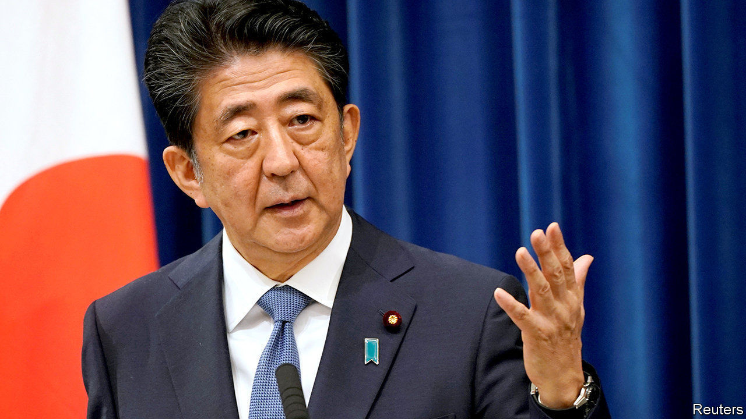

The Iconoclast. By Tobias Harris. Hurst; 392 pages; $29.95 and £25

ABE SHINZO was just five years old in 1960 when protesters surrounded his grandfather’s house in Tokyo. Kishi Nobusuke, then Japan’s prime minister, was in the midst of a pitched battle over Japan’s security treaty with America. Kishi would get his treaty that year, though it led to him losing power. For a young Mr Abe, the episode would be “the touchstone of his political identity”, argues Tobias Harris in “The Iconoclast”, a new biography of Japan’s longest-serving prime minister.

Mr Abe’s status as the grandson of a former prime minister and the son of a former foreign minister, Abe Shintaro, is well-known. Mr Harris, a longtime observer of Japanese politics, astutely explains how Mr Abe’s family influenced his thinking, and situates that thinking in the broader context of Japanese history stretching back to the Meiji restoration of 1868. This comprehensive and engaging tome may become the definitive English-language portrait of Mr Abe, made all the more relevant by his recent resignation (see [article](https://www.economist.com/node/21791382)).

As Mr Harris shows, Mr Abe is the progeny of Kishi, but a product of the American occupation and the many strange compromises it engendered. His grandfather’s fate is one of the most striking. Kishi made his name orchestrating forced labour for the Japanese war machine as a minister in Japanese-occupied Manchuria in the 1930s. He served loyally in Japan’s wartime cabinet and was arrested as a war criminal in 1945. As the cold war ramped up, Kishi was one of several ex-leaders the Americans let off in order to help rebuild Japan as a bulwark against Soviet communism. Kishi climbed to the pinnacle of power in Japan by helping to found the Liberal Democratic Party (LDP) with a bit of help from the CIA.

Re-establishing Japan’s sovereignty and seeking greater equality in the partnership with America became Kishi’s mission. But in the battle of post-war ideas, his vision lost out to the “Yoshida Doctrine” (so named after Japan’s first significant post-war prime minister, Yoshida Shigeru), wherein Japan would rely upon America for security while focusing on its own economic development. Mr Abe made it his cause to revise that consensus, embodied in the American-imposed post-war constitution that bars Japan from having armed forces (though it does, with American support, maintain mighty armed forces for the purpose of self-defence).

Mr Abe may have drawn on his grandfather’s ideas but he learned his trade at his father’s side. Shintaro visited 81 countries in the 1980s; the younger Mr Abe served as his secretary. “His father’s globe-trotting personal diplomacy impressed upon his son the importance of building trust with foreign leaders,” Mr Harris writes. That has been one of Mr Abe’s main achievements (see [Leader](https://www.economist.com/node/21791372)). He also inherited his father’s unfinished business: Shintaro died of cancer while trying to settle a territorial dispute with the Soviet Union in 1991.

After Mr Abe followed his father into the Diet, Mr Harris shows how he came to be a leader of a “new conservative” movement. He argued for a more equal alliance with America in which Japan could bear a greater burden, and latched on to the cause of Japanese citizens abducted by North Korea to prove his bona fides as a defender of his country. He also engaged in some appalling whitewashing of Japan’s wartime atrocities. Mr Abe’s allegiance to the new conservative ideas helped doom his first short-lived term as prime minister in 2006-07, which became bogged down in ideological battles over the past.

Belonging to a political dynasty gave Mr Abe a big head start. He rose fast despite having been an average student who whizzed around in a red Alfa Romeo and played a lot of mahjong. Yet it has also been a heavy burden. The reader cannot help but quake alongside Mr Abe when his mother tells him, “The LDP of the present was made by my father Kishi Nobusuke, and you must never forget those great footprints.” His mother is an enduring presence: they live in the same apartment building, and even as prime minister, he and his wife, Abe Akie, ate breakfast with her.

That, in part, explains why changing Japan’s constitution was so important to Mr Abe. He cited his failure to do so as one of his biggest regrets when he announced his resignation on August 28th. Yet history will remember Mr Abe more fondly for his readiness to subsume his ideology in favour of a pragmatic approach to national interests during his second stint in office. (Such as with his conciliatory statement on the 70th anniversary of the end of the second world war.) Even what Mr Harris dubs an “Abe Doctrine”—building up Japan’s defence capabilities and ties with other regional powers—is less a break with the Yoshida Doctrine than an offshoot.

As Mr Harris notes, Mr Abe was a keen reader of the German sociologist Max Weber. “With regard to what one should do as a politician, my grandfather consistently acted according to ‘responsibility for consequences’,” he wrote in 1996. “That is, Max Weber’s ‘ethic of responsibility’.” Mr Abe was too kind to his grandfather. The description fits him better. ■

This article was downloaded by calibre from <https://www.economist.com/books-and-arts/2020/09/03/a-timely-comprehensive-biography-of-abe-shinzo>

|  |  |  |  |
| --- | --- | --- | --- |
| Previous | Articles | Sections | Next |

|  |  |  |  |
| --- | --- | --- | --- |
| Previous | Articles | Sections | Next |

#### Home Entertainment

# Discover the taut political thrillers of Jean-Patrick Manchette

Unlike today’s noir fiction, his books waste no time on psychology

Sep 5th 2020 |

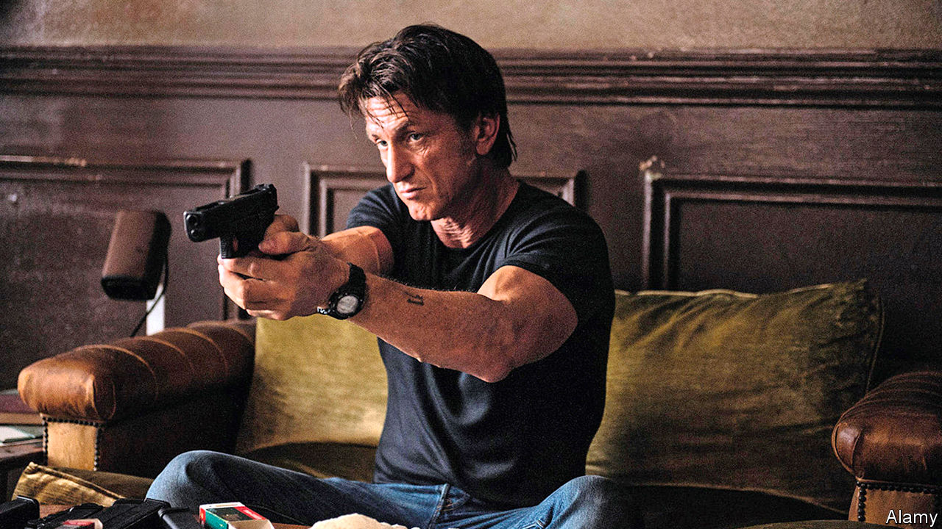

“IN THE WEST the economy was not working well, mental illness was rife, and social classes were still locked in struggle.” This familiar diagnosis comes from “Three to Kill”, a French noir novel by Jean-Patrick Manchette, published in 1976. As he wrote, far-left terrorists in Europe were bombing and kidnapping their way towards revolution. He turned this unrest into a series of politically engaged pulp fictions as smooth as a well-oiled revolver.

In his youth Manchette, who died in 1995, had been a left-wing activist. Inspired by this milieu, he created a cast of assassins, anarchists and ideologues. Martin Terrier, the hit-man at the heart of “The Prone Gunman” (published in 1981 and adapted into a film starring Sean Penn in 2015), is trying to go clean after a decade of profitable murder, only to be pursued by old enemies. Georges Gerfaut, the militant turned middle-manager in “Three to Kill”, stumbles into a bitter vendetta involving an old fascist from the Dominican Republic. Manchette’s tightly wound plots move inexorably towards bloody denouements. Along the way he portrays a society riven by a class war that has devolved into a grisly procession of tit-for-tat murders.

Manchette wastes no time on psychology. His books are all action, unfolding with a laconic efficiency that would make his killers proud. One minute Gerfaut is enjoying a dip in the sea, the next a killer in swimming trunks is punching him “matter-of-factly in the solar plexus”. Manchette dispatches his victims with grim specificity: a woman’s chest becomes “a glob of crushed bone, pulped flesh, fragments of bronchial tubes”. His characters’ interests are narrow but deep—in particular, what bullets do to bodies and the weapons that fire them.

Flashes of lyricism illuminate the murk. Manchette describes a burning house collapsing “just as matter collapses, or so they say, in the hearts of distant stars”. There are touches of black comedy. As Carlo and Bastien, a pair of bickering assassins, trail a target to the south of France, Bastien plans a holiday excursion: “We can stop at Le Lude,” he says. “It’s charming, Le Lude. It has a delightful castle.” When Bastien dies in a shoot-out, Carlo’s eulogy is a passage from “Spider-Man”.

The blend of action, ideology and humour comes together best in “Nada” (1973). The most overtly political of Manchette’s novels, it tells of a ragtag group of left-wing terrorists planning to kidnap the American ambassador to France. Manchette skewers its members—only one is a true believer; the rest are there for the kicks—as well as the quarrelsome vanity of left-wing factions. Needless to say, the group’s plan goes awry in a stupendously violent way. Just when you think all the corpses have dropped, another head explodes. ■

This article was downloaded by calibre from <https://www.economist.com/books-and-arts/2020/09/05/discover-the-taut-political-thrillers-of-jean-patrick-manchette>

|  |  |  |  |
| --- | --- | --- | --- |
| Previous | Articles | Sections | Next |

|  |  |  |
| --- | --- | --- |
| Books & arts | Sections | Graphic detail |

Economic & financial indicators

Economic data, commodities and markets

.

|  |  |  |
| --- | --- | --- |
| Books & arts | Sections | Graphic detail |

|  |  |  |  |
| --- | --- | --- | --- |
|  | Articles | Sections | Next |

# Economic data, commodities and markets

Sep 3rd 2020 |

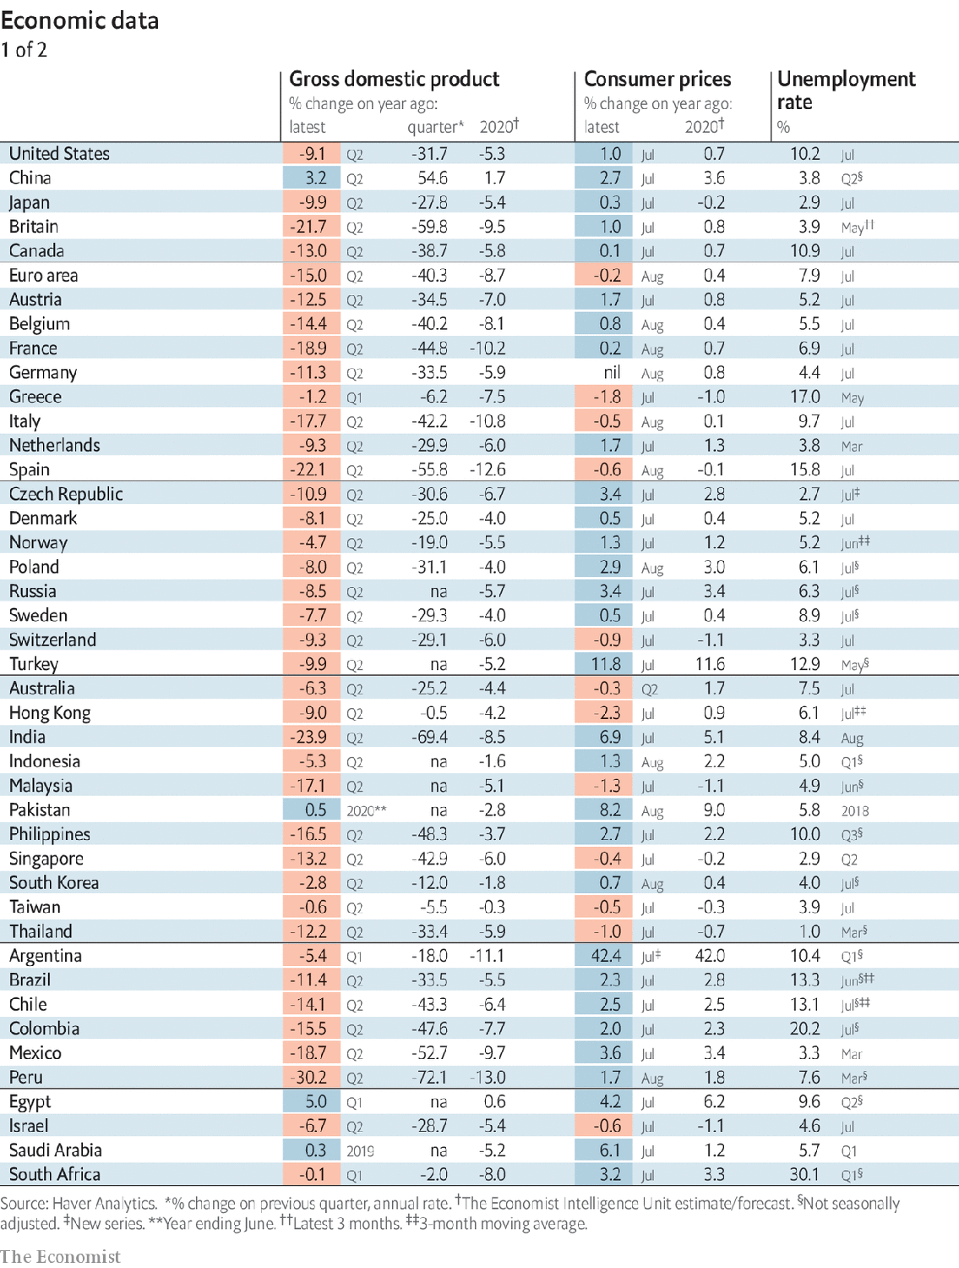

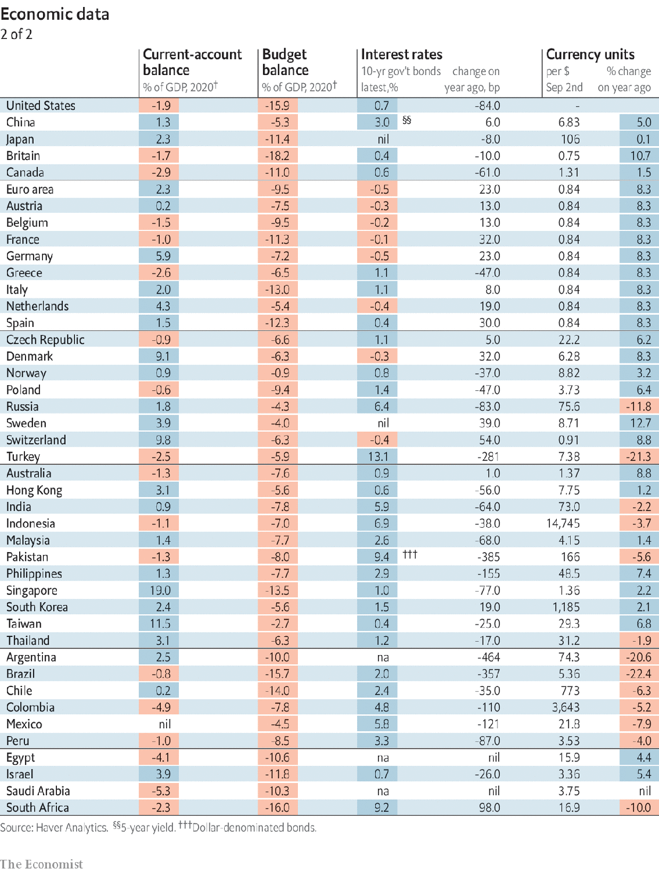

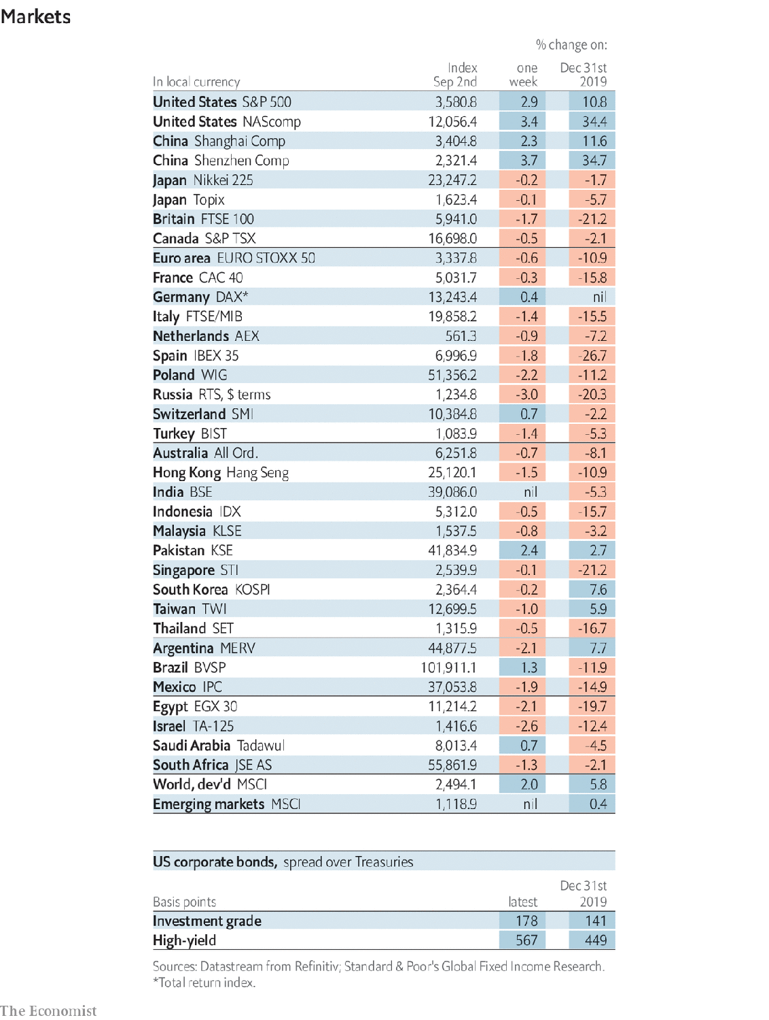

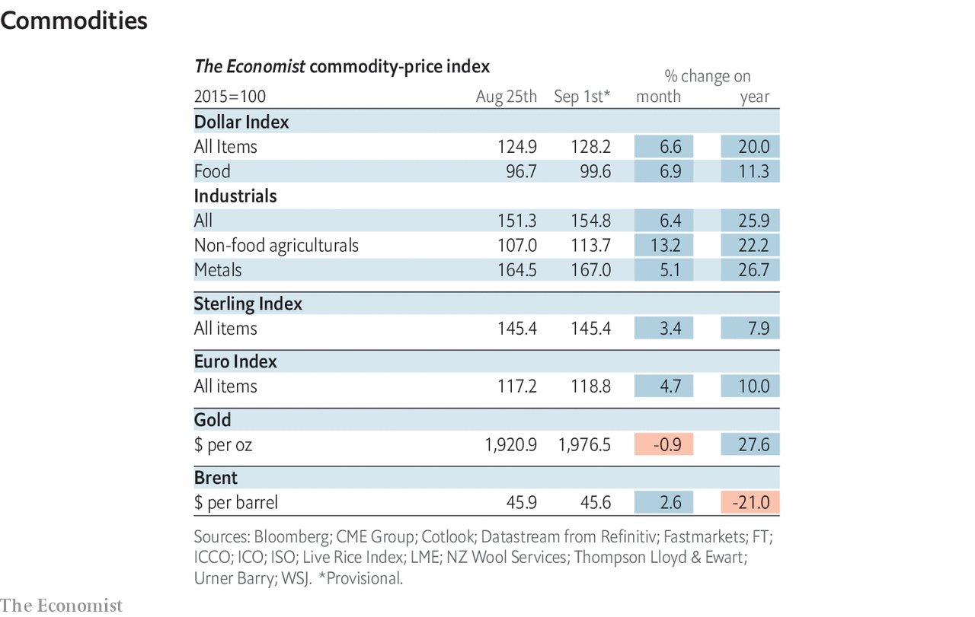

This article was downloaded by calibre from <https://www.economist.com/economic-and-financial-indicators/2020/09/03/economic-data-commodities-and-markets>

|  |  |  |  |
| --- | --- | --- | --- |
|  | Articles | Sections | Next |

|  |  |  |
| --- | --- | --- |
| Economic & ... | Sections | Obituary |

Graphic detail

Air pollution: Blue skies turn grey

.

|  |  |  |
| --- | --- | --- |
| Economic & ... | Sections | Obituary |

|  |  |  |  |
| --- | --- | --- | --- |
|  | Articles | Sections | Next |

#### Blue skies turn grey

# Air pollution is returning to pre-covid levels

This bodes ill for respiratory health

Sep 5th 2020 |

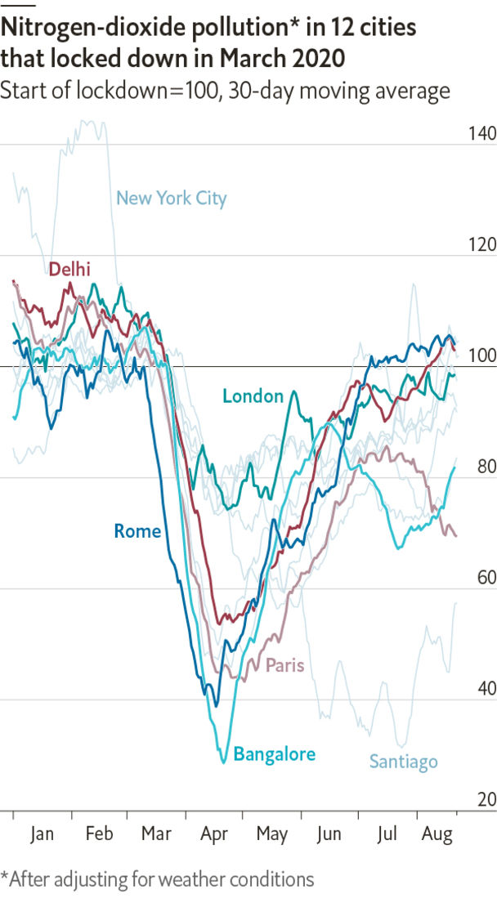

COVID-19 IS NOT all bad, as any city-dweller who stepped outside this year will have seen. The virus has killed hundreds of thousands of people and decimated economies around the world. But as GDP has fallen so has air pollution. This spring marked the first time in decades that residents of Jalandhar in northern India were able to see the snow-capped Himalayan mountains, 160km (100 miles) away.

One particularly common pollutant is nitrogen dioxide (NO2). The World Health Organisation (WHO) reckons that NO2 levels above 40 micrograms in every cubic metre of air (40µg/m3) are harmful to people. In Delhi, one of the world's most polluted big cities, NO2 fell sharply after the city imposed its lockdown, from 46µg/m3 in March to 17µg/m3 in early April. Similarly, NO2 levels in London fell from 36µg/m3 in March to 24µg/m3 two weeks later.

Air-pollution levels do not depend on human activity alone—weather conditions such as wind speed, rainfall and humidity matter, too. The Centre for Research on Energy and Clean Air (CREA), a think-tank, has produced a model which takes these factors into account to gauge the impact covid-19 has had on air-pollution levels in 12 big cities around the world. They found that NO2 levels fell by about 27% ten days after governments issued stay-at-home orders, compared with the same period in 2017-19. Levels of particulate matter less than 2.5 micrometres wide (PM2.5), which are also harmful to health, declined by an average of about 5% in a group of 12 big cities in which data are readily available.

The health benefits of cleaner air are profound. The WHO reckons that about 90% of the world’s population live in places where air quality falls short of its standards. They estimate that 4.2m people died prematurely from diseases related to air pollution, such as respiratory-tract infections and lung cancer, in 2016 alone, including 290,000 children. Millions more suffer from chronic health problems.

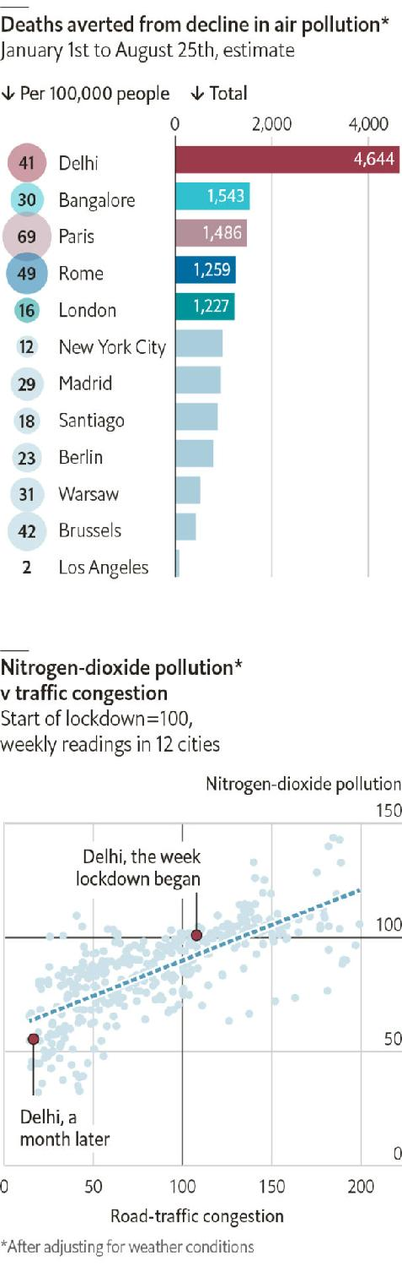

The CREA estimates that improved air quality since the covid-19 pandemic began has saved about 15,000 lives in 12 big cities. In Delhi, around 4,600 people have escaped death due to air pollution—roughly as many as are known to have died from covid-19, although the disease’s true tally is probably higher and still rising.

As people return from summer holidays in the northern hemisphere and economies begin to recover, air pollution is nearing pre-pandemic levels. Although people are still wary of using public transport, they appear to have fewer reservations about driving cars themselves—data from TomTom, a location-tech firm, show that congestion in big cities has just about returned to pre-covid levels. This increase in pollution will be deadly, especially to those who suffer from severe asthma, who are also vulnerable to covid-19. ■

Sources: Centre for Research on Energy and Clean Air; TomTom;The Economist

This article was downloaded by calibre from <https://www.economist.com/graphic-detail/2020/09/05/air-pollution-is-returning-to-pre-covid-levels>

|  |  |  |  |
| --- | --- | --- | --- |
|  | Articles | Sections | Next |

|  |  |  |
| --- | --- | --- |
| Graphic detail | Sections |  |

Obituary

Chadwick Boseman: To be a king

.

|  |  |  |
| --- | --- | --- |
| Graphic detail | Sections |  |

|  |  |  |  |
| --- | --- | --- | --- |
|  | Articles | Sections | Next |

#### To be a king

# Chadwick Boseman died on August 28th

The actor who embodied the character of Black Panther was 43

Sep 5th 2020 |

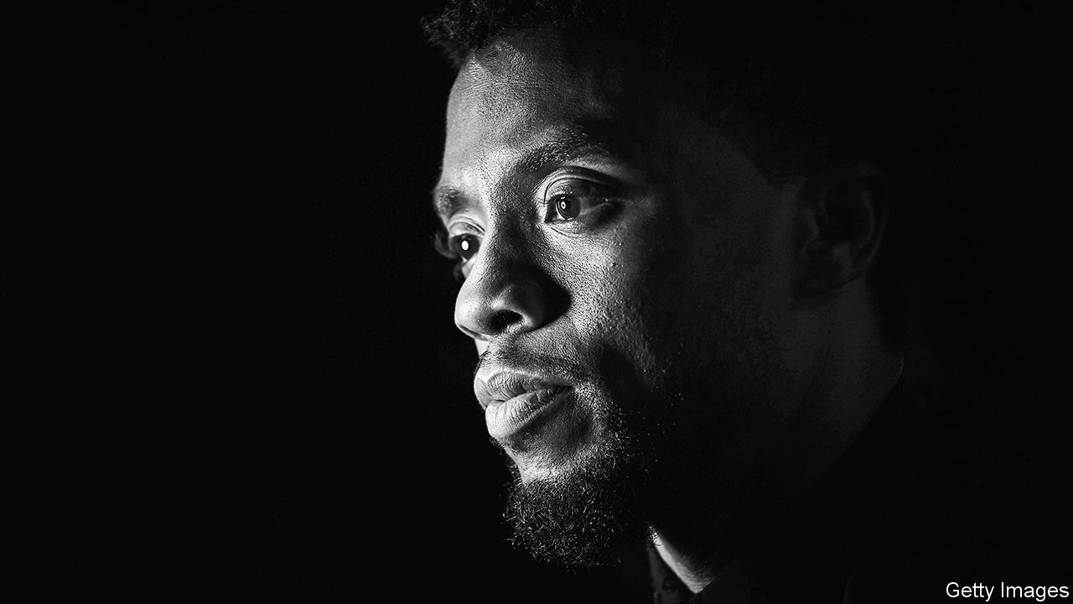

AS HE SLIPPED into each role, studiously, scene by scene, Chadwick Boseman kept one thought in mind. His character was a strong black man in a world that conflicted with his strength. It didn’t want him to be great; it tried to keep him down. But there was something in him, some particular talent, or obsession, or part of his past, that made him stand tall. That made him say, “No.”

It was fitting, then, that the role he became most famous for was a tested but triumphant black king, T’Challa, in “Black Panther” in 2018. The film was a sensation. It tipped Hollywood on its head: a $1.3bn-grossing movie whose cast and makers were, almost to a man and woman, black. Black Panther (T’Challa’s moonlighting persona) had appeared in film before, but in the “Captain America” and “Avengers” series, among a crowd of white Marvel superheroes. Now he stood alone. In a white-focused world he ruled a country, Wakanda, that was more advanced than any other, both technologically and spiritually. Never colonised, never enslaved. He himself was both an acrobatic righter of wrongs and a ruler who was cool, stately, wisecracking and wise. Even before the film came out, schools were booking cinemas for pupils to see it. For him, as the lead, success was not just black children, in their Panther costumes, crying “Wakanda for ever!” and giving the crossed-arm salute. He had put in their heads the idea that they could be great. And he had also sown in little white heads the rare, enlightening thought: “I want to be him.”

Less obviously, his major roles before then had also made that point. All were men the world could not keep down. In “42” as Jackie Robinson, the first black player in modern Major League Baseball, he struggled through white disdain, but always knew how good he was. In “Marshall”, as the lawyer who became the first black Supreme Court justice, he combined sharp clothes with a razor-sharp mind as he defended his innocent black client. And in “Get on Up” as James Brown, the firebrand singer who electrified music in the 1960s, he bowed to no prejudice but strutted through life, seizing what he wanted. All these were fighters in their way, as effective as Black Panther crouched on a speeding car to spring. Brown had that one-two step, then a punch like a boxer’s at the microphone. Marshall could floor a racist thug with one blow. Robinson would stand at the plate, ready, about to hit a homer that would shock the crowd into silence. Then cheers.

Each character he played left little bits in him, whether Brown’s sexy dance moves or Marshall’s liking for fine outfits. But Robinson taught him he should confront the world squarely, calmly, and think he was infallible. He had not been too good at doing that, in his past. Growing up in South Carolina, even well after the Civil Rights Act, he had been run off the road by rednecks, called “boy” and passed by trucks that flew Confederate flags. He had faced it, and failed at facing it. Now, in playing his characters, he could relive those things and respond in a different way.

He prepared as thoroughly as possible. For “42” he spent weeks learning to play baseball like a pro. Mick Jagger helped him with “Get on Up”, teaching him how to tease and seduce an audience. He dug deep into the backstories of the characters, filling out their weaker sides and their humanity. It was important to walk in their shoes through the world. Black characters on screen were too often one-dimensional, as if they were second-class.

Yet the fictitious role of T’Challa and his kingdom of Wakanda engaged him even more. This was a work of recovery, the celebration of a severed African past that belonged to all black people. Every part of it had to be properly done. It was he who insisted the cast spoke Xhosa, with its clicks and smacks. He found it beautiful and rhythmical, like ancient music. He helped devise the salute, which reminded him of tomb effigies of the pharaohs. (In 2016 he had played Thoth in “Gods of Egypt”, the one face of African descent among them, taking the part only because, without him, there would have been none.) For close combat he studied Zulu stick-fighting and Dambe boxing from west Africa. Costumes, sets and moves fused together different aspects of the continent he loved, a mixing and reconnection that went to his own roots: almost the moment he got the part, he had his DNA tested and found he was Yoruba from Nigeria and Limba from Sierra Leone. Last, he reinforced the film’s relevance by making T’Challa a peacemaker in the Mandela mould while his nemesis Killmonger, his abandoned cousin, was inspired by Malcolm X. That echoed a conversation he had long had with himself: forbearance, or violence.

The film’s huge success was difficult in one way. As an actor he worked at his craft by observing people. He had existed in the shadows, watching from a back table as he sipped a vegan smoothie or dined on brussels sprouts. He liked to hide. Now people spotted him from the end of the street and chased after him, a star. But in all other ways success had to be good, well beyond the audience reaction. It showed the Hollywood moguls that a thoroughly black film was viable and bankable. It opened the way, or ought to, for substantial roles for more black actors. There were countless stories in their culture that had not yet been told. Or not by them.

A storyteller was how he saw himself, part of an ancient tradition in both Africa and the West. When a friend had been shot dead in high school, writing a play about it seemed the best way to channel his emotions. Later, forging a path as an actor-director in New York, he wrote a hip-hop play on classic themes, “Deep Azure”, based on the shooting of a young black man by a black policeman. That victim, he explained, was not just another casualty lost to violence. He was a would-be leader, a would-be king.

He was already a king in the public mind when his cancer took hold. He went on making films with as much vitality and as full a laugh as before. “Black Panther II” was on: he was in the Marvel teaser, regally striding as before. One of his last texts, to his white co-star in “Marshall”, urged him to inhale, exhale and enjoy the rare rain that was falling on Los Angeles. Fate was pushing him down, but he confronted it. For as long as he could, he said “No.” ■

This article was downloaded by calibre from <https://www.economist.com/obituary/2020/09/05/chadwick-boseman-died-on-august-28th>

|  |  |  |  |
| --- | --- | --- | --- |
|  | Articles | Sections | Next |